GE6152-ENGINEERINGGRAPHICS-QUESTIONBANK

# UNIT–1



1. Constructanellipsewhenthedistancebetweenthefocusandthedirectrixis30mmandtheeccentricityis¾.DrawthetangentandnormalatanypointPonthecurveusingdirectrix.
2. AfixedpointFis7.5cmfromafixedstraightline.Draw thelocusofapointPmovinginsuchawaythatitsdistancefromthefixedstraightlineis2/3timesitsdistancefromF.Namethecurve. Draw normal and tangentata point 6cmfrom F.
3. Constructanellipsewhenthemajoraxisis120mmandthedistancebetweenthefociis108mm.Determinethelengthoftheminoraxis.Themajoraxisofaellipseis100mmandtheminoraxisis55mm.FindthefociandconstructtheellipsebyIntersectingArcsMethod.
4. Aflowerbedinabotanicalgardenisellipticalinshape.Majorandminoraxesare9cmand5.5mrespectively.Drawthe profileofthe flowerbedto ascaleof1:100.
5. Constructanellipsewhenitsmajoraxisisequalto100mmandminoraxisisequalto65mm. Finditsfoci,directrixand eccentricity.
6. Construct aparabolawhen the distancebetween focus and thedicretrixis40 mm. DrawtangentandnormalatanypointP onyourcurve.
7. AfixedpointFis7.5cmfromafixedstraightline.DrawthelocusofapointPmovinginsuchawaythatitsdistancefromthefixedstraightlineisequaltoitsdistancefromF.Namethecurve. Draw normal and tangentata point6cmfromF.
8. Construct ahyperbolawhenthe distancebetweenthe focusanddirectrixis 40mm.Theeccentricityis 4/. Drawa tangentandnormalat anypointon thehyperbola.
9. AfixedpointFis7.5cmfromafixedstraightline.DrawthefocusofapointPmovinginsuchawaythatitsdistancefromthefixedstraightlineis3/2timesitsdistancefromF.Namethecurve. Draw normal and tangentata point 6cmfrom F.
10. Thedistancebetweenafixedpointandfixedlineis54mm.Tracethepathofapointmovinginthesameplanesuchthatitsdistancebetweenthefixedpointandthefixedline is always equal. If thepointmoves up to72mmfrom thefixedpoint,plot thecurve.
11. Acoinof40mmdiameterrollsoverahorizontaltablewithoutslipping.Apointonthecircumferenceofthecoinisincontactwiththetablesurfaceinthebeginningandafteronecompleterevolution.Drawthepathtracedbythepoint.Drawatangentandnormalat anypointon thecurve.
12. Arollerof40mmdiameterrollsonastraightlinewithoutslip.IntheinitialpositionthediameterABofthecircleisparalleltothelineonwhichitrolls.Drawthelocusofthepoints.



1. AandBforonecompleterevolutionoftheroller.Namethecurve.Drawatangentandnormalatanypointonthe curve.
2. Acircleof40mmdiameterrollsonahorizontalline.DrawthecurvetracedoutbyapointRonthecircumferenceforonehalfrevolutionofthecircle.Fortheremaininghalfrevolutionthecirclerolls ontheverticalline.ThepointRisvertically abovethecenterofthecircle inthestartingposition.
3. Awheelofabikeofdiameter500mmrollsslippingonalevelroadthroughadistanceof1025mm.Trace thepathofapoint P on thewheelwhichis initiallyin contactwiththeroad. Namethe curve.Find theangle throughwhich the wheelis turned.
4. Constructacycloidgeneratedbyarollingcircleof45mmindiameter.Drawatangentanda normalata pointon thecurve 30mm above thedirectingline.
5. Drawepicycloidsofrollingcircle40mm(2r),whichrollsoutsideanothercircle(basecircle)of150mmdiameter(2R)foronerevolution.Drawatangentandnormalatanypointonthecurve.
6. Drawanepicycloid,thedirectingcircleofwhichis160mmindiameterandthegeneratingcircle40mmindiameter.Drawatangentandnormaltothecurveatanypointon it.
7. Drawanepicycloids,thedirectingcircleofwhichis160mmindiameterandthegeneratingcircle40mmindiameter.Drawatangentandnormaltothecurveatanypointon it.
8. Thepointsofintersectionofanepicycloidswiththedirectingcirclesubtendanangleofπ/2radiansatthecenterofthedirectingcircle.Ifthedirectingcirclehasadiameterof120mm,drawthe epicycloids.
9. Drawahypocycloidofacircleof40mmdiameterwhichrollsinsideanothercircleof200mmdiameterfor one revolution.Drawa tangentandnormalatanypointon it.
10. Drawahypocycloid.Thediameteroftherollingcircleis36mmandthediameterofthebase circleis108mm.Drawa tangentandnormal atanypointonthecurve.
11. Drawa hypocycloidwhenthe radiusofthedirecting circleistwicethe radiusofgeneratingcircle.Radius of thegeneratingcircleis 35mm.
12. Drawtheinvoluteofa**square**ofside25mm.DrawatangentandnormalatanypointM.

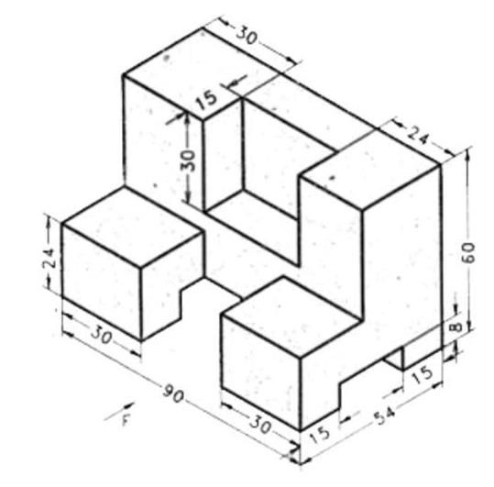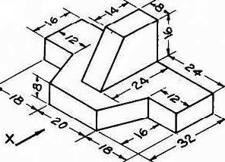

1. Acoiris unwoundfrom a drumof30 mmdiameter.Draw thelocus ofthefree endofthecoirforunwindingthroughanangleof3600.Drawalsoanormalandtangentatanypointonthecurve.
2. Aninelasticstringoflength100mmiswoundaroundacircleof26mmdiameter.Drawthepathtraced bytheendofthestring.
3. Aninelasticstringiswoundaroundthecircumferenceofasemicircularcylinderofdiameter66mm. Thestringisunwoundcompletelyby holdingitsfreeendsuchthatitisalwaystightlystretched.Drawthe pathofthefreeendofthe string.
4. Drawtheorthographicviewssuchasfrontview,topviewandanyonerearviewoftheobjectsgivenbelow

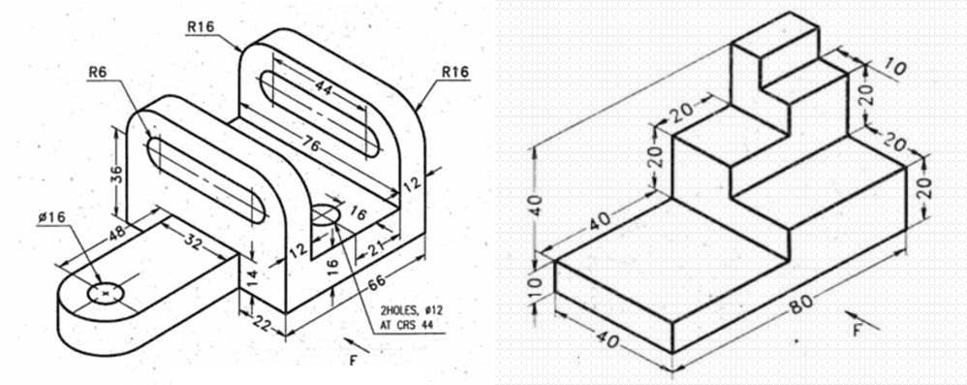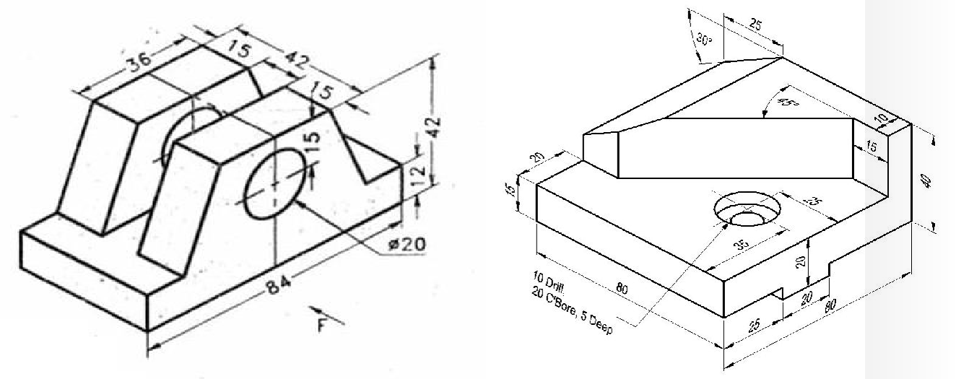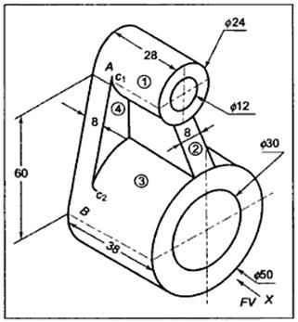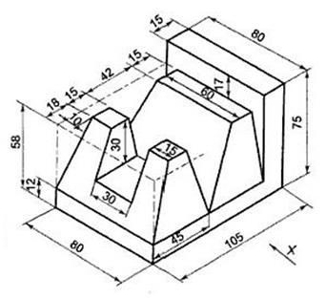

# UNIT–2

1. PointA is30 mm above HPand45mminfront of VP.Drawits frontviewandTop view.
2. Drawthe projectionsof a point A lyingon HP and50mminfrontof VP.



1. Drawthe projectionsof a point Alying on VPand55mmaboveHP.
2. Drawthe projectionsof a point Q lying on VPand58mmabove HP.
3. Drawthe projectionsof a point FwhichliesinboththeHP andtheVP.
4. A point B is45mmaboveHP and60mm behind VP.Drawitsprojections.
5. A point Cis35mm belowHP and 25mm behind VP.Drawits projections.
6. A point D is45mm belowHPand 60mm infrontofVP.Drawits projections.
7. Marktheprojectionsofthefollowingpointsonacommonreferenceline,keepingtheprojectors35mmapart.
8. Drawthe projectionsof thefollowingpointsona commonreferenceline.
9. Apoint25mmbelowXYisthetopviewoftwopointsAandB.AisHPandBis35mmbelowHP. Mark theprojectionsof A andB.
10. MentionthepositionofthefollowingpointsshowninFig.10,respecttotheplanesofprojection. Allthedimensionsaremarkedinmm.
11. A lineCD 30 mmlongis parallelto both the planes.Thelineis 40mm aboveHP and 25mminfront of VP. Drawits projections.
12. A lineRS60mmlongliesinHPand45mmin frontof VP.Drawits projections.
13. A linePQ55 mm longis lyingin VP and45mmaboveHP. Drawitsprojections.
14. A line AB55mmlongis lyingonboth HPandVP. Drawits projections.
15. AlineAB25mmlongisparalleltoVPandperpendiculartoHP.PointAis35mmaboveHPand20mminfrontofVP.PointBis10mmaboveHP.Drawtheprojectionsofthe lineAB.
16. AlineAB25mmlongisperpendiculartoVPandparalleltoHP.ItsendAis10mminfront ofVP andthelineis 20mmaboveHP.Drawthe projectionsof the line.
17. AlinePQ40mmlongisparalleltoVPandinclinedatanangleof300toHP.ThelowerendP is 15mm aboveHP and20mm infrontofVP.Drawthe projections ofthe line.
18. Draw theprojectionsofalineEF40mmlongparalleltoHPandinclinedat350toVP.Eis20mm above HPand 15mm infrontof VP.



1. AlineAB50mmlongisinVPandinclinedat350toHP.EndAis10mmaboveHP.Drawthe projections.
2. AlineRS measuring52 mm isinHPandinclined at an angleof450toVP. The endRis10mminfront of VP.Drawthe projections.
3. ThelengthofthetopviewofalineMNparalleltoVPandinclinedat450toHPis50mm.PointMis12mmaboveHPand25mminfrontofVP.Drawtheprojectionsoftheline. Finditstruelength.
4. DrawtheprojectionsofalineCD50mmlong,paralleltoHPandinclinedtoVP.TheendCis10mminfrontofVPandDis30mminfrontofVP.Thelineis15mmaboveHP.AlineCDisparalleltoVPandinclinedat400toHP.CisinHPand25mminfrontofVP.Top viewis50 mmlong. Findits truelength.
5. AlineEF60mmlongisinVPandinclinedtoHP.Thetopviewmeasures45mm.TheendE is 15mm aboveHP.Drawthe projections of theline.FinditsinclinationwithHP.
6. AlineGH45mmlongisinHPandinclinedtoVP.TheendGis15mminfrontofVP.Lengthoffrontviewis35mm.Drawtheprojectionsoftheline.DetermineitsinclinationwithVP.
7. AlineAB60mmlongisparalleltoHP.ThepointAis20mmaboveHPand35mminfront of VP.The lengthofthefrontviewis50mm. Determineits trueinclinationwithVP.
8. AlineMN50mmlongisparalleltoVPandinclinedat300toHP.TheendMis20mmabove HPand10mmin frontof VP.Drawthe projectionsoftheline.
9. AlineCDmeasuring80mmisinclinedatanangleof300toHPand450toVP.ThepointCis20mmaboveHPand30mminfrontofVP.Drawtheprojectionsofthestraightline.
10. AlinePQ75mmlonghasitsendPinbothHPandVP.Itisinclinedatanangleof300

toHP and450to VP. Drawthe projections.

1. AlineABis75mmlong.Ais50mminfrontofVP.and15mmaboveHP.Bis15mmin frontofVPand is above HP. Top viewofAB is50 mm long.Find thefront viewlengthandthetrueinclinations.
2. Alinemeasuring80mmlonghasoneofitsends60mmaboveHPand20mminfrontofVP. Theotherendis15mmaboveHPandinfrontofVP.The frontviewofthelineis60mm long. Drawthetopview.



1. AlineAB65mmlonghasitsendA20mmaboveHPand25mminfrontofVP.EndBis40mmaboveHPand65mminfrontofVP.DrawtheprojectionsofAB.Finditsinclinations with HP and VP.
2. A line AB100mm longhas itsfrontviewinclinedat anangleof450to thereferencelineseparatingtheviews.TheendAisinVPand25mmaboveHP.Thelengthofthefrontviewis60mm. Draw thetopviewoftheline andfindthetrueinclinations ofthelinewithHPandVP.
3. Thetopviewofalineis65mmlongandisinclinedat300tothereferenceline.Oneendis20mmaboveHPand10mminfrontofVP.Theotherendis60mmaboveHPand is infront of VP.
4. DrawtheprojectionsandfindthetruelengthofthelineanditstrueinclinationstoHPandVP.
5. DrawtheprojectionsofastraightlineABof100mmlengthwhenoneofitsendsistouchingtheVPandtheotherendtouchingHP.TheanglesofinclinationwithHPandVPare400and 500respectively.
6. AlineAB,65mmlonghasitsendA,15mmaboveHPand50mminfrontofVP.Thelinemeasures80mmlongandinclinedatan angleof300toHPand450toVP.Draw itsprojections.
7. Theprojectionsofalinemeasure80mminthetopviewand70mminthefrontview.Themid-pointofthelineis45mminfrontofVPand35mmaboveHP.Oneendis10mminfrontofVPandnearertoit.Drawtheprojections.Findtruelengthandtrueinclinations with referenceplanes.
8. AlineAB120mmlongisinclinedat450toHPand300toVP.Itsmid-pointCisinVPand20mm aboveHP. Theend A is in thirdquadrantand B isinfirstquadrant.Drawtheprojectionsof theline.
9. ThedistancebetweentheprojectorsoftwopointsABis70mm.Ais10mmaboveHPand15mminfrontofVP.Bis50mmaboveHPand40mminfrontofVP.FindtheshortestdistancebetweenAandBbyRotatinglineMethod.FindtrueinclinationsofABwith VPandHP.
10. OneendP’ofastraightlinePQis35mmaboveHPand25mminfrontofVP. TheendQis50mmaboveHPand 45mmin frontofVP. Thedistance betweenthe projectors is60mm.DeterminethetruelengthandtrueanglesofinclinationsofthelinewithHPandVP.
11. TheaboveproblemissolvedbyTrapezoidalPlaneMethod.SolvethisproblembyrotatingPlane Method.Comparethe results.



1. AlineLM70mmlonghasitsendL10mmaboveHPand15mminfrontofVP.Itstopandfrontviewsmeasure60mmand40mmrespectively.Drawtheprojectionsoftheline. Finditsinclinations withHP andVP.
2. AlineABmeasuring85mmhasitsendA25mmaboveHPand20mminfrontofVP.Thefrontandtopviewsofthelinemeasure70mmand55mmrespectively.Drawtheprojectionsof thelineanddetermine its trueinclinations.
3. AlineABhasitsendAinHPand40mminfrontofVP.Itsfrontviewisinclinedat500toXYandhasalengthof70mm.TheotherendBisinVP.Drawitsprojections.Also,find the truelength andtrue inclinationsof theline.
4. Apentagonallaminaof40mmsidehasacircularholeof35mmdiameterinitscenter.TheplanestandsononeofitssidesonHPwithitsplaneperpendiculartoVPand450inclined toHP. Drawthe projections.
5. Athincircularmetalplateof48mmdiameter,havingitsplaneverticalandinclinedat400toVP. Its centeris33mmaboveHP and25mm infrontof VP.Drawits projections.
6. Athinrectangularplateofsides50mmx25mmhasitsshortersideintheHPandinclinedatanangleof300totheVP.Projectitsfrontviewwhenitstopviewisaperfectsquareof 25mmside.
7. Arectangularlaminaofsize60mmx30mmisseenasasquareinthetopview,whenitrestsonone ofitsedges on HPandperpendicular toVP.
8. Drawthe projections ofthelamina.Find the trueincli-nation ofits surface with HP. Drawthefrontviewofthelaminawhentheedgeaboutwhichitistilted,isinclinedat450toVP.
9. Athinrectangularplateofsides60mmx30mmhasitsshortersideinVPandinclinedat 300toHP.Project itstopview, ifitsfront viewis a squareof 30mmlongsides.
10. Draw theprojectionsofapentagonalsheetof26mmside,havingitssurfaceinclinedat300toVP. Itsone sideisparalleltoVPand inclined at 450to HP.
11. Ahexagonallaminaof26mmsidehasasiderestingonVPandinclinedat300toHP.Itssurface isinclinedat 450 toVP.Drawprojections.



1. Aregularpentagonallaminaof30mmsideshasoneedgeinHPandinclinedatanangle of 300toVP.Drawits projectionswhenits surface is inclinedat450to HP.
2. Ahexagonallaminaof20mmsiderestsononeofitscornersontheHP.Thediagonalpassingthroughthiscornerisinclinedat450totheHP.Thelaminaisthenrotatedthrough900suchthatthetopviewofthisdiagonalisperpendiculartotheVPandthesurface isstill inclinedat450totheHP. Drawtheprojectionsofthe lamina.
3. Ahexagonalplateof25mmsideisrestingonHPsuchthatoneofitscornerstouchesbothHPandVP.Itmakes300withHPand600withVP.DrawtheprojectionsbyChangeof PositionMethod.
4. Acircularlaminaof60mmdiameterrestsonHPonapointIonthecircumference.ThelaminaisinclinedtoHPsuchthatthetopviewofitisanellipseofminoraxis35mm.The top viewofthe diameter through the point Imakesan angle of450with VP.(i) Drawtheprojections.(ii)Determinetheanglemadebythe laminawithHP.
5. Aregularhexagonalplanesurfaceof25mmside,hastwoofitsedgesparalleltobothHPandVPandthenearestedgeis15mmfromeachplane.Thesurfaceisinclinedat600toHP. Drawtheprojections.
6. Drawtheorthographicviewsofaregularhexagonallaminaof25mmside,restingonHPononeofitssideswithitsplaneperpendiculartoHPononeofitssideswithitsplaneperpendiculartoHPandinclinedat450toVPTakethenearestcornerpoint25mmawayfromVP.
7. Athinhexagonalplateof25mmsideliesonHPononesideandisinclinedat300toVP.(i)Drawtheprojectionsoftheplatewhenitstopedgeis20mmaboveHP.(ii)DetermineitsinclinationwithHP.
8. Drawtheprojectionsofapentagonalplanefigureofside28mmrestingwithoneofitsedgesonHPsuch thattheplanefigure isinclinedat300to VPand perpendicular toHP.
9. Arhombuslaminahasitsdiagonals75mmand45mmlong.Itisplacedsuchthatitstopviewappearsasa squareofdiagonal45mmlongand the verticalplanethroughthelongerdiagonalisinclinedat300toVP.Drawitsprojections.Findtheinclinationofthelonger diagonal withHP.



* 1. initiallyassumetherhombusonhpsuchthatthesmallerdiagonalisperpendiculartovp.
  2. drawthe firsttop view oftrue shape such that thesmallerdiagonal isperpendicular toxy. projectthefirstfront viewasa lineonxy.
  3. drawthesecondtopviewasasquareof45mmdiagonalandprojectthesecond

front view.Measure θ=530=inclinationofthe longer diagonal withhp.

* 1. drawfinaltopviewfromsecondtopviewsuchthatlongerdiagonalisat300toxy.drawfinalfrontviewbyprojectingsecondfront viewandfinaltopview.

64.Apentagonalplanefigureofedges25mmislyingonHPwithoneofitscornerstouchingitsuchthattheplanefiguremakes600withHP.TwooftheedgescontainingthecorneronwhichtheplanefigurerestsmakeequalinclinationswithHP.Whentheedgeoppositetothiscornermakes450withVP,drawthetopandfrontviewsoftheplanefigure inthis position.

65.Acircularlaminaof60mmdiameterappearsasanellipseinthetopview,havingitsmajoraxis60mmlongandminoraxis40mmlong.Drawitsfrontviewwhenthemajoraxisoftheellipseisparallelto boththereference planes.

66.Athincircularmetalplateof54mmdiameterhasasquareholeof27mmside,cutcentrallythroughit.DrawitsprojectionswhentheplateisrestingonHPwithitssurfaceinclined at300 toHPandanedge of thesquareholeperpendicularto VP.

67.Acircularlaminaof50mmdiameterappearsasanellipseinthefrontview,itsmajorandminor axes being50 mm and 30mmrespectively. Draw its topview when the majoraxisishorizontal.

68.Aregularhexagonallaminaof26mmsidehasacentralholeof30mmdiameter.Drawthefront and topviewswhen the surface ofthelamina is inclined at450 to HP. A side ofthe lamina isinclined at 350to VP.

69.Ahexagonalplateof25mmsidehasacorneronHP.Itssurfaceisinclinedat500toHP.ThediagonalthroughthecornerwhichisonHP,makes350withVP.Drawitsprojections

# UNIT -3

1. Apentagonalprism,sideofbase25mmandaxis50mmlong,restswithoneofitsedgesonHPsuchthatthebasecontainingthatedgemakesanangleof300toHPand itsaxisis parallelto VP.Drawits projections.
2. Ahexagonalprism,sideofbase24mmandaxis55mmlong,restswithoneofitsedgesonHPsuchthatthebasecontainingthatedgemakesonangleof450toHPand itsaxisis parallelto VP.Drawits projections.



1. A hexagonal pyramid, side ofbase 25mmandaxis 50mmlong, rests with one oftheedgesofits baseonHPand itsaxisisinclinedat300toHPandparalleltoVP.Drawitsprojections.
2. Asquarepyramid,sideofbase30mmandheight65mm,restswithoneoftheedgesofits base onHP suchthatits basemakes 300toHP. Drawitsprojections.
3. Drawtheprojectionsofapentagonalpyramidofbase25mmsideandaxis60mmlongwhenitislyingonHPononeofitsbaseedges,suchthattheaxisisparalleltoVP and inclinedat300to HP.
4. Atetrahedronof40mmsiderestswithoneofitsedgesonHPandperpendiculartoVP.Thetriangularfacecontainingthatedgeisinclinedat300toHP.Drawitsprojection.
5. Arightpentagonalpyramidofbaseside20mmandaltitude60mmrestsononeofitsedges ofthebase inHP.thebasebeingliftedup untilthehighest corner initis 20mmaboveHP.Drawtheprojectionsofthepyramidwhentheedgeonwhichitrestsismade perpendicularto VP.
6. Ahexagonalpyramidof26mmsideofbaseand70mmheightrestsonHPononeofitsbaseedgessuchthatthetriangularfacecontainingtherestingedgeisperpendicular to bothHP andVP.Drawits projections.
7. Ahexagonalpyramidsideofbase25mm,axis50mmlonglieswithoneofitstriangularfacesontheHP anditsaxisis parallel to theVP.Drawitsprojections.
8. Apentagonalpyramid,sideofbase30mmandaxis60mmlongislyingwithoneofitstriangularfacesontheHPandaxis parallelto the VP,Drawits projections.
9. Apentagonalpyramid,sideofbase25mmandaxis55mmlong,lieswithoneofitsslant edges onHPsuch thatitsaxisis parallelto VP. Drawits projections.



1. Ahexagonalprism,sideofbase25mmandaxis50mmlongrestswithoneofitsbasecornersonHPsuchthatitsbasemakesanangleof600toHPanditsaxisisparalleltoVP.Drawitsprojections.
2. Asquareprism,sideofbase40mmandaxis60mmlong,restswithoneofitsbasecornersonHP.Itsbasemakesanangleof450toHPanditsaxisisparalleltoVP.Drawits projections.
3. Asquarepyramidofsideofbase50mmandheight75mmliesonHPononeofitstriangularfaceswithitsaxis parallelto VP. Drawits projections.
4. Drawtheprojectionsofacubeofside40mmwhenitrestsonthegroundononeofitscornersandafacecontainingthatcornerisinclinedat300tothegroundandperpendicularto VP.
5. Apentagonalprismofbaseside30mmandaxislength60mmrestsonHPononeofthebasecornerswiththebaseedgescontainingitbeingequallyinclinedtoHP.The axis isinclined at 450to HPand parallel to VP. Drawthe projections ofthe prismbychange ofpositionMethod.
6. Apentagonalpyramidsideofbase20mmandaxis45mmlongrestswithoneofitscornersonHPsuchthatthebaseisinclinedatanangleof600toHPandonesideofbase isperpendicularto VP. Drawits projections.
7. Drawtheprojectionsofacylinder,base30mmdiameterandaxis40mmlong,restingwithapointofitsbasecircleonHPsuchthattheaxisismakinganangleof300with HPand parallelto VP.

# UNIT -4

1. Acubeofside30mmrestswithoneofitsfacesonHPsuchthatoneofitsverticalsquarefacesisinclinedto30ºtoVP.AsectionplaneperpendiculartoVPandinclinedat60ºtoHPpassesthroughapointontheaxis,5mmbelowitstopend.Drawitssectionaltopviewand true shapeof thesection.



1. Asquareprismofside40mmandheight80mmrestswithitsbaseonHPsuchthatoneofitsrectangularfacesisinclinedat30ºtoVP.AsectionplaneperpendiculartoVPandinclinedat60ºtoHPpassesthroughapointontheaxisataheightof60mmfromitsbase.Drawthe sectionaltop view,frontviewandtrue shape of thesection.
2. Apentagonalpyramidofheight60mmandside30mmstandsverticallywithoneofitsbaseonHPsuchthatoneofitsedgesisperpendiculartoVP.AsectionplaneperpendiculartoHPandinclinedat30ºtoVPcutsthepyramid,suchthatitpassesthroughthepyramidatashortestdistanceof5mmfromitsaxis.Drawthesectionaltopview, front viewand trueshapeofthesection.
3. Asquarepyramidsideofbase35mmandaltitude60mmrestswithitsbaseonHPandanedgeofbaseinclinedto30ºtoVP.Itiscutbythesectionplaneinclinedat45ºtoHPandintersectingtheaxisataheightof25mmaboveHP.Drawtopviewofthecutpyramid showingthe trueshapeofsection.
4. Arightregularhexagonalpyramidwithedgeofbase30mmandheight60mmstandswithitsbase on HPwithtwoofitsbase edgesparallel toVP. It iscutbya planepassingthroughapointontheaxis 30mm fromthebaseandinclinedat30ºtotheHP.Draw thesectionalfrontviewandtrue shapeofthesection.
5. Ahexagonalpyramidedgeofbase30mmandaxis70mmrestswithitsbase onHP andanedgeofthebaseinclinedat30ºtoVP.Asectionplaneinclinedat40ºtoVPandperpendiculartoHPpassesthroughthepyramidatadistanceof10mmfromtheaxisandin front of it.Drawthe sectionalfront viewandtrue shapeofthesection.
6. Acylinderwithdiameter50mmandlengthofaxis70mmrestsonHPonitsbase.AsectionplaneperpendiculartoVPandinclinedat45ºtoHPcutsthecylinder.Thesectionplanepassesthroughthecentreofthetopfaceofthecylinder.Drawthefrontviewand topviewshowingapparentshapeofsection.
7. Arightcircularconeofbase55mmandlengthofaxis70mmrestsonHPonitsbase.AsectionplaneperpendiculartoVPandinclinedat45ºtoHPcutsthecylinder.The

sectionplanepassesthroughthecentreofthetopfaceofthecone.Drawtheapparentandtrue shape ofsection.

1. Ahexagonalprismof25mmsidesand65mmheightrestsonits baseonHP withone ofitssmalleredgedparalleltoVP.Itiscutbyasectionplaneinclined atanangleof60ºtoHP.Thesectionplaneintersectstheaxisoftheprismataheightof40mmabovethebase.Drawthe sectionaltopviewand thetrueshapeofthe section.



1. Acylinderofbasediameter60mmandheight80mmstandswithitscircularbaseonHP.Asectionplanecutstheaxisatapoint25mmfromitstopend.Drawthesectionaltopview, frontviewand the trueshapeofthesection.
2. Apentagonalpyramidofside30mmandheight60mmrestswithitsbaseonHP,suchthatonesideofthebaseedgeisparalleltoVP.ItiscutbyasectionplaneperpendiculartoVP andinclined at 30ºtoHP,whichalsobisectstheaxis.Draw itsfrontview, sectional top viewandtrue shape ofthe section.
3. Aconeofdiameter60mmand80mmlongisrestingonitsbaseonHP.Itiscutbyasectionplanethatpassesthroughtheaxisatapoint40mmaboveHPandisinclined30ºto HP. Drawitsfront view, sectional top viewand trueshapeofthe section.
4. Apentagonalpyramidofbase40mmandheight80mmstandsverticalwithonebaseedgeparalleltoVP.Itiscutbyaplaneinclined45ºtoHPbisectingtheaxis.Drawthedevelopment.
5. Ahexagonalprismofbase30mmandheight50mmrestsverticallyontheHPwithoneofthesidesofbase inclinedat30º toVP. Drawthe developmentofthe prism.
6. Acubeofside30mmrestsonitsbaseontheHPwithaverticalfaceinclinedat25ºtotheVP.ItiscutbyaplaneperpendiculartotheVPandinclined50ºtoHP.Theplanebisectsthe axis ofthecube. Drawthe developmentofthesurfaces ofthe rightportionofthecut cube.
7. Ahexagonalpyramidsideofbase40mmheight80mmstandswiththebaseonHP.Athroughcircularholeof30mmdiameterisdrilledthroughthepyramidsuchthattheaxisofholeisperpendiculartoVPandintersectstheaxisofthepyramid20mmabovethebase.Drawthe developmentofthe lateralsurfaceofthepyramid.
8. Aconeofbasediameter40mmandaxislength70mmrestswithitsbaseonHP.AsectionalplaneperpendiculartoVPinclinedat35ºtoHPbisectstheaxisofthecone.Drawthe developmentofthe truncatedcone.
9. Ahexagonalprismofbase40mmandaxislength60mmisrestingonHPonitsbasewithtwoofitsverticalfacesperpendiculartoVP.Itiscutbyaplaneinclinedat50ºtoHPandperpendiculartoVPandmeetstheaxisofprismatadistance10mmfromthetopend. Drawthe development ofthe lateralsurfaceoftheprism.



1. Asquarepyramidofbaseside35mmandaltitude65mmrestsontheHPonitsbasewiththebaseedgesequallyinclinedtoVP.ItiscutbyaplaneperpendiculartotheVPandinclinedat30ºtotheHPmeetingtheaxisat25mmabovetheHP.Drawthedevelopmentof thelateralsurfaceofthepyramid.
2. Drawthedevelopmentofthelowerportionofacylinderofdiameter30mmandaxis70mmwhensectionedbyaplaneinclinedat40ºtoHP,perpendiculartoVPandbisectingtheaxis.
3. Averticalchimney ofcircularsectionof50mmdiameterjoinsaroofsloping at35ºtothehorizontal.Theshortestportionofthechimneyis325mm.determinetheshapeofthemetalsheetfromwhichthechimneycanbemade.Use1:10 scale.
4. Acylinderofbasediameter40mmandaxislength50mmisrestingonHPonitsbase,cutbyaplaneinclined55ºtoHPandperpendiculartoVP.Thecuttingplaneispassingthrough a point on theaxisat a distance30mm fromthe topend.Drawthe developmentofthelateralsurfaceofthe remainingportionofthecylinder.
5. Aconeofbasediameter40mmandaxislength60mmstandsontheHP.Acylindricalholeofdiameter20mmisdrilledrightthroughthecone.TheaxisoftheholeisperpendiculartotheVPandmeetstheaxisoftheconeat15mmabovethebaseofthecone.Drawthedevelopmentofthelateralsurfaceofthe cone withthe hole.
6. Acylinderofbasediameter40mmandheight50mmrestsononeofitsendontheHP.Asquareslotofdiagonal26mmisdrilledrightthroughthecylindersuchthatonediagonalcoincideswiththeaxisofthecylinder.TheaxisoftheslotisperpendiculartotheVPandbisectstheaxisofthecylinder.Drawthedevelopmentofthecylinderwiththehole.
7. Ahexagonalpyramidofbaseedge30mmandaltitude55mmstandsonitsbaseontheHPwithabaseedgeparalleltoVP.Acircularholeofdiameter22mmisdrilledright

throughthepyramidwithaxisoftheholeperpendiculartotheVPandmeetingtheaxisofthepyramidat20mmabovethebases.Drawthedevelopmentofthepyramidwiththehole.

1. Acubeofedge40mmrestsonitsbaseontheHPwithaverticalfaceinclinedat45ºtotheVP.Ahorizontalholeofdiameter26mmisdrilledcentrallyrightthroughthecubewithitsaxisperpendiculartotheVP.Drawthedevelopmentofthelateralsurfacesofthe cube withthe hole.

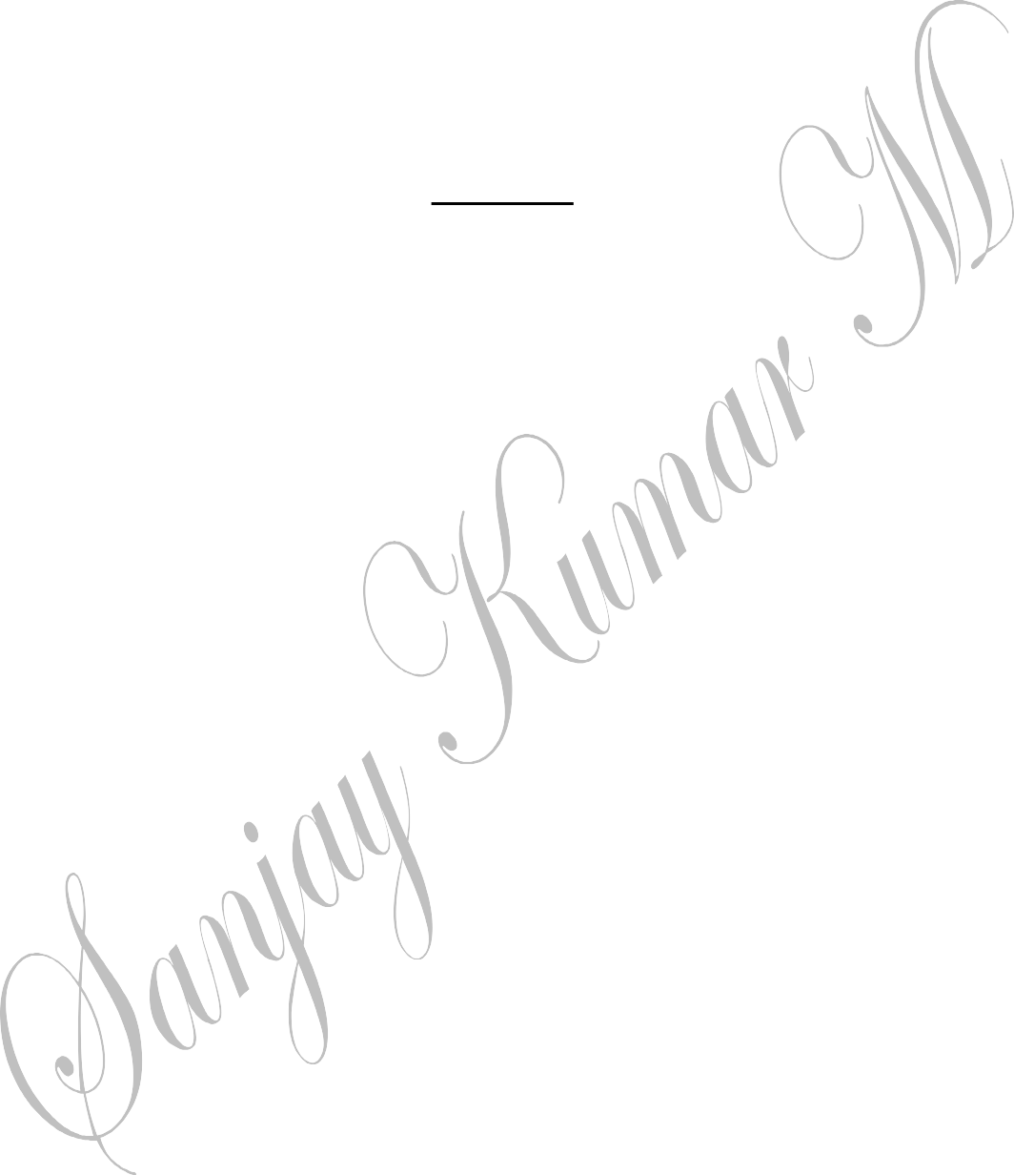

# UNIT–5

1. Apentagonalprismofbaseside30mmandaxislength60mmisrestingonHPononeofitsbases with a sideofbaseperpendicularto VP. Drawits isometric view.
2. Drawtheisometricviewofacylinderofbase40mmdiameterand50mmheightwhenitrestswith its baseonHP.
3. Drawtheisometricprojectionofahexagonalprism,sideofbase35mmandheight50mm.
4. Drawtheisometricviewofahexagonalpyramidofsideofbase40mmandheight65mm,when itsrestingonHPsuch thatanedge ofthebaseisparallel to VP.
5. Drawtheisometricprojectionofaconeofbase30mmdiameterandheight58mmwhenitrests with its baseonHP.
6. Drawtheisometricviewofafrustumofsquarepyramidofheight50mm,base40mmandthetop base20mm. thefrustumis resting withits baseon HP.
7. Drawtheisometricprojectionofapentagonalprismofsideofbase30mmandheight60mm,restingonitspentagonalbasewithonerectangularfaceparalleltoVPwhichissectionedbyacuttingplaneinclinedat40ºtothebaseandpassingthroughtheaxisata heightof40mmfrom thebase.
8. AHexagonalprism,sideofbase25mmandheight70mmrestsonHpandoneoftheedgesofitsbaseisparalleltoVP.AsectionplaneperpendiculartoVPandinclinedat40ºtoHPcutstheaxisoftheprismat55mmaboveHP.Drawtheisometricviewofthetruncatedportionof the prism,clearlyshowingthecutsurface.
9. APentagonalpyramid,30mmedgeofbaseand70mmheight,standsonHPsuchthatanedgeofthebaseisparalleltoVPandnearertoit.AsectionplaneperpendiculartoVPandinclinedat40ºtoHPcutsthepyramidpassingthroughapointontheaxisataheight of40mm fromthebase.Drawthe isometricviewofthe truncatedpyramid.
10. Acylinder50mmdiameterand75mmheightstandsonHP.AsectionplaneperpendiculartoVP,inclinedat60ºtoHPcutsthecylinderandpassesthroughapointontheaxisataheightof50mmabovethebase.Drawtheisometricviesofthetruncatedportionof the cylinder,when thecut surfaceisclearlyvisible totheobserver.



1. A Coneofbase 50mm diameterand axis 75mmlongstands on HP.It is cut bya sectionplane perpendicularto VP,inclinedat45ºtoHPand passing througha point on the axis40mmabove thebase.Drawthe isometric viesofthe truncatedcone.
2. DrawtheisometricviewofafrustumofahexagonalpyramidwhenitisrestingonitsbaseontheHPwithtwosidesofthebaseparalleltotheVP.Thesideofbaseis20mmandtop8mmand theheight of thefrustumis55mm.
3. Drawtheperspectiveviewofasquarepyramidofbase40mmsideandheightoftheapex70mm.thenearestedgeofthebaseisparalleltoand15mmbehindthepictureplane.Thestationpointissituatedatadistanceof150mminfrontofthepictureplane,30mmabove the ground planeand20mmtothe right oftheapex.
4. Asquareprismof25mmsideofbaseandheight40mmrestswithitsbaseonground,suchthatoneoftherectangularfacesisparalleltothepictureplaneand10mmbehindit.Thestationpointliesontheaxisoftheprismand60mmabovetheground.Drawtheperspective projectionofthepyramid.
5. Ahexagonalpyramidofsidesofbase25mmandheight45mmrestsonitsbaseongroundwithoneofitsbaseedgestouchingthepictureplane.Thestationpointis60mminfrontofthepictureplane,50mmtotherightoftheaxisofthepyramidand60mmabove theground.Drawthe perspective projectionofthepyramid.
6. Amodelofstepshas3stepsof15mmtreadandrise10mm.thestepmeasures60mmwide.Theverticaledgeofbottomstepwhichisnearertothepictureplaneis25mmbehindPPandthewidthofthestepsrecedetotheleftatanangleof30ºtoPP.thestationpointis100mminfrontofPPand60mmabovegroundplaneand30mmrighttothe verticaledgewhichis nearest toPP.drawtheperspective viewofthemodel.
7. Arectangularblock30x20x20mmhighislying onthegroundononeofitslargestfaces.Averticaledgeisinthepictureplaneandthelargestverticalrectangularfacesmake30ºwiththepictureplane.Thestationpointofthepictureplane,30mmabovethegroundandliesinacentralplanewhichpassesthroughthecentreoftheblock.Drawtheperspective viewoftheblock.
8. A cylinder 40mmdiameter and 60mmlength,lies onthe ground onone ofitsgeneratorswithitsaxisperpendiculartothePP.thenearestpointofthesolidis20mmontherightofSPand30mmbehindthePP.drawtheperspectiveviewofthecylinderifthestationpoint is50mm above GP and100mminfrontof PP.



1. Afrustumofsquarepyramidofbase30mmandtopedge30mm.theheightofthefrustumis35mm.itrestsonitsbaseonthegroundwiththebaseedgesequally inclinedtothePP.theaxisofthefrustumis30mmtotherightofeye.Theeyeis45mminfrontofthePPand50mmabovetheground.Thenearestbasecorneris10mmbehindthePP.drawtheperspective projectionofthefrustum.
2. Apentagonalprismof35mmsideand70mmlongrestsontheoneofitsrectangularfacesandaxisoftheprismisinclinedto30ºtothepictureplane.Thenearestcornerofthefrontface lies 20mmto the leftofthe stationpoint and10mmbehind the PP. theeyeis60mmabovethegroundand60mminfrontofthePP.drawtheperspectiveviewoftheprism.