DHANALAKSHMI SRINIVASAN COLLEGE OF ENGINEERING AND TECHNOLOGY
Mamallapuram, Chennai-603104.

DEPARTMENT OF MECHANICAL ENGINEERING

QUESTION BANK

Subject Code: ME8691 Year/Semester: III /06

Subject Name: Computer Aided Design and Manufacturing

UNIT-I INTRODUCTION
PART A- C310.1
1. Define computer-aided design?
Computer-aided design (CAD) is the use of computer systems to assist in the creation, modification, analysis, or optimization of a design. CAD software is used to increase the productivity of the designer, improve the quality of design, improve communications through documentation, and create a database for manufacturing. The digitized product details created using mechanical software packages like CATIA, Unigraphics, Pro-E, etc, have rationalized the design phase, which earlier was tedious and cumbersome.
2. Define product design & what is the design process and steps involved in Shigley’s model of the design process? (May 2016)
Product design is the process of creating a new product meeting the functional requirement and is readily available to its customers. It is essentially the efficient and effective generation and development of ideas through a process that leads to new products. NPD-New Product Design considers concurrent engineering concepts and allows flexibility in change management and accommodates proven practices like Lean and Six Sigma in the design stage.
Shigley’s Model: Market study – Conceptualization – Design – Analyze – Process Planning – Production Planning – Quality control – Dispatch - Feedback
3. What is sequential Engineering?
Sequential engineering is the term used to describe the method of production in a linear format. This is referred to as the “across the wall approach”. The different steps are done one after another, with all attention and resources focused on that one task. After it is completed it is left alone and everything is concentrated on the next task. The time consumed in this approach is high when compared to the concurrent or parallel approach of engineering.

4. What are concurrent engineering and the benefits of concurrent engineering? (April 2017, Nov 2017)
In concurrent engineering, different tasks are tackled at the same time, and not necessarily in the usual order. This means that information found out later in the process can be added to earlier parts, improving them, and also save a lot of time. Effective coordination between functional departments will prevent the cost of mistakes which can be eradicated at the early stage of product design.
5. What are the Advantages and Disadvantages of Sequential Engineering?
Advantages: 1. It is a simple, well-defined method and allows everyone to remain on the same page. 2. It is an enforced-discipline approach.
Disadvantages: 1. There is always some uncertainty at the beginning of a project. Changes that occur later in the project are difficult and often expensive. 2. Customer does not see a working product until the end, and if any changes need to be made at that point it can be costly and time-consuming
6. List the various stages of the life cycle of a product? (May 2016) (Nov / Dec-2018) (April/May 2021)
The stages are Introduction stage, Growth stage, Maturity stage, and Decline stage. All the products become obsolete during the decline stage. For example, Ordinary mobile phones face rapid growth and are now reaching the decline stage due to the development of smart phones.
7. Name the list of coordinate systems used in computer graphics systems?
1. Working Coordinate System (WCS) 2. Model (Part) Coordinate System (PCS) 3. Screen coordinate system (SCS) 4. Machine Coordinate System (MCS)
8. Define a working coordinate system?
It is a convenient user-defined system that facilitates geometric construction of the part. It can be established at any position and orientation in space that the user desires. For NC part programming and 3D model creation the WCS are used both low end (AutoCAD) and high end (CATIA, CREO, and UNIGRAPHICS) CAD/CAM software.
9. Define model coordinate system?
It is defined as the reference space of the model w.r.to all the model geometrical data is stored. A Cartesian coordinate system is widely used to define WCS represented in X-Y-Z axes where the sketching plane is also defined with respect to WCS
10. Define screen coordinate system?
SCS is defined as a 2-dimensional device-dependent coordinate system whose origin is usually located at the lower-left corner of the graphics display. It is used in view-related digitizes such as definitions of view origin and window or digitizing a view to select it for graphics operations. All other coordinate system is referenced from Screen Co-ordinate System.
11. State any two benefits of CAD. (April 2017)
1. Highly complicated drawings can be easily done in CAD which saves a lot of time.
2. Analysis and simulation can be done using CAD in the design stage itself so that design flaws can be identified before the manufacturing of the process.
12. What is Viewport and windowing? (Nov 2017)
It may be sometimes desirable to display different portions or views of the drawing in different regions of the screen. A portion of the screen where the contents of the window are displayed is called a viewport.
Let the screen size be X = 0 to 200 and Y = 0 to 130. A view port can be defined by the co-ordinates say X1 = 65, X2 = 130, Y1 = 50 and Y2 = 100.
If we use the same window as below, the definition of this viewport will display the image in the right-hand top quarter of the screen
13. Define Scaling.
Used for changing the dimensions of the window and viewport, it is possible to alter the size of drawings. This technique is not satisfactory in all cases. A drawing can be made bigger by increasing the distance between the points of the drawing. In general, this can be done by multiplying the coordinates of the drawing by an enlargement or reduction factor called scaling factor and the operation is called scaling. In general, the scaling matrix is presented below. Where S_{x} and S_{y} are scaling factors in X and Y directions.
14. Distinguish between reflection and scaling transformation.
Reflection | Scaling
a) Shading is an important element in 3-D computer graphics, as it gives the necessary realism to the representation of the object  b) In computer graphics designer can model reflected light and transmitted light | a) It may be necessary to fit a large-sized drawing within a smaller drawing sheet size. The dimensions can be automatically scaled for this purpose.  b) Changing the dimensions of the window and viewport, it is possible to alter the size of drawings.
15. What is shearing transformation?
A shearing transformation produces a distortion of an object or an entire image. There are two types of shears: X-shear and Y-shear. A Y-shear transforms the point (X, Y) to the point (X1, Y1) by a factor Sh1, where, X1 = X and Y1 = Sh1. X + Y. An X-shear transforms the point (X, Y) to (X1, Y1), Where, X1 = X + Sh2.Y and Y1 = Y, Sh2 is the shear factor.
16. Define Clipping. (April/May 2021)
Clipping is the process of determining the visible portions of a drawing lying within a window. In clipping, each graphic element of the display is examined to determine whether it is completely inside the window, completely outside the window, or crosses a window boundary. Portions outside the boundary are not drawn. If the element of a drawing crosses the boundary, the point of intersection is determined and only portions, which lie inside, are drawn.
17. What do you mean by synthesis of design? (Nov 2016)
The process of CAD and the analysis process is included in the synthesis of the design. It includes
1. CAD Part: (i) Design Conceptualization (ii) Design modeling & simulation
2. Analysis part : (i) Design Analysis (ii) Design Optimization (iii) Design Evaluation (iv) Design documentation and communication.
18. What is meant by concatenation? (Nov / Dec-2018)
In practice, a series of transformations may be applied to a geometric model. Thus combining or concatenating transformations (for example combination of scaling and rotation) are quite useful. They are simply obtained by multiplying the [T] matrices of the corresponding individual transformations.
P*= [T_{n}] [T_{n-1}]… [T₂][T₁]P
19. Define Translation.
Moving drawing or model across the screen is called translation. This is accomplished by adding to the coordinates of each corner point the distance through which the drawing is to be moved (translated). In general, to translate drawing by (TX, TY ) every point X, Y will be replaced by a point X1, Y1 where X1 = X + TX and Y = Y + TY
Original Rectangle Rectangle after Translation
20. Mention any four applications of computer-aided design in mechanical engineering. (Nov 2015)
Two Dimensional Drafting; Report generating; 3D modeling; Finite element analysis; CAM which contains CAD software as one of the components.
21. What is a 2D and 3D transformation? Transformations are used to position objects, to shape objects, to change viewing positions, and even to change how something is viewed. 2D transformations, which use 3x3 matrices, 3D transformations use 4X4 matrices (X, Y, Z, and W).
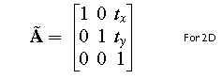
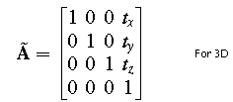

22. What does Mapping mean?
Mapping means changing the description of a point (or set of a point) belonging to an object from one coordinate system to the second one without altering the position and orientation in space w.r.to origins. This is typically opposite to rigid body transformation where transformations are defined within the same coordinate system, which stands unaltered in space. Transforming a point called P to P*, where P and P* are position vectors of point P in XYZ and P* in X*Y*Z* systems respectively and represented as
P* = f (P, Mapping parameters)
23. What are homogenous coordinates? (Nov 2016)
Homogenous coordinates are representing the points by effective way to unify the description of geometric transformations as matrix multiplications. It removes many anomalous situations encountered in Cartesian geometry such as representing points at infinity and no intersection of parallel lines. Also, they greatly simplify the expressions defining rational parametric curves and surfaces.
24. Define clipping?
Clipping algorithms are designed to efficiently identify the portions of a scene (in viewing coordinates) that lie inside a given viewport. They are useful because they:
1) Excludes unwanted graphics from the screen. 2) Improves efficiency, as the computation dedicated to objects that appear off-screen can be significantly reduced 3) Can be used in other ways (modeling of rectangular apertures, for example).
25. List and differentiate the types of 2D geometric transformations. (Nov 2015)
Modeling transformation: this transformation alters the coordinate values of the object. Basic operations are scaling, translation, rotation, and combination of one or more of these basic transformations.
A visual transformation: In this transformation, there is no change in either the geometry or the coordinates of the object. A copy of the object is placed at the desired sight, without changing the coordinate values of the object.
26. What is the reason for using a CAD system?
There are several good reasons for using a CAD system to support the engineering design function.
- To increase the productivity
- To improve the quality of the design
- To uniform design standards
- To create a manufacturing database.
- To eliminate accuracies caused by hand copying of drawing and inconsistency between drawings.
27. What is lean production?
Lean production can be defined as an adaptation of mass production in which workers and work cells are made more flexible and efficient by adopting methods that reduce waste in all forms.
28. What are the differences between lean production and mass production?
Mass Production | Lean Production
Standardized Products | Customized Products
Produce to Forecast | Produce to order
Pricing by production cost | Pricing by customer value
Inventory Buffers | Minimum Inventory

29. What is JIT?
A management philosophy that strives to eliminate sources of manufacturing waste by producing the right part in the right place at the right time. With the increasing trend toward a Just-In-Time (JIT) manufacturing environment, and its emphasis on a reduction of inventory and a more even flow of parts from suppliers, the purchasing component should also accommodate this increased frequency of inventory receipt.
30. List the four principles of lean production.
a) Minimize waste b) Perfect first-time quality c) Flexible production lines d) Continuous improvement.
31. Mention the 8 types of lean wastes.
Transport, Inventory, Movement, Waiting, Over Processing, Over-Production, Defects, Skill.
32. What are the functions of manufacturing support systems?
The design system includes the departments of the firm that are organized to accomplish product design might include research and development, design engineering, drafting, and perhaps a prototype shop. Manufacturing planning includes logistics issues, commonly known as production planning. The authorization to produce the product must be translated into the master production schedule. Manufacturing control is concerned with managing and controlling the physical operations in the factory to implement the manufacturing plans.
33. Why mathematical models are developed?
Mathematical models can be developed to analyze certain performance aspects of production and inspection.
- Effect of defect rate on production quantities in a series of production operations.
- Final inspection versus distributed inspection.
- When to inspect and when not to inspect.
34. Write the different types of production.
- Low production (Job shop production)- Quantities in the range of 1 to l00 units per year
- Medium production (Batch production) - Quantities in the range of 100 to 10,000 units annually.
- High production (Mass production) - Production quantities are 10,000 to millions of units.
35. Write the different types of plant layouts.
- If the product is large and heavy, and therefore difficult to move in the factory, it typically remains in a single location, at least during its final assembly. Workers and processing equipment are brought to the product, rather than moving the product to the equipment. This type of layout is referred to as a Fixed-position layout.
- The individual parts that comprise these large products are often made in factories that have a process layout, in which the equipment is arranged according to function or type called process layout.
- In cellular manufacturing each cell is designed to produce a limited variety of part configurations: that is. The cell specializes in the production of a given set of similar parts or products, according to the principles of group technology.
- In product layout, the work is usually moved between stations by a powered conveyor. At each station. A small amount of the total work is completed on each unit of product.

36. What are the components of the manufacturing system?
A manufacturing system consists of the following components:
- Production machines (plus tools, fixtures, and other related hardware)
- A material handling system
- A computer system to coordinate and/or control the preceding components
- Human workers to operate and manage the system.
PART B – C310.1
1. Write Short notes on (i) Design Process and (ii) CAD System architecture (May 2016)
2. What is meant by concurrent engineering? Describe the various schemes for concurrent engineering (May 2016)
3. (i) Describe various stages of the design process with an example.
(ii) Explain a line drawing algorithm. (Nov 2016) (April/May 2021)
4. (i) Define clipping. Also, explain the working principle of a simple line clipping algorithm
(ii) Deduce windowing and viewing transformation matrix parametrically. (Nov 2016)
5. Compare and contrast Sequential and concurrent engineering with suitable examples. (April 2017)
6. Explain with a block diagram, the CAD process with a suitable example. (April 2017)
7. Explain the different types of 2D transformations with examples. (Nov 2017)
8. Explain the Cohen-Sutherland line clipping approach with proper sketches (Nov 2017)
9. i) Rotate the rectangle (0,0), (2,0), (2,2),(0,2) shown in Fig., 30º counterclockwise about its centroid and find the new coordinates of the rectangle. (Nov 2015)
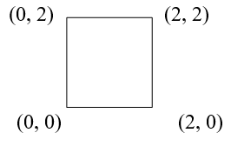
ii) Given the triangle described by the homogeneous point’s matrix below, scale it by a factor ¾, keeping the centroid in the same location. Use (1) separate matrix operation and (2) condensed matrix for transformation
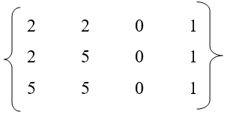
10. Rotate the rectangle shown in Fig, 30º counterclockwise about the line EF and find the new coordinates of the rectangle

F(1,4,6)

y

2

E(0,2,2)

2

x

(0,0,0)

z

11. What are the steps involved in designing and manufacturing a product. (Nov / Dec-2017)
12. Write in detail about production performance matrices. (Nov / Dec-2016)
13. Discuss job shop production and mass production. (April / May 2017)
14. Discuss the stages in the product life cycle and the importance of each stage (Nov / Dec-2018)
15. Discuss the significance of the concurrent engineering approach in limiting design changes (Nov / Dec-2018).
16. What is Design Process? Explain briefly the steps involved in the design process. (April/May 2021)

PART C - C310.1
1. A firm is going to manufacture a new gearbox for a two-wheeler. Explain the steps involved in the design and manufacturing process with the role of CAD, CAM, and CAE using concurrent engineering. Also, discuss how it is superior to sequential engineering.
2. A rectangle with co-ordinate A(2,3), B(2,5), C(6,5), and D(6,3) is reflected along the line whose equation is y =2x + 4, and sheared by 2 units in the x-direction and 2 units in the y-direction. Find the new coordinates of the object. (April/May 2021)
UNIT-II GEOMETRIC MODELING
PART A – C310.2
1. What is Bezier's surface?
A tensor product Bezier surface is an extension of the Bezier curve in two parametric directions u and v. Bezier surface allows only global control of the surface. Bezier's surface is formed as the Cartesian product of the blending functions of two orthogonal Bezier curves and is defined by a set of control points. A two-dimensional Bezier surface can be defined as a parametric surface where the position of a point is a function of the parametric coordinates u, v.
2. What are the characteristics of the B-spline surface? (April/May 2021)
A rectangular set of data or control points creates the surface. It is the general surface as Bezier's surface but with the advantage of permitting local control of the surface. This set forms the vertices of the characteristic polyhedron that approximates and controls the shape of the resulting surface. The degree of the surface is independent of the number of control points and continuity is automatically maintained throughout the surface by virtue of the form of blending functions.
3. What are the limitations of the Hermite Curve? (May 2016)
The curve follows the cubic polynomial and hence the number of control points is only three. With three control points, complicated shapes cannot be produced. Hence it has its limitations in construction.
4. State the advantages of the Bezier curve. (Nov 2016)
- It is easy to calculate points of the Bezier curve using the equation.
- The numerical algorithm is stable. (i.e. given reasonable input, the algorithm won’t blow up)
- Control of intermediate points is easy in a Bezier curve so that desired shape can be obtained.
5. What do you mean by a projection of the surface?
Projecting an entity onto a plane or a surface is useful in applications such as determining shadows or finding the position of the entity relative to the plane or the surface. These surface extensions are employed in 3D surface design typically in BIW (Body in White) automotive frame design.
6. What are Boolean operations? List the Boolean operations.
Boolean operation is the process of getting a required part from two or more primary parts. The process are 1) Addition (+) 2) Subtraction (-) 3) Union (u) 4) Intersection (n). This method is typically followed in low-end CAD/CAM software like AutoCAD for the 3D modeling of components.
7. What are the advantages and disadvantages of wireframe modeling? (May 2016) (Nov 2017)
Advantages: 1. A hidden line can be visible with the dotted line in wireframe modeling. 2. Interior parts can be visible. Disadvantages: 1. The subsequent process of assembly or features cannot be done in wireframe modeling. 2. Visibility of the edges with transparency makes selecting the entity more complicated.
8. List a few commonly used solid primitives.
The most commonly used solid primitives are a) Block b) Cylinder c) Cone d) Sphere e) Wedge f) Torus
9. Differentiate Geometry and topology.
GEOMETRY | TOPOLOGY
It is the actual dimensions that define the entities of the object  It is the visible geometry and graphical information from the user point of view  It is also called metric information | It is the connectivity and associability of the object entities  It is the non-graphical relational information stored in the solid model database from in user point of view  It is also called a combinatorial structure
10. Define Quadratic Bezier curve. (April 2017)
A Bezier curve is defined by a set of control points P0 through Pn, where n is called its order (If n = 1 it is linear Bezier curve, and If n = 2, it is quadratic bezier curve.). The first and last control points are always the endpoints of the curve; however, the intermediate control points (if any) generally do not lie on the curve. Quadratic bezier curve has 3 control points P0, P1 and P2.

11. What is the significance of CSG? (April 2017)
Constructive solid geometry has several practical uses and is greatly significant. It is used in cases where simple geometric objects are desired or where mathematical accuracy is important. Nearly all engineering CAD packages use CSG (where it may be useful for representing tool cuts and features where parts must fit together).
12. Write the equation of a circle in parametric form. (Nov 2017)
The Parametric form of a circle is x = r cos θ
y = r sin θ. 0 ≤ θ ≤ 360 and r - radius of the circle.
13. Enumerate the various polyhedral objects.
a) Simple polyhedral b) polyhedral with faces of inner loops c) polyhedral with not through holes d) polyhedral with handles (through holes)
14. What are the open polyhedral objects?
a) Wire polyhedral b) Shell polyhedral c) Lamina polyhedral d) Open three-dimensional polyhedral
15. What are rational curves importances?
A rational curve is defined by the algebraic ratio of two polynomials. A parametric curve inhomogeneous form is referred to as a rational curve. They draw their theories from projective geometry. Importance is under projective transformation that is the perspective image of a rational curve is a rational curve.
Where u is a parameter in some closed interval [a, b]
16. What do you mean by Sculptured surface?
Sculptured surfaces are used in geometric modeling to describe all sorts of bendy things like aero plane wings, car bodies, gas-turbine blades, ship's hulls and so on that can't be described by simple curved surfaces such as cylinders and cones. These complex surfaces are known as sculptured or free-form surfaces.
17. Distinguish Analytic and Synthetic curve. (Nov / Dec-2018)
Analytic Curves | Synthetic Curves
The Analytic curves are defined by analytic equations.  Analytic curves are easy in computation but not flexible for designers, Lines, conics are analytic curves | The Synthetic curves are defined by the set of data points or control points  Synthetic curves are hard in computation but very flexible to designers in making new models  Splines, Bezier curves are synthetic curves

18. List the surfaces representations.
The surfaces are a) Bicubic surface b) Bezier surface c) B-spline surface d) Coons surface c) Blending offset surface d) Triangular surface e) Sculptured surface f) Rational surface.
19. Enumerate the Surface entities provided in CAD/CAM system.
The major surface entities provided by the CAD/CAM system are
1) Plane surface 2) Ruled (lofted) surface 3) Surface of revolution 4) Tabulated cylinder 5) Bezier surface 6) B-Spline surface 7) Coons patch 8) Fillet surface 9) Offset Surface.
20. What is surface segmentation?
Surface segmentation is a reparametrization or parameter transformation of the surface while keeping the degree of its polynomial in u and v unchanged. Efficient segmentation of globally optimal surfaces representing object boundaries in volumetric data sets is important and challenging in many medical image analysis applications.
21. List down the basic types of surfaces.
a) Synthetic surface (B-Spline, Bezier surface, Hermite Spline, NURBS, Coons Patches) and b) Analytic Surface (plane, ruled, and the surface of revolution).
22. Why B rep modeling approaches are widely followed than the CSG approach? (Nov 2016)
B rep (Boundary representation) models calculate the solid using no of edges, vertex, faces, etc. and hence complicated shape can be modeled, whereas CSG uses only standard primitives for creating the solid. In actual practice, complicated shapes need to be designed and hence B rep modeling approaches are widely used.
23. What is Hybrid Modeling? (Nov / Dec 2018)
In computer-aided design (CAD), hybrid modeling is a method for reconstructing complex designs or objects in a CAD environment. For example, not every design can be replicated through traditional CAD modeling approaches. As a result, other methods such as scanning and building point cloud data are brought in to help with the process.
24. Generate the conical surface obtained by rotation of the line segment AB around the z-axis with A= (1, 0, 1) and B= (7, 0, 7) (Nov 2015)
Line AB can be represented in parametric form as: P (t) = [x(t) y(t) z(t)], and the parametric equation of a line is, P (t) = A + (B-A) t ,based on this equation, the coordinates of a point on the line are given as, x(t) = 1 + (7-1) t = 1+ 6t, y(t) = 0 z(t) = 1 + (7-1) t = 1 + 6t The equation of the surface as given above is, P(t, θ) = [x(t) cosθ x(t) sinθ z(t)] or = [(1+6t) cosθ (1+6t) sinθ (1+6t)] - equation of the surface. Any point on the surface can be located by substituting t and θ values in the above equation, e.g.: at t = 0.4 and θ = π/2 radians P(0.4, π/2) = [1+6(.4)cos (π/2) 1+ 6(.4) sin (π/2) 1 + 6(.4) ] = [0 3.4 3. 4], which is the point on the surface at (.4, π/2)
25. Differentiate between analytical curves, interpolated curves, and approximated curves. (Nov 2015)
Analytical curve: This type of curve can be represented by a simple mathematical equation such as a circle or ellipse. They have a fixed form and cannot be modified to achieve a shape that violates the mathematical equation.
Interpolated curve: An interpolated curve is drawn by interpolating the given data points, dictated by the given data points. These curves have some limited flexibility in shape creation, dictated by the data points.
Approximated curves: These curves provide the most flexibility in drawing curves of very complex shapes. The model of a curved automobile fender can be easily created with the help of approximated curves and surfaces.
26. Differentiate CSG and B-Rep Models. (April/May 2021)
CSG refers to Constructive Solid Geometry. It uses standard primitives like Block, Cylinder, Cone, Cube, etc. shapes, and solid models can be generated by using Boolean operations of Addition, Subtraction, Union, Intersection, etc.
In B-Rep or Boundary Representation Models, Vertex, edges, faces, surfaces will be defined using Euler’s equation and building the blocks with the representation of these entities.
PART B - C310.2
- (i) Explain different features of a Bezier curve with construction details.
(ii) Derive the transformation matrix for a Hermite curve. (Nov 2016)
- What are Bezier curves? Discuss its important properties. (May 2016)
- (i) What do you understand by the Boundary representation (B rep) technique of solid modeling? Explain briefly the data structure of the B-rep solid model. (May 2016) (Nov 2016) (Nov 2017)
(ii) Write notes on bicubic patches (Nov 2016)
- What are B-spline curves? What are the properties and characteristics of B-spline curves?
- (i) Using Bresenham's circle algorithm constructs a circle whose radius is 4 units and center is (8,8)
(ii) A set of control points is given by P₀ = (4,4,4), P₁ = (6,8,6) and P₂ = (10,3,4). Compute Bezier curve with two intermediate points. (Nov 2017)
- Explain the various curve generation techniques with suitable examples. (April 2017)
- What is the solid model and differentiate geometry and topology of a model?
- With a neat sketch explain the most commonly used solid primitives or entities.
- Briefly explain the different schemes used to generate the solid model.(Nov 2015,April 2017)
- Write short notes on approximated synthetic curves. (Nov 2015)
- Write short notes on the parametric representation of synthetic surfaces. (Nov / Dec-2018)
- Discuss the following for CSG and B-Rep Schemes: (i) how to represent surface normal and neighborhoods (ii) how to develop a classification algorithm. (Nov / Dec-2018)
- Derive the equation for Hermite Cubic Spline Curve. (April/May 2021)
- Find the equation of the Bezier Surface with four corner points as shown in the figure and also find the midpoint of the surface. (April/May 2021)

PART C - C310.2
1. Derive the equation for Bezier Curve. Find the equation of a Bezier curve which is defined by the four points as P0 (2, 2, 0), P1 (2, 3, 0), P2 (3, 3, 0), and P3 (3, 1, 0) also find the points on the curve for u = 0, 1/4, ½, ¾, 1. (April/May 2021)
2. Explain the constructive solid geometry technique. What is the role of primitives and Boolean operations in CSG? Explain with a suitable example. (Nov 2017)
3. Construct the given shape using Constructive solid geometry with primitives and corresponding Boolean operation and draw the CSG tree for the same.
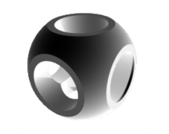

UNIT-III CAD STANDARDS
PART A – C310.3
1. What are the basic elements associated with a CAD system?
i) Operator (user) ii) Graphics support system iii) Other user interface support system iv) Application functions v) Database
2. What are the reasons for evolving graphic standards?
i) Need for exchanging graphic data between different computer systems
ii) Need for a clear distinction between modeling and review aspects
3. Define Graphics Kernel system and brief the purposes of the Graphical Kernel System (GKS)? (April 2017)
GKS (the Graphical Kernel System) is an ANSI and ISO standard. GKS standardizes two-dimensional graphics functionality at a relatively low level. The purpose of GKS are:
(i) To provide for portability of graphics application programs
(ii) To aid in the understanding of graphics method by application programs
(iii) Provide the guidelines for manufacturers in describing useful graphics capabilities.
4. Define Open Graphics Library? (April 2017) (Nov 2017)
OpenGL (Open Graphics Library)is a cross-language, multi-platform application programming interface (application program interface-API) for rendering 2D and 3D vector graphics. The API is typically used to interact with a graphics processing unit (GPU), to achieve hardware-accelerated rendering.
5. What is the importance of standards in CAD? (May 2016) (Nov / Dec-2018)
The CAD standards are important for easy exchange of data between the different users and retrieving the data of different CAD package users. Also, it enables the importing of the complicated cad data for analysis in an analysis package like ANSYS, where complicated cad can't be constructed.
6. Name the basic methods of transferring data?
There are three methods of transferring data from one CAD system to another. 1. Direct CAD system export/import 2. Direct 3rd party translators.3.Intermediate data exchange formats.
7. What is the IGES system and mention its uses? (Nov 2017) (April/May 2021)
The Initial Graphics Exchange Specification (IGES) (pronounced eye-jess) is a file format that defines a vendor-neutral data format that allows the digital exchange of information among Computer-aided design (CAD) systems. It is used for storing cad data in a common standard file format.
8. Write any three CAD standards for the exchange of modeling data? (May 2016) i) IGES (Initial Graphics Exchange specifications), (ii) STEP (Standard for Exchange of Product model data) (iii) CALS (Continuous Acquisition and Lifecycle Support)
9. Mention the different file sections in IGES?
i) Flag section(optional) ii) Start section(S) iii) Global section(G) iv) Directory entry(D) section v) Parameter Data section vi) Terminal section
10. What is the use of STEP data exchange format?
STEP(Standard for the Exchange of Product model data) can be used to exchange data between CAD, computer-aided manufacturing, computer-aided engineering, product data management/enterprise data modeling, and other CAx systems. STEP is addressing product data from mechanical and electrical design, geometric dimensioning and tolerancing, analysis, and manufacturing, with additional information specific to various industries such as automotive, aerospace, building construction, ship, oil and gas, process plants, and others
11. What is GKS Cell Array? (Nov 2016)
The GKS cell array function displays raster-like images in a device-independent manner. The cell array function takes the two corner points of a rectangle that you specify a number of divisions (M) in the X direction and a number of divisions (N) in the Y direction. It then partitions the rectangle into M x N sub-rectangles called cells.
12. Mention the requirements of a conformant STEP application?
i) Implementation of either a preprocessor or a postprocessor or both, ii) using one of the STEP implementation methods STEP-File, STEP-XML, or SDAI for the AIM/MIM data model, and iii) supporting one or several conformance classes of an AP.
13. What is the need for CALS (Continuous Acquisition and Lifecycle Support)?
To establish an integrated system in which any information obtained at each stage (survey, designing, construction, and maintenance) of public works should be digitalized so that every person of each section both in public and private sectors could share and re-use the information.
14. What are the three layers of architecture?
i) Application layer ii) Logical layer iii) Physical layer 15. What is Graphic Communication?
Graphic communication as the name suggests is about communicating through graphics. It is the process of creating and producing drawings or images that get a message across. For example, a poster advertises an event, a drawing showing the plans for a building, or a 3D computer model showing what a new product will look like.
16. Compare the shape-based and the product data-based exchange standards. (Nov 2015)
IGES: exchanges primarily shape (both geometric and topological) and non-data, which is referred to as CAD to CAD exchange. STEP: The goal of the standard is to enable the exchange of a computerized model with all of its supporting types of data in a neutral format.
17. Define communication protocol?
Communicating systems use well-defined formats (protocol) for exchanging messages. Each message has an exact meaning intended to elicit a response from a range of possible responses pre-determined for that particular situation. Thus, a protocol must define the syntax, semantics, and synchronization of communication; the specified behavior is typically independent of how it is to be implemented.
18. What is the model communication policy?
1. Openness, accessibility availability, and willingness to respond. 2. Truthfulness, unconditional honesty is the only policy.3. Responsiveness, recognition that any constituent concern is by definition legitimate and must be addressed.4. No secrets, our behavior, our attitudes, our plans, even our strategic discussions must be unchallengeable, unassailable, and positive
19. What is meant by CAD data exchange? Mention its importance & need. (Nov 2015) (Nov 2016) (April/May 2021)
CAD data exchange involves a number of software technologies and methods to translate data from one computer-aided design system to another CAD file format. This PLM technology is required to facilitate collaborative work (CPD) between OEM’s and their suppliers.
NC programming typically requires that the geometry be received from a CAD system.
20. How does PHIGS differ from IGES?
PHIGS is an improved version of GKS and CORE. It offers an extended set of primitives for graphical elements from which the models may be generated. It is mainly used in high functional systems. It has additional features such as hidden lines, surface manipulation and graphics animation, etc. It is known as Programmers Hierarchical Interactive Graphics system
21. Define annotation? (Nov / Dec-2018)
Annotation is defined as a note by way of explanation or comment added to a text or diagram.

PART B – C310.3
1. Explain in detail about GKS and features of the Graphics Kernel System?
(Nov 2016- 8 marks, Nov 2017 - 7 marks) (April/May 2021)
2. Write short notes on (i) Open GL (ii) Standards for computer graphics. (Nov 2015) (Nov / Dec-2018)
3. Write short notes on the Drawing exchange format (DXF) standard (May 2016) (April/May 2021)
4. Write short notes on Data Exchange standards. (April 2017 - 8 marks)
5. Explain the IGES methodology? (Nov 2015) (Nov 2016 - 8 marks) (April 2017) (Nov / Dec-2018)
6. State the need & requirement of product data exchange between dissimilar CAD/CAM systems. Describe the STEP methodology? (Nov 2016- 8 marks) (Nov 2017)
7. Explain the procedure in the CALS format? (Nov 2017 - 6 marks)
8. Explain the principles for communication standards? (Nov 2016 - 8 marks) (April 2017 - 8 marks)
9. Briefly explain any one of the known graphics standards. (May 2016)
10. Explain PHIGS and write short notes on database management.
PART C - C310.3
1. Discuss the requirement of product data exchange between dissimilar CAD/CAM systems.
2. Explain the procedure for constructing an assembled component in CAD package and importing it in Analysis package for analyzing with suitable example.
3. Discuss the advantages and limitations of various Data Exchange standards and justify the best data exchange standard in the CAD system and explain why?

UNIT-IV FUNDAMENTALS OF CNC AND PART PROGRAMMING
PART A – C310.4
1. List down the two ways to program modern CNC Machines.
a) Conversational Programming-this is a macro programming language used to instruct the machine to perform pre-programmed cycles and b) CAM Programming-Using this method, you import your part model into a CAM (computer-aided manufacturing) program and define the parameters associated with each and every machined feature on part c) Offline Programming linked to CAD programs d) MDI-Manual Data Input e) Word-address coding using G and M-codes
2. What is CNC?
CNC (Computer Numerical Control) is the general term used for a system that controls the functions of a machine tool using coded instructions (G and M codes) processed by a computer. Modern CNC machines have embedded controllers like FANUC and SIEMENS controllers used for integrating CNC machines with program codes.
3. List down the advantages of CNC Manufacturing.
CNC manufacturing offers advantages on two types of parts: (1) simple parts that are mass-produced and/or (2) complex parts with features requiring multiple axes of simultaneous motion. For simple parts in low quantity, it is often quicker to produce the parts on manual machines. Modern CNC machines offer increased productivity due to stiffer machine and spindle designs, more powerful motors, high-pressure coolant (up to 1000 psi) that floods the cutting zone, automatic tool changers, digital workpiece, tool probing, and/or horizontally mounted spindles.
4. Define the NC system and list the components used in the NC manufacturing system.
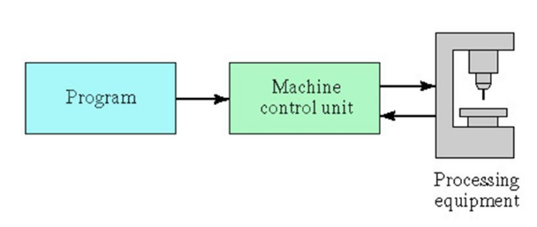
5. Define the CNC machine and list the components used in the CNC manufacturing system.
In CNC machining, movement is usually directed across X and Y axes. The tool, in turn, is positioned and guided via stepper or servo motors, which replicate exact movements as determined by the G-code. If the force and speed are minimal, the process can be run via open-loop control. For everything else, closed-loop control is necessary to ensure the speed, consistency, and accuracy required for industrial applications, such as metalwork. The program input device is the mechanism for part programs to be entered into the CNC control. The most commonly used program input devices are keyboards, punched tape readers, diskette drivers, through RS 232 serial ports and networks.
6. List the two types of programming modes in the CNC part program
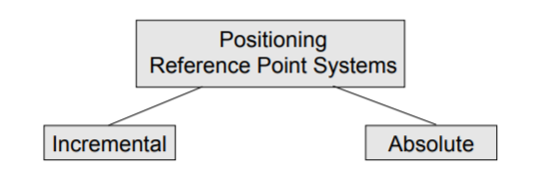
Incremental program locations are always given as the distance and direction from the immediately preceding point. Absolute program locations are always given from a single fixed zero or origin point.
7. Define Computer Aided Part Programming Schematically.

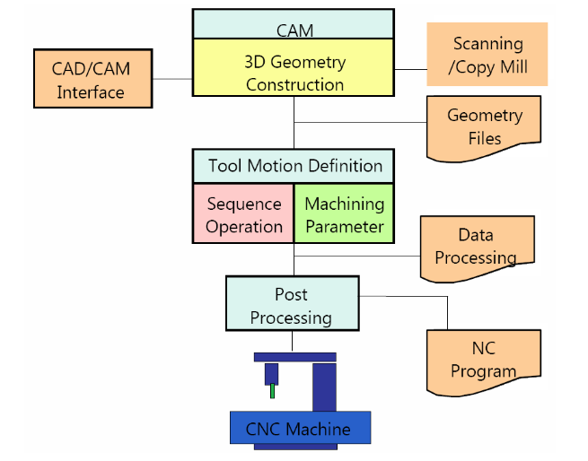

8. What is VFD?
VFD stands for Variable Frequency Drive. Spindle heads work in conjunction with spindle drives, called VFD, It has added a spindle speed controller card, allowing the operator to turn ON or OFF the spindle, forward or reverse the spindle rotation direction.

9. Define machining centers and list down the types based on machining centers.
A machining center is the face or surface of the material that will be normal to the axis of the tool. The face can be a flat face machined in a single setup (VMC-Vertical Machining Center) or more than one face in a single setup (HMC-Horizontal Machining Center) and primarily for one operation (HBC-Horizontal Boring Centers).
10. List down the types of controller systems.
The MCU (Machine Control Unit) of a CNC system is of two types as listed below
a) Point to Point: When making an axes move all affected drive motors run at the same speed
b) Continuous Path Machine: Can move the drive motors at varying rates of speed while positioning the machine
11. List down the types of CNC machines based on feedback systems.
Loop systems are electronic feedback systems that send and receive electronic information from the drive motors. Typical categorization includes; a) Open Loop: use stepper motors b) Closed Loop: Usually hydraulic, AC and DC Servomotors
12. Draw the block diagram of a CNC machine.
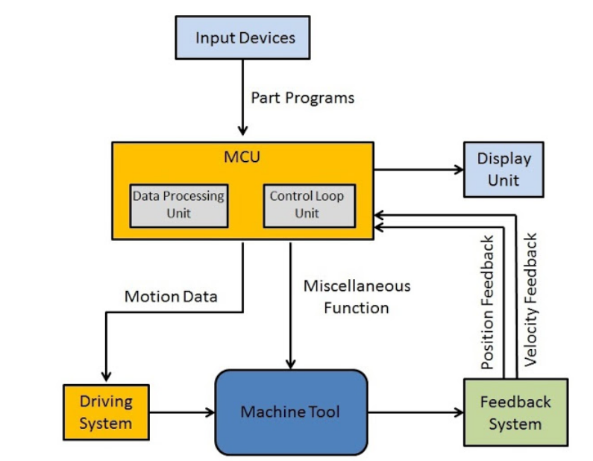
13. List the positioning systems of a CNC machine. (April/May 2021)
a) Absolute Positioning: Absolute coordinates refer to a Cartesian System that uses an x-axis, y-axis, and sometimes z-axis to establish a point some distance from a common origin. All machine positions are taken from one fixed zero point (origin-home position).
b) Incremental Positioning: Each machine position is specified by the previous one.
14. Explain the coordinate system used in the CNC machine?
The basic of machine movement is the Cartesian coordinate system. The points in the Cartesian coordinates are defined by X/Y or X/Y/Z coordinates. In 6 axis CNC machine, the U/V/W are referred to as rotation about X-axis, rotation about Y-axis, and rotation about Z-axis respectively.
In a VMC, the z-axis is always the spindle axis.
15. List down the elements of a CNC Machine.
Anti-friction slideways; Lead screws; Machine guarding and swarf control; Machine spindle; work or servo-controlled machine table, drive motors with VFD-variable frequency drive card; ATC (Automatic Tool Changer), MDI-Manual Data Input handle; MCU-machine control unit like FANUC, SINUMERIC, etc.
16. List down the advantages of CNC machines / Programming.
Easier to program; Easy storage of existing programs; Easy to change a program; Avoids human errors; NC machines are safer to operate; Complex geometry is produced as cheaply as simple ones; Usually generates closer tolerances than manual machines
17. What is the DNC manufacturing system?
Direct Numerical Control is a manufacturing system in which a number of machines (NC machines) are controlled by a computer through direct connection and in real-time, with a provision for on-demand distribution of data to machines. The following are the components of a DNC machine: a) Central Computer; b) Bulk Memory Storage; C) Telecommunication Lines and d) Machine Tool-NC Machines and e) Satellite Minicomputers
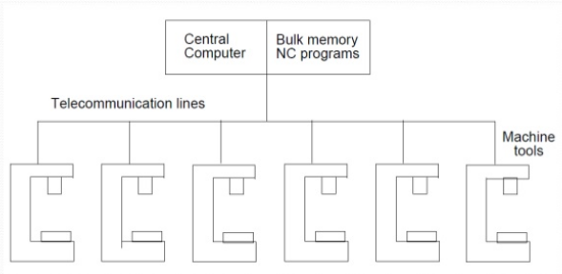
18. List down the CNC controller components.
Data Processing Unit (DPU): a) Input device [RS-232 port/ Tape Reader/ Punched Tape Reader]; b) Data Reading Circuits and Parity Checking Circuits; c) Decoders to distribute data to the axes controllers
Control Loops Unit (CLU): a) Interpolator to supply machine-motion commands between data points; b) Position control loop hardware for each axis of motion.
19. List some of the CNC controllers used worldwide.

- Sinumerik
- Fanuc.
- Heidenhain.
- Mitsubishi
- Haas.
- Mazak.
- Hurco.
- Cincinati

20. Differentiate NC with CNC machine tools.
NC Machine | CNC Machine
NC stands for Numerical Control | CNC stands for Computer Numerical Control.
It is defined as a machine that is controlled by a set of instructions in the form of numbers, letters, and symbols. The set of instructions is called a program. | It is defined as the machine which is used to control the motions of the workpiece and tool with the help of a prepared program in a computer. The program is written in alphanumeric data.
In NC machine the programs are fed into the punch cards. | In a CNC machine, the programs are fed directly into the computer by a small keyboard similar to our traditional keyboard.
Modification in the program is difficult. | Modification in the program is very easy.
A high skilled operator is required. | A less skilled operator is required.
The cost of the machine is less. | The cost of the CNC machine is high.
The maintenance cost is less | The maintenance cost is high.
The programs in the NC machine cannot be stored. | In CNC machines, the programs can be stored in the computer and can be used again and again.
It offers less flexibility and computational capability. | It offers additional flexibility and computational capability.
The accuracy is less as compared with the CNC. | It has high accuracy.
It requires more time for the execution of the job. | It takes very less time, in the execution of the job.

21. List the CNC codes and their purpose.
G-code: Preparatory codes are used for linear and circular interpolation machining codes
M-code: Miscellaneous or machine codes relate to drive controls, door controls, etc.
Functional Parameter codes: F-Feed/min; S-Spindle Speed/min; H-Tool length offset; T-Tool Selection
22. Draw the schematic diagram for open loop and closed loop CNC machines
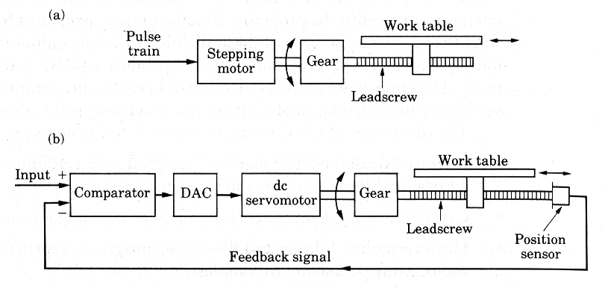
23. List down the components of Servo-motor controlled CNC machine.
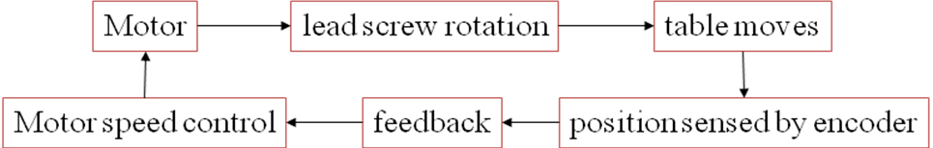
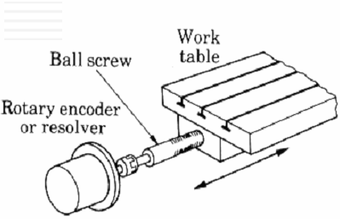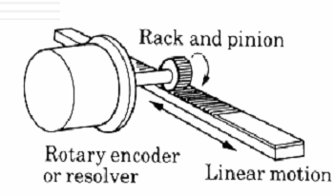
24. Define CNC Part Program?
A part program contains all the information for machining a component which is given as input to the control unit. The control unit provides the control signals at the correct time and in the correct sequence to the various drive units of the machine. The input information required is a series of blocks; one operation requires one block. Within each block, there may be different types of data.
Standard Part programming language: RS 274-D (Gerber, GN-code)
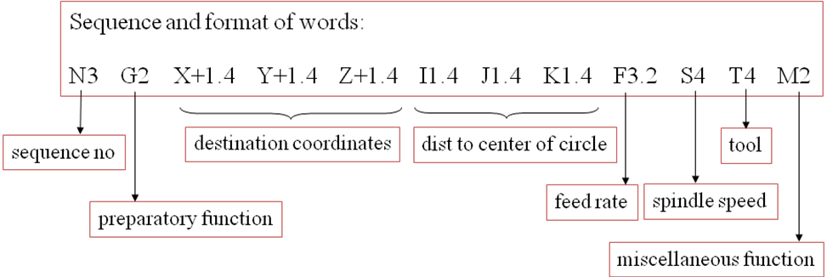

25. List the functions of MCU of a CNC system.
- Read coded instructions (CNC Programs)
- Decode coded instructions
- Implement interpolations (linear, circular, and helical) to generate axis motion commands
- Feed axis motion commands to the amplifier circuits for driving the axis mechanisms
- Receive the feedback signals of position and speed for each drive axis
- Implement auxiliary control functions such as coolant or spindle on/off, and tool change
26. What is a canned cycle in CNC machine means?
A canned cycle is a way of conveniently performing repetitive CNC machine operations. Canned cycles automate certain machining functions such as drilling, boring, threading, pocketing, etc...
Some of the canned cycle macros are listed below

G73 Peck drilling
G74 Left-hand tapping
G76 Precision boring
G80 Cancel any fixed G81 Drilling cycle
G83 Peck drilling cycle
G84 Right-hand tapping G85 Boring cycle
G86 Boring cycle
G87 Back boring cycle
G88 Boring cycle
G89 Boring cycle

27. What is subprogram in CNC machine means?
A subprogram is essentially a smaller program within the main program, more often than not a subprogram is used for repeat processes such as bolt hole circles. Sub-programming can also be used to make file sizes smaller, in the instance of your CNC only being able to load a few hundred kilobytes worth of code it becomes a very valuable skill. Subprograms are normal CNC programs that are called from a program (normally called main-program) to add some kind of repeatable machining operation. Subprograms end with M99 while the Main program ends with M30.
28. What is meant by G00, M30 in CNC part programming? (April/May 2021)
G00 – Rapid Travel
M30 - Program End
29. Define CAM and list some of the widely used CAM packages in industries.
Computer-aided manufacturing (CAM) commonly refers to the use of numerical control (NC) computer software applications to create detailed instructions (G-code) that drive computer numerical control (CNC) machine tools for manufacturing parts. Manufacturers in a variety of industries depend on the capabilities of CAM to produce high-quality parts.

CAMWorks
EdgeCAM
hyperMill
Mastercam
Powermill
Siemens NX CAM
SolidCAM
SolidWorks CAM
SprutCAM

PART B – C310.4
- Explain CNC Machine Structural Design with elements in detail.
- Differentiate NC CNC and DNC systems functionally and list the pros and cons concisely.
- Explain in detail a typical VMC with specifications.
- Explain in detail a typical HMC with specifications.
- Explain in detail the role of NC and CNC machines in modern manufacturing systems
- List down the CNC coding structure for a Lathe machine with a typical illustration.
- Explain in detail sub-programming for pattern rotating; multiple operations on a specific set of hole locations.
- What is a canned cycle? Explain any two drilling canned cycles with their syntax. (April/May 2021)
- Explain in detail macro programming with the illustration.
- Write a program for the multi-pass thread cutting cycle with an explanation.
- Write a program for deep hole peck drilling operation using the canned cycle concept.
- Explain the working and construction features of CNC with a neat sketch. (April/May 2021)
PART C – C310.4
1. Explain in detail the application of CNC manufacturing systems for Industry 4.0.
2. Interpret the following NC Program block by block. Plot the complete tool center path with the corresponding coordinates. Mark the corresponding NC block on the tool patch segment.
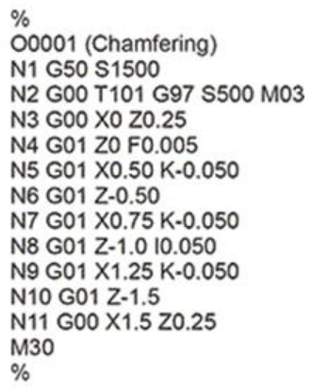
UNIT-V CELLULAR MANUFACTURING AND FLEXIBLE MANUFACTURING SYSTEM
PART A – C310.5
1. Define Group Technology (GT). (Nov/Dec-2013)
Group Technology (GT) is a manufacturing methodology in which identical or similar components are grouped processed together during design, process planning, and manufacturing so that a wide variety of components can be manufactured, at the least expense of time, inventory, person-hours, and material handling. Group technology is an operations management philosophy based on the recognition that similarities occur in the design and manufacture of discrete parts.
2. List out the stages in Group Technology.
a) Production planners to set up the GT database; b) Grouping the parts or components into part-families with some similar characteristics; c) Re-design the shop-floor arrangement according to common shape, function or manufacturing process and tooling.
3. List out the techniques available for the formation of cells in GT. (May/June-2012)
Cell Formation Techniques can be broadly classified as a) Descriptive Procedures, b) Cluster Analysis, c) Graph Partitioning, d) Artificial Intelligence, and e) Mathematical Programming
4. State the role of GT in CAD/CAM Integration. (Nov/Dec-2011)(Nov/Dec 2015)
a) Using coding and classification schemes of group technology (GT), models developed for part family formation and plan retrieval and stored as manufacturing data in CAD/CAM systems used to develop standard process plan. b) The process of acquisition and documentation of manufacturing knowledge is a recurring dynamic phenomenon.
5. What are the three basic code structures used in GT applications.
a) Hierarchical codes (or monocodes or tree structure); b) Attribute codes (or poly code or chain type structure) c) Decision-tree codes (or hybrid codes or mixed codes).
6. Provide examples for the classical grouping of parts.
In the machine tool manufacturing industry, large part families can be grouped as a) Heavy parts - beds, columns, etc; b) Shafts, characterized by large L/D ratios; c) Spindles (long shafts, screw rods included); d) Non-rounds (small prismatic parts); e) Gears, disc type parts (whose L/D ratios are small).
7. Explain the two categories of attributes of parts.
Design attributes (Basic-External/Internal shape; Axisymmetric/Prismatic/sheet metal; Length/diameter ratio; Material; Major dimensions; Minor dimensions; Tolerances; Surface, Manufacturing attributes (Major process of manufacture; Surface treatments/coatings; Machine tool/processing equipment; Cutting tools; Operation sequence; Production time; Batch quantity Production rate; Fixtures needed) which consider the sequence of processing steps required to make a part.
8. What is part family (Nov/Dec-2010), (Nov/Dec 2017)
Part-family is defined as a" collection of parts which are similar in terms of geometric shape, size, and similar processing steps required in manufacturing, so the flow of materials through the plant improves". A part family is a collection of parts that are similar either because of geometry and size or because similar processing steps are required in their manufacture. The parts within a family are different, but their similarities are close enough to merit their identification as members of the part family.
9. List out the premises for the development of the DCLASS code.
a) A part may be best-characterized bytes basic shape, usually is most apartment attribute; b) Each basic shape may have several features, such as holes, slots, threads, and grooves; c) A part can be completely characterized by basic shape; size; precision and material type, form, and condition; d) Several short code segments can be linked to from classification code that is human recognizable and adequate for human monitoring; e) Each of these code segments can point to more detailed information.
10. What is the main difference between hierarchical codes and attribute codes? (May/June-2013)
Hierarchical Codes | Attribute Codes
With the hierarchical structure, the interpretation of each succeeding symbol depends on the value of the preceding symbols. | Part classification and coding are concerned with identifying the similarities and using these similarities to evolve a classification code. Similarities are of two types: design attributes (such as geometric shape and size), and manufacturing attributes (the sequence of processing steps required to make the part).
11. What is PFA?
Production flow analysis (PFA) is a technique for pre-planning the division of the whole factory into groups or departmental groups. When the knowledge of division is available, then it is possible to plan the layout and optimize the manufacturing cell to enhance productivity.
12. What are the applications of GT?
Design: In a firm, many components have a similar shape. They can be grouped into design families and a design can be created by simply modifying an existing component design from the same family. Manufacturing: For this purpose, GT gives great importance than simply a design philosophy. Parts that are not similar in shape may still need similar manufacturing processes. Parts of this type are called the production family. (All parts may need the same operation like drilling, milling thread cutting, etc.). Process Planning: Process-planning work can be facilitated, as similar processes are needed for all components of a particular family. This helps production planning and control much easier because only similar parts are considered for each cell. Such a cell-oriented layout is called a group technology layout or cellular layout.
13. What are the benefits of Computer-Aided Process Planning? (Nov/Dec-2010)(Nov/Dec 2015)
a) Process rationalization: Computer-automated preparation of operation routings is more likely to be consistent, logical, and optimal than its manual counterpart. b) Increased productivity of process planners: With computer-aided process planning, there is reduced clerical effort, fewer errors are made and the planners have immediate access to the process planning database. c) Reduced turnaround time: This leads to an overall reduction in manufacturing lead time. d) Improved legibility: The computer-prepared document is neater and easier to read than manually written route sheets. f) Incorporation of other application programs.
14. List down the factors to be considered for selecting a coding system for components.
When selecting a coding system for a component’s representation, there are several factors to be considered. They include a) The geometry of components (i.e., rotational, prismatic, deep drawn, sheet metal, etc.); b) The code structure; c) The digital representation (i.e., binary, octal, hexadecimal, etc.); e) Material of manufacture - ferrous, non - ferrous, plastics, composites, etc.
15. What is the main difference between hierarchical codes and attribute code structures?
In a hierarchical structure, the interpretation of each symbol in the sequence depends on the value of preceding symbols. Whereas in attribute/poly code structure, the interpretation of each symbol in the sequence does not depend on the value of preceding symbols.
16. List any six coding systems that are widely recognized in industries.
OPITZ classification system, b) MICLASS system, c) DCLASS system, d) CODE system, e) KK-3 system, f) CUTPLAN system, g) COFORM –coding for machining.
17. Explain OPITZ coding system. (Nov/Dec-2013)
The OPITZ coding system uses the following digit sequence: 12345 6789 ABCD. The basic code consists of nine digits, which can be extended by adding four more digits. The first nine digits are intended to convey both design and manufacturing data. The first five digits, 12345, are called the “form code” and describe the primary design attributes of the part. The next four digits, 6789, constitute the “supplementary code”. It indicates some of the attributes that would be of use to manufacturing (work material, raw work piece shape, and accuracy). The extra four digits, “ABCD”, are referred to as the “secondary code”.
18. What is cellular manufacturing? (Nov/Dec 2016)
Cellular manufacturing (CM) is an application of group technology in which similar machines have been aggregated into cells, each of which is dedicated to the production of a part family.
19. List any four-design considerations guiding the cell-formation.
Parts/products to be fully completed in the cell; higher operator utilization; fewer operations than equipment; Balanced equipment utilization in the cell.
20. Explain the Composite part concept. (Nov/Dec 2016)
The part family which comprises all the attributes like design and manufacturing comes under a composite part concept. Most of the model comes under a composite part concept.
21. How machine cells are classified? (Nov/Dec 2017)
- Single machine cell
- group machine cell with manual handling
- group machine cell with semi-integrated handling FMC and FMS
22. How the part families are identified? (Apr/May 2017)
- Design attributes
- Manufacturing attributes
23. Define FMS.
A Flexible Manufacturing System is an integrated approach to automating a production system to accommodate fast response to product changes. It is designed to be flexible so that it can manufacture a variety of products at relatively low volumes, with minimum lead-time between product changes.
24. Define FMC. (Nov/ Dec 2015)
The simplest, hence most flexible type of FMS is a flexible manufacturing cell. It consists of one or more CNC machine tools, general-purpose or special design interfaced with automated material handling and tool changers. FMC’s are capable of automatically machining a wide range of different workpieces. They are usually employed in one-off and small batch production as independent machining centers but are frequently the starting point for FMS.
25. List the benefits of FMS. (Nov/ Dec 2015) (Nov/Dec 2016)
Reduced cycle times; Lower work-in-process (WIP) inventory; Low direct labor costs; Ability to change over to different parts quickly; Improved quality of the product (due to consistency); Higher utilization of equipment and resources (Utilization better than standalone CNC machines); Quicker response to market changes; Reduced space requirements; Ability to optimize loading and throughput of machines.
26. List down the major elements of FMS
Production systems, Support systems; materials handling systems; automated storage and retrieval systems, buffer storing of parts; chip removal and washing systems; computer control systems.
27. List the function of the FMS computer control system.
Workstation control, Material Handling system control, Workpiece Monitoring, Tool Control, Failure Diagnosis & Safety Monitoring, Production control, Reporting, etc.,
28. List the types of data associated with the FMC
A typical FMC system handles four different types of data: Master data, control data, status data, and general management data. These data are generated from CAD, CAP, and CAM functions.
29. Write any two applications of FMS.
Gantry (Robot) for Loading and Unloading (Automatic Part Changing); Automatic Tool Change Systems; automated storage and retrieval systems; Tool Condition Monitoring System
30. List the typical FMS layout subsystems.
a) Automatic storage and retrieval system; b) CNC machines; c) Workpiece carriers (AGV’s); d) Palletizing station; e) Washing station; f) Tool presetting station; g) Computer control system.
31. What are the types of FMS layouts?
In-line layout; Loop layout; Ladder layout; Open field layout; Robot centered layout
32. List some Material handling systems.
Material handling includes parts transfer from conveyors and palletization. Robots perform well in these applications as well as handling fragile components and heavy ones and parts that are very hot or very cold. The tasks can be simple or complex involving tracking in one or two axes or a moving conveyor. Some robots equipped with multiple tooling can handle more than one part at a time. A variety of end effectors has been used including mechanical grippers, magnets, vacuum cups, conveyors, cranes, industrial trucks, monorails automated guided vehicles, and industrial robots.
33. State the purpose of the primary and secondary material handling system.
Primary handling system - establishes the basic layout of the FMS and is responsible for moving work parts between stations in the system. Secondary handling system - consists of transfer devices, automatic pallet changers, and similar mechanisms located at the workstations in the FMS.
34. Differentiate between FMS and FMC.
a) A FMC has two or three machines, while an FMS has four or more machines. b) FMS generally includes non-processing workstations. However, FMC does not have any non-processing workstations. c) The computer control systems of an FMS are generally larger and more sophisticated than that of an FMC.
35. What are the different types of flexibility?
a) Machine flexibility, b) Production flexibility, c) Mix flexibility, d) Volume flexibility, e) Expansion flexibility, f) Routing flexibility, g) Product flexibility.
36. Write the different components of FMS?
(1) Workstations, (2) material handling and storage system, and (3) computer control system. In addition, even though an FMS is highly automated, (4) people are required to manage and operate the system.
37. What are the FMS planning issues?
Part family considerations, Processing requirements, Physical characteristics of the work parts, Production volume are the FMS issues.
38. How FMS quantitative analysis techniques are classified?
FMS analysis techniques can be classified as follows: (l) deterministic models, (2) queuing models, (3) discrete event simulation, and (4) other approaches, including heuristics.
39. What is AGV?
AGVs are battery-powered, automatically steered vehicles that follow defined pathways on the floor. The pathways are unobtrusive. AGVs are used to move unit loads between loads and unload stations in the facility.
40. Write the advantages of AGVS in FMS.
(i) Flexibility: The route of the AGV’s can be easily altered, expanded, and modified, simply by changing the guide path of the vehicles. This is more cost-effective than modifying fixed conveyor lines or rail-guided vehicles.
(ii) Real-time monitoring and control: Because of computer control, AGV’s can be monitored in real-time. If the FMS control system decides to change the schedule, the vehicles can be re-routed and urgent requests can be served. AGV’s are usually controlled through wires implanted on the factory floor.
(iii) Safety: AGV’s can travel at a slow speed but typically operate in the range of 10 to 70 m/min. They have on-board microprocessor control to communicate with local zone controllers which direct the traffic and prevent collisions between vehicles as well as the vehicle and other objects
41. List out the types of AGV’s (Nov/Dec 2016), (Apr/May 2017)
Towing vehicles, unit load carriers, pallet trucks, forklift trucks, light load transporters, assembly line vehicles.
42. What is the weakness of PFA? (April/May 2021)
The weakness of production flow analysis is that the data used in the technique are derived from existing production route sheets. In all likelihood, these route sheets have been prepared by different process planners, and the routings may contain operations that are non-optimal, illogical, or unnecessary.
43. How does FMS classified based on the number of machines? (April/May 2021)
Flexible manufacturing systems can be distinguished according to the number of machines in the system. The following are typical categories:
• Single machine cell
• Flexible manufacturing cell
• Flexible manufacturing system
PART B – C310.5
1. Explain parts classification and coding. (May/June 2012)
2. Explain about OPITZ CODING system. (Nov/Dec 2016) (April/May 2021)
3. Explain the composite part concept in cellular manufacturing. (May/June 2013)
4. Explain the methods of part family formation with a suitable illustration and discuss with examples the coding system structure. (May/June 2013), (Nov/Dec 2015)
5. Explain the MCLASS system? (Nov/Dec 2015)
6. Discuss how group technology is used in designing manufacturing cells.
7. Discuss the parts classification and coding structure employed in-group technology.
8. Give the form code for the part family using any one coding system.
9. Discuss the principle and advantages of group technology coding.
10. Classify a component using either OPITZ or MICLASS system.
11. Explain the component of FMS and FMS layout configuration. (Nov/Dec 2016, 2017)
12. Write notes on various materials handling equipment that is commonly used in an FMS. (Nov/Dec 2017)
13. Explain about FMS workstation. List the applications of FMS. (Nov/ Dec 2015)
14. Explain the functions of the FMS Computer control system.
15. Discuss the application, advantages, and disadvantages of an FMS. (Nov/Dec 2017)
16. Write quantitative analysis issues in FMS.
17. Write the factors influencing FMS planning issues.
18. Explain the different flexibilities in FMS. (April/May 2021)
PART C – C310.5
1. An analysis of 50 parts processed on four machines has been summarized in the from-to chart of the following table. Additional information is that 50 parts enter the machining grouping machine 3, 20 parts leave after processing at machine 1, 30 parts leave after machine 4. Determine a logical machine arrangement using the Hollier method.
 | TO | 1 | 2 | 3 | 4
FROM | 1 | 0 | 5 | 0 | 25
FROM | 2 | 30 | 0 | 0 | 15
FROM | 3 | 10 | 40 | 0 | 0
FROM | 4 | 10 | 0 | 0 | 0
2. Develop the form code in the Opitz system for the part design of Fig.
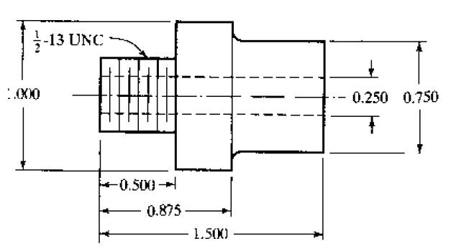
3. Explain the following with its advantages (a) Line Layout (b) Functional layout
4. Explain the bar code Printer with its application.
5. Explain the various types of automatic storage and retrieval system that is classified.

