DHANALAKSHMI SRINIVASAN COLLEGE OF ENGINEERING AND TECHNOLOGY
Mamalapuram Chennai
DEPARTMENT OF
ELECTRICAL AND ELECTRONICS ENGINEERING

QUESTION BANK

V SEMESTER
EE6501-Power system Analysis Regulation – 2013
Academic Year 2018-19

DHANALAKSHMI SRINIVASAN COLLEGE OF ENGINEERING AND TECHNOLOGY
DEPARTMENT OF ELECTRICAL AND ELECTRONICS ENGINEERRING

QUESTION BANK
SUBJECT : EE6501-Power system Analysis
SEM / YEAR: V SEMESTER / ACADEMIC YEAR 2018-2019

UNIT I -INTRODUCTION
Need for system planning and operational studies – basic components of a power system.-Introduction to restructuring - Single line diagram – per phase and per unit analysis – Generator - transformer – transmission line and load representation for different power system studies.- Primitive network - construction of Y-bus using inspection and singular transformation methods – z-bus.
PART - A
Q.No | Questions | BT Level | Competence
1 | Mention the requirement of planning the operation of power system | BT-1 | Remember
2 | Define per unit value of an electrical quantity and write equation for base impedance for three phase power system | BT-2 | Understand
3 | Define bus admittance matrix, bus impedance matrix? | BT-1 | Remember
4 | A generator rated 25MVA, 11KV has a reactance of 15%. Calculate its p.u. reactance for a base of 50MVA and 10KV | BT-6 | Create
5 | What is single line diagram | BT-2 | Understand
6 | Prepare the single phase equivalent circuit of three winding transformer | BT-3 | Apply
7 | Point out the approximations made in impedance diagram? | BT-4 | Analyze
8 | Write equation for per unit impedance if change base occurs | BT-3 | Apply
9 | What is the need of base values | BT-1 | Remember
10 | Contrast the π circuit representation of a transformer with off –  nominal ratio ‘α’ | BT-4 | Analyze
11 | What are the function of modern power system | BT-2 | Understand
12 | How are the loads are represented in the reactance and impedance  diagram | BT-4 | Analyze
13 | Summarize the functions of power system analysis? | BT-2 | Understand
14 | Examine the applications of Y-bus and Z-bus matrix? | BT-5 | Evaluate
15 | Define restructure power system? | BT-1 | Remember
16 | Define off nominal transformer ratio? | BT-1 | Remember
17 | Define primitive network? | BT-1 | Remember
18 | Order the methods available for forming bus impedance matrix | BT-5 | Evaluate
19 | Distinguish bus admittance matrix is preferred in load flow? | BT-3 | Apply
20 | Discuss the restructure Models? | BT-6 | Create
PART - B

1 | The single line diagram of a simple power system is shown in Fig. The rating of the generators and transformers are given below:  Generator 1: 25MVA, 6.6KV, X=0.2p.u Generator 2: 5MVA, 6.6KV, X=0.15p.u Generator 3: 30MVA, 13.2KV, X=0.15p.u Transformer1: 30MVA, 6.9∆/115Υ KV, X=10% Transformer2: 15MVA, 6.9∆/115Υ KV, X=1 0%  Transformer3: Single phase units each rated 10MVA, 6.9/69 KV, X=10%  Examine the impedance diagram and mark all values in p.u  choosing a base of 30MVA,  6.6KV in the generator 1 circuit. (13) | BT-2 | Understand
2 | Examine the reactance diagram for the power system shown in fig. Neglect resistance and use a base of 100MVA, 220kV in 50KΩ line. The ratings of the generator motor and transformer are give below. (13)  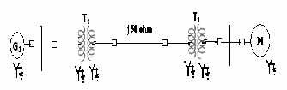  Generator: 40MVA, 25KV, X’’ =20%.  Synchronous Motor: 50MVA, 11KV, X’’ =30% T1: Y-Y transformer : 40MVA 33/220KV, X=15% T2:Y- Y transformer : 30 MVA 11/220KV, X=15% | BT-3 | Apply

3 | Prepare a per phase schematic of the system in fig. and show all the impedance in per unit on a 100 MVA, 132 KV base in the transmission line circuit. The necessary data are  Given as follows. (13)  G1 : 50MVA, 12.2KV, X=0.15 pu. G2 : 20MVA, 13.8KV, X=0.15 pu. T1 : 80MVA, 12.2/161KV, X=0.1 pu. T2 : 40MVA, 13.8/161KV, X=0.1 pu.  LOAD: 50MVA, 0.8 power factor lag operating at 154KV. Evaluate the p.u impedance of the load. (13)  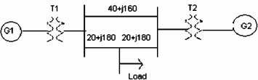 | BT-2 | Understand
4 | - The parameters of a four system are as under:  Point out the Network and find bus admittance matrix. (10)  - Generalize the impedance and reactance diagram? Explain with assumptions. (3). | BT-3 | Apply
5 | ( i) Discuss the primitive network matrix and represent its forms? Prove Ybus =At[y]A using singular  t ransformation? (7)  ii)Estimate the Ybus for the given network:  Element Positive sequence reactance 1-2 j1.0  2-3 j0.4  2-4 j0.2  3-4 j0.2  3-1 j0.8  4-5 j0.08 (6) | BT-4 | Analyze
6 | - Show that the per unit equivalent impedance of a two winding transformer is the same whether the calculation is made from the high voltage side or the low voltage side (7)  - Explain the π model for a transformer with off nominal tap  ratio. (6) | BT-1 | Remember
Line No. | Line starting  bus | Line ending  bus | Line impedance(pu) | Line Charging Admittance(pu)
1 | 1 | 2 | 0.2+j0.8 | j0.02
2 | 2 | 3 | 0.3+j0.9 | j0.03
3 | 2 | 4 | 0.25+j1.0 | j0.04
4 | 3 | 4 | 0.2+j0.8 | j0.02
5 | 1 | 3 | 0.1+j0.4 | j0.01

7 | Give p.u impedance d i a g r a m o f the power system of figure. Choose base quantities as 15 MVA and 33 KV.  Generator: 30 MVA, 10.5 KV, X ′′ = 1.6 ohms. Transformers T 1 & T2 : 15 MVA, 33/11 KV, X = 15 ohms referred to HV Transmission line: 20 ohms / phase.  Load: 40 MW, 6.6 KV, 0.85 lagging p.f. (13)  .  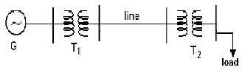 | BT-4 | Analyze
8 | Draw the p.u impedance diagram for the system shown in figure. Choose Base MVA as 100 MVA and Base KV as 20 KV. (13) | BT-5 | Evaluate
9 | Explain in detailed the three major restructure Models in power system (13) | BT-1 | Remember
10 | (i).Explain the structure of modern power system with neat sketch.  (7)  (ii).Describe about representation of loads. (6) | BT-1  BT-1 | Remember  Remember
11 | (i)Estimate the per unit impedance diagram shown in fig below.  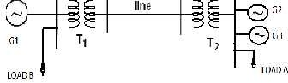  Generator1: 30MVA, 10.5KV, X’’ =1.6 ohms Generator2: 15MVA, 6.6KV, X’’ =1.2 ohms Generator3: 25MVA, 16.6KV, X’’=0.56ohms Transformer T1(3Φ):15MVA,33/11 KV,X=15.2 HT Side Transformer T2(3Φ):15MVA,33/6.2 KV,X=16 HT Side  Transmission line: 20.5Ω/phase  Load A: 15MW, 11KV, 0.9 LPF  Load B: 40MW, 6.6KV, 0.85 LPF (7)  (ii). Express the per unit equivalent circuit of single phase transformer? (6) | BT-6 | Create

12 | A 90 MVA 11KV 3Φ generator has a reactance if 25%.The generator supplies two motors through transformer and transmission line as shown in fig. The transformer T1 is a 3Φ transformer, 100 MVA, 10/132 KV, 6% reactance. The transformer T2 is composed of 3 single phase units each rated, 300 MVA, 66/20 KV, with 5% reactance. The connection of T1 and T2 are shown fig. The motors are rated at 50 MVA and 400 MVA both 10KV and 20% reactance. Taking the generator rating as base. Show reactance diagram. Reactance of the line is 100Ω. (13)  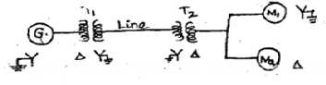 | BT-5 | Evaluate
13 | Form Y bus of the test system shown in figure using singular transformation method. The impedance data is given in Table Take  (1) as reference node (13)  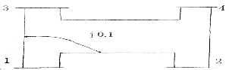  Element No Self Mutual  Bus code Impedance Bus code Impedance 1 1-2 0.5  2 1-3 0.6 1-2 0.1  3 3-4 0.4  4 2-4 0.3 | BT-3 | Apply
14 | - The sub transient reactance of a 500MVA, 18kV generator is 0.25p.u on its rating. It is connected to a network through a 20/400kV transformer. Find out the sub transient reactance of the generator on a base of 100MVA and 20kV  - A transformer interconnects a strong 400kV and weaker 200kV system and is provided with a tap changer on the 400 kV side. What is the effect of setting the tap such that the voltage ratio is 410/200kV on the 400 and 200kV sides  - Draw the pu reactance diagram of a three winding transformer whose three phase rating are: primary wye- grounded 15MVA,66kV Secondary (S) wye- grounded,10MVA 13.2 kV tertiary (t) delta connected 5 MVA 2.3 kV. Mark the appropriate value of the impedance are ZPS=7% ON 15MV;ZPT=9% on 15 MVA and 66KV ST=8% ON 10MVA and 13.2kV | BT-2 | Understand

PART - C
1 | Examine modelling of transformer, transmission line, loads and generators for a load flow, short circuit and stability studies (15) | BT-5 | Evaluate
2 | The parameter pf a 4 bus system are as under  Line Starting Line Ending Line impedance Line charging admittance Bus bus  1 2 0.2+j0.8 j0.02  2 3 0.3+j0.9 j0.03  2 4 0.25+j1.0 j0.04  3 4 0.2+j0.8 j0.02  1 3 0.1+j0.4 j0.01  Draw the network and find admittance matrix (15) | BT-5 | Evaluate
3 | Draw the reactance diagram for the power system shown in figure. The ratings of generator, motor and transformers are given below. Neglect resistance and use a base of 50MVA, 13.8kV in the 40 ohm line  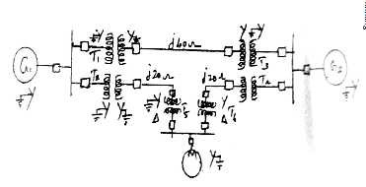  Generator G1: 20MVA,18kV, X”=20% Generator G2: 40MVA 18kV,X”=20% Synchronous motor:30MVA,13.8kV,X”=20%  3phase Y-Y Transformer:20MVA 13.8/20kV, X=10% | BT-6 | Create

4 | Prepare a per phase schematic of the system shown in figure and show all the impedance in per unit on a 100 MVA,132 kV base in the transmission line circuit. The necessary data are given follows  G1:50MVA 12.2kV X=0.15p.u G2:20MVA,13.8kV,X=0.15p.u  T1: 80 MVA 12.2/161 kV, X=0.1p.u T2: 40MVA, 13.8/161kV,X=0.1p.u  Load: 50MVA,0.8 pf lag operating at 154 kV Determine the p.u impedance of the load  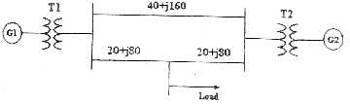 | BT-6 | Create

UNIT II- POWER FLOW ANALYSIS
Importance of power flow analysis in planning and operation of power systems - statement of power flow problem - classification of buses - development of power flow model in complex variables form - iterative solution using Gauss-Seidel method - Q-limit check for voltage controlled buses – power flow model in polar form - iterative solution using Newton-Raphson method .
PART - A
Q.No | Questions | BT Level | Competence
1 | Mentioned the various types of buses in power system with specified  quantitates for each bus | BT-1 | Remember
2 | What is the need for slack bus in power flow analysis | BT-4 | Analyze
3 | When will the generator bus is treated as load bus | BT-2 | Understand
4 | Extend the acceleration factor in Gauss Seidal Method | BT-5 | Evaluate
5 | Prepare the advantages and disadvantages of Gauss Seidal method | BT-3 | Apply
6 | What is the need for load flow analysis | BT-1 | Remember
7 | Associate with load flow studies are important for planning the existing system as well as the future expansion | BT-2 | Understand
8 | Relate why bus admittance matrix is used in Gauss Seidal instead of bus impedance matrix | BT-3 | Apply
9 | Show the general power flow equation | BT-4 | Analyze
10 | Describe the need for power flow study | BT-1 | Remember
11 | Compare GSM and NRM with respect to number of iterations taken for convergence and memory requirement | BT-4 | Analyze
12 | Discuss the effect of acceleration factor in the load flow solution  algorithm | BT-2 | Understand
13 | What are the disadvantage NR method | BT-3 | Apply
14 | What are the advantage FDLF method | BT-1 | Remember
15 | Compare GS and NR method. | BT-5 | Evaluate
16 | Explain what do you mean by flat voltage start | BT-6 | Create
17 | Define bus incidence matrix | BT-1 | Remember
18 | Tabulate practical load flow problem | BT-6 | Create
19 | What is jocobian matrix | BT-2 | Understand
20 | Define voltage controlled bus and load bus | BT-1 | Remember
PART - B
1 | Prepare the load flow algorithm using Gauss Seidal method with flow chart and discuss the advantages of the method. (13) | BT-1 | Remember

2 | For the sample system shown in the fig. the generators are connected at all four buses while the loads are at buses 2 and 3. Assuming a flat voltage start, examine bus voltages and bus angles at the end of first Gauss seidal iterations and consider the reactive power limitas 0.2 ≤ Q2 ≤1 . (13)  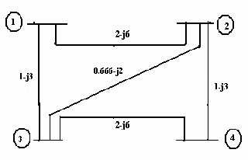 | BT-3 | Apply
3 | Using Gauss Seidal method examines bus voltages for the fig shown. Take base MVA as100, α=1.1.  (13)  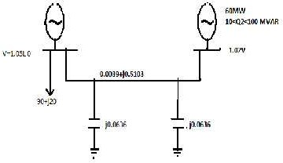 | BT-3 | Apply
Bus | P in pu | Q in pu | V in pu | Remarks
1 | - | - | 1.04∟0o | Slack bus
2 | 0.5 | - | 1.04pu | PV bus
3 | -1.0 | 0.5 | - | PQ bus
4 | 0.3 | -0.1 | - | PQ bus

4 | In the power system network shown in figure, bus 1 is slack bus with V1= 1.0 + j0.0 per unit and bus 2 is a load bus with S2 = 280MW = j60MVAR. The line impedance on a base of 100MVA is Z = 0.02 + j0.04 per unit. Using Gauss – Seidal method, give V2.Use  (0)  an initial estimate of V2 = 1.0 + j0.0 and perform four iterations.  Also find S1 and the real, reactive power loss in the line, assuming that the bus voltages have converged. (13)  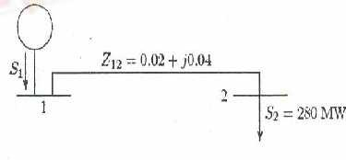 | BT-6 | Create
5 | The system data for a load flow problem are given in table.  - Compute Y bus.  - Solve bus voltages at the end of first iteration by G-S method by taking α =1.6. (16) | BT-3 | Apply
6 | Fig shown below a three bus system Bus 1: slack bus V=1.05∟0  p.u. Bus 2:PV bus│=1.0 p.u, Pe=3 p.u.Bus 3:PQ bus PL=4 p.u, QL=2p.u. examine one iteration of load flow solution by Gauss seidel method. neglect limits on reactive power generation? (13)  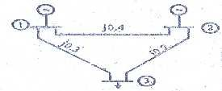 | BT-4 | Analyze
Line no | Bus code | Admittance in pu
1 | 1-2 | 2-j8
2 | 1-3 | 1-j4
3 | 2-3 | 0.6-j2.6

7 | A three bus power system is shown in figure. the relevant per unit line admittance on 100MVA base are indicated on the diagram and bus data are given in table. form Ybus and Give the voltage at bus 2 and bus 3 after first iteration using gauss seidal method. Take the acceleration factor α=1.6. (13)  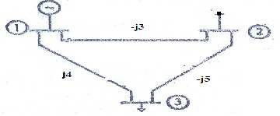 | BT-5 | Evaluate
8 | Explain the types of buses and derive the power flow equations in load flow analysis. (13) | BT-1 | Remember
9 | Solve necessary expressions for the off-diagonal and diagonal elements of the sub- matrices J1 , J2 , J3 and J4 for carrying  out a load flow study on power system by using N-R method in Polar form. (13) | BT-2 | Understand
10 | The converged load flow solution is available how do you determine the slack bus complex power injection and system total loss? (13) | BT-1 | Remember
11 | - Give the classification of various types of buses in a power system for load flow studies (5)  - Give the advantages and limitations of Newton Raphson method (5)  - What is meant by decoupled load flow study (3) | BT-1 | Remember
Bus Number | Type | Generation PG QG  (MW)  (MVAR) | Load  PG QG (MW)  (MVAR) | Bus voltage  V(p.u) δ  deg
1 | Slack | - | 0 0 | 1.02 0
2 | PQ | 25 15 | 50 25 | - -
3 | PQ | 0 0 | 60 30 | - -

12 | Figure shows the one line diagram of a simple three bus power system with generation at buses at 1 and 2.the voltage at bus 1 is V=1+j0.0 V per unit. Voltage magnitude at bus 2 is fixed at 1.05 p.u. with a real power generation of 400 MW. A Load consisting of 500MW and 400 MVAR base. For the purpose of hand calculation, line resistance and line charging susceptances are neglected  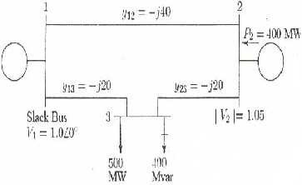  Using Newton-Raphson method, start with the initial estimates of  0 0  V2 =1.05+j0.0 and V3 =1.05+j0.0, and keeping │V2│=1.05 p.u.,  examine the phasor values v2 and v3.perform two iterations. (13) | BT-5 | Evaluate
13 | Derive N-R method of load flow algorithm and explain the implementation of this algorithm with the flowchart. (13) | BT-2 | Understand
14 | ( i) Derive the static load flow equations of n-bus system. (7)  (ii) Compare GSLF, NRLF Methods. (6) | BT-4 | Analyze
PART - C
1 | Draw and explain the step by step procedure of load flow solutions for the Gauss seidal method when PV buses are present (15) | BT-6 | Create
2 | The Figure shows the one line diagram of a simple 3 bus system with generation at buses 1 and 3 . Line impedance are marked in p.u on a 100 MVA base. Determine the bus voltages at the end of second iteration using Gauss seidal method (15)  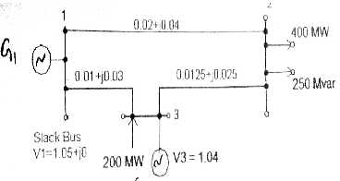 | BT-3 | Apply

3 | Consider the power system with following data  =  Generation Load Voltage Bus No Type P Q P Q Mag. Ang.  1 Slack - - - - 1.0 0˚  2 P-V 5.0 - 0 - 1.05 -  3 P-Q 0 0 3.0 0.5 - -  Assume that the bus 2 can supply any amount of reactive power. With a flat start, perform the first iteration of power flow analysis using Newton Raphson method (15) | BT-5 | Evaluate
4 | With a neat flow chart explain the computational procedure for load flow solving using Newton Raphson iterative method when the system contain all types of buses (15) | BT-5 | Evaluate


UNIT III FAULT ANALYSIS – BALANCED FAULTS
Importance of short circuit analysis - assumptions in fault analysis - analysis using Thevenin’s theorem - Z-bus building algorithm - fault analysis using Z-bus – computations of short circuit capacity, post fault voltage and currents
PART - A
Q.No | Questions |  |  |  |  |  |  |  | BT Level | Competence
1 | Examine the order of severity and symmetrical fault? |  |  |  |  |  |  |  | BT-4 | Analyze
2 | Define short circuit capacity of power system |  |  |  |  |  |  |  | BT-1 | Remember
3 | Show the oscillation of short circuit current when an unloaded generator is subjected to a symmetrical fault clearly marking sub- |  |  |  |  |  |  |  | BT-3 | Apply
4 | Discuss the  computation? | prefault | currents | are | usually | neglected | in | fault | BT-4 | Analyze
5 | What is meant by fault calculations |  |  |  |  |  |  |  | BT-2 | Understand
6 | Point out the various types of shunt and series faults |  |  |  |  |  |  |  | BT-5 | Evaluate
7 | Distinguish between symmetrical and unsymmetrical short circuits. |  |  |  |  |  |  |  | BT-5 | Evaluate
8 | Define bolted fault? |  |  |  |  |  |  |  | BT-1 | Remember
9 | The Z bus method is very suitable for fault studies on large system  infer? |  |  |  |  |  |  |  | BT-4 | Analyze
10 | Summarize two approximations made in short circuit studies |  |  |  |  |  |  |  | BT-1 | Remember
11 | How do Short circuits occur in power system and Summarize two objective of Short circuit analysis? |  |  |  |  |  |  |  | BT-3 | Apply
12 | Discover the main differences in representation of power system for  load flow and short circuit studies. |  |  |  |  |  |  |  | BT-2 | Understand
13 | Compose, What is meant by doubling effect? |  |  |  |  |  |  |  | BT-2 | Understand
14 | Explain the need for fault analysis in power system? |  |  |  |  |  |  |  | BT-6 | Create
15 | Explain the sub transient reactance and transient reactance? |  |  |  |  |  |  |  | BT-1 | Remember
16 | Summarize the reason for transients during short circuit? |  |  |  |  |  |  |  | BT-6 | Create
17 | State and explain symmetrical fault |  |  |  |  |  |  |  | BT-3 | Apply
18 | Define synchronous reactance, transient reactance, sub transient reactance |  |  |  |  |  |  |  | BT-1 | Remember
19 | Define fault level. |  |  |  |  |  |  |  | BT-1 | Remember
20 | Summarize the applications of short circuit analysis |  |  |  |  |  |  |  | BT-2 | Understand
PART - B
1 | Explain the step by step procedure for systematic fault analysis for a three phase fault using bus impedance matrix. (13) |  |  |  |  |  |  |  | BT-1 | Remember
2 | A generator is connected through a transformer to a synchronous motor. The sub transient reactance of generator and motor are  0.15 p.u and 0.35p.u respectively. The leakage reactance of the transformer is 0.1 p.u . All the reactance are calculated on a common base. A three phase fault occurs at the terminal of the motor when the terminal voltage of the generator is 0.9p.u .The output current of generator is 1p.u and 0.8 pf leading. Find the sub transient current in p.u in the fault, generator and motor. Use the terminal voltage of generator as reference vector. (1 3 ) |  |  |  |  |  |  |  | BT-2 | Understand

3 | Two synchronous motor are connected to the bus of large system through a short transmission line shown in fig. The rating of the various components is given.  MOTOR (each): 1 MVA, 440V, 0.1 p.u.  Transient reactance line: 0.05Ω (reactance)  Large system: Short circuit MVA at its bus at 440V is 8 When the motor are operating at 400V, examine the short circuit current (symmetrical) fed into a three phase fault at motor bus. (13)  . 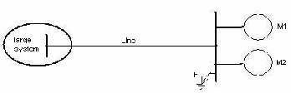 | BT-5 | Evaluate
4 | Explain the step by step procedure to find the fault current of three phase symmetrical fault by using thevenin’s theorem. (13) | BT-1 | Remember
5 | For the radial network shown in figure , a 3 phase fault occurs at point F. examine the fault current. (13)  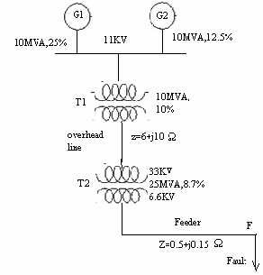 | BT-4 | Analyze

6 | A symmetrical fault occurs on bus 4 of system shown in figure; examine the fault current, post fault voltages, line flows.  Generator G1 ,G2 :100MVA,20KV,X1=15%.  Transformer T1, T2:, Xleak=9%, Transmission line L1,L2: X1=10%  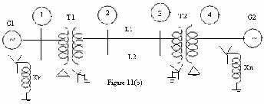  (13) | BT-1 | Remember
7 | Examine the bus impedance matrix using bus building algorithm for the given network.  (13) | BT-2 | Understand
8 | . (i)Determine Bus Impedance matrix by Bus Building Algorithm.(6)  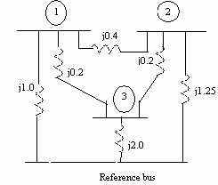  ii) Point out Bus impedance matrix. Describe the construction of Bus impedance matrix ZBus using Bus building algorithm for lines without mutual coupling .(6) | BT-3  BT2 | Apply  Understand
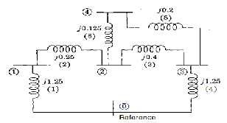
9 | 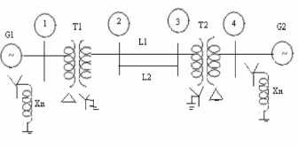  A symmetrical fault occurs on bus 4 of system through Zf=j0.14 pu in figure. Using bus building algorithm, calculate the fault current, post fault voltages, line flows.  G 1 , G 2 : 1 0 0 M V A , 2 0 k V , X + = 1 5 %  Transformer T1,T2: Xleak=9%  Transmission line L1,L2, X+=10%. (13) | BT-2 | Understand
10 | A 3-phase 5MVA, 6.6 KV alternators with a reactance of 8% is connected to a feeder of series impedance (0.12+j0.48) ohm/phase/Km through a step up transformer. The transformer is rated at 3 MVA, 6.6 KV/33KV and has a reactance of 5%. Calculate the fault current supplied by the generator operating under no load with a voltage of 6.9 KV when a three phase symmetrical fault occurs at a point 15Km along the feeder.(13) | BT-3 | Apply
11 | Two generator are connected in parallel to the low voltage side of a 3Φ delta star transformer as shown in figure. generator 1 is rated 60,000 KVA, 11 KV.generator 2 is rated 30,000 KVA, 11KV.each generator has a sub transient reactance of  ”  Xd =25%.the transformer is rated 90,000 KVA at 11 KV-  delta/66KV star with a reactance of 10%.before a fault occurred, the voltage on the HT side of the transformer is 63KV.the transformer is unloaded and there is no circulating current between the generators. Calculate the sub transient current in each generator when a three phase fault occurs on the HT side of the transformer. (13)  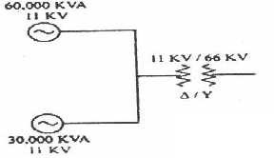 | BT-5 | Evaluate

12 | A generator transformer unit is connected to a line circuit breaker.the unit rating are:  Generator: 10MVA, 6.6KV; Xd”=0.1 p.u, Xd’=0.2 p.u and  Xd=0.8 p.u Transformer:10mva,6.9/33KV,X=0.08 p.u,  The system is operating on no load at a line voltage of 30 KV,  when a 3Φ fault occurs on the line jest beyond the circuit breaker.  Solve  - The initial symmetrical rms current in the breaker.  - The maximum possible dc offset current in the breaker. (iii)the momentary current rating of the breaker  - the current to be interrupted by the breaker and the interrupting KVA  - the sustained short circuit current in the breaker. (13) | BT-4 | Analyze
13 | A 25,000 KVA, 13.8 kV generator with X”d = 15% is connected through a transformer to a bus which supplies four identical motors as shown in Fig. The sub transient reactance X”d of each motor is 20% on a base of 5000 KVA, 6.9 kV. The three-phase rating of the transformer is 25,000 KVA, 13.8/6.9 kV, with a leakage reactance of 10%. The bus voltage at the motors is 6.9 kV when a three- phase fault occurs at point p. for the fault specified, Point out  (i) The sub transient current in the fault (ii) the sub transient current in breaker A and (iii) the symmetrical short-circuit interrupting current in the fault and in breaker A. (13) | BT-4 | Analyze
14 | With help of detailed flow chart, explain how symmetrical fault can be analysed using Zbus (13) | BT-1 | Remember
PART - C
1 | A 3 phases 5 MVA, 6.6 kV alternator with a reactance of 8% is connected to a feeder series impedance (0.12+j0.48) ohm/phase/km through a step up transformer. The transformer rated at 3 MVA, 6.6 kV/33kV and has reactance of 5%.Determine the fault current supplied by the generator operating under no load with a voltage of  6.9 kV, when a 3 phases symmetrical fault occurs at a point 15km along the feeder. (15) | BT-4 | Analyze
2 | A 3 phase transmission line operating at 33kV and having resistance of 5 Ω and reactance of 20Ω is connected to the generating station through 15,000 KVA step up transformers. Connected to the bus bar are two alternators one of 10,000KVA with 10% reactance and another of 5000 KVA with 7.5% reactance. Draw the single line diagram and calculate the short circuit KVA for symmetrical fault between phases at the load end of the transmission line (15) | BT-5 | Evaluate

3 | For the network shown in fig.Find the sub transient current in per unit from generator 1 and in line 1-3 and the voltages at bus 1 and 2 for a three phase fault on bus 3. Assume that no current is flowing prior to the fault and that the pre fault voltage at bus 3 is 1 p.u . Use  (i) bus impedance method (ii) network reduction method for calculation (15)  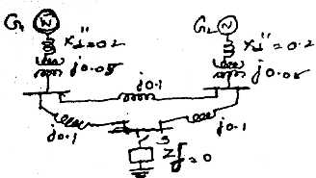 | BT-5 | Evaluate
4 | For the radial network shown in figure 3 phase fault occurs at point  F. Determine the fault current and the line voltage at 11.8 kV bus under fault condition | BT-3 | Apply

UNIT IV FAULT ANALYSIS – UNBALANCED FAULTS
Introduction to symmetrical components – sequence impedances – sequence circuits of synchronous machine, transformer and transmission lines - sequence networks analysis of single line to ground, line to line and double line to ground faults using Thevenin’s theorem and Z-bus matrix.
PART - A
Q.No | Questions | BT Level | Competence
1 | Point out the order of severity and occurrence of different types of  fault? | BT-1 | Remember
2 | Why the neutral grounding impedance Zn appears as 3Zn in zero  sequence equivalent circuit | BT-2 | Understand
3 | Point out the sequence network diagram for line to line fault with fault impedance | BT-5 | Evaluate
4 | Evaluate the sequence network diagram for line to ground with fault impedance | BT-3 | Apply
5 | Explain the significance of sub transient reactance and transient reactance in short circuit studies | BT-2 | Understand
6 | Write boundary conditions for single line to ground faults | BT-1 | Remember
7 | Describe the symmetrical component of phase ‘a” in ters of the  current | BT-4 | Analyze
8 | Describe the equation for sub transient and transient internal voltage | BT-3 | Apply
9 | Define doubling effect and DC off-set current | BT-1 | Remember
10 | Summarize different between sub transient and transient reactance
11 | Explain the features of zero sequence current? | BT-3 | Apply
12 | Discuss the symmetrical components of three phase system | BT-5 | Evaluate
13 | Define negative sequence and zero sequence components | BT-1 | Remember
14 | Define short circuit capacity | BT-1 | Remember
15 | Discover the symmetrical components Va1, Va2 and Va0 in terms of unbalanced vectors Va, Vb and Vc. | BT-4 | Analyze
16 | Write down the equation determine symmetrical currents for un balanced current | BT-6 | Create
17 | What are symmetrical components | BT-2 | Understand
18 | Demonstrate the zero sequence network diagram of a delta-delta connected transformer. | BT-4 | Analyze
19 | In which fault, the negative and zero sequence currents are absent? | BT-6 | Create
20 | Develop the connection of sequence networks for line –to-line fault without fault impedance. | BT-2 | Understand
PART – B
1 | Examine the sequence impedance of synchronous machine, transmission lines and Star connected loads. (13) | BT-5 | Evaluate
2 | Label the transformer zero sequence equivalent circuits for the various winding connections and delta connected load (13) | BT-1 | Remember

3 | A 25MVA, 11KV, three phase generator has a sub transient reactance of 20%. The generator supplies two motors over a transmission line with transformers at both ends as shown in one line diagram a of figure. The motors have rated inputs of 15 and  7.5 MVA both 10KV with 25% sub transient reactance. The three phase transformers are rated 30MVA, 10.8/121KV, and connection delta-star with leakage reactance of 10% each. The series reactance of the line is 100 ohms. Label the positive and negative sequence networks of the system with reactance marked in per unit.  (13) | BT-6 | Create
4 | Examine the sequence network for a double line to ground (LLG) fault. (13) | BT-2 | Understand
5 | A salient pole generator without dampers is rated 20 MVA, 13.6 KV and has direct axis sub – transient reactance of 0.2 per unit. The negative and zero sequence reactance’s are, respectively,  0.35 and 0.1 per unit. The neutral of the generator is solidly grounded. With the generator operating unloaded at rated voltage with Ean=1.0 ∟0° per unit, a single line to ground fault occurs at the machine terminals, which then have per -unit voltage to ground,  Va = 0; Vb = 1.013∟-102.25°; Vc=1.013∟102.25°  Give the sub transient current in the generator and the line to line voltage for sub transient conditions due to the fault. (13) | BT-3 | Apply
6 | Discuss the expression for fault current in single line to ground fault on unloaded generator. Draw an equivalent network showing the inter connection of networks to simulate single line to ground fault (13) | BT-1 | Remember
7 | Show the expression for fault current in double line to ground fault on unloaded generator. Draw an equivalent network showing the inter connection of networks to simulate double line to ground fault  (13) | BT-1 | Remember
8 | Show the expression for fault current in line to line fault on unloaded generator. Draw an equivalent network showing the inter connection of networks to simulate double line to line fault. (13) | BT-2 | Understand
9 | A 25 MVA,13.2KV alternator with solidly grounded neutral has a sub transient reactance os 0.25.the negative and zero sequence reactance are 0.35 and 0.01 p.u .respectively if a double line to ground fault occuers at the terminals of the alternator. Point out the fault current and line to line voltage at the fault. (13) | BT-3 | Apply
10 | Point out the expression for fault current for a line to line fault taken place through impedance Zb in a power system. (13) | BT-2 | Understand

11 | A Double Line to Ground fault occurs on line b and c at point F in the system of figure . Point out the sub transient current in phase c of the machine 1.assuming pre fault current to be zero. Both machine are rated 1200 KVA,600 V with reactance of X’’=X2=10% AND XO=5%.each tree phase transformer is rated 1200KVA,600V- delta/300V-star with leakage reactance of 5%.the reactance of the transmission line are X1=X2=20% and X0=40% on the base of 1200 KVA,3300V.the reactance of the neutral of the grounding reactors are 5% on the KVA base of the machines. (13) | BT-3 | Apply
12 | . Calculate the sub transient current in each phase for a dead short circuit on the one phase to ground at bus ‘q’ for the system shown in figure below. (13)  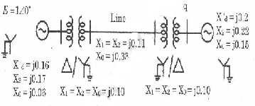 | BT-4 | Analyze
13 | . The one-line diagram of a power system is shown below. (16)  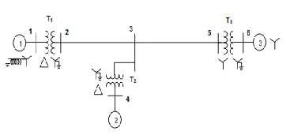  The following are the p.u. reactances of different elements on a common base  Generator 1: Xg0 = 0.075; X n = 0.075; X 1 = X2 = 0.25  Generator 2: Xg0 = 0.15; X n = 0.15; X 1 = X2 = 0.2 Generator 3: Xg0 = 0.072; X1 = X2 = 0.15  Transformer 1: X0 = X1 = X2 = 0.12 Transformer 2: X0 = X1 = X2 = 0.24 Transformer 3: X0 = X1 = X2 = 0.1276  Transmission line 2 – 3 X0 = 0.5671; X₁ = X2 = 0.18  Transmission line 3 – 5 X0 = 0.4764; X1 = X2 = 0.12  Prepare the three sequence networks and determine reactances Zbus0,Zbus1,Zbus2 | BT-4 | Analyze
14 | Give the Zero sequence diagram for the system whose one line diagram is shown in fig. (16)  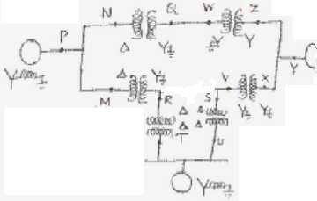 | BT-5 | Evaluate
PART - C
1 | 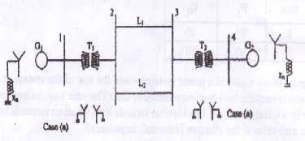  It is proposed to conduct fault analysis on two alternative configuration of the 4 bus system G1,G2:100MVA,200kV.X⁺=X⁻=Xd”=20%,X0=4%,Xn=5% T1,T2:100MVA,20kV/345kV,Xleak=8%  L1,L2:X⁺=X⁻=15%;X0=50% on a base of 100MVA  For a three phase to ground (solid) fault at bus 4, determine the fault current and MVA at faulted bus, post fault bus voltages, fault current distribution in different elements of the network using Thevenine equivalent circuit. Draw a single line diagram showing the above results | BT-5 | Evaluate
2 | A 50 Hz 50 MVA,13.2kV star grounded alternator is connected to a line though a Δ-Y transformer as shown in figure. The positive, negative, zero sequence impedance of the alternator ar j0.1,j0.1,j0.05 respectively. The transformer rated at 13.2 kV Δ /120kV Y,50Hz with Y solidly grounded has the sequence impedance Xʺ=X2=X0=j0.1p.u. The line impedance between Q and R are X1ʺ=j0.03,X2=j0.03,X0=j0.09. Assuming that the fault to be takes place at Q, determine the sub transient fault for a (i) 3 phase fault (ii) L-G fault (iii) L-L-G fault. Draw the connection diagram for the sequence diagram in each fault (15)  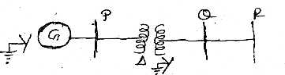 | BT-4 | Analyze

3 | Explain the concept of symmetrical component is used short circuit studies in the power system (15) | BT-3 | Apply
4 | - What are the assumption to made in short circuit studies (7)  - Deduce and the draw the sequence network for LLG fault at the terminals of unloaded generator (8) | BT-6 | Create

UNIT V -STABILITY ANALYSIS
Importance of stability analysis in power system planning and operation - classification of power system stability - angle and voltage stability – Single Machine Infinite Bus (SMIB) system: Development of swing equation - equal area criterion - determination of critical clearing angle and time – solution of swing equation by modified Euler method and Runge-Kutta fourth order method.
PART - A
Q.No | Questions | BT Level | Competence
1 | A four pole,60HZ synchronous generator has a rating of 200MVA,0.8 power factor lagging. the moment of inertia of the rotor is 45100 kg-m2.formulate M and H | BT-6 | Create
2 | Define stability | BT-1 | Remember
3 | Infer the significance of critical clearing time | BT-4 | Analyze
4 | Discuss transient stability. | BT-2 | Understand
5 | Summarize assumptions upon transient stability | BT-4 | Analyze
6 | Define steady state stability limit? | BT-1 | Remember
7 | Explain transient stability limit? | BT-3 | Apply
8 | Examine ,How to improve the transient stability limit of power | BT-5 | Evaluate
9 | Classify steady state stability limit. Define them | BT-2 | Understand
10 | Discover the machine problems seen in the stability study | BT-3 | Apply
11 | Give the expression for swing equation. Explain each term along with their units. | BT-1 | Remember
12 | Order are the assumptions made in solving swing equation? | BT-2 | Understand
13 | Define swing curve. What is the use of swing curve? | BT-1 | Remember
14 | pointout the control schemes included in stability control | BT-3 | Apply
15 | Generalize the systems design strategies aimed at lowering system | BT-4 | Analyze
16 | Point out equal area criterion | BT-1 | Remember
17 | Give the expression for critical clearing time | BT-6 | Create
18 | List the types of disturbances that may occur in a single machine | BT-5 | Evaluate
19 | Define critical clearing angle. | BT-1 | Remember
20 | List the assumptions made in multi machine stability studies | BT-2 | Understand
PART - B
1 | Examine swing equation used for stability studies in power system.  (13) | BT-1 | Remember
2 | Describe the equal area criterion for transient stability analysis of a system (13) | BT-4 | Analyze
3 | Interpret the computation algorithm for obtaining swing curves using modified Euler’s method (13 ) | BT-2 | Understand
4 | . Examine a short note on  - Factors influencing transient stability (7)  - Voltage collapse (6) | BT-1 | Remember

5 | . Given the system of figure below where a three phase fault is applied at a point P as shown.  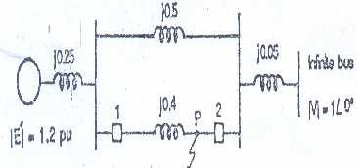  Examine the critical clearing angle for clearing the fault with simultaneous opening of the breakers 1 and 2. The reactance vales of various components are indicated on the diagram. The generator is delivering 1.0 p.u power at the instant preceding the fault. The fault occurs at point P as shown in above figure. (13) | BT-2 | Understand
6 | Examine the swing equation of a synchronous machine swinging against an infinite bus. Clearly state the assumption in deducing the swing equation. (13) | BT-6 | Create
7 | - Derive Expression for critical clearing angle. (6)  - A 150 MVA generator – transformer unit having an overall reactance of 0.3 p.u. is delivering 150 MW to infinite bus bar over a double circuit 220 KV line having reactance per phase per circuit of 100 ohms. A 3 - phase fault occurs midway along one of the transmission lines. Give the maximum angle of swing that the generator may achieve before the fault is cleared without loss of stability. (7) | BT-4  BT-4 | Analyze  Analyze
8 | A 50 Hz, 500 MVA, 400 KV generator (with transformer) is connected to a 400 KV infinite bus bar through an interconnector. The generator has H = 2.5 MJ/MVA, Voltage behind transient reactance of 450 KV and is loaded 460 MW. The transfer reactances between generator and bus bar under various conditions are :  Prefault 0.5 Pu During Fault 1.0 Pu Post fault 0.75 Pu  Calculate the swing curve using intervals of 0.05 sec and  assuming that the fault is cleared at 0.15 sec. (13) | BT-5 | Evaluate
9 | Explain the modified Euler method of analyzing multi machine power system for stability, with neat flow chart. (13) | BT-1 | Remember

10 | The single line diagram of a system is shown in fiqure.there are four identical generators of rating 555 MVA,24 KV,60 HZ supplying power infinite bus bus bar through two transmission circuits. the reactance shown in figure are in p.u. on 2220 MVA,24 KV base(refer to the voltage side of the transformer).resistance are assumed to be negligible. the initial operating conditions, with quantities expressed in p.u on 2220 MVA,24 KV base is as follows:  P=0.9,Q=0.436(over exited),Et=1.0<28.34,Eb=0.90081<0.  The generator are modeled as a single equivalent generator represented by the classical modal with the following parameter  in per unit on 2220 MVA, 24KVbase. Xd’=0.3,H=3.5MWs/MVA,KD=0. circuit 2 experiences a solid three phase fault at point f, and the fault is cleared by isolating the fault circuit. Calculate the critical clearing time and critical clearing angle by computing the time response of the rotor angle, using numerical integration. (13)  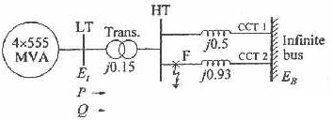 | BT-2 | Understand
11 | In the power system shown in Fig three phase fault occurs at P and the faulty line was opened a little later. Find the power output equations for the pre-fault, during fault and post-fault condition.if delivering 1.0 p.u jest before fault occurs, calculate δcc. (13) | BT-3 | Apply

12 | .(i)A 60HZ synchronous generator has a transient reactance of 0.2  p.u and an inertia constant of 5.66MJ/MVA. the generator is connected to an infinite bus through a transformer and a double circuit transmission line, as shown in fiqure.resistsnce are neglected and reactance are expressed on a common MVA base and are marked on the diagram. the generator is delivering a real power of 0.77 p.u to bus bar 1. Voltage magnitude at bus 1 is 1.1 p.u.the infinite bus voltage V=1.06<0 p.u. evaluate the generator excitation voltage and swing equation. (10)  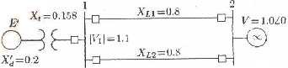  (ii)A synchronous motor having a steady state stability limit of 200 MW is receiving 50 MW from the infinite bus bars. Find the maximum additional load that can be applied suddenly without causing instability. (3) | BT-3 | Apply
13 | . (i) A 2-pole 50 Hz, 11kV turbo alternator has a ratio of 100 MW, power factor 0.85 lagging. The rotor has a moment of inertia of  2  10,000 kgm . Evaluate H and M .(4)  (ii) A 50 HZ generator is delivering 50% of the power that it is capable of delivering through a transmission line to an infinite bus. A fault occurs that increases the reactance between the generator and the infinite bus to 500% of the value before the fault. When the fault is isolated, the maximum power that can be delivered is 75% of the original maximum value. Evaluate the critical clearing angle for the condition described (9) | BT-3 | Apply
14 | Develop the Runge-Kutta method of solution of swing equation for multi-machine systems. (13) | BT-1 | Remember
PART - C
1 | - A generator is operating 50Hz,delivers 1.0 p.u power to an infinite through a transmission circuit in which resistance is ignored. A fault taken place reducing a maximum power transferable to 0.5 p.u. Before the fault, this power was 2.0 p.u and after the clearance of the fault it is 1.5p.u. By using equal area criterion ,determine the critical clearing angle (10)  - Discuss the method by which transient stability improved (5) | BT-3 | Apply
2 | Derive the swing equation and discuss the importance of stability studies in power system planning and operation (15) | BT-4 | Analyze
3 | Explain the equal area criteria for the following applications  - Sustained fault  - Fault with subsequent clearing (15) | BT-4 | Analyze
4 | A synchronous motor is receiving 30% of the power that it is capable of receiving from on infinite bus. If the load on the motor is doubled, calculate the maximum value of δ during the swinging of the motor around its new equilibrium position (15) | BT-3 | Apply

