**DHANALAKSHMI SRINIVASAN COLLEGE OF ENGINEERING AND TECHNOLOGY**

**ECR, MAMALLAPURAM**

**CHENNAI-603104**

**DEPARTMENT OF ELECTRONICS AND COMMUNICATION ENGINEERING**

**EC8252- ELECTRON DEVICES**

**QUESTION BANK**



**PREPARED BY**

**M.PRIYADARSHINI /AP/ECE**

**UNIT I SEMICONDUCTOR DIODE**

**PART A**

**1.What are semiconductors?**

The materials whose electrical property lies between those of conductors and insulators are known as Semiconductors. Ex germanium, silicon.

It has two types.

1. Intrinsic semiconductor 2. Extrinsic semiconductor.

**2.Differentiate between intrinsic and extrinsic semiconductor intrinsic semiconductor**

**Intrinsic semiconductor**

Pure form of semiconductors are said to be intrinsic semiconductor.

**Ex: germanium, silicon.**

It has poor conductivity

**Extrinsic semiconductor**

If certain amount of impurity atom is added to intrinsic semiconductor the resulting semiconductor is Extrinsic or impure Semiconductor

It has good conductivity.

**3. What is meant by biasing a PN junction?**

Connecting a PN junction to an external voltage source is biasing a PN junction.

**4.What are the types of biasing a PN junction?**

1.Forward bias 2. Reverse bias.

**5.What is forward bias and reverse bias in a PN junction?**

When positive terminal of the external supply is connected to P region and negative terminal to N region ,the PN junction is said to be forward biased. under forward biased condition the PN region offers a very low resistance and a large amount of current flows through it.

**6.Define drift current?**

When an electric field is applied across the semiconductor, the holes move towards the negative terminal of the battery and electron move towards the positive terminal of the battery. This drift movement of charge carriers will result in a current termed as drift current.

**7.Give the expression for drift current density** Drift current density due to electrons

**Jn = q n μnE**

Where,

Jn - drift current density due to electron

q- Charge of electron

μn - Mobility of electron

E - applied electric field

Drift current density due to holes**.**

**Jp = q p μp E**

Where,

Jn - drift current density due to holes

q - Charge of holes

μp - Mobility of holes

E - applied electric field

**8.Define the term diffusion current?**

A concentration gradient exists, if the number of either electrons or holes is greater in one region of a semiconductor as compared to the rest of the region. The holes and electron tend to move from region of higher concentration to the region of lower concentration. This process in called diffusion and the current produced due this movement is diffusion current.

**9.Give the expression for diffusion current density** Diffusion current density due to electrons

**Jn = q Dn dn / dx**

Where

Jn - diffusion current density due to electron

q - Charge of an electron

Dn – diffusion constant for electron

dn / dx – concentration gradient

Diffusion current density due to holes

**Jp = - q Dp dp / dx**

Where

Jp - diffusion current density due to holes

q - Charge of a hole

Dp – diffusion constant for hole

dn / dx – concentration gradient

**10.Differentiate between drift and diffusion currents.**

**Drift current**

1. It is developed due to potential gradient.
2. This phenomenon is found both in metals and semiconductors

**Diffusion current**

1. It is developed due to charge concentration gradient.
2. This phenomenon is found only in metals

**11.What is depletion region in PN junction?**

The region around the junction from which the mobile charge carriers ( electrons and holes) are depleted is called as depletion region.since this region has immobile ions, which are electrically charged , the depletion region is also known as space charge region.

**12.What is barrier potential?**

Because of the oppositely charged ions present on both sides of PN junction an electric potential is established across the junction even without any external voltage source which is termed as barrier potential.

**13.What is Reverse saturation current?**

The current due to the minority carriers in reverse bias is said to be reverse saturation current. This current is independent of the value of the reverse bias voltage.

**14.What is the total current at the junction of pn junction diode?**

The total in the junction is due to the hole current entering the n material and theelectron current entering the p material. Total current is given by

**I = Ipn(0) + Inp(0)**

Where,

I – Total current

Ipn(0) - hole current entering the n material

Inp(0) - electron current entering the p material

**15.Give the diode current equation?**

The diode current equation relating the voltage V and current I is given by

where

I – diode current

Io – diode reverse saturation current at roomtemperature

V – external voltage applied to the diode

VT = kT/q = T/11600, thermal voltage

1. – Boltzmann’s constant (1.38066x10^-23 J/K)

q – charge of electron (1.6x10^-19 C)

T – temperature of the diode junction

**16.What is recovery time? Give its types.**

When a diode has its state changed from one type of bias to other a transient accompanies the diode response, i.e., the diode reaches steady state only after an interval of time “ tr” called as recovery time. The recovery time can be divided in to two types such as

1. forward recovery time
2. reverse recovery time

**17.Define storage time**.

The interval time for the stored minority charge to become zero is called storage time. It is represented as ts.

**18.Define transition time**.

The time when the diode has normally recovered and the diode reverse current reaches reverse saturation current Io is called as transition time. It is represented as tt

**19.Define PIV**. Peak inverse voltage is the maximum reverse voltage that can be appliedto the PN junction without damage to the junction.

**20.Draw V-I characteristics of pn diode**

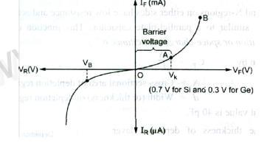

**21.Give the value of Charge, Mass of an electron.** Charge of an electron – 1.6 x 10 -19 coloumbs Mass of an electron - 9.11 x 10 -31 Kgs

**22.What are valence electrons?**

Electron in the outermost shell of an atom is called valence electron.

**23.What is forbidden energy gap?**

The space between the valence and conduction band is said to be forbidden energy gap.

**24.What are conductors? Give examples?**

`Conductors are materials in which the valence and conduction band overlap each other so there is a swift movement of electrons which leads to conduction. Ex: Copper, silver.

**25.What are insulators? Give examples?**

Insulators are materials in which the valence and conduction band are far away from each other. So no movement of free electrons and thus no conduction. Ex glass, plastic.

**26. Give the energy band structure of Insulator.**

In Insulators there is a wide forbidden energy gap. So movement of valence electron from valence to conduction band is not possible.

**27. Give the energy band structure of Semi conductor.**

In Semiconductors there is a small forbidden energy gap. So movement of valence electron from valence to conduction band is possible if the valence electrons are supplied with some energy.

**28. Give the energy band structure of conductor.**

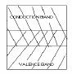

In conductors there is no forbidden energy gap, valence band and conduction and overlap each other. so there is a heavy movement of valence electrons.

**29.Define Mass – action law.**

Under thermal equilibrium the product of free electron concentration (n) and hole concentration (p) is constant regardless of the individual magnitude.

**n.p = ni2**

**30.Write the application of pn diode**

* Can be used as rectifier in DC Power Supplies.
* In Demodulation or Detector Circuits.
* In clamping networks used as DC Restorers
* In clipping circuits used for waveform generation.
* As switches in digital logic circuits.
* In demodulation circuit

**PART B**

1. Explain the drift and diffusion currents for PN diode. **(April/May 2015)**
2. Derive the quantitative theory of PN diode currents. (16)
3. Give diode current equation. **(May/june 2014)**
4. Explain the operation of PN junction under forward bias condition with its characteristics. **(May/june 2016)**
5. Explain the operation of PN junction under reverse bias condition with its characteristics. **(May/june 2016)**
6. Explain details about the switching characteristics on PN diode with neat Sketch. **(May/june 2014) (Nov/Dec 2014)**
7. Explain how the barrier potential is developed in the PN junction diode? **(Dec/Jan 2016)**
8. Calculate the built in potential barrier in a PN junction. Consider a silicon PN junction at 300K with doping densities Na=1*10^18cm-3 and Nd=1*10^15cm-3.Assume ni=1.5*10^10cm-3. **(Nov/Dec 2014)**
9. Explain the basic structure of PN junction diode. **(Nov/Dec 2014)**

**UNIT II BIPOLAR JUNCTION**

**PART A**

**1.Why an ordinary transistor is called bipolar?**

The operation of the transistor depends on both majority and minority carriers. So it is called bipolar device.

**2.Collector region of transistor is larger than emitter. Why?**

Collector is made physically larger than emitter and base because collector is to dissipate much power.

**3.Why is BJT is called current controlled device?**

The output voltage, current, or power is controlled by the input current in a transistor. So it is called the current controlled device.

**4.Define Early Effect**.

1. variation of the base-collector voltage results in a variation of the quasi-neutral width in the base. The gradient of the minority-carrier density in the base therefore changes, yielding an increased collector current as the collector-base current is increased. This effect is referred to as the Early effect.

**5.Draw the characteristics of CE configuration.**

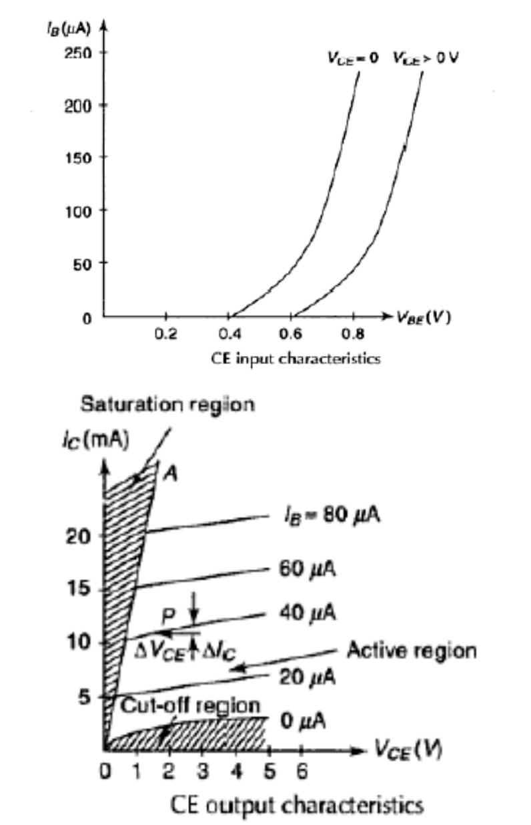

**6.Among CE, CB, CC which one is most popular. Why?**

CE is most popular among the three because it has high gain compared to base and collector configuration. It has the gain about to 500 that finds excellent usage in audio frequency applications.

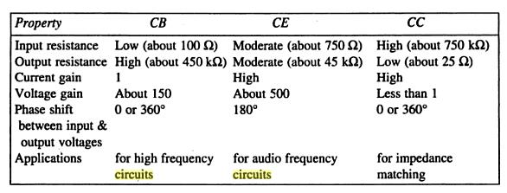**7.Compare CE, CB, CC.**

**8.Why h parameter model is important forBJT** It is important because:

* 1. its values are used on specification sheets
  2. it is one model that may be used to analyze circuit behavior
  3. it may be used to form the basis of a more accurate transistor model

1. **Define current amplification factor**

In a transistor amplifier with a.c. input signal, the ratio of change in output current to be the change in input current is known as the current amplification factor.

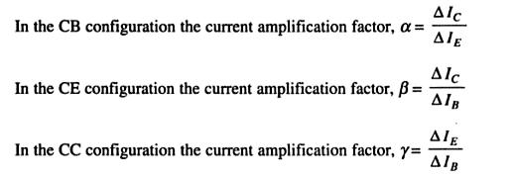

**10.Why h parameter model is important for BJT** It is important because:

* 1. its values are used on specification sheets
  2. it is one model that may be used to analyze circuit behavior
  3. it may be used to form the basis of a more accurate transistor model

**11.What do you meant by multi emitter transistor.**

**Transistor–transistor logic** (**TTL**) is a class of digital circuits built from bipolarjunction transistors (BJT) and resistors. It is called *transistor–transistor logic* because both the logic gating function (e.g., AND) and the amplifying function are performed by transistors.

TTL is notable for being a widespread integrated circuit (IC) family used in many applications such as computers, industrial controls, test equipment and instrumentation, consumer electronics, synthesizers, etc.

**12.In a CR connection, the value of IE is 6.28 mA and the collector current Ic is 6.20 mA.**

**Determine d.c. current gain.**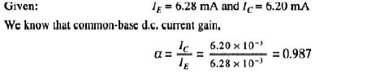

13.**The transistor has IE = 10 mA and α = 0.98. Find the value of base and collector currents.**

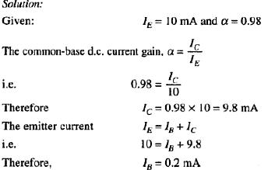

**14. If a transistor has a α of 0.97 find the value of β. If β=200, find the value of α.**

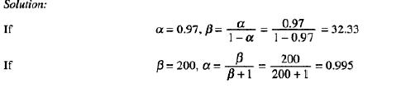

**15. Give some applications of BJT.**

The BJT remains a device that excels in some applications, such as discrete circuit design, due to the very wide selection of BJT types available, and because of its high transconductance and output resistance compared to MOSFETs.

The BJT is also the choice for demanding analog circuits, especially for very-high-frequency applications, such as radio-frequency circuits for wireless systems.

Bipolar transistors can be combined with MOSFETs in an integrated circuit by using a BiCMOS process of wafer fabrication to create circuits that take advantage of the application strengths of both types of transistor.

**PART B**

1. Explain the operation of NPN transistor. **(April/May 2015)**
2. Explain the operation of PNP transistor. **(April/May 2015)**
3. Explain the input and output characteristics of a transistor in CB configuration. (10)
4. Draw the circuit diagram of a NPN transistor CE configuration and the input and output characteristics. Also define its operating regions. **(Nov/Dec 2013) (April/May 2015)**
5. Explain the common base configuration with its neat sketch. **(Nov/Dec 2011) (May/june 2014)**
6. Explain the input and output characteristics of a transistor in CC configuration. (10)
7. Give the comparison of CE,CB,CC configuration. **(May/june 2014)**
8. Give the relationship between α, β and γ of a transistor (6)
9. Explain briefly about the Gummel Poon model (10)
10. How multi emitter transistor is working? Explain it with neat diagram. (12)
11. Explain details about the Ebers Moll model. **(Nov/Dec 2014)**
12. With relevant expressions and figures, describe early effect. **(Nov/Dec 2014)**
13. Draw and explain the hybrid model for CE configuration. **(Nov/Dec 2011,2013,2014) (May/june 2014)**
14. Draw a voltage divider bias circuit and derive an expression for its stability factor. **(May/june 2014)**

**UNIT III FIELD EFFECT TRANSISTORS**

**PART A**

**1.Why it is called field effect transistor?**

The drain current ID of the transistor is controlled by the electric field that extends into the channel due to reverse biased voltage applied to the gate, hence this device has been given the name Field Effect Transistor.

**2.Why FET is called voltage controlled device.**

*FET* the value of the current depends upon the value of the voltage applied at the gate anddrain. So it is *known as voltage controlled device*.

**3.Define the term threshold voltage.**

The **threshold voltage**, commonly abbreviated as **Vth**, of a field-effect transistor(FET) is the value of the gate–source voltage when the conducting channel just begins to connect the source and drain contacts of the transistor, allowing significant current.

The threshold voltage of a junction field-effect transistor is often called **pinch-off voltage** instead, which is somewhat confusing since "pinch off" for an insulated-gate field-effect transistor is used to refer to the channel pinching that leads to current saturation behaviour under high source–drain bias, even though the current is never off. The term "threshold voltage" is unambiguous and refers to the same concept in any field-effect transistor.

One of several short-channel effects in MOSFET scaling, **channel length modulation** (**CLM**) is a shortening of the length of the inverted channel region with increase in drain bias for large drain biases.

As the drain voltage increases, its control over the current extends further toward the source, so the uninverted region expands toward the source, shortening the length of the channel region, the effect called *channel-length modulation*.

**4.Compare JFET with BJT.**

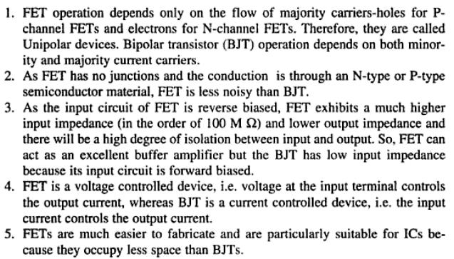

**5.Draw the transfer characteristics curve for JFET.**

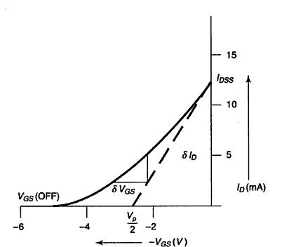

**6.Differentiate between N and P channel FETs**

1. in an N channel JFET the current carriers are electrons, whereas the current carriers are holes in a P channel JFET.
2. Mobility of electrons is large in N channel JFET; Mobility of holes is poor in P channel JFET.
3. The input noise is less in N channel JFET than that of P channel JFET.
4. The transconductance is larger in N channel JFET than that of P channel JFET.

**7.Write some applications for JFET.**

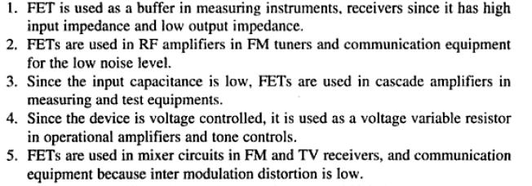

**8.Compare MOSFET with JFET.**

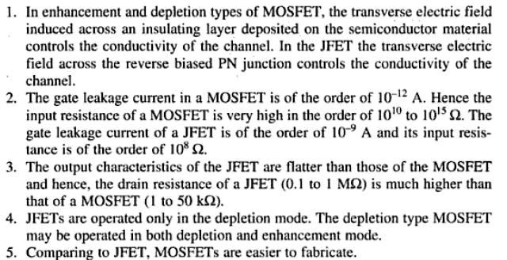

**9.Compare N channel MOSFET with P channel MOSFET.**

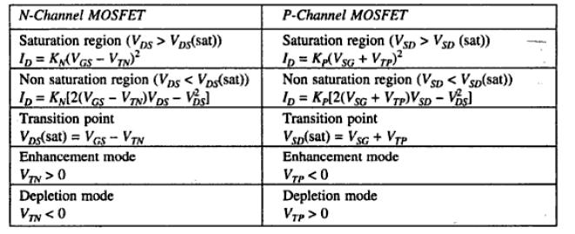

**10.Differentiate between current voltage relationships of the N channel and P channel MOSFET**

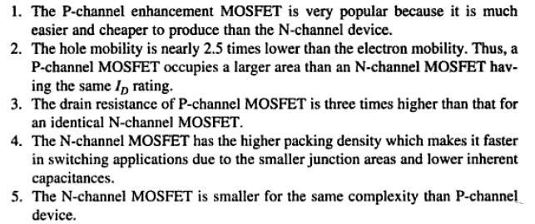

**11.Draw the V-I characteristics curve of MOSFET**.

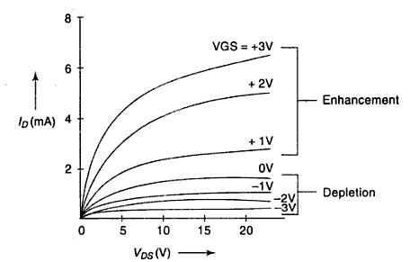

**PART B**

1. Explain the operation of JFET and derive the drain and transfer characteristics. **(Nov/Dec 2010)**
2. Draw the circuit diagram for obtaining the drain and transfer characteristics for an N channel JFET. **(May/june 2010)**
3. With neat diagram explain the operation of MOSFET in Depletion mode and derive its current equations. **(Nov/Dec 2010,2012,2013)**
4. With neat diagram explain the operation of MOSFET in Enhancement mode and derive its current equations. **(Nov/Dec 2010,2012,2013) (May/june 2014)**
5. Give some characteristics of MOSFET. (8)
6. Explain the operation of dual gate MOSFET. **(May/june 2014)**
7. How the JFET can be used as an amplifier and as a variable resistor with circuit diagram. **(Nov/Dec 2012) (April/May 2011)**
8. With the help of suitable diagrams explain the working of different types of MOSFET. **(May/june 2014)**

**UNIT IV SPECIAL SEMICONDUCTOR DEVICES**

**PART A**

**1.What is a metal semiconductor contact?**

A metal semiconductor contact is a contact between a metal and a semiconductor which according to the doping level and requirement may act as a rectifying diode or just a simple contact between a semiconductor device and the outside world.

**2.Define contact potential in metal semiconductor contact.**

The difference of potential between the work function of metal and the work function of semiconductor in a metal semiconductor contact is termed as contact potential.

**3.Give the symbol and structure of schottky diode.**

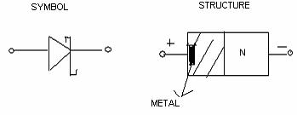

**4.Give the applications of schottky diode.**

1. It can switch off faster than bipolar diodes
2. It is used to rectify very high frequency signals (>10 MHZ)
3. as a switching device in digital computers.
4. It is used in clipping and clamping circuits.
5. It is used in communication systems such as frequency mixers, modulators and detectors.

**5.Why zener diode is often preferred than PN diode.**

When the reverse voltage reaches breakdown voltage in normal PN junction diode the current through the junction and the power dissipated at the junction will high. Such an operation is destructive and the diode gets damaged.

Whereas diode can be designed with adequate power dissipation capabilities to operate in breakdown region. That diode is known as zener diode. It is heavily doped than ordinary diode.

**6.Compare between schottky diode and conventional diode.**

|  |  |  |
| --- | --- | --- |
| **PN junction diode** |  | **Schottky diode** |
|  |  |  |
| 1. Here the contact is established between two | 1. | Here the contact is established between the |
| semiconductors | semiconductor and metal | |
|  |  | |
| 2. current conduction is due to both | 2. current conduction is only due to | |
| majority and minority carriers | majority carriers | |
|  |  |  |
| 3. large reverse recovery time | 3. | Small reverse recovery time |
|  |  |  |
| 4. barrier potential is high about 0.7 V | 4. | Barrier potential is low about 0.25 V |
|  |  | |
| 5. switching speed is less | 5. switching speed is high | |
|  |  | |
| 6. cannot operate at high frequency | 6. can operate at very high frequency (> | |
|  | 300MHz) | |
|  |  |  |

**7.Draw the V-I characteristics curve for zener diode.**

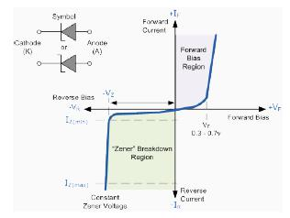

**8.What is zener breakdown?**

Zener break down takes place when both sides of the junction are very heavily doped and Consequently the depletion layer is thin and consequently the depletion layer is tin. When a small value of reverse bias voltage is applied , a very strong electric field is set up across the thin depletion layer. This electric field is enough to break the covalent bonds. Now extremely large number of free charge carriers are produced which constitute the zener current. This process is known as zener break down.

**9. What is avalanche break down?**

When bias is applied , thermally generated carriers which are already present in the diode acquire sufficient energy from the applied potential to produce new carriers by removing valence electron from their bonds. These newly generated additional carriers acquire more energy from the potential and they strike the lattice and create more number of free electrons and holes. This process goes on as long as bias is increased and the number of free carriers get multiplied. This process is termed as avalanche multiplication. Thus the break down which occur in the junction resulting in heavy flow of current is termed as avalanche break down.

**10.What is tunneling phenomenon?**

The phenomenon of penetration of the charge carriers directly though the potential barrier instead of climbing over it is called as tunneling.

**11.Give the application of tunnel diode.**

* As logic memory storage device
* As microwave oscillator
* In relaxation oscillator circuit
* As an amplifier
* As an ultra-high speed switch

**12.Give the advantages and disadvantages of tunnel diode.**

**Advantages**

* Low noise
* Ease of operation
* High speed
* Low power

**Disadvantages**

* Voltage range over which it can be operated is 1 V less.
* Being a two terminal device there is no isolation between the input and output circuit.

**13.Draw equivalent circuit of tunnel diode**

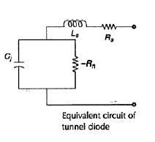

* This is the equivalent circuit of tunnel diode when biased in negative resistance region.
* At higher frequencies the series R and L can be ignored.
* Hence equivalent circuit can be reduced to parallel combination of junction capacitance and negative resistance.

**14.What is varactor diode?**

A varactor diode is best explained as a variable capacitor. Think of the depletion region as a variable dielectric. The diode is placed in reverse bias. The dielectric is “adjusted” by reverse bias voltage changes.

* Junction capacitance is present in all reverse biased diodes because of the depletion region.
* Junction capacitance is optimized in a varactor diode and is used for high frequencies and switching applications.
* Varactor diodes are often used for electronic tuning applications in FM radios and televisions.

**PART B**

1. Explain about the ohmic contact of metal semiconductor junction. **(April/May 2015)**
2. Explain the operation of zener diode and how it is used as a voltage regulator. **(May/june 2014) (Nov/Dec 2014)**
3. Explain the operation of tunnel diode and draw its equivalent circuit. (12)
4. With neat diagram give the working principle of LASER diode. **(May/june 2014,2016)**
5. Explain the operation of varactor diode . **(May/june 2014,2016) (Nov/Dec 2014) (April/May 2015)**
6. Explain the operation of schottky diode. **(May/june 2014)**
7. What is meant by tunneling? Explain the VI characteristics of a tunnel diode using energy band diagram. **(May/june 2016) (April/May 2015)**
8. Explain the operation of Gunn diode.

**UNIT V POWER DEVICES AND DISPLAY DEVICES**

**PART A**

**1.What is intrinsic stand- off ratio of an UJT?**

If a voltage VBB is applied between the bases with emitter open the circuit will behave as a potential divider. Thus the voltage VBB will be divided across RB1 and RB2

Voltage across resistance RB1,



The resistance ratio ƞ = RB1 / RBB is known as intrinsic stand -off ratio.

**2.Give the V-I characteristics of UJT.**

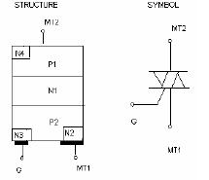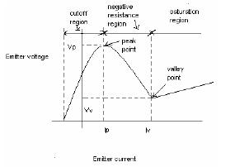

**3.Mention the applications of UJT.**

1. It is used in timing circuits
2. It is used in switching circuits
3. It is used in phase control circuits
4. It can be used as trigger device for SCR and triac.
5. It is used in saw tooth generator.
6. It is used for pulse generation

**4.What is a TRIAC? Give the symbol and structure of TRIAC.**

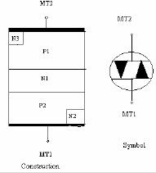TRIAC is a three terminal bidirectional semiconductor switching device. It can conduct in both the directions for any desired period. In operation it is equivalent to two SCR’s connected in antiparallel.

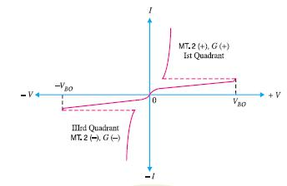**5.Draw the V-I characteristics for TRIAC.**

1. **Give the application of TRIAC.**
   1. Heater control
   2. Motor speed control
   3. Phase control
   4. Static switches

**7.What is a DIAC? Give the basic construction and symbol of DIAC.**

DIAC is a two terminal bidirectional semiconductor switching device. . It can conduct in either direction depending upon the polarity of the voltage applied across its main terminals. In operation DIAC is equivalent to two 4 layer diodes connected in antiparallel.

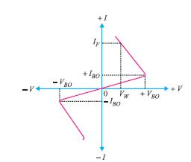**8.Draw the V-I curve for DIAC**

**9.Give some applications of DIAC.**

1. To trigger TRIAC
2. Motor speed control
3. Heat control
4. Light dimmer circuits

**10.Why SCR cannot be used as a bidirectional switch.**

SCR can do conduction only when anode is positive with respect to cathode with proper gate current. Therefore, SCR operates only in one direction and cannot be used as bidirectional switch.

**11.How turning on of SCR is done?**

1. By increasing the voltage across SCR above forward break over voltage.
2. By applying a small positive voltage at gate.
3. By rapidly increasing the anode to cathode voltage.
4. By irradiating SCR with light.

**12. How turning off of SCR is done?**

1. By reversing the polarity of anode to cathode voltage.
2. By reducing the current through the SCR below holding current.

3.By interrupting anode current by means of momentarily series or parallel switching

**13.Define holding current in a SCR.**

Holding current is defined as the minimum value of anode current to keep the SCR ON.

**14. List the advantages of SCR.**

1. SCR can handle and control large currents.
2. Its switching speed is very high
3. It has no moving parts, therefore it gives noiseless operation.
4. Its operating efficiency is high.

**15.List the application of SCR.**

1. It can be used as a speed controller in DC and AC motors.
2. It can be used as an inverter.
3. It can be used as a converter
4. It is used in battery chargers.
5. It is used for phase control and heater control.
6. It is used in light dimming control circuits

**16. Compare SCR with TRIAC**

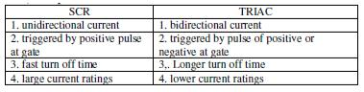

**17.Differentiate BJT and UJT.**

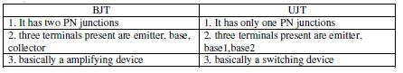

**18.State the principle of operation of an LED**

When a free electron from the higher energy level gets recombined with the hole, it gives the light output. Here in case of LEDs, the supply of higher level electrons is provided by the battery connection.

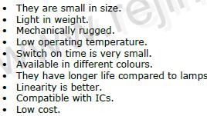**19.Give the advantages of LED**

**20.State some disadvantages of LED**



**21.List the applications of LED**

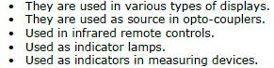

**22.Give some advantages and disadvantages for LCD Advantages of LCD**

* Low power is required
* Good contrast
* Low cost

**Disadvantages of LCD**

* Speed of operation is slow
* LCD occupy a large area
* LCD life span is quite small, when used on d.c. Therefore, they are used with a.c. suppliers.

**23.Give applications of LCD**

* Used as numerical counters for counting production items.
* Analog quantities can also be displayed as a number on a suitable device. (e.g.) Digital multimeter.
* Used for solid state video displays.
* Used for image sensing circuits.
* Used for numerical display in pocket calculators.

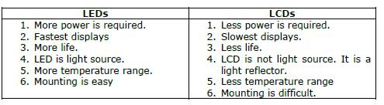**24.Compare LEDs and LCDs.**

**25.Give some notes on CCD.**

A **charge-coupled device** (**CCD**) is a device for the movement of electrical charge, usually from within the device to an area where the charge can be manipulated.

**For example** conversion into a digital value.

This is achieved by "shifting" the signals between stages within the device one at a time. CCDs move charge between capacitive *bins* in the device, with the shift allowing for the transfer of charge between bins.

The CCD is a major piece of technology in digital imaging. In a CCD image sensor, pixels are represented by p-doped MOS capacitors.

**PART B**

1. Explain the construction , operation, V-I characteristics and application of SCR and explain its two transistor model. **(Nov/Dec 2013) (May/june 2014)**
2. Explain the construction , operation, equivalent circuit V-I characteristics and application of UJT. **(Nov/Dec 2012,2013,2014)**
3. Explain the construction , operation, equivalent circuit V-I characteristics and application of TRIAC. **(Nov/Dec 2013)**
4. Explain the construction and principle of operation of LED. **(Nov/Dec 2012)**
5. Explain the construction and principle of operation of LCD. **(April/May 2015)**
6. Write short notes on CCD. **(May/june 2014) (Nov/Dec 2014) (April/May 2015)**
7. Explain the construction , operation, equivalent circuit V-I characteristics and application of TRIAC (16)
8. Write short notes on optocoupler. **(Nov/Dec 2014)**
9. Write short notes on Photo transistor. **(Nov/Dec 2014)**
10. With the neat diagram explain the operation of Solar cell. **(May/june 2014)**
11. Explain Power BJT and Power MOSFET. **(April/May 2015)**
12. Explain the construction , operation, equivalent circuit V-I characteristics and application of DIAC (16)
13. Explain:(a) DMOS (8) (b) VMOS (8)