**QUESTION BANK**

**CE 6306 - STRENGTH OF MATERIALS**

**UNIT I**

**STRESS STRAIN DEFORMATION OF SOLIDS**

**PART- A (2 Marks)**

1. **What is meant by factor of safety?**

It is the ratio between ultimate stress to the working stress.

Factor of safety = Ultimate stress

Permissible stress

* 1. **Define Resilience.**

The capability of a strained body to recover its size and shape after deformation caused especially by compressive stress

1. **Define Hooke**

It states that when a material is loaded, within its elastic limit, the stress is directly proportional to the strain. Stress α Strain

* + - α e
    - = Ee

E = σ /e N/mm2

where E is young’s modulus

σ is stres and

e is strain

**4. Define Poisson’s ratio.**

The ratio of lateral strain to the longitudinal strain is a constant for a given material, when the material is stressed within the elastic limit. This ratio is called Poisson’s ratio and it is generally denoted by 1/m (or) µ

* + =

1. **sWhat is meant by Poinsson’s ratio? Which material has the higher value of Poisson’s ratio?**

When a body is stressed, within its elastic limit, the ratio of lateral strain to the longitudinal strain is constant for a given material, which is known as Poisson’s ratio.

Poisson’ ratio (μ or 1/m) = Lateral strain / Longitudinal strain The shear stress is directly proportional to shear strain.

N= Shear stress / Shear strain

1. **Define – Strain Energy.**

Whenever a body is strained, some amount of energy is absorbed in the body. The energy which is absorbed in the body due to straining effect is known as strain energy.

1. **Define – Modulus of Elasticity.**

It is defined as the ratio between the stress to strain is a constant when a material is loaded within an elastic limit.

**8. Define – Modulus of rigidity.**

It is defined as the ratio between the shear stress to shear strain is a constant when a material is loaded within an elastic limit.

**9. Define – Bulk Modulus.**

It is defined as the ratio between the direct stress to volumetric strain is a constant when a material is loaded within an elastic limit.

**10. What are the three types of stresses?**

1. Tensile stress
2. Compressive stress
3. Shear stress

**11. Define – Lateral Strain and Longitudinal Strain**

When a body is subjected to axial load P, the length of the body is increased. The ratio of axial deformation to the original length of the body is known as longitudinal strain.

The strain, at right angle to the direction of the applied load, is called lateral strain.

|  |  |  |  |
| --- | --- | --- | --- |
| **12. State the relationship between Young’s Modulus and Modulus of Rigidity.** | | |  |
| E = 2G (1 + 1/m) | |  |  |
| where | E | is Young’s modulus |  |
|  | G | is modulus of rigidity |  |
| and | 1/m | is Poisson’s ratio |  |

**PART- B**

1. A Mild steel rod of 20 mm diameter and 300 mm long is enclosed centrally inside a hollow copper tube of external diameter 30 mm and internal diameter 25 mm. The ends of the rod and tube are brazed together, and the composite bar is subjected to an axial pull of 40 kN. If E for steel and copper is 200 GN/m2 and 100 GN/m2 respectively, find the stresses developed in the rod and the tube also find the extension of the rod.
2. A cast iron flat 300 mm long and 30 mm (thickness) × 60 mm (width) uniform cross section, is acted upon by the following forces : 30 kN tensile in the direction of the length 360 kN compression in the direction of the width 240 kN tensile in the direction of the thickness. Calculate the direct strain, net strain in each direction and change in volume of the flat. Assume the modulus of elasticity and Poisson’s ratio for cast iron as 140 kN/mm2 and 0.25 respectively.
3. A bar of 30 mm diameter is subjected to a pull of 60 kN. The measured extension on gauge length of 200 mm is 0.09 mm and the change in diameter is 0.0039 mm. calculate the Poisson’s ratio and the values of the three moduli.
4. The bar shown in fig. is subjected to a tensile load of 160 KN. If the stress in the middle portion is limited to 150 N/mm2, determine the diameter of the middle portion. Find also the length of the middle portion if the total elongation of the bar is to be 0.2mm. young’s modulus is given as equal to 2.1 x 105 N/mm2.

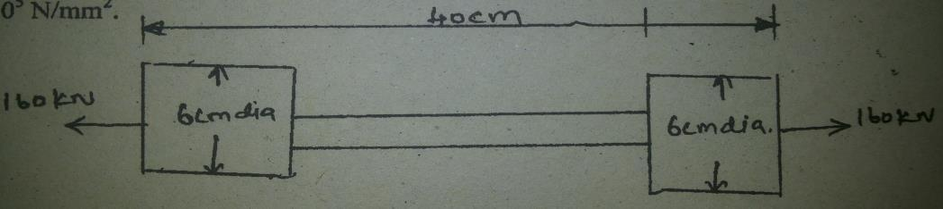

1. A member ABCD is subjected to point loads P1, P2, P3, P4 as shown in fig. calculate the force P2 necessary for equilibrium, if P1 = 45 KN, P3 = 450 KN and P4 = 139 KN.

Determine the total elongation of the member, assuming the modulus of elasticity to be 2.1 x 105 N/mm2.

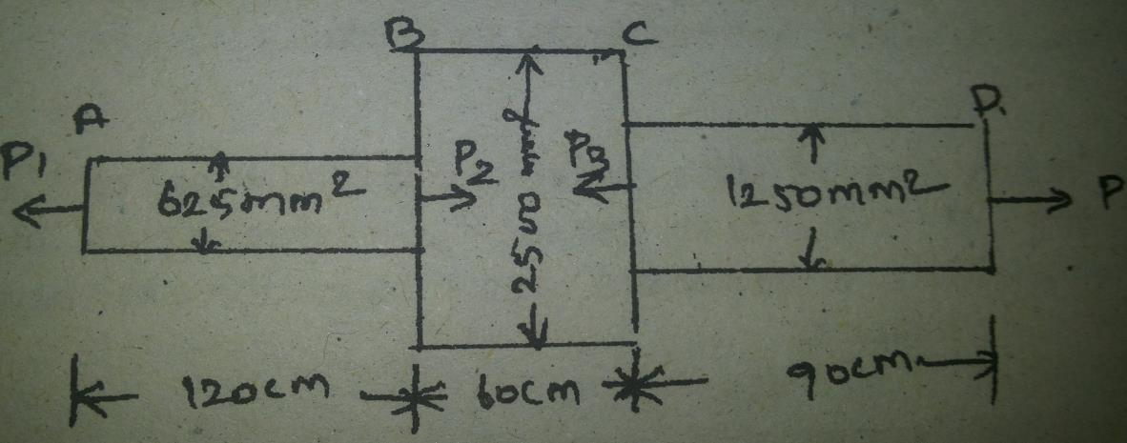

1. A steel rod of 20mm diameter passes centrally through a copper tube of 50mm external diameter and 40mm internal diameter. The tube is closed at each end by rigid plates of negligible thickness. The nuts are tightened lightly home on the projecting parts of the rod. If the temperature of the assembly is raised by 50˚C, calculate the stress developed in copper and steel. Take E for steel and copper as 200 GN/m2 and 100 GN/m2 and α for steel and copper as 12 x 10-6 per ˚C and 18 x 10-6 per ˚C.
2. Two vertical rods one of steel and the other of copper are each rigidly fixed at the top and 50cm apart. Diameters and lengths of each rod are 2cm and 4m respectively. A cross bar fixed to the rods at the lower ends carries a load of 5000 N such that the cross bar remains horizontal even after loading. Find the stress in each rod and the position of the load on the bar. Take E for steel = 2 x 105 N/mm2 and E for copper = 1x 105 N/mm2.
3. Drive the relationship between modulus of elasticity and modulus of rigidity. Calculate the modulus of rigidity and bulk modulus of a cylindrical bar of diameter 30 mm and of length 1.5 m if the longitudinal strain in a bar during a tensile stress is four times the lateral strain. Find the change in volume, when the bar is subjected to a hydrostatic pressure of 10 N/mm2. Take E = 1X 105 N/mm2.
4. (A). Find the young’s modulus of a rod of diameter 30mm and of length 300mm which is subjected to a tensile load of 60 KN and the extension of the rod is equal to 0.4 mm.

(B). The ultimate stress for a hollow steel column which carries an axial load of 2MN is 500

N/mm2 .If the external diameter of the column is 250mm, determine the internal diameter Take the factor of safety as 4.0

1. The extension in a rectangular steel bar of length 400mm and thickness 3mm is found be 0.21mm .The bar tapers uniformly in width from 20mm to 60mm E for the bar is 2x 105 N/mm2.Determine the axial load on the bar.

**UNIT II**

**BEAMS – LOADS AND STRESSES**

**PART- A**

1. **How do you relate shearing force and bending moment?**

Shear force at any cross section is defined as the algebraic sum of all the forces acting on any one side of the section. Bending moment at any cross section is defined as the algebraic sum of the moments of all the forces, which are placed on any one side of that section.

1. **Write a short note on location of point of maximum bending moment in a simply supported beam.**

The bending moment is maximum, when shear force is zero. Equating the shear force at that point to zero, one can find out the distance x from one end. Then find the maximum bending moment at that point by taking moments of all the forces on right or left hand side.

1. **List out any two assumptions in simple bending**
   1. The material of the beam is homogeneous and isotropic.
   2. The beam material is stressed within the elastic limit and thus obey hooke ‟s law.
   3. The transverse section which was plane before bending remains plains after bending also.
   4. Each layer of the beam is free to expand or contract independently about the layer, above or below.
   5. The value of E is the same in both compression and tension.
2. **Define the term’ moment of resistance’.**

Due to pure bending, the layers above the N.A are subjected to compressive stresses, whereas the layers below the N.A are subjected to tensile stresses. Due to these stresses, the forces will be acting on the layers. These forces will have moment about the N.A. The total moment of these forces about the N.A for a section is known as moment of resistance of the section.

1. **Define point of contra flexure? In which beam it occurs?**

It is the point where the B.M is zero after changing its sign from positive to negative or vice versa. It occurs in overhanging beam.

1. **Define shear force and bending moment?**

SF at any cross section is defined as algebraic sum of the vertical forces acting either side of beam. BM at any cross section is defined as algebraic sum of the moments of all the forces which are placed either side from that point.

**7. Define – Cantilever Beam and Simply Supported Beam**

A beam with one end free and the other end fixed is called cantilever beam.

A beam which is simply supported at its both ends is termed as simply supported beam.

**8. Define – Uniformly Distributed Load.**

If a load, which is spread over a beam in such a manner that the rate of loading w is uniform throughout the length then it is called uniformly distributed load.

**9.** **What are the types of beams?**

The types of beams are:

a) Cantilever beam

b) Simply supported beam

c) Fixed beam

d) Continuous beam

e) Over hanging beam

**10.** **What are the types of loads?**

Types of loads are:

a) Concentrated load or point load

b) Uniformly distributed load

c) Uniformly varying load

**PART- B**

1. Three blanks of each 50 x200 mm timber are built up to a symmetrical I section for a beam. The maximum shear force over the beam is 4KN. Propose an alternate rectangular section of the same material so that the maximum shear stress developed is same in both sections. Assume then width of the section to be 2/3 of the depth.
2. A beam of uniform section 10 m long carries a udl of 2KN/m for the entire length and a concentrated load of 10 KN at right end. The beam is freely supported at the left end. Find the position of the second support so that the maximum bending moment in the beam is as minimum as possible. Also compute the maximum bending moment.
3. A beam of size 150 mm wide, 250 mm deep carries a uniformly distributed load of w kN/m over entire span of 4 m. A concentrated load 1 kN is acting at a distance of 1.2 m from the left support. If the bending stress at a section 1.8 m from the left support is not to exceed 3.25

N/mm2 find the load w.

1. A cantilever of 2m length carries a point load of 20 KN at 0.8 m from the fixed end and another point of 5 KN at the free end. In addition, a u.d.l. of 15 KN/m is spread over the entire length of the cantilever. Draw the S.F.D, and B.M.D.
2. A Simply supported beam of effective span 6 m carries three point loads of 30 KN, 25 KN and 40 KN at 1m, 3m and 4.5m respectively from the left support. Draw the SFD and BMD. Indicating values at salient points.
3. A Simply supported beam of length 6 metres carries a udl of 20KN/m throughout its length and a point of 30 KN at 2 metres from the right support. Draw the shear force and bending moment diagram. Also find the position and magnitude of maximum Bending moment.
4. A Simply supported beam 6 metre span carries udl of 20 KN/m for left half of span and two point loads of 25 KN end 35 KN at 4 m and 5 m from left support. Find maximum SF and BM and their location drawing SF and BM diagrams.
5. A cantilever 1.5m long is loaded with a uniformly distribution load of 2 kN/m run over a length of 1.25m from the free end it also carries a point load of 3kn at a distance of 0.25m from the free end. Draw the shear force and bending moment diagram of the cantilever.
6. 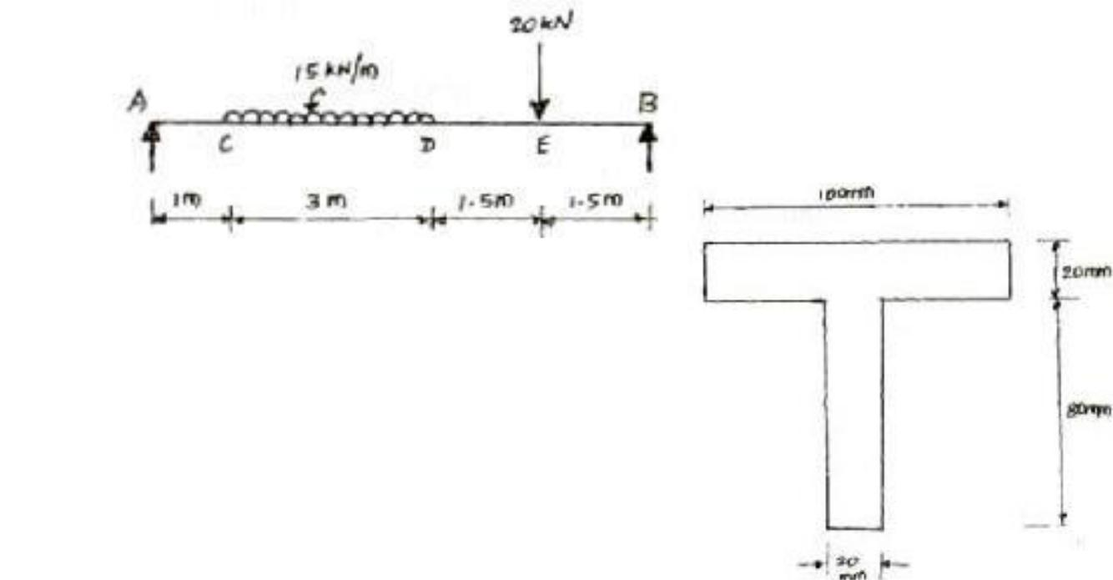For the simply supported beam loaded as shown in Fig. , draw the shear force diagram and bending moment diagram. Also, obtain the maximum bending moment.
7. A cast iron beam is of T-section as shown in Fig. The beam is simply supported on a span of 6 m. The beam carries a uniformly distributed load of 2kN/m on the entire length (span). Determine the maximum tensile and maximum compressive stress.

**UNIT III**

**TORSION**

**PART-A (2 Marks)**

1. **Define method of singularity functions?**

In Macaulay’s method a single equation is formed for all loading on a beam, the equation is constructed in such a way that the constant of Integration apply to all portions of the beam. This method is also called method of singularity functions.

1. **Define: conjugate beam.**

Conjugate beam is an imaginary beam of length equal to that of original beam but for which load diagram is M/EI diagram.

1. **What are the advantages of Macaulay’s method over double integration method for beam deflection analysis?**

Macaulay’s method is used in finding slope and deflection at any point of a beam. The points used in this method are:

Brackets are to be integrated as a whole

Constants are written after the first term

The section, for which BM is to be found, should be taken in the last part

1. **What are the methods for finding out the slope and deflection at a section?**

The important methods used for finding out the slope and deflection at a section in a loaded beam are:

Double integration method

Moment area method

Macaulay’s method

The first two methods are suitable for a single load, whereas the last one is suitable for several loads.

1. **What is meant by propped cantilever?**

A cantilever which has an additional support at the free end is termed as propped cantilever.

1. **How do you determine the maximum deflection in a simply supported beam?**

The maximum deflection occurs where slope is zero. The position of the maximum deflection is found out by equating the slope equation zero. Then the value of x is substituted in the deflection equation to calculate the maximum deflection.

1. **What is moment area method? Where is it conveniently used?**

The moment area method is a semigraphical procedure that utilizes the properties of the area under the bending moment diagram. It is the quickest way to compute the deflection at a specific location if the bending moment diagram has a simple shape.

1. **Write an expression for deflection by moment area method.**

The shear stress at a fiber in a section of a beam is given by:

y = Ax / EI

where A is area of BM diagram between A and B

and x is distance of CG of area from B

1. **Write the maximum value of deflection for a simply supported beam of constant EI, span L carrying central concentration load W.**

The deflection at the centre of a simply supported beam carrying a point load at the centre is given by: yc = – (WL3/ 48EI)

1. **Where the maximum deflection will occur in a simply supported beam loaded with UDL of w kN/m run?**

The deflection at the centre of a simply supported beam carrying a point load at the centre is given by: yc = – (WL3/ 48EI)

**PART- B**

1. Determine the diameter of a solid shaft which will transmit 300 KN at 250 rpm. The maximum shear stress should not exceed 30 N/mm2 and twist should not be more than 10 in a shaft length 2m. Take modulus of rigidity = 1 x 105 N/mm2.

2. The stiffness of the closed coil helical spring at mean diameter 20 cm is made of 3 cm diameter rod and has 16 turns. A weight of 3 KN is dropped on this spring. Find the height by

which the weight should be dropped before striking the spring so that the spring may be compressed by 18 cm. Take C= 8x104 N/mm2.

3. It is required to design a closed coiled helical spring which shall deflect 1mm under an axial load of 100 N at a shear stress of 90 Mpa. The spring is to be made of round wire having shear

modulus of 0.8 x 105 Mpa. The mean diameter of the coil is 10 times that of the coil wire. Find the diameter and length of the wire.

1. A steel shaft ABCD having a total length of 2400 mm is contributed by three different sections as follows. The portion AB is hollow having outside and inside diameters 80 mm and 50 mm respectively, BC is solid and 80 mm diameter. CD is also solid and 70 mm diameter. If the angle

of twist is same for each section, determine the length of each portion and the total angle of twist. Maximum permissible shear stress is 50 Mpa and shear modulus 0.82 x 105 MPa

1. The stiffness of close coiled helical spring is 1.5 N/mm of compression under a maximum load

of 60 N. The maximum shear stress in the wire of the spring is 125 N/mm2. The solid length of the spring (when the coils are touching) is 50 mm. Find the diameter of coil, diameter of wire and number of coils. C = 4.5.

1. Calculate the power that can be transmitted at a 300 r.p.m. by a hollow steel shaft of 75 mm external diameter and 50 mm internal diameter when the permissible shear stress for the steel is

70 N/mm2 and the maximum torque is 1.3 times the mean. Compare the strength of this hollow shaft with that of an solid shaft. The same material, weight and length of both the shafts are the same.

7. A solid cylindrical shaft is to transmit 300 kN power at 100 rpm. If the shear stress is not to

exceed 60 N/mm2, find its diameter. What percent saving in weight would be obtained if this shaft is replaced by a hollow one whose internal diameter equals to 0.6 of the external diameter, the length, the material and maximum shear stress being the same.

1. A helical spring of circular cross-section wire 18 mm in diameter is loaded by a force of 500 N. The mean coil diameter of the spring is 125mm. The modulus of rigidity is 80 kN/mm2. Determine the maximum shear stress in the material of the spring. What number of coils must the spring have for its deflection to be 6 mm?
2. A close coiled helical spring is to have a stiffness of 1.5 N/mm of compression under a maximum load of 60 N. the maximum shearing stress produced in the wire of the spring is 125N/mm2 .The solid length of the spring is 50mm. Find the diameter of coil, diameter of wire and number of coils .C = 4.5 xl04N/mm2.
3. A closely coiled helical spring of round steel wire 10 mm in diameter having 10 complete turns with a mean diameter of 12 cm is subjected to an axial load of 250 N. Determine
4. the deflection of the spring
5. maximum shear stress in the wire and
6. stiffness of the spring and
7. frequency of vibration. Take C = 0.8 x 105 N/mm2 .

**UNIT IV**

**DEFLECTION OF BEAMS**

**PART-A (2 Marks)**

1. **Define – Polar Modulus**

Polar modulus is the ratio between polar moment of inertia and radius of the shaft.

Polar Modulus = Polar moment of inertia (J) / Radius (R)

|  |  |  |
| --- | --- | --- |
| **2.** | **What is a composite shaft?** |  |
|  | Sometimes a shaft is made up of composite section i.e. one type of shaft is sleeved over other types of shaft. At the time of sleeving, the two shafts are joined together in a way that the composite shaft behaves like a single shaft. | |
|  |  | |
|  |  |  |
| **3.** | **Why hollow circular shafts are preferred over solid circular shafts.** |  |
|  | The torque transmitted by the hollow shaft is greater than the solid shaft. For the same material, length and given torque, the weight of the hollow shaft will be less compared to that of solid shaft. | |
|  |  | |
| **4.** | **Define Torsional rigidity.** |  |

When a pair of forces of equal magnitude but opposite directions act on a body, it tends to twist the body. The resistant to that magnitude is called torsional rigidity.

**5.Write the expression for strain energy stores in a shaft of uniform section subjected to torsion.**

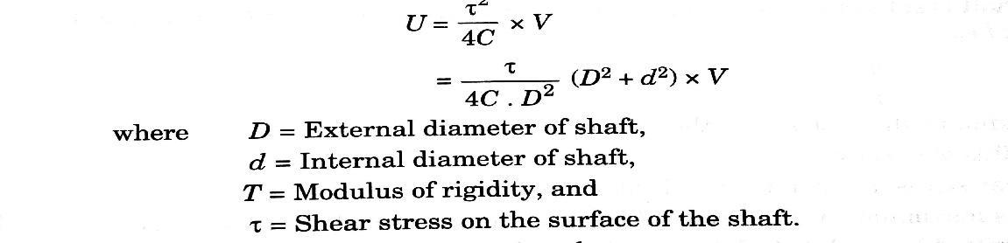

**6. Mention the various types of springs.**

Various types of springs are:

* Helical springs
* Spiral springs
* Leaf springs
* Disc spring or Belleville springs

**7.Write the expression for power transmitted by a shaft.**

The expression for power transmitted by a shaft is:

P = 2πNT/60

where N is speed in rpm

and T is torque

**8.Define leaf spring.**

A laminated spring which consist of a number of parallel strips of metal having different lengths and same width place one over the other all bent to the same curvature .these are widely used in railway carriages, motor vehicles , trolleys

**9.what is meant by resilience of a helical spring and stiffness of spring.**

Resilience is the strain energy stored in the spring when loaded within the elastic limit. Once the load is removed, the energy is realeased.

The stiffness of a body is a measure of the resistance offered by an elastic body to deformation. Every object in this universe has some stiffness. Spring stiffness is the force required to cause unit deflection.

**10. Classify the helical springs.**

The helical springs are classified as:

Close – coiled or tension helical spring

Open – coiled or compression helical spring

**PART-B**

1. A beam AB of length 8 m is simply supported at its ends and carries two point loads of 50 kN and 40 kN at a distance of 2 m and 5 m respectively from left support A. Determine, deflection under each load, maximum deflection and the position at which maximum deflection occurs.

Take E = 2 x 105 N/mm2 and I = 8.5 *X*106 mm4 .

1. For the cantilever beam shown in Fig.3. Find the deflection and slope at the free end. EI = 10000 kN/m2.

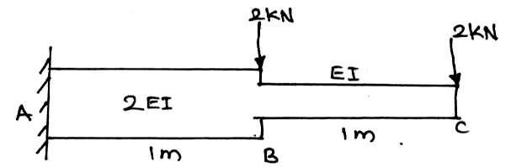

Fig.3

1. A beam is simply supported at its ends over a span of 10 m and carries two concentrated loads of 100 kN and 60 kN at a distance of 2 m and 5 m respectively from the left support. Calculate
2. slope at the left support (ii)slope and deflection under the 100 kN load. Assume EI = 36 x 104 kN-m2.
3. A 3 m long cantilever of uniform rectangular cross–section 150 mm wide and 300 mm deep is loaded with a point load of 3 kN at the free end and a udl of 2 kN/m over the entire length. Find the maximum deflection. E = 210 kN/mm2. Use Macaulay’s method.
4. A simply supported beam of span 6 m is subjected to a udl of 2 kN/m over the entire span and a point load of 3 kN at 4 m from the left support. Find the deflection under the point load in terms of EI. Use strain energy method.
5. A simply supported beam of uniform flexural rigidity EI and span *l*, carries two symmetrically placed loads *P* at one–third of the span from each end. Find the slope at the supports and the deflection at mid–span. Use moment area theorems.
6. Derive double integration method for cantilever
7. beam concentrated load at free end.

**UNIT V**

**PART-A (2 Marks)**

|  |  |  |  |  |
| --- | --- | --- | --- | --- |
| **1.** | **What is tension coefficient?** | | |  |
|  | The force per unit length of a member is known as tension coefficient. | | |  |
|  | T = F/ L |  |  |  |
|  | where | T | is tension coefficient |  |
|  |  | F | is force |  |
|  | and | L | is length of the member |  |

1. **What are the assumptions made in analysis of a pin-joined plane truss?**

The assumptions are

* + The frame is a perfect frame.
  + The frame carries a load at the joints.
  + All the members are pin-jointed.

**3. What is the use of Mohr’s circle?**

Mohr’s circle is used to find normal, tangential and resultant stresses on an oblique plane

**4. What are Deficient and Redundant frames?**

If the number of members are more than (2j – 3), then the frame is known as redundant frame.

**5. What are principal planes?**

The planes, which have no shear stress, are known as principal planes. These planes carry only normal stresses.

**6. What are the assumptions made in finding out the forces in a frame?**

The assumptions made in finding out the forces in a frame are:

a) The frame is perfect

b) The frame carries load at the joints

c) All the members are pin-jointed

**7.What are the methods available for the analysis of a frame?**

The following are the methods available for the analysis of a frame:

a) Methods of joints

b) Methods of sections

c) Graphical method

**8.Define Tie and Strut.**

Tension members in trusses are called ties and these are members which being stretched.

Compression members in trusses are called struts and these are members which are being shortened.

**9.what are the advantages of trusses of trusses over beams?**

Trusses are designed only for axial loads

* Beam and truss elements are separated in the way they take up loads. Beams take up lateral loads and moments in contrast to trusses take axial loads.

**10.Define tension co-effieient**

The tension co efficient for a member of a frame is defined as the pull or tension in that member divided by its length. Thus, t=T/l where,

t- is the tension co efficient for the members. This is +ve if the forces in the member in tensile.

T- is the pull in the member, l- is its length.

Tension co efficient are initially assumed to be positive.

**PART –B ( 16 MARKS)**

1. A thin cylinder 1.5 m internal diameter and 5 m long is subjected to an internal pressure of 2 N/mm2. If the maximum stress is limited to 160 N/mm2, find the thickness of the cylinder. *E* =

200 kN/mm2 and Poisson’s ratio = 0.3. Also find the changes in diameter, length and volume of the cylinder.

2. At a point in a strained material the horizontal tensile stress is 80 N/mm2 and the vertical

compressive stress is 140 N/mm2. The shear stress is 40N/mm 2. Find the principal stresses and the principal planes. Find also the maximum shear stress and its planes.

1. A thin cylindrical shell 3 m long has 1m internal diameter and 15 mm metal thickness.

Calculate the circumferential and longitudinal stresses induced and also the change in the dimensions of the shell, if it is subjected to an internal pressure of1.5 N/mm2 Take E = 2x105 N/mm2 and poison’s ratio =0.3. Also calculate change in volume.

1. A closed cylindrical vessel made of steel plates 4 mm thick with plane ends, carries fluid under pressure of 3 N/mm2. The diameter of the cylinder is 25cm and length is75 cm. Calculate the longitudinal and hoop stresses in the cylinder wall and determine the change in diameter,

length and Volume of the cylinder. Take E=2.1x105 N/mm2 and 1/m = 0.286.

1. A cylindrical shell 3 m long, 1 m internal diameter and 10 mm thick is subjected to an internal

pressure of 1.5 N/mm2. Calculate the changes in length, diameter and volume of the cylinder. E = 200 kN/mm2, Poisson’s ratio = 0.3.

1. A steel cylindrical shell 3 m long which is closed at its ends, had an internal diameter of 1.5 m

and a wall thickness of 20 mm. Calculate the circumferential and longitudinal stress induced and also the change in dimensions of the shell if it is subjected to an internal pressure of 1.0N/mm2.

Assume the modulus of elasticity and Poisson's ratio for steel as 200kN/mm2 and 0.3 respectively.

1. A cylindrical shell 3 m long which is closed at the ends has an internal diameter 1m and wall

thickness of 15 mm. Calculate the change in dimensions and change in volume if the internal pressure is 1.5 N/mm2,E = 2 x 105 N/min2, μ= 0.3.

8.A cylindrical shell 3 m long which is closed at the ends, has an internal diameter of 1m and a wall thickness of 20 mm. Calculate the circumferential and longitudinal stresses induced and also changes in the dimensions of the shell, if it is subjected to an

internal pressure of 2.0 N/mm2 . Take E = 2 X 105 N/mm2 and — 1= 0.3.m

9. A closed cylindrical vessel made of steel plates 5 mm thick with plane ends, carries fluid

under pressure of 6 N/mm2 The diameter of the cylinder is 35cm and length is 85 cm. Calculate the longitudinal and hoop stresses in the cylinder wall and determine the change in diameter, length and Volume of the cylinder. Take E=2.1x105 N/mm2 and 1/m = 0.286

1. Determine the maximum hoop stress across the section of a pipe of external diameter 600mm

and internal diameter 440mm. when the pipe is subjected to an internal fluid pressure of 50N/mm2.

* Beam and truss elements are separated in the way they take up loads. Beams take up lateral loads and moments in contrast to trusses take axial loads.

**10.Define tension co-effieient**

The tension co efficient for a member of a frame is defined as the pull or tension in that member divided by its length. Thus, t=T/l where,

t- is the tension co efficient for the members. This is +ve if the forces in the member in tensile.

T- is the pull in the member, l- is its length.

Tension co efficient are initially assumed to be positive.