**CE6502 - FOUNDATION ENGINEERING**

**UNIT I**

**SITE INVESTIGATION AND SELECTION OF FOUNDATION**

**Scope And Objectives –Methods Of Exploration- Auguring And Boring-Wash Boring And Rotary Drilling- Depth Of Boring-Spacing Of Bore Hole-Sampling Techniques-Representative And Undisturbed Sampling-Methods-Split Spoon Sampler, Thin Wall Sampler, Stationery Piston Sampler-Penetration Tests (Spt And Scpt) -Bore Log Report -Data Interpretation - Strength Parameters And Liquefaction Potential-Selection Of Foundation Based On Soil Condition.**

**TWO MARKS**

**1. What is soil exploration?(APR/MAY-2004)**

The field and laboratory studies carried out for obtaining the necessary information about

the subsoil characteristics including the position of ground water table are known as soil exploration.

**2. What is the scope or objective of soil exploration? (APR/MAY 2013)**

To obtain the information about the stratigraphy (study of arrangement of strata) and physical properties of the soil at site including the ground water table and its positions.

**3. What are the methods of soil exploration? (NOV/DEC 2010)**

It is carried out in two phases: 1) preliminary exploration 2) detailed investigation

**4. What is preliminary investigation?**

It consists of the geological study of the site and site reconnaissance. During the visit the

study of local topography, excavations, cuttings, drainage patterns, and other natural factors like

streams, flood marks , etc. are made.

**5. What is detailed investigation? (NOV/DEC 2009)**

It is to determine the nature, sequence and thickness of various subsoil layers. Lateral variations of soil layers, physical properties and ground water table positions are also determined.

**6. What is boring? On what factors does it depend?**

Making and advancing of bore holes by the process of drilling is known as boring. It

depends on the following factors:

a) Nature of soil.

b) Position of water table

c) The ease and accuracy with which the changes in the soil and ground water conditions can be determined.

d) Disturbances of soil samples that are to be taken.

**7. What are the methods of boring?**

a) Auger boring

b) Wash boring

c) Percussion boring

d) Rotary boring

**8. Name the types of soil samples.**

a) Disturbed samples.

* Representative samples
* Non – representative samples

b) Undisturbed samples.

**9. What are representative samples? (MAY/JUNE 2009)**

The natural soil structure gets modified or destroyed during the sample operation. With suitable precautions natural, moisture content and the proportion of mineral constituents can be preserved. Representative samples are useful for identifications.

**10. What are non- representative samples? (MAY/JUNE 2009)**

In addition to the alteration in the original soil structure, soils from the other layers get mixed up and the mineral constituents get altered. Non-representative samples are of no use.

**11. What are undisturbed samples?**

Undisturbed soil samples are the one in which the original soil structure and the material properties are preserved.

**12. What are the different types of samplers?**

a) Open drive samplers

b) Piston samples

c) Rotary samplers

**13. What are the different types of field tests used in soil exploration?**

**List the methods of soil sampling techniques? (APR/MAY 2009)**

a)Penetrometer test, b) pressure meter test, c) vane shear test, d) plate load test and e) geophysical methods.

**14. Name the types of penetrometer tests followed for investigation.**

Standard penetration test, dynamic cone penetration test and static cone penetration test

(or Dutch cone test)

**15. What is a site investigation report?**

A site investigation report is the collection of the investigated data, exploration and testing programme reports which may be required for long term or ongoing observations. If required recommendations related to design and construction may also be suggested.

**16. List the contents of soil investigation report.**

1) Investigation, 2) borehole logs 3) final and laboratory results, 4) analysis of the data,

5) Recommendations and 6) preferences.

**17**. **What are the corrections to be applied for the N-Value obtained from the SPT?**

(1) Over burden correction

(2) Dilatancy correction

**18. What is inside clearance, outside clearance, area ratio and recovery ratio? What is its**

**use ?( MAY 2009/MAY 2012)(NOV/DEC 2013) Explain the terms inside clearance, outside**

**clearance for a sampler (NOV/DEC 2014)**



**Area ratio = {(D2 2 – D12)/ D12}*100 percent**

**Inside clearance = {(D3-D1)/D1}*100 percent**

**Outside clearance = {(D2 – D4)/ D4}*100 percent**

**19. What is significant depth of exploration? (APR/MAY 2004)**

Depth of exploration is done till a suitable foundation material is found which can withstand the load transferred to the soil from the structure within the permissible limit of settlement. This depth is known as “Significant Depth of Exploration”.

**20. List the important parameter to fix the significant depth of exploration. (APR/MAY 2008)**

Significant Depth of exploration should be carried to a depth such that the net increase in soil stress due to load of the structure is less than 10 % of the average contact pressure. In the case of square loaded areas, the isobar of 10% intensity of loading at foundation level extents to a depth of about twice the depth of the foundation below the base of the foundation.

**21. What are the factors affecting the sample disturbances? (NOV/DEC 2008)**

Dimensions of the cutting edge and the sampling tube, the characteristics of non-return

valve and the wall friction are the major factors affecting the sample disturbances.

**22. Write the function of bentonite slurry in rotary drilling method of boring (APR/MAY 2012)**

Bentonite slurry or drilling mud is forced under pressure through the drill rod and it comes up bringing the cuttings to the surface. Bentonite slurry is also used for eliminating the friction on the driving rods.

**23. What is meant by RQD? (APR/MAY 2012)**

Rock Quality Designation (RQD). It is the ratio of the total length of the core recovered to the length of the sampler used.

**24. Define Bore log and what are the uses of bore log report (NOV/DEC 2012)**

Information on subsurface conditions obtained from the boring operation is typically presented in the form of a boring record, commonly known as Bore Log.

Bore Log is useful in describing or classifying the various soil and rock types encountered, data regarding the ground water table and the list of methods used in sampling, site location, soil sampler used. Depth of exploration and diameter of bore hole.

**25. What is meant by site reconnaissance? (APR/MAY 2013)**

Site reconnaissance may be in the form of a field trip to the site which can reveal information on the type and behavior of adjacent sites and structures such as cracks ,noticeable sags, and possibly sticking doors and windows. The type of local existing structure may influence, to a considerable extent, the exploration program and the best foundation type for the proposed adjacent structure.

**26. List out the method of sampling techniques (MAY/JUNE 2009)**

• Simple Random Sampling

• Systematic Sampling

• Stratified Sampling

• Cluster or Multi-stage Sampling

**27. The internal diameter of a sampler is 40 mm and the external diameter is 42 mm, will**

**you consider the sample obtained from the sampler as disturbed or undisturbed?**

**(APR/MAY 2011)**

**GIVEN**

Di=40mm

D0=42mm

Ar = {(D02-Di2)/Di2}*100

= {(422 -402)/402}*100

= 10.25%

Thus, the sample obtained from the sample is considered as a disturbed sample

**28. What is the objective of site exploration? (MAY/JUNE 2013)**

Following are some of the primary objectives of the site investigation:

 • To determine the thickness of the strata, and to assess sequentially.

 • To determine the quality of the bedrock and to verify the depth of the over burdening

soil.

• To determine the position limit and the fluctuations of the ground water table during

dry or wet seasons.

• To search the anomalies within the depth of exploration

**29**. **List the field tests commonly used in subsurface investigation. (NOV/DEC 2013)**

Grain size; Moisture content; Specific gravity; Liquid limit; Plastic limit; Shrinkage limit Compaction; Direct Shear; Permeability

**30. What are the two common test used for determining the bearing capacity of the soil?**

(i) CBR-California bearing capacity test

(ii) Plate load test

**31. What is meant by significant depth of investigation? (NOV/DEC 2014)**

The depth at which suitable foundation material is found which can withstand the load transferred to the soil from the structure within the permissible limit of settlement. This depth is known as **“Significant Depth of Exploration”.**

**32. What is the function of drilling mud? (NOV/DEC 2014)**

• Control formation pressures

• Seal permeable formations

• Transmit hydraulic energy to tools and bit

• Cool, lubricate and support the bit and drilling assembly

• Maintain wellbore stability

**33. Differentiate: Non representative and undisturbed samples. (APR/MAY 2015)**

|  |  |  |
| --- | --- | --- |
| **Sl**  **No** | **Non representative**  **(Disturbed soil)** | **Undisturbed samples.** |
| 1. | In addition to the alteration in the original soil structure, soils from the other layers get mixed up and the mineral constituents get altered. | Undisturbed soil samples are the one in which the original soil structure and the material properties are preserved. |
| 2. | The properties of the soil get disturbed | The properties of the soil remains same as nature |

**16 marks(PART-B)**

1. **EXPLAIN WHY SITE INVESTIGATION AND SOIL EXPLORATION IS ESSENTIAL?**
2. **WRITE SHORT NOTES ON SITE RECONNAISSANCE AND COMMON PROBLEMS IN FOUNDATION.**

1. **WHAT ARE THE SCOPE AND OBJECTIVES OF SITE INVESTIGATION?**

**OBJECTIVES OF SITE INVESTIGATION**

**4.EXPLAIN THE NECESSARY STEPS TAKEN BEFORE THE SOIL EXPLORATION.**

**5.DESCRIBE THE PRELIMINARY DESIGN DETAILS OF BUILDINGS AND BRIDGES.**

**6.WRITE SHORT NOTES ON PRELIMINARY INVESTIGATION AND DETAILED INVESTIGATION OF SOIL.**

**7.EXPLAIN THE VARIOUS METHODS OF EXPLORATION IN DETAI. (NOV/DEC 2016).**

**8.WRITE SHORT NOTES ON BORING METHODS. (NOV/DEC-2010)**

**9.EXPLAIN ANY TWO METHODS OF EXPLORATION IN DETAIL.(NOV/DEC 201**

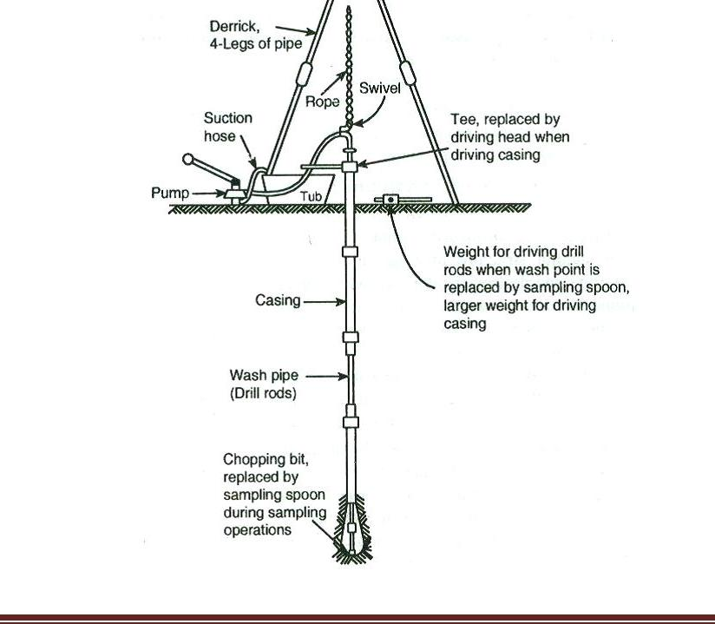

**10.EXPLAIN WASH BORING METHOD OF ADVANCING BORE HOLE(NOV/DEC 2014)**

**11.EXPLAIN BRIEFLY ABOUT DEPTH OF BORING AND SPACING OF BORE HOLE.**

**13.WHAT ARE THE TYPES OF SAMPLER USED IN THE SOIL EXPLORATION? (MAY 2009/MAY 2013)**

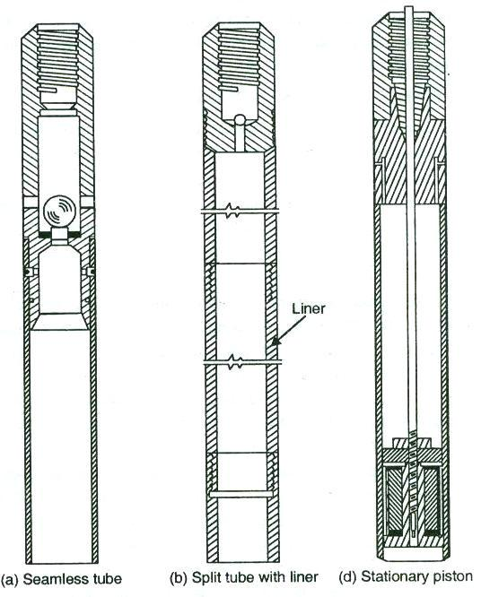

**UNIT II**

**SHALLOW FOUNDATION**

**Introduction – location and depth of foundation-codal provisions-bearing capacity of shallow foundation on homogeneous deposits-Terzaghi’s formula and BIS formula- factors affecting bearing capacity –problems- bearing capacity from insitu tests (SPT,SCPT and Plate load)allowable bearing pressure-seismic consideration in bearing capacity evaluation. Determination of settlement of foundation on granular and clay deposits-total and differential settlement-allowable settlements-codal provision-methods of minimizing total and differential settlements**

**TWO MARKS**

**1. What are components of total foundation settlement? (DEC 2008/MAY 2004)**

* Elastic settlement
* Consolidation settlement
* Secondary consolidation settlement.

**2. What are the types of shear failure? (DEC 2009)**

* General shear failure
* local shear failure
* Punching shear failure.

**3. What are assumptions in Terzaghi’s bearing capacity theory?**

* The base of the footing is rough
* The load on footing is vertical and uniformly distributed
* The footing is continuous

4. **What are the limitations of Terzaghi’s analysis?**

As the soil compresses, pi changes slight down ward movement of footing may not

develop fully the plastic zones

Error due to assumption that the resultant passive pressure consists of three components

is small

**5. Define ultimate bearing capacity. (MAY 2013)**

It is the minimum gross pressure intensity at the base of the foundation at which the soil

fails in shear.

**6. Define net ultimate bearing capacity.**

It is the minimum net pressure intensity at the base of the foundation that causes failure in

Shear

**7. Define allowable bearing capacity.**

It is the net loading intensity at which neither the soil fails in shear nor there is excessive

settlement detrimental to the structure.

**8. What are the factors on which depth depends on?**

Type of soil, size of structure, magnitude of loads, environmental conditions, etc

**9. Define net pressure intensity. (MAY 2013)**

It is the excess pressure, or the difference in intensities of the gross pressure after the

construction of the structure and the original overburden pressure.

**10. What are the zones used in the Terzaghi’s bearing capacity analysis for dividing the failure envelope of the soil?**

* Elastic equilibrium zone,
* Radial Stress zone,
* Plastic zone.

**11. Define Shallow foundation.**

If the depth of the foundation is less than its breadth, such foundation is known as shallow foundation.

**12. For which type of foundation, Terzaghi’s bearing capacity equation is applicable. Why?**

It is applicable for Shallow foundation only, because the effect of the depth is not considered.

**13. When will the Consolidation settlement get completed?**

In the case of cohesion-less soil, the consolidation settlement gets completed once the construction is over. But In the case of cohesive soil, the consolidation settlement takes place for

several years.

**14. Define Deep foundation**

If the depth of the foundation is equal to or greater than the breadth of the foundation such foundation is called as deep foundation.

**15. When will the total settlement be completed in the case of cohesion-less soil?**

Once the construction is over, the total settlement is assumed to be completed.

**16. Define differential settlement.**

If any two points of the foundation base experiences different settlements then such settlement is known as differential settlement.

**17. What type of shear failure of soil is more likely to happen in the case of very dense soil?**

Usually punching shear failure and local shear failure may also be possible.

**18. Define gross pressure intensity.**

Gross pressure intensity (q) is the total pressure at the base of the footing due to the weight of the super structure, self weight of the footing and the weight from the earth fill, if any.

**19. Define swelling potential. (DEC 2012)**

In the case of fine grained soils, water is held between the flaky particles by certain forces. This water can be removed by compression. When this compressive stress is removed, the forces present in soil structure sucks the water back again, resulting in the phenomenon of “Swelling”. The swelling potential of the soil is directly related to the plasticity index of the soil. Higher the plasticity index, greater the quantity of water entering the soil structure and hence greater the swelling potential.

**20. What are the components of total settlement? (DEC 2012)**

(i) Immediate elastic settlement (si)

(ii) Consolidation settlement (sc)

(iii)Settlement due to secondary consolidation (ssc)

**St= si +sc+ ssc**

**21. Define punching shear failure. (DEC 2012)**

Punching shear failure occurs when there is a high compression of soil under the footing,

accompanied by shearing in the vertical direction around the edges of the footing. It is generally

found in loose deposits and soils having low bearing capacity.

**22. Define safe bearing pressure or net soil pressure. (MAY 2013)**

It is the intensity of loading that will cause permissible settlement or specified settlement for the structure.

**23. What is the total settlement of a footing? (MAY 2013)**

The total settlement of the footing comprises the settlement due to immediate settling of soil after the construction and long time bound settlement due to consolidation of soil after many

years.

**24. Define General shear failure.**

Continuous failure surface developing between the edge of the footing and the ground surface is known as general shear failure. More heaving of soil occurs on the ground surface. It occurs generally in dense sand and hard clays

**25. Define local shear failure. (or) Draw Terzaghi’s bearing capacity failure surface with all details. (APRIL/MAY 2015)**

In local shear failure, significant compression of soil occurs under the footing and the failure

surfaces do not reach the ground surface. Slight heaving of soil occurs on the ground surface. It

occurs in medium sand and stiff clays.



**26. What are the major criteria to be satisfied in the design of a foundation? (NOV/DEC**

**2013)**

* Groundwater Pressures
* Factors of Safety
* Load Factors and Load Combinations

**27. What is the effect of rise of water table on the bearing capacity and the settlement of**

**footing on sand?(NOV/DEC 2013)**

When water tables raise the bearing capacity will decrease and therefore settlement of

footing on sand will increase

**28. Define safe bearing capacity(NOV/DEC 2010)**

Safe bearing capacity is defined as the maximum load support by soil before it fails.

**29. Differentiate net safe bearing capacity and allowable bearing capacity.(NOV/DEC 2014) (May/June 2015)**

|  |  |
| --- | --- |
| **Net safe Bearing capacity** | **Allowable Bearing capacity** |
| 1. The net safe bearing capacity is the net  ultimate bearing capacity divided by  factor of safety  2. It is denoted by qns  3. qns= qns/F | It is the net loading intensity at which neither  the soil fails in shear nor there is excessive  settlement for the structure.  It is denoted by qa. |

**30. What factors determine whether a foundation type is shallow or deep? ( APRIL/MAY**

**2015)**

Depth and breadth are the two main factors that determine whether a foundation is Shallow or deep

• If B>D, then it is shallow foundation,

• If D>B, then it is deep foundation.

Where B,D are breadth and depth.

**31. Why are the bearing capacity equations for clay usually has undrained shear strength?**

**( APRIL/MAY 2015)**

**τ=Cu+**σtanϕu

where cu, ϕu- undrained shear strength parameters.

• The undrained strength is only relevant in practice to clayey soils that in short term

remain undrained.

• As the pore pressures are unknown for undrained loading, the effective stress failure

criterion cannot be used.

**32. Say true or false and justify your answer: In Terzaghi’s bearing capacity theory, as**

**the shearing resistance above the base of the footing is ignored, the bearing capacity is**

**independent of depth of footing( NOV/DEC 2014).**

Statement is true. Because failure zones do not extend above the horizontal plane through the

base of the footing, i.e. the shear resistance of the soil above the base of footing is neglected and

the effect of soil around the footing is considered equivalent to a surcharge σ=γD.

**16 marks(PART-B)**

**CODAL PROVISIONS**

**1.EXPLAIN THE IS CODE METHOD TO CALCULATE THE BEARING CAPACITY OF THE SOIL.(NOV/DEC 2015)**

2.EXPLAIN THE TERZAGHI’S ANALYSIS WITH SHEAR FAILURE THEORIES.(NOV/DEC 2016)

**3.FACTORS AFFECTING BEARING CAPACITY**

**4.BEARING CAPACITY FROM INSITU TESTS**

**5.EXPLAIN THE PROCEDURE OF PLATE LOAD TEST.(Apr/May 2011)(Nov/Dec 2013)**

**6.METHODS OF MINIMIZING TOTAL AND DIFFERENTIAL SETTLEMENTS**



**FOOTINGS AND RAFTS**

**UNIT 3**

**QUESTION BANK**

**PART A**

**(2MARKS)**

**1. State the types of shallow foundations**. **(Nov/Dec 2013,16)**

* Strip footing or wall footing
* Spread footing or isolated footing
* Single footing,
* Stepped footing,
* Sloped footing.
* Combined footing
* Rectangular combined footing,
* Trapezoidal combined footing
* Strap footing or Cantilever footing
* Raft or mat foundation.

**2. Define combined footing and Raft footing. (Nov/Dec 2013, 2016)**

**Combined footing**:

* It is a long footing supported with two or more columns in one row.
* According to shape, it may be Rectangular or Trapezoidal.

**Raft (or) mat foundation**:

* A raft or a mat foundation is a large footing
* It is usually supporting with several columns in two or more rows.

**3. When trapezoidal combined footings are provided? (Apr/May 2004)**

The trapezoidal combined footings are commonly provided at the time when,

* The projection parallel to the length of footing is restricted on both sides.
* The length of the footing is restricted.

**4. Give the advantages of floating foundation. (Apr/May 2004)**

* The structural load on a floating foundation is reduced.

Q’ = Q – Ws

Q- Gross loads,

Ws- Excavated soil weight.

* In a soil having almost no shear strength, floating foundation could be an effective solution.

**5. Under what circumstances, a strap footing is adopted? (Nov/Dec 2012, 14, 16)**

* A strap footing may be provided where the distance between the columns is so great.
* When the combined trapezoidal footing becomes quite narrow, with high bending moments or where x< L/3.

**6. Under what circumstances a rectangular and trapezoidal combined footing are adopted?**

Sufficient space, beyond each column --- Rectangular combined footing

Interior Column relatively heavier

(Rectangular combined footing) One column is near property line

Interior column relatively light,

(Trapezoidal combined footing)

The selection of shape is based on to keep the resultant of the column loads through the centre of gravity of the footing.

**7. What are the two methods of design of raft foundation as per IS?**

* Conventional method.
* Elastic method or Soil line method.

**8. When you provide strap footing? (May /June 2009) (Apr/May 2010)**

A strap footing is required in following two cases

* When x’< L/3, where x’ is the distance of the resultant of column loads from the exterior face of the exterior column, and ‘L’ is the length of footing.
* When the distance between the two columns is so large that a combined footing becomes excessively long and narrow.

**9. Name the different types of raft.**

* Flat plate type
* Flat plate thickened under columns
* Beam and slab construction.
* Box structures
* Mats placed on piles.

**10. What is the condition for selecting the critical section for bending moment of a spread or isolated footing?**

The critical section for B.M is taken as under

* 1. At the face of the column or pedestal monolithic with the footing when no metal plate is used.
  2. Halfway between the face of the column or pedestal and the edge of the metal plate on which the column or pedestal rests

The maximum B.M for the case (i) given by,

M = 

**11. Draw the contact pressure distribution below rigid footing.**

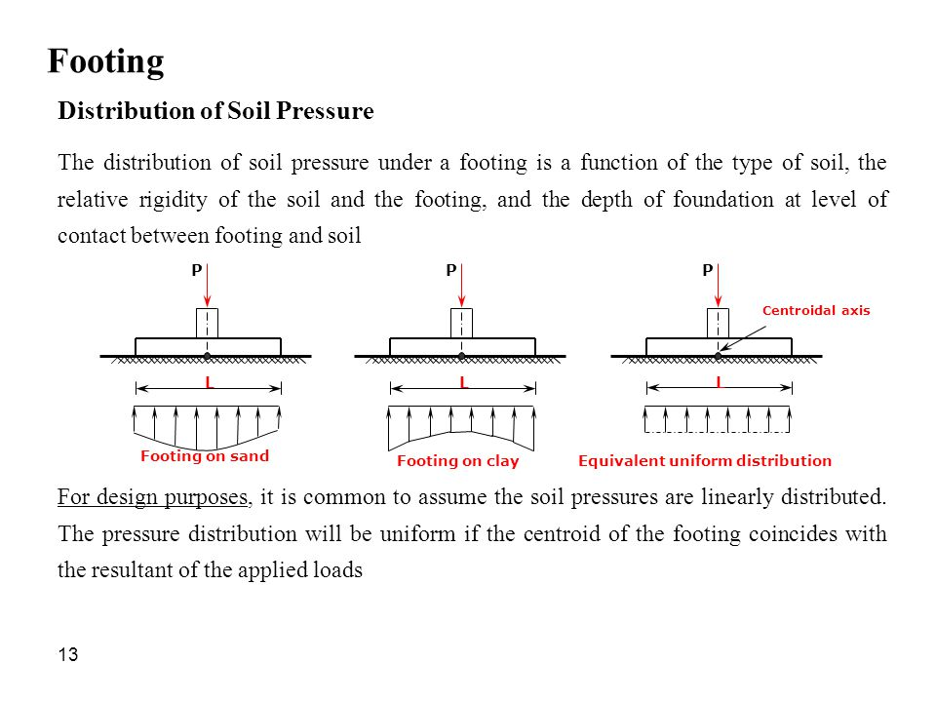

**12. What is the function of strap beam in strap footing? (Nov/Dec 2010)**

* The strap connects the two isolated footing such that they behave as one unit.
* The strap simply acts as connecting beams.

**13. What is floating raft foundation?**

* If the weight of the soil removed is equal to the total load of building imposed on the raft foundation, then the raft is a floating raft.
* Since it is not transferring any pressure (contact pressure) on the bearing soil below the raft.
* The result is zero settlement of building.

**14. List out the types of foundation for a shallow depth (Nov/ Dec 2010)**

* Spread footing
* Isolated footing
* Strip/ continuous footing
* Strap footing
* Combined footing
* Rectangular combined
* Trapezoidal combined footing
* Raft footing

**15. What are the design methods available for the mat foundation?**

* Conventional Method.
* Elastic method or soil line method.
  1. Simplified elastics foundation.
  2. Truly elastics foundation.

**16. Distinguish between Shallow foundation and deep foundation.**

* If the depth of foundation is less than the width of foundation (D < B), is known as shallow foundation.( Eg : spread footing, combined footing, raft)
* If the depth of foundation is more than the width of foundation (D > B), is known as deep foundation. (Eg : piles, caissons, well foundations, piers)

**17. What is mean by proportioning of footing?**

* Portioning of footing is defined as the arrangement of footing in the combined footing system.
* It is arranged in such a way that, the centroid of the area in contact with the soil lies on the line of action of the resultant of the loads.

**18. What are the assumptions made in combined footing?**

 The footing is rigid and rests on a homogenous soil to give rise to linear stress

Distribution on the bottom of the footing.

 The resultant of the soil pressure coincides with the resultant of the loads, and

then it is assumed to be uniformly distributed.

**19. What are the footings comes under shallow foundation?**

* Spread footing or pad footing,
* Strap footings,
* Combined footings,
* Raft or mat foundation

**20. What are the footings comes under deep foundation?**

* Pile
* Piers
* Caissons(well foundation)

**21. What are types of foundation?**

* Shallow foundation
* Deep foundation

**22**. **What is mean by strap footing ?**

If the independent spread footing of two columns is connected by a beam it is known as strap footing.

**23. What is mean by combined footing?**

A spread footing which supports two or more columns is termed as a combined footing.

**24. What is mean by spread footing?**

* It is a type of shallow foundation used to transmit the load of isolated column, or

that of wall to sub soil.

* The base of footing is enlarged and spread to provide individual support for load.

**25. What is a mat or raft foundation?**

A raft or mat is a combined footing that covers the entire area beneath a structure and supports all the walls and columns.

**26. Under what circumstances mat or raft foundation is used. (May 2009/2012, Nov 2012)**

* When the soil is having a low bearing capacity
* When the building loads are heavy, the use of spread footings would cover more than one-half of the area.
* It is economical to use mat or raft foundation.
* They are also used where the soil mass contains compressible lenses or erratic soil deposits.
* It is also used to control the differential settlements in soils.

**27. Define floating foundation.**

It is defined as a foundation in which the weight of the building is approximately equal to the full weight of the soil including water excavated from the site of the building.

**28. What are the assumptions made in combined footing?**

* The footing is rigid and rests on a homogenous soil to give rise to linear stress distribution on the bottom of the footing.
* The resultant of the soil pressure coincides with the resultant of the loads, then it is assumed to be uniformly distributed.

**29. What are the assumptions made in the conventional structural design of footings? (May2009/2012)**

* The foundation is infinitely rigid and, therefore, the actual deflection of the raft does not influence the pressure distribution below the raft.
* The soil pressure is assumed to be planer such that the centroid of the soil pressure coincides with the line of action of the resultant force of all the loads acting on the foundation.

**30. What is Safe bearing pressure or Net soil pressure? (May 2013)**

It is the intensity of loading that will cause a permissible settlement or specified

Settlement of the structure.

**31. What is allowable bearing capacity or pressure? (May-2012)**

Allowable bearing capacity or pressure (qa) is the net loading intensity at which neither the soil fails in shear nor there is excessive settlement of structure.

**32. Draw the contact pressure distribution of rigid footing founded on clay and sand deposits (Nov/Dec 2013) (or) Draw the contact pressure distribution diagram for flexible and rigid footing resting on sand and clay respectively. (Nov/Dec 201**

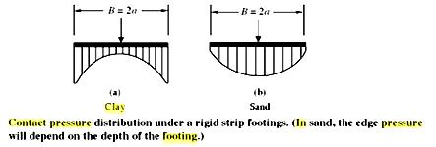

**33. List the different types of raft foundation. Which type of raft is commonly used?**

**(Nov/Dec 2013)**

Types of raft foundation are

1. Solid slab raft
2. Beam and slab raft
3. Cellular rafts

Mat or raft foundation is a large slab supporting a number of columns and walls under the entire structure or a large part of the structure to lower the contact pressure compared to spread footing.

It is recommended for the following purposes.

* + Bearing capacity of soil is low,
  + walls of the structure are so close that individual footings would overlap,
  + it is used for large loads,
  + Individual footings would cover more than about half of the construction area.

** ****What are the advantages and disadvantages of raft foundation?**

**Advantages of Raft Foundation**

It has many advantages as well as disadvantages. The advantages of raft foundation are as follows,

* Raft or mat foundation is economic due to combination of foundation and floor slab.
* It requires little excavation.
* It can cope with mixed or poor ground condition.
* It reduces differential settlement.

**Disadvantages of Raft Foundation**

It has some disadvantages also.

* + Mat foundation requires specific treatment for point loads.
  + Edge erosion occurs if not treated proper

**35**. **Plate load test is not applicable for heterogeneous soils. Why? (Nov/Dec 2014)**

* **Yes,** plate load test will not applicable for heterogeneous soils.
* Because heterogeneoussoil has different type of soil layers.
* Different type of soil will give different in settlement.

**36. What is meant by ‘Partially floating foundation’? (Nov /Dec 2014)**

The technique where the load of the structure is partially adjusted by the relief of load due to excavation is called partial floatation.

**37. List and sketch different types of mat (or) raft foundation (Apr/May 2015)**

Types of raft (or) Mat foundation are

(a) Flat plate

1. Flat plate thickened under column
2. Beams and slab
3. Slab with basement wall

**Part B(16 MARKS)**

1. State the Principles of proportioning of footings.
2. Explain the general procedure for designing the footing
3. Explain the Procedure for designing the P.C.C. strip footings
4. Explain the Procedure for designing the R.C.C. strip footings.
5. Explain the procedure for the Design of spread or isolated footings.
6. Explain the Procedure for proportioning and designing of the rectangular combined footings.
7. Explain the Procedure for proportioning and designing of the Trapezoidal combined footings.
8. Design a trapezoidal Footing for the two columns. Take allowable soil pressure as 200kN/m2
9. Explain the Procedure for proportioning and designing of the strap footings.
10. Explain the Procedure of conventional design of the raft footings.
11. What are the Causes for the settlement of foundation.
12. Define Differential settlement and enumerate its causes.
13. A trapezoidal footing is to be produced to support two square columns of 30 cm and 50 cm sides respectively. Columns are 6 meters apart and the safe bearing capacity of the soil is 400 kN/m2. The bigger column carries a load of 500 kN and the smaller carries a load of 3000kN. Design a suitable size of the footing so that if does not extend beyond the face of the columns.
14. Design a square footing to carry a load of 1000kN on a column 300x300 mm. allowable soil pressure 200kN/m2. Permissible stress 500kN/m2.use M20 & Fe415 steel.
15. The plan of a mat foundation with 9 columns assuming that the mat is rigid, Determine the soil pressure distribution. All the columns are of size 0.6m x 0.6m
16. What are the Effects of differential settlement

Enumerate the Remedial measures against harmful settlements

**UNIT 4**

**PILE FOUNDATION**

Types of piles and their function – Factors influencing the selection of pile – Carrying capacity of single pile in granular and cohesive soil – static formula – dynamic formulae (Engineering news and Hileys) – Capacity from insitu tests (SPT and SCPT) – Negative skin friction – uplift capacity- Group capacity by different methods (Feld’s rule, Converse – Labarra formula and block failure criterion) – Settlement of pile groups – Interpretation of pile load test (routine test only) – Under reamed piles – Capacity under compression and uplift.

**PART B&C**

**(13 marks and 15marks)**

**1. Explain the various methods of Hammer driving.**

## 2. What are the various Classification of Piles based upon Type of Materials?[Nov/Dec 2015][April/May 2017

**3. Discuss about various Classification of pile based on the function**:**[Nov/Dec 2015,12][April/May 2017]**

**4.. Classification based on method of installation[nov/dec 2015]**

5.. **WHAT ARE THE FACTORS THAT INFLUENCING THE SELECTION OF PILE**

6. **Write a short note on NEGATIVE SKIN FRICTION ON PILES (Nov/Dec 2011,2015)**

**7. Explain the Static method for Estimating the load carrying capacity of a single**

**8. Describe the** **Efficiency of pile group by Feld’s rule and Seiler- Keeney formula.**

**UNIT IV- 2MARKS**

1. **Define End bearing pile.(Apr/May 2004)**

* End bearing piles are used to transfer load through water or soft soil to a suitable bearing stratum.
* The end bearing pile is driven through poor soil strata and rests on a firm incompressible stratum such as rock, developing the bearing pressure of its base and passing it to that firm stratum.

**2. Define group Efficiency of pile. (Apr/May 2004)**

* The ratio of resting capacity of a pile group to the sum of individual capacities of piles in the group is termed as group efficiency.

Group efficiency , n = Qg/ (Np x Qp)

Where, Qg - Group capacity

Qp - Pile load on single pile

Np - Number of piles

**3. List out the type of pile based on material used.**

* Timber pile
* Concrete pile
* Steel pile
* Composite pile

**4. How is the selection of pile carried out?**

* The selection of the type, length and capacity is usually made from estimation based on the soil condition and magnitude of the load.

**5. What is mean by group settlement ratio?**

* The settlement of pile group is found to be many times that of a single pile.
* The ratio of the settlement of the pile group to that of a single pile is known as the group settlement ratio.

**6. What are the factors consider while selecting the type of pile?**

* The loads
* Time available for completion of the job
* Availability of equipment
* The ground water conditions
* The characteristics of the soil strata involved

**7. What are the types of hammer used for pile driving?**

* Drop hammer
* Diesel hammer
* Double acting hammer
* Single acting hammer
* Vibratory hammer

**8. What is pile driver?**

* Piles are commonly driven by means of a hammer supported by a crane or by a special device known as a pile driver.

**9. What are methods to determine the load carrying capacity of a pile?(Apr/May 2010)**

* Dynamic formulae
* static formula
* pile load test
* penetration test

**10. What are the two types of dynamic formulae?**

* Engineering News Formula
* Hiley’s Formula

**11. What is meant by single-under reamed pile?**

* The pile has only one bulb is known as single under reamed pile

**12. Write down the static formulae?**

* The static formulae are based on assumption that the ultimate bearing capacity Qup of a pile is the sum of the ultimate skin friction Rf and total ultimate point or and bearing resistance Rp.
* Qup=Rf+Rp
* Qup=As.rf +Ap.rp

**13. Define modulus of subgrade reaction.**

* The ratio of soil reaction (p) to the deflection (y) at any point is defined as the modulus of

sub grade reaction Es or soil modulus.

**14. What are the limitations of dynamic pile load test?**

* It is largely depend on the nature of the ground through which the pile was driven to get down to finished level.
* It takes very little account of the effect of friction on sides of pile, and this friction tends only to develop later.

**15. List the piles based on materials of installation.**

* End bearing pile
* Friction pile
* Compaction pile
* Tension pile
* Anchor pile
* Fender pile and dolphins
* Batter pile
* Sheet pile

**16. What are anchor piles?**

* Anchor piles are the type of the piles which provide anchorage edge against horizontal pull from the sheet piling or other pulling forces.

**17. What are fender piles?**

* Fender piles are the type of the piles which are used to protect water front structures against impact from ships or other floating objects.

**18. What are the factors governing selection of pile?**

* Soil condition
* Type of structure or building
* Adjacent site condition
* Construction techniques availability
* Location of ground water table
* Durability etc.

**19. Define Negative skin pressure**

* Negative skin friction force for a single pile is equal to the sharing resistance times the surface area of the pile. Therefore the negative skin friction on a pile group is

Fn = τLp + γLA for group

Fn = n τ L ԓ d for individual

**20. What are the conditions where a pile foundation is more suitable than a shallow foundation? (Apr/May2011)**

* Huge vertical load with respect to capacity
* Very weak soil
* Huge lateral loads
* For fills having very large depth
* Uplift situation
* Urban areas for future and huge construction near the existing building.

**21. What is meant by friction pile?(Nov/Dec 2010)**

* Friction piles are used to transfer loads to a depth of a friction load carrying material by means of skin friction along the length of the pile.

**22. What is floating raft foundation?**

* If the weight of the soil removed is equal to the total load of the building imposed on the raft foundation, then the raft is a floating raft.
* Since it is not transferring any, pressure on the bearing soil below the raft, the result is zero settlement of the building.

**23. For identical soil conditions, the load permitted on bored pile is lesser than driven pile of identical shape and dimensions, why?(Nov/Dec 2010)**

* The load carrying capacity of bored cast in situ pile will be much smaller than that of a driven pile in sand.
* The angle of shearing resistance of the soil is reduced by 30, to account for the loosening of the sand due to the drilling of the hole.

**24. Define Negative skin friction. (Apr/May 2011) (Nov/Dec 2010)**

* When the soil layer surrounding a portion of the pile shaft settles more than a pile, a downward drag occurs on the pile.
* The downward drag is known as negative skin friction.
* If the negative friction occur then the pile mus be designed to carry the additional load(downward drag force).
* Its effects on the pile.
* The downward drag force tends to reduce the pile capacity or increase load on the pile as the drag force is additional load.

**25. What is the use of batter pile?**

The batter piles are used to resist large horizontal forces or inclined forces.

**26. Write down the Meyerhof method for the elastic settlement of a pile group in sandy soils.(Nov/Dec 2011)**

Sg/Si = s(5 – s/3)/(1+(1/r))2

Sg/Si – settlement ratio

Sg – Settlement of pile group

Si – settlement of individual pile

S – ratio of pile spacing to pile diameters

r – number of rows in the pile group.

**27. State the reasons for settlement of pile group.**

* Elastic compression of the pile
* Movement of pile relative to the surrounding soil
* Settlement of surrounding soil due to pile load; this comprises of elastic deformation and consolidation settlement Settlement of soil under the pile tip (elastic as well as consolidation)
* Creep of pile material under constant axial load.

**28. What are the factors affecting group efficiency?**

* Spacing of piles.
* Total number of piles in a row and number of rows in a group.
* Characteristics of pile (material, diameter and length).

**29. Define group action of piles**

* Group action of piles is evaluated by considering the piles to fail as a unit around the perimeter of the group. Both end bearing and friction piles are considered in evaluating the group capacity.
* End bearing pile is evaluated by considering the area enclosed by the perimeter of piles as the area of footing located at a depth corresponding to the elevation of pile tips.
* The friction component of pile support is evaluated by considering the friction that can be mobilized around the perimeter of the pile group over the length of the piles

**30.** **Give the importance of spacing of piles in group action**.

* Piles in closely spaced groups behave differently than single isolated piles because of pile-soil-pile interactions that takes place in the group.
* It is generally recognized that deflections of a pile in a closely spaced group are greater than the deflections of an individual pile at the same load because of these interaction effects.
* The maximum bending moment in a group will also be larger than that for a single pile, because the soil behaves as if it has less resistance, allowing the group to deflect more for the same load per pile.

**31. What are the aspects considered for minimum spacing of piles?**

The minimum centre-to-centre spacing of pile is considered from three aspects, namely,

* Practical aspects of installing the piles.
* Diameter of the pile.
* Nature of the load transfer to the soil and possible reduction in the load capacity of piles group.

**32. State the procedure for driving the piles as a group.**

* A charge of zero-slump concrete is poured into the bottom of a [steel](https://en.wikipedia.org/wiki/Steel) driving [pipe](https://en.wikipedia.org/wiki/Pipe_(fluid_conveyance)) that is placed vertically on the ground. A [diesel](https://en.wikipedia.org/wiki/Diesel_engine)-operated [drop hammer](https://en.wikipedia.org/wiki/Pile_driver) is then driven on the concrete, forming a [watertight](https://en.wikipedia.org/wiki/Watertight) concrete plug.
* The concrete plug is driven into the ground by the drop hammer. The pipe is also dragged into the ground due to [friction](https://en.wikipedia.org/wiki/Friction) developed between the steel and the concrete.
* When the desired depth is reached, the pipe is held in position by leads structures which guide and align the pile and hammer. The hammer is then applied to the concrete, driving it outwards through the bottom of the pile and forming a [mushroom](https://en.wikipedia.org/wiki/Mushroom)-shaped base.
* At this point, a [cylindrical](https://en.wikipedia.org/wiki/Cylindrical) [rebar](https://en.wikipedia.org/wiki/Rebar) cage can be driven into the concrete if supplementary reinforcement is desired.
* Additional charges of concrete are added and driven while the steel casing is simultaneously pulled up until the shaft of the pile is formed

**33. What are the Reasons for conducting initial tests on piles?**

* To ensure the safe load capacity of piles.
* To obtain back figured soil data that will enable other piles to design.
* To confirm pile lengths.
* To determine the load settlement behaviour of the pile.
* To verify structural soundness of pile.
* Detection of any unusual performance contrary to the findings of the Initial Test.

**34. What are the preparations should be made for pile load test**

* The area surrounding the test pile must be cleared of pile spoil, slurry and rubbish.
* A properly designed level platform of sufficient plan dimensions to support the testing equipment safely and with suitable access for operatives, transport vehicles and lifting plant must be provided.

**35. Define Pile load test**

* A [static load](http://www.dictionaryofconstruction.com/definition/static-load.html) [test](http://www.dictionaryofconstruction.com/definition/test.html) of a pile or group of [piles](http://www.dictionaryofconstruction.com/definition/pile.html) used to establish an [allowable load](http://www.dictionaryofconstruction.com/definition/allowable-load.html). The applied [load](http://www.dictionaryofconstruction.com/definition/load.html) is usually 150% to 200% of the allowable load.
* Pile load testing includes designing and conducting a procedure for determining in-place pile capacity using static load testing and high strain dynamic load testing

**36. Where the deep foundations are employed?**

* There are many reasons a [geotechnical engineer](https://en.wikipedia.org/wiki/Geotechnical_engineer) would recommend a deep foundation over a [shallow foundation](https://en.wikipedia.org/wiki/Shallow_foundation), but some of the common reasons are
* very large design loads,
* a poor [soil](https://en.wikipedia.org/wiki/Soil) at shallow depth, or site constraints (like [property lines](https://en.wikipedia.org/wiki/Property_line)).

**37. What are the General forms of deep foundation?**

* There are different terms used to describe different types of deep foundations including the pile (which is analogous to a [pole](https://en.wiktionary.org/wiki/pole))
* The pier (which is analogous to a [column](https://en.wikipedia.org/wiki/Column))
* Drilled shafts
* [Caissons](https://en.wikipedia.org/wiki/Caisson_(engineering)) (Open Wells).

**38. What is felds rule for determining group capacity of pile groups?(May/Jun 2016)**

n = €Qr/(n. €Qp)

**39. What is under reamed pile when it is preferred? (May/Jun 2016)**

* A bored cast in situ or bored compaction concrete pile with an enlarged bulb(s) made by either cutting or scooping out the soil or by any other suitable process.
* Under reamed piles have mechanically based enlarged bases that have been as much as 6m in diameter.
* It is suitable for the foundation in black cotton soil.

**40.  What type of piles would you recommend for the following types of soil and site conditions? (Nov/Dec 2015)**

(a) For a multi-storeyed building in the central part of a city surrounded by existing buildings.

Batter piles are used.  
 (b) For a harbour structure**.** Steel and concrete piles are used.



**UNIT V**

**RETAINING WALL**

Plastic equilibrium in soils – active and passive states – Rankine’s theory – cohesion less and cohesive soil - Coulomb’s wedge theory – condition for critical failure plane - Earth pressure on retaining walls of simple configurations – Graphical methods (Rebhann’s and Culmann’s) - pressure on the wall due to line load – Stability of retaining walls.

**RETAINING WALLS**

**PART B**

**(11marks & 15 marks)**

**1. What are the different types of earth pressure? Give examples. Derive an equation for determining the magnitude of earth pressure at rest. (Nov/Dec 2010)**

**2. Explain Rankine’s Active earth pressure theory for cohesion less soil**

**[Nov/Dec 2011][May/June 2009]**

**Backfill with sloping surface**

**3. Explain Rankine’s Active earth pressure theory for cohesive soil**

**Active earth pressure of cohesive soils**.

**4. Explain Rankine’s Passive earth pressure theory for cohesion less and cohesive**

**5. Explain the coulomb’s Wedge theory of earth pressure with a neat sketch. (Apr/May11, 2012,13)**

**6. Explain Culmann’s construction for active pressure of cohesion less soil**

**[April/May 2017][Nov/Dec 2012]**

**7. Explain the Rebhann’s Graphical method for active pressure of cohesion less soil**

**8. Explain the Effect of line load on retaining wall**

***9. What are different modes of failure of retaining wall? (Nov/Dec 2009)***

***1. A gravity retaining wall retains 12 m of a back fill, ɣ = 17.7 kN/m3, ɣ sub = 10kN/m3. φ = 25 with a uniform horizontal surface. Assume the wall interface to be vertical, determine the magnitude and point of application of the total active pressure****.****If the water table is at a height of 6m, how far do the magnitude and the point of application***

***2. A wall of 8 m height retains sand having a density of 1.936 Mg/m3 and angle of internal friction of 34°. If the surface of the backfill slopes upwards at 15° to the horizontal, find the active thrust per unit length of the wall. Use Rankine’s conditions****.* ***(AU Nov/Dec 2011,13)***

**Solution**

***3. A counter fort wall of 10 m height retains non – cohesive backfill. The void ratio and angle of internal friction of the backfill respectively are 0.70 and 30° in the loose state and they are 0.40 and 40° in the dense state. Calculate and compare active and passive earth pressures in both the cases. Take specific gravity of soil grains. (AU Nov/Dec 2011,13)***

**Solution**

***4. A retaining wall has a vertical back and is 7.32 m high. The soil is sandy loam of unit weight 17.3 kN/m3. it shows a cohesion of 12 kN/m2 and φ = 20°. Neglecting wall friction, determine the thrust on the wall. The upper surface of the fill is horizontal****.* ***(AU Nov/Dec 2010,14)***

**Solution**

.

***5. A rigid retaining wall of 6 m height (fig) has two layers of back fill. The top layer up to depth of 1.5 m is sandy clay having φ = 30°C , c= 0, and γ=17.25 kN/m3.Determine the total active earth pressure acting on the wall and draw the pressure distribution diagram. (AU Nov/Dec 2011,15)***

**For the top layer**

**PART A**

**(2 marks)**

**1. Define Active Earth pressure**.

If the soil exerts a push against the wall by virtue of its tendency to slip laterally and seek its natural slope (angle of repose) thus making the wall to move slightly away from the back filled soil mass. This kind of pressure is known as AEP.

**2. Define Passive Earth pressure.**

The pressure or resistance which soil develops in response to movement of the structure towards it is called the Passive Earth Pressure.

**3. Define coefficient of earth pressure [May/ June 2013]**

From Mohr’s coulomb equation,



c = 0



For active case for passive case

σ1 = σv (major) σ1 = σh (major)

σ3 = σh (minor) σ3 = σv (minor)



 Kp = tan2 (45+)

Ka =  Kp = 

**4. What is the critical height of an unsupported vertical cut in cohesive soil**

The critical height Hc of an unsupported vertical cut in cohesive soil is thus given by,

Hc = 2zo = 

Where α = 45 +

**5.** **Enumerate the assumptions made in Coulomb’s Wedge theory.[April/May 2017]**

1. Soil is dry, cohesion less, homogeneous, isotropic and ideally plastic material
2. The slip surface is a plane passing through the kneel of the wall
3. The wall surface is rough.
4. The resultant earth pressure on the wall is inclined at an angle δ to the normal to the wall (δ - angle of friction between wall & back fill).
5. The sliding wedge itself acts as a rigid body

**6. Give the criteria for the design of gravity retaining wall.**

1. Maximum pressure should not exceed the bearing capacity of soi (Base width).
2. No tension should be developed any where in the wall

e < 

1. The wall must be safe against sliding.
2. The wall must be safe against sliding.
3. The wall must be safe against overturning.

**7. Sketch the variation of earth pressure and coefficient of earth pressure with the movement of the wall**

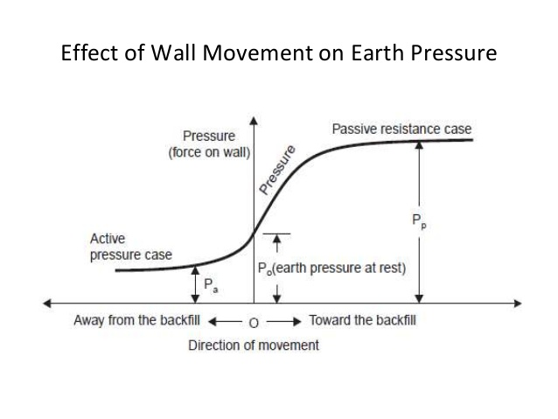

**8. What are the stability conditions should be checked for the retaining walls [Nov/Dec 2010]**

The stability of retaining walls should be checked against the following conditions

1. The wall should be stable against sliding
2. The wall should be stable against Overturning
3. The wall should be stable against Bearing capacity failure.

**9. Give the minimum factor of safety for the stability of a retaining wall.**

(a) The wall should be stable against sliding = 1.5

(b) The wall should be stable against Overturning

For Granular Backfill = 1.5

For cohesive backfill = 2.0

1. The wall should be stable against Bearing capacity failure.

For Granular Backfill = 1.5

For cohesive backfill = 2.0

**10. Draw the various Drainage provisions in Retaining wall**

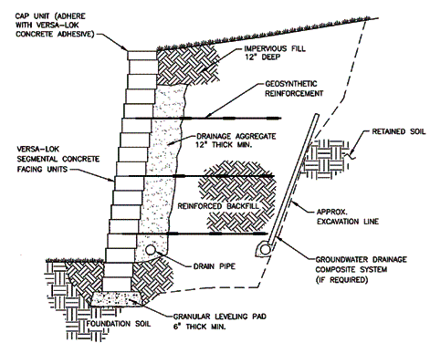

**11. If a retaining wall of 5 m high is restrained from yielding, what will be the total earth pressure at rest per metre length of wall? Given: the back fill is cohesion less soil having φ = 30° and γ = 18 kN/m3.**

Solution

ko = 1 – sin φ = 1 – sin 30° = 0.5

Po = 

**12. A cantilever retaining wall of 7 metre height retains sand. The properties of the sand are γd = 17.66KN/m3 and γsat = 29.92 KN/m3 φ = 30°. using Rankine’s theory determine active earth pressure at the base when the backfill is (i) Dry, (ii) Saturated and (iii) Submerged.**

submerged density

γb = γsat - γw = 20.92-9.81 = 11.1kN/m3

for φ = 30, KA = 

active earth pressure at the base is

1. for dry backfill,

Pa = KAγdH = 

1. for saturated backfill,

Pa = KAγsatH = 

1. for submerged backfill,

Pa = KAγbH = 

**13. A rigid retaining wall of 6 m high has a saturated backfill of soft clay soil. The properties of the clay soil are γsat = 17.56 kN/m3,**

**unit cohesion cu = 18 kN/m2. Determine the expected depth of tensile crack in the soil**

**Solution**

At z = 0, Pa = -2c = -2 x 18 = -36kN/m3 since φ = 0

At z = H, Pa = γH – 2c = 17.56 x 6 – 2 x 18 = 69.36 kN/m2.

The depth of tensile crack z0 is (for φ = 0)

z0 = 

**14. A retaining wall of 6 m high has a saturated backfill of soft clay soil. The properties of the clay soil are γsat = 17.56 kN/m3, unit cohesion cu = 18 kN/m2. Determine (a) the expected depth of tensile crack in the soil (b) the active earth pressure before the occurrence of tensile crack, and (c) the active pressure after the occurrence of tensile crack**

**Solution**

At z = 0, Pa = -2c = -2 x 18 = -36kN/m3 since φ = 0

At z = H, Pa = γH – 2c = 17.56 x 6 – 2 x 18 = 69.36 kN/m2.

The active earth pressure before crack occurs.

Pa = 

Since KA = 1 for φ = 0. substituting, we have

Pa = 

The active earth pressure after the occurrence of tensile crack,

Pa = 

Substituting

Pa = 

**15. Define conjugate stresses? (Nov/Dec 2009.11)**

The stress acting on the conjugate planes is called conjugate stresses

**16. Define angle of repose (Φ) ? (Nov/Dec 2011,12)**

Maximum natural slope at which the soil particles may rest due to their internal friction, if

left unsupported for sufficient length of time.

**17. Define theory of plasticity? (Nov/Dec 2014)**

The theory on which the condition of the **stress in a** **state of a plastic equilibrium** is called as theory of plasticity.

**18. How to prevent land sliding?**

Sheet piles, retaining wall may be used to prevent the land sliding.

**19. Write down any two assumptions of Rankine’s theory? (Nov/Dec 2014/2012)**

* Semi infinite soil
* Cohesion-less backfill
* Homogenous soil
* The ground surface is a plane which may be horizontally inclined
* The back of the wall is smooth and vertical.

**20. Distinguish Coloumb’s wedge theory from Rankine’s theory?**

Rankine considered a soil particle at plastic equilibrium but Coulomb considered the

whole soil mass.

21**. What is meant by critical depth of vertical cut for a clay soil?**

* Due to negative pressure, a tension crack usually developed in the soil near the top of the wall, upto to a depth Z0. Also, the total pressure upon a depth 2Z0 is zero.
* This means that a cohesive soil should be able to stand with a vertical face upto a depth 2Z0 without any lateral support.
* The critical height Hc of an unsupported vertical cut in cohesive soil is thus given by,
* Hc = 2Z0 = 4 C tanαγ

**22. Why retaining walls are usually designed for active earth pressure?**

**(May/June 2009)**

* From Rankine’s assumption, no-existence of frictional forces at the wall face, the resultant pressure must be parallel to the surface of the backfill.
* The existence of friction makes the resultant pressure inclined to the normal to the wall at an angle between the soil and the wall.

**23. What do you understand by plastic equilibrium in soil? [May/June 2012]**

A body of soil is said to be in plastic equilibrium, if every point of it is on the verge of failure.

**24. What is critical failure plane?[May/June 2012]**

Critical failure plane defined as the plane along which the failure occurs in which the shear stress on the plane is less than the maximum shear stress.

**25. What is surcharge angle?[May/June 2013,2014][Nov/Dec 2015]**

* The angle of surcharge of a material is the angle to the horizontal,
* The surface of the materials assumes, while the material is at rest on a moving conveyor belt.
* The surcharge angle is generally 5‟ to 15‟ less than the angle of repose.

**26. What is earth pressure at rest? [May/June 2013,2014]**

The earth pressure at rest is defined as the intensity of lateral earth pressure when the lateral strain is zero and it is expressed as PR = KR . γ . Z, where KR – coefficient of earth pressure.

**27. Write the types of retaining wall. ( Nov/Dec 2012)**

The earth retaining walls are of following types:

**(a) Gravity wall**

(i) Mass concrete or masonry wall

(ii) Wall on wells

(iii) Precast block wall

(iv) Two row sheet pile wall

(v) Crib wall

**(b) Reinforced concrete wall**

(i) Cantilever type „T‟ wall or „L‟ wall

(ii) Counterforted or butteressed wall

**(c) Sheet pile wall**

(i) Cantilever sheet pile wall

(ii) Anchored sheet pile wall or Anchored bulkhead.

**28. List the assumptions common to Rankine and coulomb theory of earth pressures.(Nov/Dec 2010)**

* Soil mass is semi-infinitive
* Ground surface is a plane
* The back of the wall is smooth and vertical.

**29. What are the assumptions in coulomb’s theory?(May/June 2009)**

* Uniform c – Φ
* Failure plane is straight
* Failure wedge is a rigid body
* Frictional force is developed along the wall boundary during the movement of wedge

**30. Compare Rankine’s and Coulomb’s theory. (Apr/May 2010)**

* ***Rankine’s theory :***

The intensity of earth pressure at each depth is known. So point of application of the earth pressure is known at any depth

Only the total earth pressure value acting on the retaining structures can be calculated.

* ***Coulomb’s theory :***

The point of application of earth pressure can be calculated from Coulomb’s assumption that all points on the back of the retaining wall are essentially considered as feet of failure surface Wall is smooth and vertical Wall is rough and sloped Wall moved sufficiently so soil is in plastic failure mass Wall is rigid, straight failure plane and rigid failure wedge.

**31. Define plastic equilibrium (Nov/Dec 2010)**

A mass of soil is said to be in a state of plastic equilibrium if failure is incipient or imminent at all points within the mass.

**32. What are the conditions to be satisfied while designing a retaining wall?**

**(Nov/Dec 2010)**

**Sliding resistance:**

Factor of safety = 𝑆𝑢𝑚 𝑜𝑓 𝑟𝑒𝑠𝑖𝑠𝑡𝑖𝑛𝑔 𝑓𝑜𝑟𝑐𝑒/𝑆𝑢𝑚 𝑜𝑓 𝑑𝑟𝑖𝑣𝑖𝑛𝑔 𝑓𝑜𝑟𝑐𝑒

Factor of safety against sliding should be at least 1.5 for sandy soil and 2.0 for clayey soil.

**Overturning:**

To avoid overturning the resultant thrust must fall within the middle third of wall base.

Factor of safety = 𝑆𝑢𝑚 𝑜𝑓 𝑟𝑒𝑠𝑖𝑠𝑡𝑖𝑛𝑔 𝑓𝑜𝑟𝑐𝑒/𝑆𝑢𝑚 𝑜𝑓 𝑜𝑣𝑒𝑟𝑡𝑢𝑟𝑛𝑖𝑛𝑔 𝑓𝑜𝑟𝑐𝑒

Factor of safety against overturning should be at least 1.5 for sandy soil and 2.0 for clayey soil.

**Bearing Capacity:**

Factor of safety = 𝐴𝑙𝑙𝑜𝑤𝑎𝑏𝑙𝑒 𝑏𝑒𝑎𝑟𝑖𝑛𝑔 𝑝𝑟𝑒𝑠𝑠𝑢𝑟𝑒/𝑀𝑎𝑥𝑖𝑚𝑢𝑚

Factor of safety against bearing capacity should be at least 2.5 for sandy soil and 3.0 for clayey soil.

**33. Give the design criteria of gravity retaining wall (Nov/Dec 2005)**

* The base width of the wall must be such that the maximum pressure exerted on the foundation soil does not exceed the safe bearing capacity of the soil
* No tension should be developed anywhere in the wall
* The wall must be safe against overturning and sliding.

**34. What are the joints required for retaining walls?**

* A retaining wall is provided with construction, contraction or expansion joints.
* ***Construction joints*** are provided between two successive pours of concrete and are vertical and horizontal joints.
* ***Contraction joints*** are vertical grooves or joints, 8mm wide and 12 to 16mm deep, provided in the face of the wall.
* ***Expansion joints*** are provided to withstand the effects of expansion due to temperature changes.

**35. What do you understand by arching in soil?**

If one part of a support retaining soil mass yields while the rest of its remains in position, the soil near the yielding part of the support moves from its original position.

**36. What are retaining structures? (Nov/Dec 2014)**

* Structures which are used to hold back a soil mass are called retaining structures.
* Examples are retaining wall, sheet pile walls, crib walls etc.

**37. What are the requirements of backfill material?**

* Backfill materials should have property to transfer a minimum lateral pressure on the wall.
* A good backfill material should satisfy two important requirements high long term strength and free drainage.

**38. What is the significance of assumption of plane of rupture surface in coulomb’s earth pressure theory?**

* If wall friction is considered in conjunction with plane surface of failure unsafe values of earth resistance result in.
* This aspect is very significant especially in case of high friction angles.

**39. Explain the effect of wall movement on lateral earth pressure. (Nov/Dec 2014)**

* When a wall is rigid and unyielding the soil mass is in a state of rest and there are deformations and displacements.
* The lateral earth pressure corresponding to this state is called the earth pressure at rest.

**40. What are gravity type retaining walls? (Apr/May 2014)**

Gravity type walls provide slope and soil retention by their weight, which can consists of masonry, concrete mass, and concrete in combination with soil weight, or the weight of the earth mass alone.

**41. Draw the lateral earth pressure diagram of clay depends for active condition.(Nov/Dec 2015,16)**

ea1**=**-2cka

H

ea2 = -2cka + γHka

**42. What are the forces acting on gravity retaining walls? (Nov/Dec 2011,13,15)**

* Lateral forces (Earth pressure due to backfill and surcharge).
* Vertical forces (Upward forces and downward forces).