DHANALAKSHMI SRINIVASAN COLLEGE OF ENGINEERING AND TECHNOLOGY



CE 6501 STRUCTURAL ANALYSIS - I

(REGULATION-2013)

FACULTY OF ENGINEERING

DEPARTMENT OF CIVIL ENGINEERING

ANNA UNIVERSITY EXPECTED
QUESTION BANK

UNIT-I
INDETERMINATE STRUCTURES
PART-A
Two Mark Question With Answer

1. Why is it necessary to compute deflections in structures?
Computation of deflection of structures is necessary for the following reasons:

- If the deflection of a structure is more than the permissible, the structure will not look aesthetic and will cause psychological upsetting of the occupants.

- Exessive deflection may cause cracking in the materials attached to the structure. For example, if the deflection of a floor beam is excessive, the floor finishes and partition walls supported on the beam may get cracked and unserviceable.

2. What is meant by cambering technique in structures?

Cambering is a technique applied on site, in which a slight upward curve is made in the structure/beam during construction, so that it will straighten out and attain the straight shape during loading. This will considerably reduce the downward deflection that may occur at later stages.

3. Name any four methods used for computation of deflections in structures.
1. | Double integration method | 2. | Macaulay’s method
3. | Conjugate beam method | 4. | Moment area method
5. | Method of elastic weights | 6. | Virtual work method- Dummy unit load method
7. | Strain energy method | 8. | Williot Mohr diagram method

- State the difference between strain energy method and unit load method in the determination of deflection of structures.

In strain energy method, an imaginary load P is applied at the point where the deflection is desired to be determined. P is equated to zero in the final step and the deflection is obtained.

In unit load method, an unit load (instead of P) is applied at the point where the deflection is desired.

- What are the assumptions made in the unit load method?
  - 1. The external & internal forces are in equilibrium.
    - Supports are rigid and no movement is possible.
    - The materials is strained well with in the elastic limit.

- Give the equation that is used for the determination of deflection at a given point in beams and frames.

Deflection at a point is given by,
δ_{I} = ^{l} M_{x} m_{x} dx
EI

0
Where M_{x} = moment at a section X due to the applied loads

m_{x} = moment at a section X due to a unit load applied at that point I and in the direction of the Desired displacement
EI = flexural rigidity

7. Distinguish between pin jointed and rigidly jointed structure.

Sl.no | Pin jointed structure | Rigidly jointed structure
1. | The joints permit change of angle | The members connected at a rigid joint will
 | Between connected member. | maintain the angle between them even
 |  | under deformation due to loads.
2. | The joints are incapable of transferring | Members can transmit both forces and
 | any moment to the connected members | moments between themselves through the
 | and vice-versa. | joint.
3. | The pins transmit forces between | Provision of rigid joints normally increases
 | Connected member by developing shear. | the redundancy of the structures.

8. What is meant by thermal stresses?

Thermal stresses are stresses developed in a structure/member due to change in temperature. Normally, determine structures do not develop thermal stresses. They can absorb changes in lengths and consequent displacements without developing stresses.

9. What is meant by lack of fit in a truss?

One or more members in a pin jointed statically indeterminate frame may be a little shorter or longer than what is required. Such members will have to be forced in place during the assembling. These are called members having Lack of fit. Internal forces can develop in a redundant frame (without external loads) due to lack of fit.

10.Write down the two methods of determining displacements in pin jointed plane frames by the unit load concept.

The methods of using unit loads to compute displacements are,
  - dummy unit load method.
  - Using the principle of virtual work.

11. What is the effect of temperature on the members of a statically determinate plane truss.

In determinate structures temperature changes do not create any internal stresses. The changes in lengths of members may result in displacement of joints. But these would not result in internal stresses or changes in external reactions.

12. Distinguish between ‘deck type’ and ‘through type’ trusses.

A deck type is truss is one in which the road is at the top chord level of the trusses. We would not see the trusses when we ride on the road way.

A through type truss is one in which the road is at the bottom chord level of the trusses. When we travel on the road way, we would see the web members of the trusses on our left and right. That gives us the impression that we are going` through’ the bridge.

13. Define static indeterminacy of a structure.

If the conditions of statics i.e., ΣH=0, ΣV=0 and ΣM=0 alone are not sufficient to find either external reactions or internal forces in a structure, the structure is called a statically indeterminate structure.

14. Differentiate the statically determinate structures and statically indeterminate structures?

Sl.No | statically determinate structures | statically indeterminate structures
1. | Conditions of equilibrium are sufficient | Conditions of equilibrium are insufficient to
 | to analyze the structure | analyze the structure
2. | Bending moment and shear force is | Bending moment and shear force is dependent
 | independent of material and cross | of material and independent of cross sectional
 | sectional area. | area.
3. | No stresses are caused due to | Stresses are caused due to temperature change
 | temperature change and lack of fit. | and lack of fit.

15. Define : Trussed Beam.
A beam strengthened by providing ties and struts is known as Trussed Beams.

16. Define: Unit load method.

The external load is removed and the unit load is applied at the point, where the deflection or rotation is to found.

17.Give the procedure for unit load method.
    - Find the forces P1, P2, ……. in all the members due to external loads.

    - Remove the external loads and apply the unit vertical point load at the joint if the vertical deflection is required and find the stress.

  - Apply the equation for vertical and horizontal deflection.

PART-B (16 MARKS )
- Determine the vertical and horizontal displacement of the joint „B‟ in a pin jointed frame shown in fig
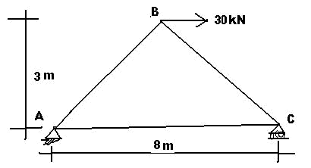
.

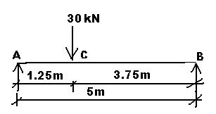
- A beam AB is simply supported over a span 5m in length. A concentrated load of 30kN is acting at a section 1.25m from support. Calculate the deflection under the load point. Take E = 200 x 10⁶ kN/m². And I = 13 x 10⁻⁶ m⁴

- Determine the vertical and horizontal displacement of the joint C‟ in a pin jointed truss shown in fig. The sectional area of members are A=1000 mm² E= 200 x 10⁵ N/mm². .(Nov/Dec 2010)
- Explain the concepts involved in the Williot diagram and its application. (May/June 2014)
- Explain the steps involved in the determination of deflection of pin jointed plane frames and rigid plane frames. (May/June 2014)
- Determine the vertical deflection of joint E for the Warren truss shown in Fig. (Nov/Dec 2010).

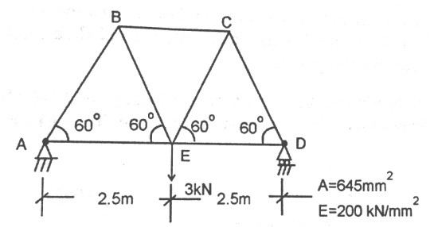

- Determine the vertical deflection of point C in the truss shown in Fig. The cross sectional area of the members AD and DE are 1500 mm² while those of other members are 1000 mm². Take E = 200GPa. (May/June 2012).
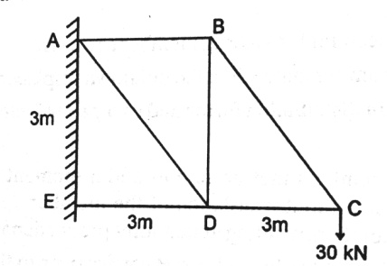
- Find the forces in the members of the truss shown in Fig. The cross sectional area and Young’s Modulus of all the members are the same. (Nov/Dec 2015)
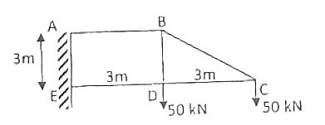
- Analyse the truss shown in Fig. by consistent deformation method. Assume that the cross sectional area of all the members are the same. (Nov/Dec 2015)
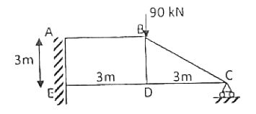

UNIT-II
INFLUENCE LINES
PART-A
Two Mark Question With Answer

1. Where do you get rolling loads in practice?

Shifting of load positions is common enough in buildings. But they are more pronounced in bridges and in gantry girders over which vehicles keep rolling.

- Name the type of rolling loads for which the absolute maximum bending moment occurs at the midspan of a beam.

(i) Single concentrated load (ii) udl longer than the span (iii) udl shorter than the span (iv) Also when the resultant of several concentrated loads crossing a span, coincides with a concentrated load then also the maximum bending moment occurs at the centre of the span.

3. What is meant by absolute maximum bending moment in a beam?

When a given load system moves from one end to the other end of a girder, depending upon the position of the load, there will be a maximum bending moment for every section. The maximum of these bending moments will usually occur near or at the midspan. The maximum of maximum bending moments is called the absolute maximum bending moment.

- Where do you have the absolute maximum bending moment in a simply supported beam when a series of wheel loads cross it?

When a series of wheel loads crosses a simply supported beam, the absolute maximum bending moment will occur near midspan under the load W_{cr} , nearest to midspan (or the heaviest load). If W_{cr} is placed to one side of midspan C, the resultant of the load system R shall be on the other side of C; and W_{cr} and R shall be equidistant from C. Now the absolute maximum bending moment will occur under W_{cr} . If W_{cr} and R coincide, the absolute maximum bending moment will occur at midspan.

- What is the absolute maximum bending moment due to a moving udl longer than the span of a simply supported beam?

When a simply supported beam is subjected to a moving udl longer than the span, the absolute maximum bending moment occurs when the whole span is loaded.
M_{max max} = wl²
8

6. State the location of maximum shear force in a simple beam with any kind of loading.

In a simple beam with any kind of load, the maximum positive shear force occurs at the left hand support and maximum negative shear force occurs at right hand support.

7. What is meant by maximum shear force diagram?

Due to a given system of rolling loads the maximum shear force for every section of the girder can be worked out by placing the loads in appropriate positions. When these are plotted for all the sections of the girder, the diagram that we obtain is the maximum shear force diagram. This diagram yields the ‘design shear’ for each cross section.

8. What is meant by influence lines?

An influence line is a graph showing, for any given frame or truss, the variation of any force or displacement quantity (such as shear force, bending moment, tension, deflection) for all positions of a moving unit load as it crosses the structure from one end to the other.

- What are the uses of influence line diagrams?

  - Influence lines are very useful in the quick determination of reactions, shear force, bending moment or similar functions at a given section under any given system of moving loads and

  - Influence lines are useful in determining the load position to cause maximum value of a given function in a structure on which load positions can vary.

10. What do you understand by the term reversal of stresses?

In certain long trusses the web members can develop either tension or compression depending upon the position of live loads. This tendancy to change the nature of stresses is called reversal of stresses.

11. State Muller-Breslau principle.

Muller-Breslau principle states that, if we want to sketch the influence line for any force quantity (like thrust, shear, reaction, support moment or bending moment) in a structure,

- We remove from the structure the resistant to that force quantity and

- We apply on the remaining structure a unit displacement corresponding to that force quantity. The resulting displacements in the structure are the influence line ordinates sought.

- What is the necessity of model analysis?
  - When the mathematical analysis of problem is virtually impossible.

- Mathematical analysis though possible is so complicatedand time consuming that the model analysis offers a short cut.

- The importance of the problem is such that verification of mathematical analysis by an actual test is essential.

- Define similitude.

Similitude means similarity between two objects namely the model and the prototype with regard to their physical characteristics:
  - Geometric similitude is similarity of form

  - Kinematic similitude is similarity of motion
    - Dynamic and/or mechanical similitude is similarity of masses and/or forces.

- State the principle on which indirect model analysis is based.
The indirect model analysis is based on the Muller Breslau principle.

Muller Breslau principle has lead to a simple method of using models of structures to get the influence lines for force quantities like bending moments, support moments, reactions, internal shears, thrusts, etc.

To get the influence line for any force quantity, (i) remove the resistant due to the force, (ii) apply a unit displacement in the direction of the (iii) plot the resulting displacement diagram. This diagram is the influence line for the force.

15. What is the principle of dimensional similarity?

Dimensional similarity means geometric similarity of form. This means that all homologous dimensions of prototype and model must be in some constant ratio.

16. What is Begg’s deformeter?

Begg’s deformeter is a device to carry out indirect model analysis on structures. It has the facility to apply displacement corresponding to moment, shear or thrust at any desired point in the model. In addition, it provides facility to measure accurately the consequent displacements all over the model.

17. Name any four model making materials.

Perspex, plexiglass, acrylic, plywood, sheet araldite and bakelite are some of the model making materials. Micro-concrete, mortar and plaster of paris can also be used for models.

PART-B(16 MARKS)
- A simply supported beam has a span of 15 m and is subjected to a udl of 30 kN/m, 5 m long travelling from left to right. Draw the ILD for shear force and bending moment at a section 6 m from left end. Use these diagrams for calculating the maximum BM and SF at this section. (Nov/Dec 2010).
- Two point loads of 100 kN and 200 kN spaced at 3 m apart cross a girder of span 12 m from left to right with the 100 kN leading. Draw the ILD for shear force and bending moment and find the values of maximum shear force and bending moment at a section 4 m from the left hand support. Also evaluate the absolute maximum bending moment due to the given loading system. (May/June 2012)
- One span of a road bridge ABCD consists of two cantilever projecting from abutments A and D and carrying a suspended span BC between AB=CD=3L; BC=4L. Draw the influence lines for:
- BM at A and at centre of ABC
- SF at B and at D (Nov/Dec 2011)
- A two span beam ABC has internal hinges at D and E as shown in Fig. Using Muller Breslau’s Influence diagram, sketch Influence lines for:
- Reaction at A
- Reaction at B
- Reaction at C
- Moment at C. (Nov/Dec 2012)
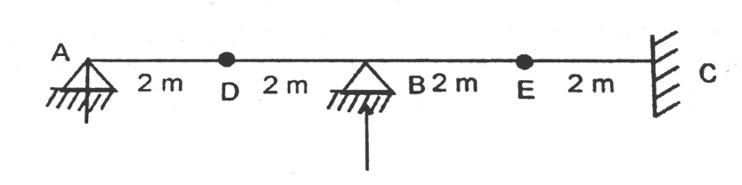
- Two wheel loads of 40 kN and 20 kN spaced 4 m apart cross a girder of 10 m span, with the 20 kN load leading from left to right. Draw the maximum shear force and bending moment diagrams. (Nov/Dec 2013)
- A live load of 15 kN/m, 5 m long moves on a girder simply supported on a span of 13 m. Find the maximum bending moment that can occur at a section 6 m from the left end. (May/June 2014)
- Explain the procedure and applications of Begg’s Deformeter. (May/June 2014)
- Using Muller Breslau principle, draw the influence line for the bending moment at D, the middle point of span AB of a continuous beam shown in Fig. Compute the ordinates at 1 m interval. Determine the maximum hogging bending moment in the beam when two concentrated loads of 8 kN each and separated by a distance 1 m passes through the beam from left to right. (Nov/Dec 2015)
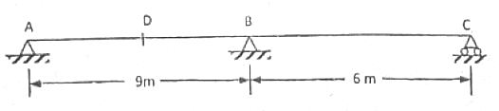
- A simply supported beam has a span of 16 m, and is subjected to a UDL (dead load) of 5 kN/m and a UDL (live load) of 8 kN/m (longer than the span) travelling from left to right. Draw the ILD for shear force and bending moment at a section 4 m from the left end. Use these diagrams to determine the maximum shear force and bending moment at the section. (May/June 2012)

UNIT-III ARCHES
PART-A
Two Mark Question With Answer

1.What is an arch? Explain.
An arch is defined as a curved girder, having convexity upwards and supported at its ends.

The supports must effectively arrest displacements in the vertical and horizontal directions. Only then there will be arch action.

2. State Eddy’ theorem.

Eddy’s theorem states that “ The bending moment at any section of an arch is proportional to the vertical intercept between the linear arch (or theoretical arch) and the centre line of the actual arch.”

3.What is the degree of static indeterminacy of a three hinged parabolic arch?

For a three hinged parabolic arch, the degree of static indeterminancy is zero. It is statically determinate.

4.Explain with the aid of a sketch, the normal thrust and radial shear in an arch rib.

Let us take a section X of an arch. (fig (a) ). Let θ be the inclination of the tangent at X. If H is the horizontal thrust and V the vertical shear at X, from the free body of the RHS of the arch, it is clear that V and H will have normal and radial components given by,
N= H cosθ + V sinθ
R= V cosθ - H sinθ

5.Which of the two arches, viz. circular and parabolic is preferable to carry a uniformly distributed load? Why? Parabolic arches are preferably to carry distributed loads. Because, both, the shape of the arch and the shape of the bending moment diagram are parabolic. Hence the intercept between the theoretical arch and actual arch is zero everywhere. Hence, the bending moment at every section of the arch will be zero.

The arch will be under pure compression which will be economical.

6.What is the difference between the basic action of an arch and a suspension cable?

An arch is essentially a compression member which can also take bending moments and shears. Bending moments and shears will be absent if the arch is parabolic and the loading uniformly distributed.

A cable can take only tension. A suspension bridge will therefore have a cable and a stiffening girder. The girder will take the bending moment and shears in the bridge and the cable, only tension.
Because of the thrusts in the cables and arches, the bending moments are considerably reduced.

If the load on the girder is uniform, the bridge will have only cable tension and no bending moment on the girder.

7.Under what conditions will the bending moment in an arch be zero throughout.
The bending moment in an arch throughout the span will be zero, if
(i) the arch is parabolic and (ii) the arch carries uniformly distributed load throughout the span.

8. Indicate the positions of a moving point load for maximum negative and positive bending moments in a three hinged arch.

onsidering a three hinged parabolic arch of span ‘l’ and subjected to a moving point load W, the position of the point load for

- Maximum negative bending moment is 0.25l from end supports.
- Maximum positive bending moment is 0.211l from end supports.

9.Sketch the ILD for the normal thrust at a section X of a symmetric three hinged parabolic arch. Normal thrust at X is given by P = H cosθ + V sinθ,

where θ is the inclination of tangent at X.

l cosθ
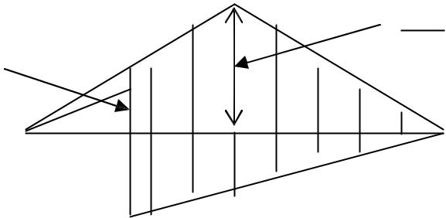
4y_{c}
- sinθ

l
(l-x)sinθ
l

10. Distinguish between two hinged and three hinged arches.

Sl.No. | Two hinged arches | Three hinged arches
1. | Statically indeterminate to first degree | Statically determinate
2. | Might develop temperature stresses | Increase in temperature causes increase in
 |  | central rise. No stresses.
3. | Structurally more efficient | Easy to analyse. But in costruction, the central
 |  | hinge may involve additional expenditure.
4. | Will develop stresses due to sinking of | Since this is determinate, no stresses due to
 | supports | support sinking.

11. Explain rib-shortening in the case of arches.

In a two hinged arch, the normal thrust which is a compressive force along the axis of the arch will shorten the rib of the arch. This in turn will release part of the horizontal thrust. Normally, this effect is not considered in the analysis (in the case of two hinged arches).

Depending upon the importance of the work we can either take into account or omit the effect of rib shortening. This will be done by considering (or omitting) strain energy due to axial compression along with the strain energy due to bending in evaluating H.

12.How will you calculate the horizontal thrust in a two hinged parabolic arch if there is a rise in temperature.

Horizontal thrust = |  | l α TEI
 |  | ^{l} y²dx
0
where l = span length of the arch
y = rise of the arch at any point x

  - = coefficient of thermal expansion T = change in temperature

E = Young’s Modulus of the material of the arch I = Moment of inertia

13.What are the types of arches according to the support conditions.
    - Three hinged arch

  - Two hinged arch iii. Single hinged arch
      - Fixed arch (or) hingeless arch

14.What are the types of arches according to their shapes.
      - Curved arch
      - Parabolic arch
      - Elliptical arch
    - Polygonal arch

PART-B (16 MARK)
- A circular three hinged arch of span 25m with a central rise of 5m is hinged at the crown and the end supports. It carries a point load of 100kN at 6m from the left support. Examine and Calculate
i. The reaction at the supports (8 Marks)
ii. Moment at 5m from the left support (8 Marks) MAY/JUNE 2012
- A three hinged parabolic arch of span 30m and rise 5m carries a uniformly distributed load of 40kN per meter on the whole span and a point load of 200kN at a distance of 5m from the right end. Find and examine the horizontal thrust, resultant reaction, bending moment and normal thrust at a section 5m from the left end. MAY/JUNE 2012
- A three hinged circular arch of span 16m and rise 4m is subjected to two point loads of 100 kN and 80 kN at the left and right quarter span points respectively. Examine and find the reaction at the supports. Find also the bending moment, radial shear and normal thrust at 6m from left support. MAY/JUNE 2011
- A two hinged parabolic arch of span 25m and rise 5m carries a udl of 38kN/m covering a distance of 10m from the left end. Calculate the
i) Horizontal thrust (5 marks)
ii) The reactions at the hinges (5 marks)
iii) Maximum negative moment (6 marks) MAY/JUNE 2011
- Three hinged parabolic arch has supports at different levels having span 20m and carries a UDL of 30kN/m over the left half of the span. The left support is 5m below the crown and the right support is 4m below the crown. Draw the BMD. Also analyze and find the normal thrust and radial shear at a section 4m from the left support. APRIL/MAY 2011
- A parabolic arch hinged at the ends has a span of 60m and a central rise of 12m. A concentrated load of 8 kN acts at 15m from the left hinge. The second moment of area varies as the secant of the inclination of the arches calculate the horizontal thrust and the reactions at the hinge. Also calculate the net bending moment at the section. APRIL/MAY 2011
- A parabolic two hinged arch of span 60 m and central rise of 6 m is subjected to a crown load of 40 kN. Allowing rib shortening and temperature rise of 20⁰C, determine horizontal thrust, H. I_{C} = 6 x10⁵, A_{C} = 1000 cm², E = 1 x 10⁴ MPa, α = 11 x 10⁻⁶/⁰C, I = I_{C} secθ. (CE2302 –Nov/Dec 2010)
- A parabolic 3 hinged arch carries a udl of 25 kN/m on the left half of the span. It has a span of 16 m and a central rise of 3 m. Determine the resultant reaction at supports. Find also the bending moment, normal thrust and radial shear at a section 4 m from the left support. (CE2302 –Nov/Dec 2010) two hinged parabolic arch of span 30m and central rise 5m carries a uniformly
distributed load of 20kN/m over the left half of the span. Determine the position and value of maximum bending moment. Also find the normal thrust and radial shear force at the section. Assume that the moment of inertia at a section varies as secant of the inclination at the section.
- A three hinged parabolic arch of span 100m and rise 20m carries a uniformly
distributed load of 2KN/m length on the right half as shown in the figure. Determine
the maximum bending moment in the arch.

- symmetrical three hinged arch has a span of 50 & rise 5m. Find and examine the maximum bending moment at a quarter point of the arch caused by a uniformly distributed load of 10kN/m which occupies any portion of the span. Indicate the position of the load for this condition.
- three hinged parabolic arch has supports at different levels having span 20m and carries a UDL of 30kN/m over the left half of the span. The left support is 5m below the crown and the right support is 4m below the crown. Draw the BMD. Also analyze and find the normal thrust and radial shear at a section 4m from the left support.
- parabolic two hinged arch has a span of 40m and a rise of 5m. A concentrated load 10kN acts at 15m from the left support. The second moment of area varies as the secant of the inclination of the arch axis. Calculate the horizontal thrust and reactions at the hinge. Also calculate maximum bending moment at the section.
- Evaluate the horizontal thrust in a two hinged parabolic arch of span 10m and rise 25m carrying an UDL of 24 kN/m over the left half span, assuming secant variation of its sectional moment of area. Also calculate the Bending Moment at the crown and draw the BMD.
- A two hinged parabolic arch of span 25m and rise 5m carries a udl of 38kN/m covering a distance of 10m from the left end. Calculate the
i) Horizontal thrust (5 marks)
ii) The reactions at the hinges (5 marks)
iii) Maximum negative moment (6 marks)

UNIT-1V
SLOPE-DEFLECTION METHOD
PART-A
Two Mark Question With Answer

- What are the assumptions made in slope-deflection method?
  - Between each pair of the supports the beam section is constant.

  - The joint in structure may rotate or deflect as a whole, but the angles between the members meeting at that joint remain the same.

- How many slope deflection equations are available for a two span continuous beam?
There will be 4 nos. of slope-deflection equations, two for each span.

- What is the moment at a hinged end of a simple beam? Moment at the hinged ends of a simple beam is zero.

- What are the quantities in terms of which the unknown moments are expressed in slope-deflection method?

In slope-deflection method, unknown moments are expressed in terms of
  - slopes (θ) and (ii) deflections (∆)

5. How do you account for sway in slope deflection method for portal frames?

Because of sway, there will br rotations in the vertical members of a frame. This causes moments in the vertical members. To account for this, besides the equilibrium, one more equation namely shear equation connecting the joint-moments is used.

6. Who introduced slope-deflection method of analysis?
Slope-deflection method was introduced by Prof. George A.Maney in 1915.

7. Mention any three reasons due to which sway may occur in portal frames.

Sway in portal frames may occur due to (i) unsymmetry in geometry of the frame (ii) unsymmetry in loading or (iii) Settlement of one end of a frame.

8. How many slope-deflection equations are available for each span?

Two numbers of slope-deflection equations are available for each span, describing the moment at each end of the span.

9. State the limitations of slope deflection method.

- It is not easy to account for varying member sections
- It becomes very cumbersome when the unknown displacements are large in number.

10.Why is slope-deflection method called a ‘displacement method’?

In slope-deflection method, displacements (like slopes and displacements) are treated as unknowns and hence the method is a ‘displacement method’.

11. Define degrees of freedom.

In a structure, the number of independent joint displacements that the structure can undrgo are known as degrees of freedom.

12.A rigid frame is having totally 10 joints including support joints. Out of slope-deflection and moment distribution methods, which method would you prefer for analysis? Why?

Moment distribution method is preferable.

If we use slope-deflection method, there would be 10 (or more) unknown displacements and an equal number of equilibrium equations. In addition, there would be 2 unknown support momentsper span and the same number of slope-deflection equations. Solving them is difficult.

13.What is the basis on which the sway equation is formed for a structure?

Sway is dealt with in slope-deflection method by considering the horizontal equilibrium of the whole frame taking into account the shears at the base level of columns and external horizontal forces.
The shear condition isM_{AB} + M_{BA} – Ph +MCD + M_{DC} + P = 0lL

PART-B
IMPORTANT QUESTIONS

- A Continuous beam ABCD fixed at A and D and continuous over supports B and C. The span AB=5m carries a central concentrated load of 10kN. The span BC=4m carries a uniformly distributed load of 4 kN/m over the entire span of BC. The span CD=6m carries a non central concentrated load of 8 kN acting at a distance of 2m from the end D. Analyse the beam and draw bending moment diagram using slope deflection method and tabulate the results. MAY/JUNE 2011
- A continuous beam ABC consist of span AB=3m and BC=4m, the ends A and C being fixed. AB and BC carry uniformly distributed loads of intensity 4kN/m and 5kN/m respectively. The beam is of uniform section throughout. What are its support moments? Draw the bending moment diagram for the beam. MAY/JUNE 2010
- Examine the given continuous beam and draw its BMD and SFD using slope deflection method. EI=Constant. MAY/JUNE 2010

- Analyse the continuous beam ABCD shown in fig. by slope deflection method and summarize its results .Take EI=Constant. Also sketch the shear force and Bending Moment diagram. NOV/DEC 2011

- Analyse the continuous beam shown in fig. by slope deflection method and evaluate its results. Support B settles by 8mm and C settles by 12 mm. I=60000cm4, E=210x106 kN/m2. Draw the SFD and BMD. NOV/DEC 2011

- Analyse the portal frame ABCD shown in Fig. by slope deflection metjod and draw the bending moment diagram. Take EI = Constant. (CE2302-Nov/Dec 2010)

- Analyse the portal frame shown in Fig using slope deflection method. (CE2302-Nov/Dec 2012)

- A continuous beam ABC consists of spans AB and BC of 5 m length in each. Both the ends of the beam are fixed. The span AB carries a point load of 15 kN at its middle point. The span BC carries a point load of 25 kN at its middle point. Find the moments and reactions at the supports. Assume the beam is of uniform section. Use Slope deflection method. (CE2302-Nov/Dec 2012)
- ABC is a continuous beam with constant EI throughout its length. The end supports A and C are fixed and the beam is continuous over middle support B. Span BC is uniformly loaded with 15 kN/m while a concentrated vertical downward load of 125 kN acts at the midspan of AB. Calculate the moments by slope deflection method. (CE2302-Nov/Dec 2013)
- A continuous beam ABC 16 m long is loaded with point load of 9 kN at 3 m from A and a point load of 10 kN at the midspan of BC. Span AB=BC=8 m. Using Slope deflection method, compute the end moments and plot the bending moment diagram. The beam has constant EI for both the spans. (CE2302- May/June 2014)
- Examine the given continuous beam and draw its BMD and SFD using slope deflection method.

- Analyze the portal frame shown in fig. by slope deflection method.

- A continuous beam ABC consist of span AB=5m and BC=6m, the ends A and C being fixed. AB and BC carry uniformly distributed loads of intensity 10kN/m and 15kN/m respectively. The beam is of uniform section throughout. What are its support moments? Draw the bending moment diagram for the beam.
- A continuous beam ABC consist of span AB=3m and BC=3m, the ends A and C being fixed. AB and BC carry point loads of intensity 10kN and 15kN respectively. The beam is of uniform section throughout. What are its support moments? Draw the bending moment diagram for the beam.
- A symmetrical portal frame ABCD is hinged at A and D, and is loaded with a udl of ‘w’ kN/m over the span BC. Span AB=CD=L m and BC = 2L m. Treating joints B and C as rigid, calculate the moments at A, B, C and D using Slope deflection method. Draw the bending moment diagram. EI is constant.
- Analyse the continuous beam ABC shown in Fig. by slope deflection method and sketch the bending moment diagram. Take EI = Constant. (CE2302-Nov/Dec 2010)

UNIT-V
MOMENT DISTRIBUTION METHOD
PART-A
Two Mark Question With Answer

- What is the difference between absolute and relative stiffness?
Absolute stiffness is represented in terms of E, I and l, such as 4EI / l.
Relative stiffness is represented in terms of I and l, omitting the constant E.
Relative stiffness is the ratio of stiffness to two or more members at a joint.

2. Define: Continuous beam.

A Continuous beam is one, which is supported on more than two supports. For usual loading on the beam hogging ( - ive ) moments causing convexity upwards at the supports and sagging ( + ve ) moments causing concavity upwards occur at mid span.

- What are the advantages of Continuous beam over simply supported beam?

  - The maximum bending moment in case of continuous beam is much less than in case of simply supported beam of same span carrying same loads.

  - In case of continuous beam, the average bending moment is lesser and hence
lighter materials of construction can be used to resist the bending moment.

- In a member AB, if a moment of –10 KNm is applied at A, what is the moment carried over to B? Carry over moment = Half of the applied moment

∴Carry over moment to B = -10/5 = -5 KNm

5. Define: Moment distribution method.( Hardy Cross mrthod).

It is widely used for the analysis of indeterminate structures. In this method, all the members of the structure are first assumed to be fixed in position and fixed end moments due to external loads are obtained.

6. Define: Stiffness factor.

It is the moment required to rotate the end while acting on it through a unit rotation, without translation of the far end being

- Simply supported is given by k = 3 EI / L (ii) Fixed is given by k = 4 EI / L

where, E = Young’s modulus of the beam material.

I = Moment of inertia of the beam
L = Beam’s span length.

7. Define: Distribution factor.

When several members meet at a joint and a moment is applied at the joint to produce rotation without translation of the members, the moment is distributed among all the members meeting at that joint proportionate to their stiffness.

Distribution factor = Relative stiffness / Sum of relative stiffness at the joint

If there is 3 members, Distribution factors = |  | k₁ | , |  | k₂ | , |  | k3
_{k1 + k2 + k3k1 + k2 + k3}
_{k1 + k2 + k}3

8.Define: Carry over moment and Carry over factor.

Carry over moment: It is defined as the moment induced at the fixed end of the beam by the action of a moment applied at the other end, which is hinged. Carry over moment is the same nature of the applied moment.

Carry over factor ( C.O) : A moment applied at the hinged end B “ carries over” to the fixed end A, a moment equal to half the amount of applied moment and of the same rotational sense. C.O =0.5

9. Define Flexural Rigidity of Beams.

The product of young’s modulus (E) and moment of inertia (I) is called Flexural Rigidity (EI) of Beams. The unit is N mm ².

10. Define: Constant strength beam.

If the flexural Rigidity (EI) is constant over the uniform section, it is called Constant strength beam.

11.What is the sum of distribution factors at a joint? Sum of distribution factors at a joint = 1.

12.Define the term ‘sway’.

Sway is the lateral movement of joints in a portal frame due to the unsymmetry in dimensions, loads, moments of inertia, end conditions, etc.

- What are the situations where in sway will occur in portal frames?
    - Eccentric or unsymmetric loading
    - Unsymmetrical geometry
    - Different end conditions of the columns
    - Non-uniform section of the members
    - Unsymmetrical settlement of supports
    - A combination of the above

PART-B
IMPORTANT QUESTIONS
- Draw the bending moment diagram and shear force diagram for the continuous beam shown in figure below using moment distribution method. EI is constant. (May/June 2014) (May/June 2009) (May/June 2010)
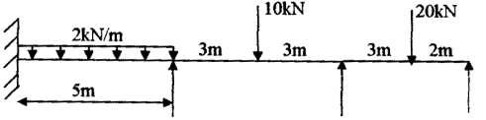

2. A beam ABCD, 16m long is continuous over three spans AB=6m, BC = 5m & CD = 5m the supports being at the same level. There is a udl of 15kN/m over BC. On AB, is a point load of 80kN at 2m from A and CD there is a point load of 50 kN at 3m from D, calculate the moments by using moment distribution method. Assume EI constant.
3. Analyze a continuous beam shown in Fig (3) by Moment distribution method. Draw BMD. (May/June 2010) (May/June 2011) .(Nov/Dec 2007 )
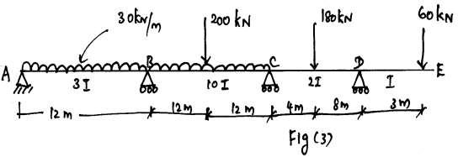

4 A portal frame ABCD, fixed at ends A and D carriers a point load 2.5Kn as shown in figure .Analyze the portal by Moment distribution method and draw the BMD.

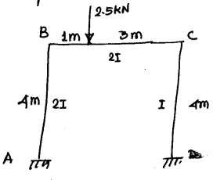

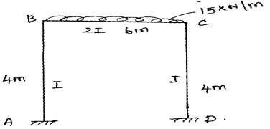
5.Analyze the frame given in figure by Moment distribution method and draw the B.M.D(May/June 2014) (May/June 2011)

- Analysis the frame shown in figure by moment Distribution Method.Draw bending moment diagram.(Nov/Dec 2011 ) (May/June 2008)

- Analyze a continuous beam shown in Fig by Moment distribution method. Draw BMD. (Nov/Dec 2012)

- A continuous beam ABCD of spans AB=3m, BC = 4m & CD = 3m fixed at the supports A & D & continuous over the supports B & C. using moment distribution method calculate the moments induced at the ends if the support B settles by 25mm . There is a udl of 15kN/m over BC. On AB, is a point load of 80kN at 2m from A and CD there is a point load of 50 kN at 1m from D, by. Assume EI constant. E=2x10⁶ N/mm² I=4x10⁶ mm⁴. (Nov/Dec 2011 )

