AE 2202- AERO ENGINEERING THERMODYNAMICS

QUESTION BANK

UNIT-I
BASIC THERMODYNAMICS

PART –A

1) What is system and surrounding?

System- it is a quantity of matter or region in space upon which the attention is concentrated in the analysis of a problem. Surrounding -Everything external to the system is the surrounding.

2) Distinguish between Open and Closed system
Closed system – system of fixed mass. No mass transfer, only energy transfer
Open system – System in which the mass crosses the boundary of the system.
Both mass and energy transfer occurs.

3) Define an isolated system
No interaction between the system and the surrounding

4) Define quasi static process?

When a process proceeds in such a manner that the system remains infinitesimally close to an equilibrium state, at all times is called as quasi static equilibrium.

5) Differentiate Extensive and intensive properties?

Intensive properties – Independent of the mass of the system eg, temperature Extensive properties – Depends on the mass of the system.

6) State Zeroth Law?

When a body A is in thermal equilibrium with body B and separately with body C, then the bodies B and C will be in thermal equilibrium.

7) State First law of Thermodynamics?

Energy can neither be created nor be destroyed during the process but it can be transferred from one form to another form.

- Write the two statements of the Second law of thermodynamics.
  - Kelvin Plank’s statements of Thermodynamics
  - Clausius statement

- State Kelvin Plank’s statements of Thermodynamics.

It is impossible for any device that operates on a cycle to receive the heat from the single reservoir and produce a net amount of work.

10) State Clausius statements of Thermodynamics.

It is impossible to construct a device that operated in a cycle and produces no effect other than the transfer of heat from the lower temperature body to a higher temperature body.

PART –B

- one kg of gas expands at CO&11stant pressure from 0.085 m3 to 0.13m3.if the initial temperature of the gas is 22.5 °c. Find the final. Temperatures, net heat transfer, change in internal energy, pressure of gas.

- A certain quantity of gas is head at constant pressure from 35 °0 to 185°c.

Estimate the amount of hem transferred, ideal work done, change in internal energy, when the initial volume of the gas is 0.6 .

- 2kg of gas at a pressure of 1.5 bar. Occupies a volume of 2.5 m3. If this gas compresses isothermally to 1/3 times the initial volume. Find initial. Final temperature, work done, heat transfer.

- one kg of air is compressed polytropically (n=1.3) from 1 bar and 27 deg Celsius to 3 bar. Find I. work transfer, 2.Heat transfer, 3. Change in internal energy.

- Air is compressed in a reversible process in a cylinder from 100 kPa, 293 K to 500 kPa, according to PV1.3 = constant. Calculate the work done and heat

transfer per kilogram. Also calculate the change in the entropy. Assume air to be an ideal gas C_{p, air} = 1.005 kJ/kgk? γ = 1.4

- Explain in detail the second law of thermodynamics.

UNlT-2
AIR CYCLES

PART –A

1) Differentiate isothermal and isobaric process?
Isothermal – const temperature process Isobaric – Const pressure process

2) What is mean effective pressure?

It is the net work done on the piston, W, divided by the piston displacement volume, V1 – V2.
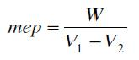

3) What is isentropic process?
Reversible adiabatic process ie., no change in entrophy.

4) What are gas power cycles?
Gas power cycles are,
- Carnot cycle
- Otto cycle
- Diesel cycle
- Dual cycle
- Brayton cycle

5) What is a thermodynamic cycle?

It is any process that brings the system back to its original state. It is essentially a closed cycle.

6) What is four stroke IC engine?

In spark ignition engines, the piston executes four complete strokes within the cylinder and the crank shaft completes two revolutions for each thermodynamic cycles.

- Differentiate Otto cycle and diesel cycle. th,Otto>th,Diesel

- What is thermal efficiency?

The thermal efficiency of a cycle is defined as the fraction of heat supplied to a thermodynamic cycle that is converted to work.
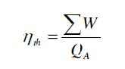

- What are the basic assumptions in power cycle?
  - The cycle does not involve any friction.
  - All the expansion and compression takes place in quasi equilibrium manner

  - The pipes connecting the various components are well insulated and the heat transfer is very negligible.
  - The change in potential and kinetic energy of the fluid is negligible.

- Mention the processes that under goes in Carnot cycle?
It is totally reversible process.
  - Isothermal heat addition
  - Isentropic expansion
  - Isothermal heat rejection
  - Isentropic compression

- Mention the processes in Ideal Otto cycle?
  - Isentropic compression
  - Constant volume heat addition
  - Isentropic expansion
  - Constant volume heat rejection

- What is compression ratio and specific heat ratio? Compression ratio =

Specific heat ratio, =

13) What is cut off volume?
It is the ratio of volume at constant pressure heat addition process in diesel cycle.

- What is the ideal cycle for gas turbine engines? Brayton cycle

PART B

- In an air standard otto cycle the compression ratio is 6. The compression begins 400C and 0.1 MPa. The heat supplied per kg of air at the end of the compression is 852 KJ. Find the temperature and pressure at all salient points and the efficiency.

- An ideal diesel cycle using air as the working fluid has a compression ratio of 16 and a cut off ratio of 2. The intake conditions are 100 kPa, 200 C and 2000 cm3. Determine

(i)ss The net work output
  - Thermal efficiency of cycle
  - The mean effective pressure.

- Represent the processes of Brayton cycle by P-V and T – S diagram.

- Derive an expression for thermal efficiency of Brayton cycle as a function of pressure ratio.

- A gas turbine plant operates on the Brayton cycle between Tmin = 300 K and Tmax = 1073 K. Find the maximum work done per kg of air and the corresponding cycle efficiency. Compare the efficiency with carnot efficiency operating between the same two temperature.

- Show the Otto cycle on P – V and T –S diagrams. Derive expressions for the efficiency and mean effective pressure and plot their variation with compression ratio.

- In an air standard Diesel cycle, the compression ratio is 16, and at the beginning of isentropic compression, the temperature is 288 K, and the pressure is 0.1 MPa. The maximum temperature in the cycle is 1753 K. Calculate
  - The pressure and temperature at all the four important points in the cycle.
  - The cycle efficiency.

- A Carnot heat engine operates between the temperatures of 300 K and 900 K. If the heat received from the higher temperature source is 1000 kJ, calculate the works output.

- An ideal Otto cycle has a compression ratio of 8. At the beginning of the compression process, air is at 100 kPa and 17º, and 800 kJ/kg of heat is transferred to air during the constant-volume heat addition process. Accounting for the variation of specific heats of air with temperature, determine (a) the maximum temperature and pressure that occur during the cycle, (b) the net work output, (c) the thermal efficiency, and (d ) the mean effective pressure for the cycle.

UNIT- 3

THERMODYNAMICS OF ONE DIMENTIONAL FLUID FLOW PART A

1) Give the general form of continuity equation.¤ = µ

- Give the general form of momentum equation?

    - +
¤
= const

- Give the energy equation?

ℎ + ₂ = µ

- Draw the T-S diagram for Rankine cycle.
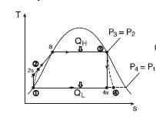

5) What is Rankine efficiency?
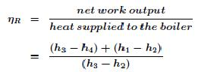

6) Give the isentropic efficiency for the expansion and the compression process?

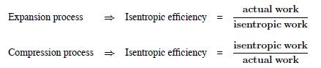

7) What is chocked flow?

When the sonic condition was attained in the throat of the nozzle, further decrease in the pressure in the nozzle exit will not affect the convergent section of the nozzle. This flow is chocked flow.

8) What is specific impulse?
Specific impulse is the change in momentum per unit mass for rocket fuels

9) What is propulsive efficiency and propulsive power?

Propulsive power,
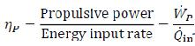

Propulsive efficiency,

PART B

- An aircraft flies at 960 kmph. One of its turbojet engines takes in 40 kg/s of air and expands the gases to the ambient pressure. The air – fuel ratio is 50 and the lower calorific value of the fuel is 43 MJ/kg. For maximum thrust power determine

(i)Jet velocity
- Thrust
- Specific thrust
- Thrust power
- Propulsive, thermal and overall efficiencies and
- TSFC

  - Derive the area – velocity ratio for the isentropic flow in a variable area duct.

  - Explain the isentropic flow of ideal gas through the nozzle in detail.

  - Briefly explain the application of continuity, energy and momentum equation.

  - With neat sketch explain the principle and operation of thrust rocket motor.

UNIT IV

REFRIGERATION AND AIR CONDITIONING
PART A
1) What is refrigeration?

Refrigeration is a process of removal of heat from a space where it is unwanted and transferring the same to the surrounding environment where it makes little or no difference.

2) What do you mean by air conditioning?

It is the process of simultaneous control of temperature, humidity, cleanliness and air motion.

3) Give the relationship between refrigeration and air conditioning?
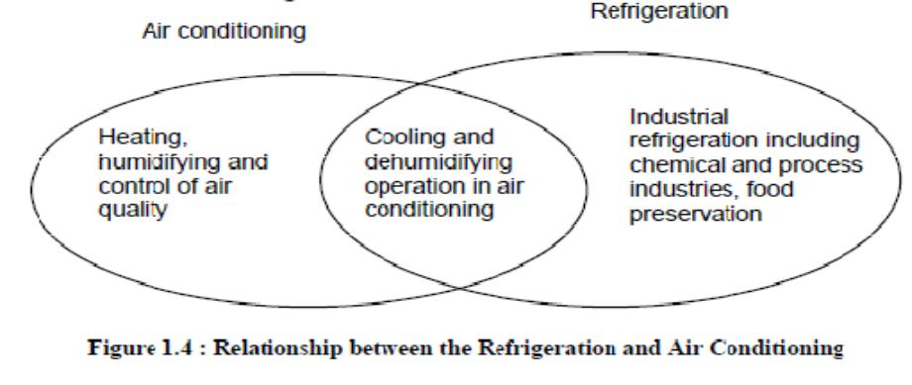

4) Define the term COP.

The coefficient of performance (COP) is the ratio of the refrigeration effect to energy input.

5) What is a ton of refrigeration?

It is equivalent to the rate of heat transfer needed to produce 1 ton (2000 lbs) of ice at 32 0F from water at 32 0F in one day, i.e., 24 hours

6) What is refrigeration effect?
It is the amount of cooling produced by the system.

- What is difference between a heat pump and refrigerator? Heat pump is the reverse refrigerator.
^{§)}-
!"
^{= 1 + §)}$-%$&'-$ ($

- Mention some refrigerants and give properties.

Some of the refrigerants are R11, R12, R13, R14, R21, R22, R113, R114, methyl chloride, carbon dioxide, water. Some of the properties are,

- The critical temperature of the refrigerant should be as high as possible above the condensing temperature
- The specific heat of the liquid should be as small as possible
- Large enthalpy of vaporization.

  - High conductivity

- What is refrigerant?

Refrigerant is the fluid used for heat transfer in a refrigerating system that absorbs heat during evaporation from the region of low temperature and pressure, and releases heat during condensation at a region of higher temperature and pressure.

PART B

- Two Carnot engines work in series between the sources and sink temperature of 500 K and 300 K. If both engines develop equal power. Determine the intermediate temperature.

- A refrigerating machine using R12 works between – 180 C and 370 C. the enthalpy of liquid at 370 C is 71 kJ/kg. The enthalpies of R12 entering and leaving the compressor are 183 kJ/kg and 210 kJ/kg respectively. The rate of circulation of refrigerant is 2 kg/min and efficiency of compressor is 0.85. Determine :

  - Capacity of the plant in tons of refrigeration
  - Power required running the plant.
  - COP of the plant.

- Two reversible heat engines A and B are arranged in series. A rejecting heat directly to B. Engine A receives 200 KJ at a temperature of 4210 C from a hot source, while engine B is in communication with a cold sink at a temperature of 4.40 C. If the work output of A is twice that of B, find the efficiency of the each engine.

- Steam at 20 bar, 633 K is expanded in a steam turbine to 0.08 bar. It then enters a condenser, where it is condensed to saturated liquid water. The pump feeds back the water into their boiler. Assuming ideal processes, find per kg of steam, the network and cycle efficiency.

- With the help of a block diagram, explain the working of the simple vapour compression refrigeration system. Show the cycle on T-S and p-h diagrams. Derive expression for C.O.P in terms of the enthalpy.

- Write notes on properties of Refrigerants.

- Distinguish between simple vapour compression and vapour absorption refrigeration's systems.

UNIT V
AIR COMPRESSOR
PART A

1) What is an air compressor?

An air compressor is a device that converts power (usually from an electric motor, a diesel engine or a gasoline engine) into kinetic energy by compressing and pressurizing air, which, on command, can be released in quick bursts.

- What are the classifications of compressor?
  - Axial compressor
  - Reciprocating compressor

- Define isentropic efficiency of a compressor?

It is the ratio of work input required to raise the pressure of a gas to a specified value in an isentropic manner to the actual work input.

4) What is isothermal efficiency?

It is the ratio of the required work input to the compressor for the reversible isothermal to the actual case.

PART –B

- A centrifugal air compressor delivers 15 kg of air, per minute. The inlet and outlet conditions of air are V1 = 10m/s, p1 = 1 bar vs1 = 0.5 m3/kg and V2 = 80 m/s, p2 = 7 bar, vs2 = 0.15 m3/kg. The increase in enthalpy of air passing through the compressor is 160 kJ/kg and heat loss to the surroundings is 720 KJ/min. Find the power required to drive the compressor. Assume that inlet and discharge lines are at the same level.

- A single stage double acting air compressor of 62.5 kW I.P. running at 120 r.p.m. takes air at 1 bar and delivers at 10 bar. Assuming the law of expansion and compression as pv 1.35 = constant, find the diameter and stroke of the cylinder.

- Show that in the case of reciprocating compressor, the work input is independent clearance ratio. Explain with the help of p – v diagrams.

- Derive an expression for the volumetric efficiency of a two – stage reciprocating compressor in terms of clearance ratio and pressure ratio.

- In an aircraft cooling system, air enters the compressor at 0.1 MPa, 40C and is compressed to 0.3 MPa with an isentropic efficiency of 72%. After being cooled to 550C at constant pressure in a heat exchanger the air then expands in a turbine to 0.1 MPa with an isentropic efficiency of 78%. The low temperature air absorbs a cooling load o 3 tonnes of refrigeration at constant pressure before reentering the compressor which is driven by the turbine. Assuming air to be ideal gas determine the C.O.P of refrigerator. Represent the system schematically and by T – S diagram. Also estimate the driving power required and the air mass flow rate.

- Discuss in detail various types of Air Compressors with suitable diagrams.

- A two stage air compressor with inter cooling takes in air at 1 bar and 270C. The compression process is polytrophic of index 1.3. The compressed air is delivered at 9 bar. Calculate per kg of air, the maximum work done and heat rejected to the intercooler.

- With the help of a neat sketch explain the construction and working of a reciprocating air compressor. Derive an expression for the work of compression in terms of pressure ration and clearance ratio.

