INDUSTRIAL AERODYNAMICS

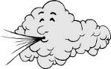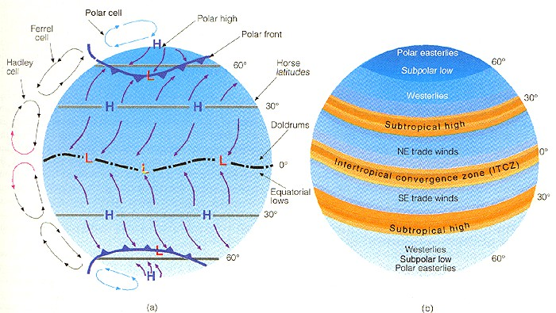

Unit I

Wind Energy Collectors

INTRODUCTION

Air Movement

Wind Air Current Circulation

The horizontal movement of air along the earth’s surface is called a Wind. The vertical movement of the air is known as an air current. Winds and air current together comprise a system of circulation in the atmosphere.

TYPES OF WINDS

On the earth’s surface, certain winds blow constantly in a particular direction throughout   
the year. These are known as the ‘Prevailing Winds’. They are also called the Permanent or the   
Planetary Winds. Certain winds blow in one direction in one season and in the opposite direction   
in another. They are known as Periodic Winds. Then, there are Local Winds in different parts of   
the world.

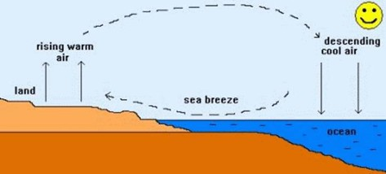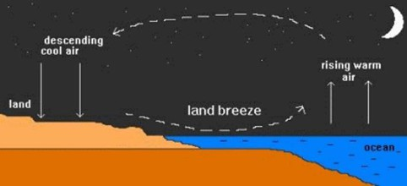

1. Planetary Winds:

There are three main planetary winds that constantly blow in the same direction all around the world. They are also called prevailing or permanent winds.

1.Trade Winds:

Blow from the subtropical high pressure belt towards the Equator. They are called the   
north-east trades in the northern hemisphere and south-east trades in the southern hemisphere.

2.Westerly winds:

Blow from the same subtropical high pressure belts, towards 60˚ S and 60˚ N latitude. They are called the sought Westerly wind sin the northern hemisphere and North Westerly winds in the southern hemispheres.

3.Polar Winds

Blow from the polar high pressure to the sub polar low pressure area. In the northern   
hemisphere, their direction is from the north-east. In the southern hemisphere, they blow from   
the south-east.

2. Periodic Winds

These winds are known to blow for a certain time in a certain direction - it may be for a part of a day or a particular season of the year.

Example 1: Land and Sea breeze

During the day, near an ocean, sea or   
lake, the land heats up faster than the water.   
The air above the land also gets heated. As   
warm air rises, it draws cooler air from over the   
water to blow towards the land, creating a sea   
breeze.

At night, the opposite conditions   
prevail. The land loses heat rapidly while the   
sea is still warm. The air resting over the land   
is cold while the air resting over the sea is   
warm and rises creating a low pressure area. A   
land breeze thus blows in from the high

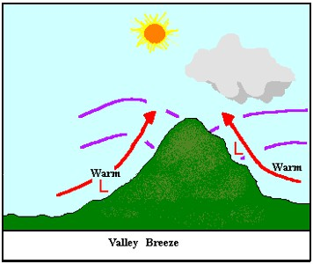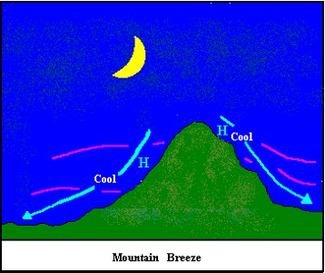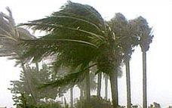

pressure over the land towards the water. These land and sea breezes maintain air circulation in the coastal areas and have a moderating effect on the temperatures.

Example 2: Monsoons

They are land and sea breezes on a large scale. The   
word ‘monsoon’ comes from the Arabic word ‘mausim’   
meaning weather. They change or reverse their directions   
according to the seasons. Strong contrasts in temperature   
between summer and winter because great differences in

pressure conditions over the interior parts of the big continents like Asia. Hence winds blow onshore from a sea to the land in summer and from land to the sea in winter. The onshore winds bring moisture and heavy rainfall while the offshore winds are relatively dry. Although the monsoons are associated with south-east USA, Australia, parts of South America and East Africa they are most effective over south-east Asia and India blows from June to September while the winter monsoons prevails from October to December.

Example 3: Mountain and Valley Breezes (tertiary circulation)

During the day, the valley heats up, so the warm less dense air flows up the mountain, creating a valley breeze.

At night, the mountain will cool off faster than the valley, so the cool mountain air descends because it is more dense, creating a mountain breeze.

3. Local Winds

On the earth’s surface, some local variations of temperature on the land may cause   
changes in air pressure. As a result local winds blow. They blow in a particular season and are

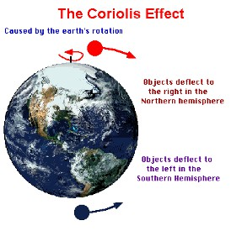

known by the local names in that region. For instance, the hot dry, dusty winds that blow in the month of May and June over the northern plains in India are called Loo.

Some other examples of local winds that bring unusual changes in the temperature of the   
places are the warm Chinooks that devour the snow on the leeward side of the Rocky mountains   
of North America, the Foehn in the Swiss Alps and the hot, sand laden Siocco that blows over   
Southern Europe from the Sahara and causes ‘blood rain’ which is actually desert sand and dust   
that falls with the rain.

There are still other types of winds that are irregular and keep changing their direction and blow in an area for a very short time, such as tornadoes, typhoons and cyclones.

CAUSES OF VARIATION OF WINDS

The movement and the speed of wind are affected by three main factors

1. Pressure Gradient Force

• The change in pressure measured across a given distance is called a "pressure gradient".

• The pressure gradient results in a net force that is directed from high to low pressure. The   
 magnitude of the force depends on

1) How great the pressure difference is between the high pressure area and low pressure area

2) how far apart the two pressure areas are from each other. A large difference in pressure combined   
with pressure areas that are close to each other will cause a huge pressure gradient which produces a   
strong wind.

2. Coriolis Effect

The Coriolis Effect (also called the Coriolis force) is defined as the apparent deflection of objects (such as airplanes, wind, missiles, and ocean currents) moving in a straight path relative to the earth's surface.

If the Earth did not rotate upon its axis, winds would follow the direction of the pressure gradient. But the rotation produces another force other than the pressure force. It is called the ‘Coriolis force’.

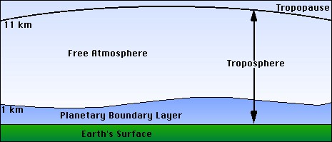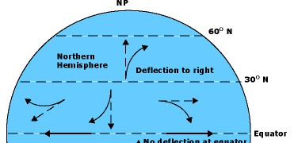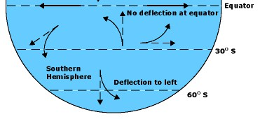

■ Causes air to move in a curved path

■ It is caused by the Earth spinning on its axis

■ The Earth spins fastest at the equator, and

slowest near the poles

■ As air moves from the equator to the pole, it

will travel east faster than the land beneath it   
 causing the air to follow a curved path   
 ■ So the Coriolis effect causes wind flowing

from high pressure to low pressure to curve as the wind moves

■ In the Northern Hemisphere, the Coriolis effect causes things to curve to the Right   
■ In the Southern Hemisphere, the Coriolis effect causes things to curve to the Left

3. Friction

The surface of the Earth exerts a frictional drag on the air blowing just above it. This friction can act to change the wind's direction and slow it down -- keeping it from blowing as fast as the wind aloft. Actually, the difference in terrain conditions directly affects how much friction is exerted. For example, a calm ocean surface is pretty smooth, so the wind blowing over it does not move up, down, and around any features. By contrast, hills and forests force the wind to slow down and/or change direction much more.

ATMOSPHERIC BOUNDARY LAYER

The planetary boundary layer (PBL), also known as the atmospheric boundary layer (ABL), is the lowest part of the atmosphere and its behavior is directly influenced by its contact with a planetary surface. Above the PBL is the "free atmosphere" where the wind is approximately geostrophic (parallel to the isobars) while within the PBL the wind is affected by surface drag. The free atmosphere is usually non-turbulent.

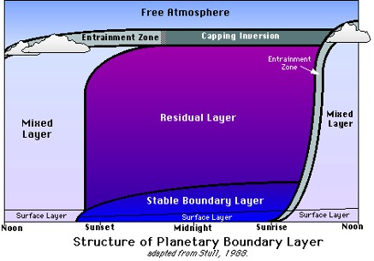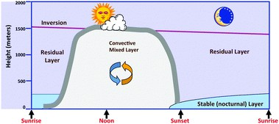

Structure of the Planetary Boundary Layer

The PBL can be subdivided into four separate component layers: the surface layer, the mixed layer, the stable layer, and the residual layer. We will discuss each of these in turn.

(or)

1. Mixed Layer(or) Convective Boundary Layer (CBL)

During the daytime, surface heating leads to convective motion in the PBL. Heat transfer   
from the surface forms rising warm air. Radiative cooling from clouds forms sinking cooler air.   
Convective motion also leads to significant turbulence which mixes the air within this layer.   
Because of the convective motion and significant mixing of air, this sub-layer is called the   
convective layer or mixed layer. Above the mixed layer is a stable layer which prevents the   
continued upward motion of thermals. This stable layer also restricts turbulence, preventing   
frictional influences from reaching above the PBL. This stable layer is called the entrainment   
zone, because it is here where air from above the PBL entrains into the mixed layer. During the   
day, the mixed layer reaches heights over 1 km and make up the entire layer of the PBL above   
the surface layer. However, the mixed layer vanishes with the sun as the thermally driven   
convection ceases.

2. Stable Layer(or) Nocturnal Boundary Layer (NBL)

After sunset, convective motion dramatically decreases. However, the earth's surface still   
affects the air, and a stable boundary layer forms (also called the nocturnal boundary layer). This   
boundary layer is charaterized by light winds and weaker, more sporadic turbulence than in the   
mixed layer. The height of the PBL, therefore, decreases significantly during the night. Though   
the height of the nocturnal layer varies, it is usually less than half that of the mixed layer. Unlike

the mixed layer, the stable boundary layer does not have a well-defined top. Instead, it slowly merges with the residual layer.

3. Residual Layer

As turbulence and the mixed layer decay with sunset, the air maintains many of the state variables that the well-mixed air had. This layer is called the residual layer (because its properties are residuals of the mixed layer) and forms above the stable boundary layer. While the nocturnal boundary layer has a very stable profile, the residual layer tends to have more of a neutral profile. The residual layer does not have contact with the earth's surface, and so is not influenced by turbulent stresses like the stable boundary layer below it. The residual layer is bounded above by a capping inversion, which approximates the height of the daytime height of the mixed layer. This inversion simply prevents entrainment from aloft.

Because the residual layer is not influenced directly by the earth's surface (i.e. no turbulent stresses) it is not considered a boundary layer. However, we include it in our discussion for descriptive purposes. Only the mixed layer and stable layer are true boundary layers.

4. Mixing Height (or) Gradient Height (or) Height of the PBL

Because turbulent fluxes vary based on surface heating and other factors, the height of the PBL also varies. At night, the height of the PBL decreases dramatically as the stable layer forms. The height of the PBL is called the mixing height, because it is the height up to which the air is well-mixed. The mixing height is very important to air quality experts when determining air pollution dispersion. We will cover this more in the Focus on Air Quality section. Meanwhile, we'll look at some of the factors which influence the PBL.

EFFECT OF TERRAIN ON GRADIENT HEIGHT

For winds near ground surface, frictional effects play a significant role. Ground   
obstruction retard the movement of air close to the ground surface, causing a reduction in wind   
speed.

At some height above ground, the movement of air is no longer affected by ground   
obstruction. This height is called gradient height (ZG) which is a function of ground roughness.

The unobstructed wind speed is called gradient wind speed (VZg) and it is considered to be constant above gradient height.

Wind Profile

Wind profile is the variation of mean wind speed with height above ground.It is usually represented by power law or logarithmic law.

1. Power law

The Power law, which is used by some engineers to represent variation of wind speed with height, is an empirical equation, which for the case of mean speeds takes the form of

𝛼

𝑉𝑍

=[

𝑍

቉

𝑉 𝑍𝑔 𝑍𝑔

Where,

Vz, Vzg = the wind speeds at height Z, Zg respectively, and α = the power law exponent.

(Zg and α are functions of ground roughness)

2. Logarithmic law

The Logarithmic law is used by both engineers and meteorologists. It is based on physics of the boundary layer and it is valid in the bottom 20 to 30% of the boundary layer.

Mean wind speed ̅̅̅=2.5× 𝑈∗ × 𝑙𝑛~~𝑍~~𝑍

𝑍𝑜

Where,

Zo= Roughness length - see typical values in Table 1 U*= Friction velocity = √~~𝜏~~~~𝑜~~

𝜌

τo= Shear stress at the ground surface ρ= Air density

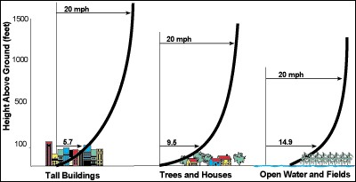

Table 1: Typical values of parameters in wind profiles based on effect of terrain type

|  |  |  |  |  |
| --- | --- | --- | --- | --- |
| Terrain  category | Terrain description | Gradient  height  Zg (m) | Roughness  length  Zo (m) | Mean  speed  exponent  α |
| 1 | Open sea, ice, tundra, desert | 250 | 0.001 | 0.11 |
| 2 | Open country with low scrub or scattered  trees | 300 | 0.03 | 0.15 |
| 3 | Suburban areas, small towns, well  wooded areas | 400 | 0.3 | 0.25 |
| 4 | Numerous tall buildings. City centers,  well developed industrial areas | 500 | 3 | 0.36 |

Figure: Variation of wind speed with height for different terrain types

The turbulence created is higher in rougher terrain than in smoother terrain. Turbulence decreases with increasing height above ground.

Turbulence Intensity

The most commonly used parameter to define turbulence in time domain isturbulence intensity. It is a measure of the relative amplitude of the fluctuationscompared to the mean component of wind. It is expressed as:

𝑇𝑢 =

𝜎

𝑉 𝑍

Where,

Tu = The turbulence intensity.

σ = The root mean square of wind speed, and VZ= The mean wind speed.

Turbulence intensity decreases with height since the mean wind speed increasesand the fluctuation of wind decreases.

WIND ENERGY

Wind energy is produced by the movement of air (wind) and converted into power for human use. Wind has been used as a source of energy for more than a thousand years, but was replaced by fossil fuels for much of the 20th century. Today, wind is making a comeback as a source of electricity and power.

WIND ENERGY CONVERSION SYSTEM

An apparatus for converting the kinetic energy available in the wind to mechanical energy that can be used to power machinery (grain mills, water pumps, etc) and/or to operate an electrical generator.

Windmills

Windmills convert wind energy directly into mechanical energy for such tasks as milling grain or pumping water, which is usually the purpose of windmills you see on farms.

Windmill Mechanism

The spinning vanes of a windmill turn a camshaft, which is connected by gears and rods to the machinery that does the work. All power is directed into the work

Wind Turbines

A wind turbine converts wind energy into electricity, which can then be used to power electrical equipment, stored in batteries or transmitted over power lines.

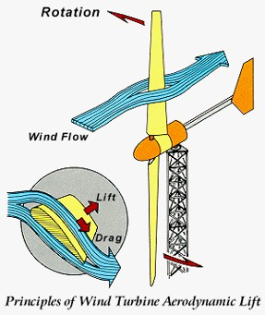

Wind Turbine Mechanism

The blades turn, convert the energy of wind into rotational energy, a form of mechanical energy, and this energy is in turn converted into electrical energy.A wind turbine has essentially the same parts as a simple electric motor, but it works in reverse: A motor uses electrical current to produce motion; a wind turbine uses motion to create electrical current.

Wind Farms

In order to generate a large amount of electricity, wind turbines are often constructed in large groups called wind farms. Wind farms are made up of hundreds of turbines, spaced out over hundreds of acres.

The two main categories of wind turbines are

1. Vertical axis wind turbines and

2. Horizontal axis wind turbines.

HORIZONTAL AXIS MACHINES

A wind turbine in which the axis of the rotor's rotation is   
parallel to the wind stream and the ground. All grid-connected   
commercial wind turbines today are built with a propeller-type   
rotor on a horizontal axis. Horizontal-axis wind turbines (HAWT)   
have the main rotor shaft and electrical generator at the top of a   
tower, and may be pointed into or out of the wind. Small turbines   
are pointed by a simple wind vane, while large turbines generally   
use a wind sensor coupled with a servo motor. Most have a   
gearbox, which turns the slow rotation of the blades into a quicker   
rotation that is more suitable to drive an electrical generator.

HAWTs can be subdivided into upwind wind turbines and downwind wind turbines. Compare with vertical-axis wind turbine.

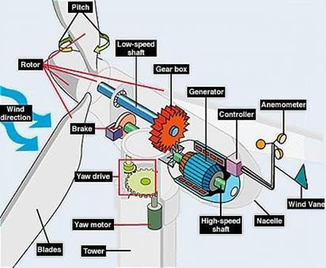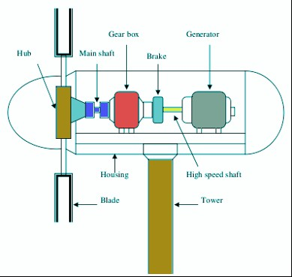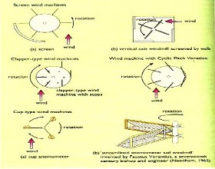

Parts of the wind turbine

1. Blades

Most wind turbines have three blades. Very small turbines may use two blades for ease of construction and installation. Vibration intensity decreases with larger numbers of blades. Noise and wear are generally lower, and efficiency higher, with three instead of two blades.

Also, the cost of the turbine usually increases with the number of blades. Based on blade

style classified as

Leading

Edge

L F

Trailing

➢ The lifting style wind turbine blade. These are the most

Wind D

Angle

Edge

efficiently designed, especially for capturing energy of strong, fast winds.

➢ The drag style wind turbine blade, most popularly used for   
 water mills, as seen in the old Dutch windmills. The blades

are flattened plates which catch the wind. These are poorly designed for capturing the energy of heightened winds.

2. Rotor

of

Attack

The rotor is designed aerodynamically to capture the maximum surface area of wind in order to spin the most ergonomically. The blades are lightweight, durable and corrosion-resistant material. The best materials are composites of fiberglass and reinforced plastic.

3. Gear box

A gear box magnifies or amplifies the energy

Low Speed Gear

output of the rotor. The gear box is situated directly between the rotor and the generator. A rotor rotates the generator (which is protected by a nacelle), as directed by the tail vane.

4. Generator

Lower

speed shaft

Higher

Speed

shaft

High Speed   
Gear

The generator produces electricity from the rotation of the rotor. Generators come in   
various sizes, relative to the output you wish to generate. The nacelle is the housing or enclosure   
that seals and protects the generator and gear box from the elements. It is easily removed for   
maintenance.

5. Yaw Mechanism

Yaw mechanism turns the rotor into the upwind direction as the wind direction changes. Electric motors and gear boxes are used to keep the turbine yawed against wind. This can be also used as controlling mechanism during high wind speeds.

6. Anemometers

Wind speed is the most important factor for determining the power content in the wind. The power content in the wind is directly proportional to cube of the wind velocity. Measuring wind speed is important for site selection. The device which is used for measuring wind speed is called anemometer. These are usually located on top of the nacelle.

Advantages

➢ Higher wind speeds   
➢ Great efficiency

Disadvantages

➢ Angle of turbine is relevant

➢ Difficult access to generator for repairs

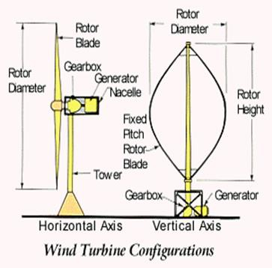

VERTICAL AXIS MACHINES

A type of wind turbine in which the axis of   
rotation is perpendicular to the wind stream and the   
ground. A vertical-axis wind turbine’s (VAWTs) main   
rotor shaft is set vertically and the main components are   
located at the base of the turbine.VAWTs work somewhat   
like a classical water wheel in which water arrives at a   
right angle (perpendicular) to the rotational axis (shaft) of   
the water wheel. Vertical-axis wind turbines fall into two   
major categories: Darrieus turbines (Lift Device) and

Savonius turbines (Drag Device). Neither type is in wide use today.

The basic theoretical advantages of a vertical axis machine are:

➢ The generator, gearbox etc. may be placed on the ground, and a tower is not essential for   
 the machine

➢ A yaw mechanism isn't needed to turn the rotor against the wind

The basic disadvantages are:

➢ Wind speeds are very low close to ground level, so although a tower isn't essential, the   
 wind speeds will be very low on the lower part of the rotor

➢ The overall efficiency of the vertical axis machines is not impressive

➢ The machine is not self-starting, i.e. a Darrieus machine needs a "push" before it will   
 start. This is only a minor inconvenience for a grid-connected turbine, however, since the

generator may be used as a motor drawing current from the grid to to start the machine

➢ The machine may need guy wires to hold it up, but guy wires are impractical in heavily   
 farmed areas

➢ Replacing the main bearing for the rotor necessitates removing the rotor on both a   
 horizontal and a vertical axis machine. In the case of the latter, it means tearing the whole

machine down.

POWER COEFFICIENT, BETZ COEFFICIENT BY MOMENTUM THEORY

Introduction

Available Wind Energy

The kinetic energy of a stream of air:

1 2

E mV   
 2

Available Wind Power

Power is the energy per unittime and expressed

P=dE/dt

P  Power Co-efficient

1

2

a ATV

3

The efficiency is the ratio of actual power developed by wind turbine rotor to the available wind power. It is also defined as power coefficient and expressed as

Cp 

1

2

P T

a ATV

3

The power coefficient or the power picked up by the wind turbine rotor is influenced by many factors:

- profile of the rotor blade

- number of blades

- blade arrangement

Torque Co-efficient

The thrust force developed by the rotor is

F

The rotor torque is

1

2

 a ATV

2

2

T  ~~1~~ A V R

a

2

T

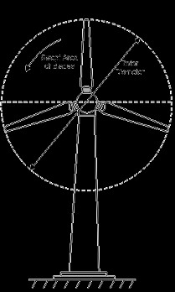

The torque developed by the rotor shaft is less than the maximum theoretical torque and given in terms of coefficient of torque

T r

CT 

2

~~1~~a ATV T

2

Tip Speed Ratio

Vrw 

Where,

R = radius of the rotor

= Angular velocity

N = Rotor rotational speed, rpm

R

V



2NR

V

Also, it can be shown that power coefficient and torque coefficient is related by relative speed:

CP

V 

R

C rwT V

Solidity

Solidity is the ratio of total rotor plan form area to total swept area.   
 Solidity = 3a/A

Betz’ Limit

All wind power cannot be captured by rotor or air would be completely still behind rotor   
and not allow more wind to pass through.Betz’ law States the theoretical limit for the conversion   
of wind energy in wind turbine.According to this law maximum possible wind turbine efficiency   
is less than 59.3 %

Cp,max 

16

27

.5926

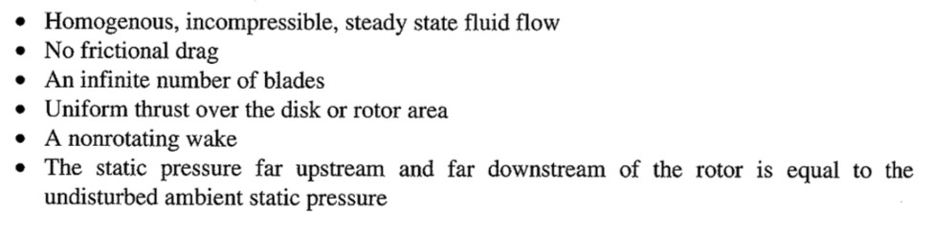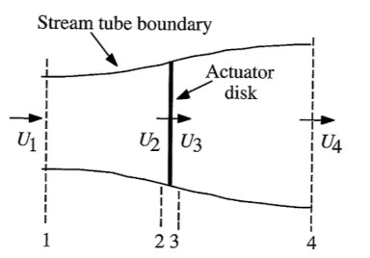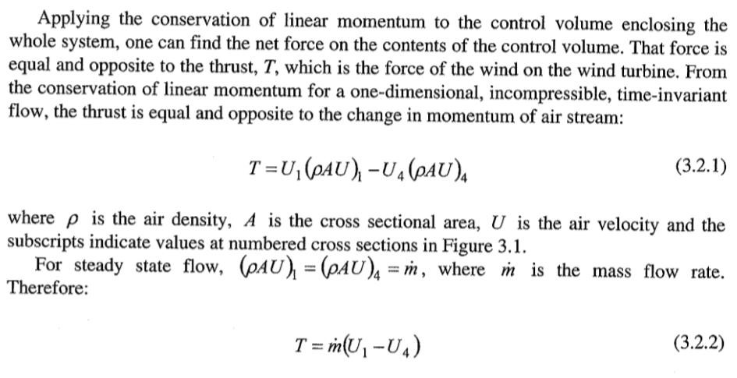

BETZ COEFFICIENT BY MOMENTUM THEORY

This analysis uses the following assumptions:

Figure: Actuator model of a wind turbine: U=Mean air velocity; 1,2,3,4, indicate locations

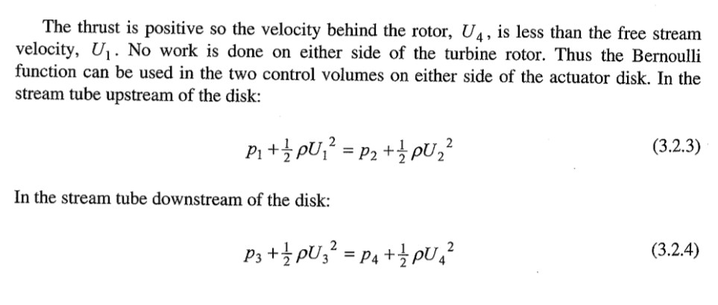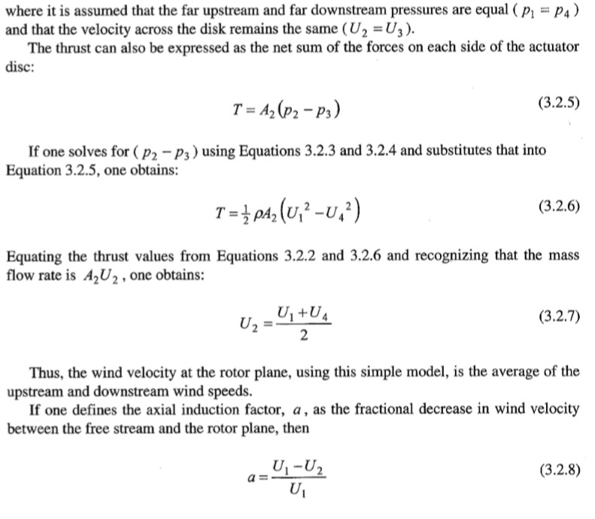

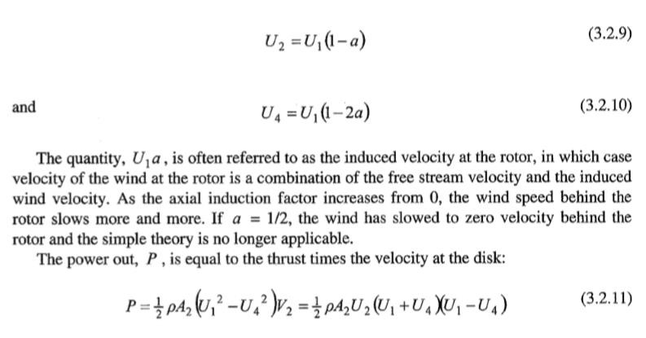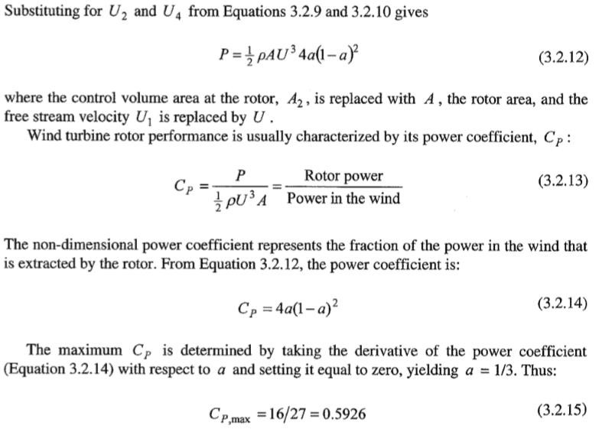

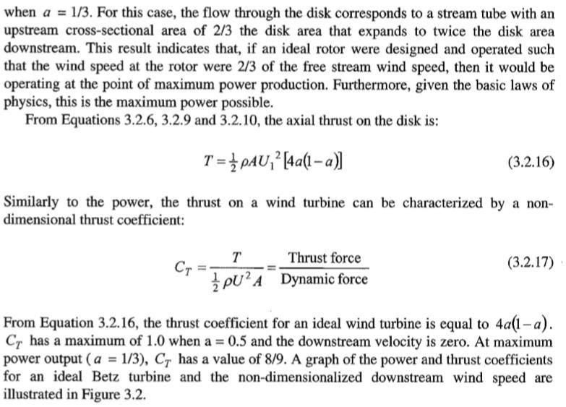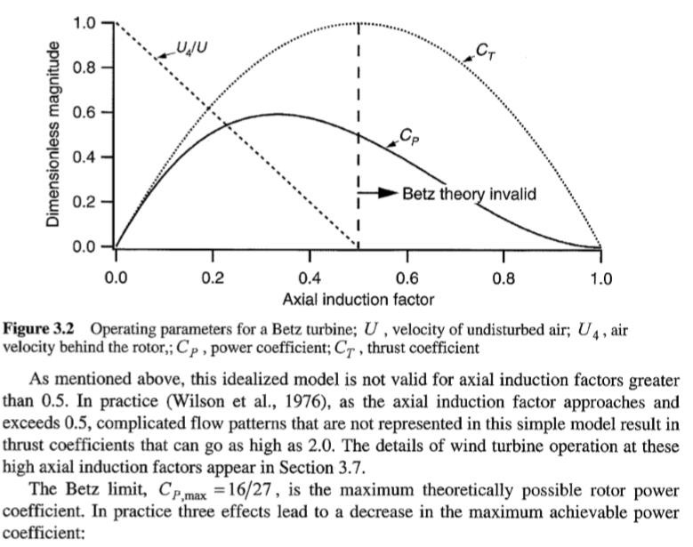

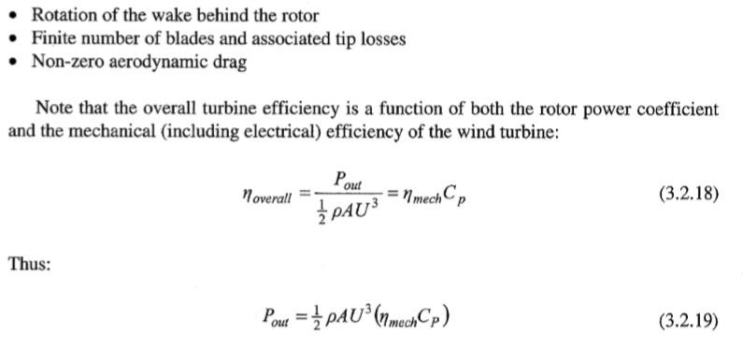

******************

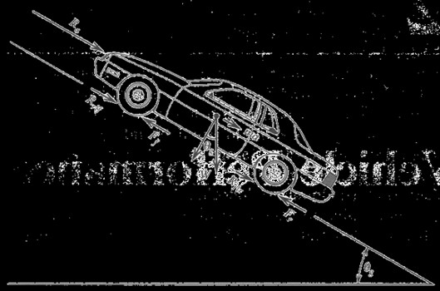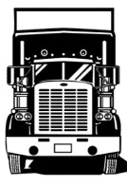

Unit II

Ground Vehicle Aerodynamics

Ground Vehicle aerodynamics is the study of the [aerodynamics](http://en.wikipedia.org/wiki/Aerodynamics) of road vehicles. Its   
main goals are reducing [drag](http://en.wikipedia.org/wiki/Drag_(physics)) and wind noise, minimizing [noise emission,](http://en.wikipedia.org/wiki/Roadway_noise) and preventing   
undesired [lift](http://en.wikipedia.org/wiki/Lift_(force)) forces and other causes of [aerodynamic instability](http://en.wikipedia.org/wiki/Oversteer#Aerodynamic_stability) at high speeds. For some classes   
of racing vehicles, it may also be important to produce [downforce](http://en.wikipedia.org/wiki/Downforce) to improve traction and thus   
cornering abilities.

Comparison with Aircraft Aerodynamics

Ground Vehicle aerodynamics differs from aircraft aerodynamics in several ways. First, the characteristic shape of a road vehicle is much less streamlined compared to an aircraft. Second, the vehicle operates very close to the ground, rather than in free air. Third, the operating speeds are lower (and aerodynamic drag varies as the square of speed). Fourth, a ground vehicle has fewer degrees of freedom than an aircraft, and its motion is less affected by aerodynamic forces. Fifth, passenger and commercial ground vehicles have very specific design constraints such as their intended purpose, high safety standards (requiring, for example, more 'dead' structural space to act as crumple zones), and certain regulations.

VEHICLE POWER REQUIREMENTS

Resistance forces acting on a ground vehicle are

1. Aerodynamic

2. Rolling

3. Grade

F  maRa  Rrl  R g

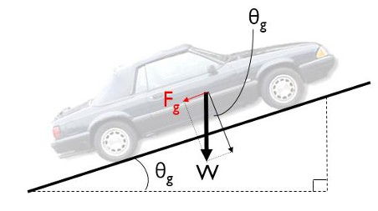

Aerodynamic Resistance (Ra)

Composed of:

1. Turbulent air flow around vehicle body (85%)

2. Friction of air over vehicle body (12%)

3. Vehicle component resistance, from radiators and air vents (3%)

❒ 2

Ra  C A V

2

Where,

CD = drag coefficient

ρ = Density of air 1.225 kg/m3 V = flow velocity

Af = characteristic frontal area of the body Rolling Resistance (Rrl)

Composed primarily of

D f

1. Resistance from tire deformation (90%)

2. Tire penetration and surface compression ( 4%)

3. Tire slippage and air circulation around wheel ( 6%)

Rrl=CR.m.g

Where,

CR = coefficient of rolling resistance

m = mass of vehicle [kg]

g = 9.81 m/s

Grade Resistance Rg Composed of

- Gravitational force acting on the vehicle   
 R W sing

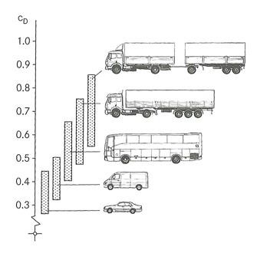

The coefficients of rolling resistance and drag are determined from experiment. A typical value for the coefficient of rolling resistance is 0.015. The drag coefficient for cars varies, a value of 0.3 is commonly used.

The power output requirement can be determined from the drag force given above and the vehicle velocity.

P = F.V

DRAG COEFFICIENTS OF AUTOMOBILES

 The drag coefficient expresses the drag of an object in a moving fluid.

 Reducing the drag coefficient in an automobile improves the performance of the vehicle as it

pertains to speed and fuel efficiency.

Drag force can be expressed as:   
 Fd = cd .(1/2).ρ.v2 .A

Where,

Fd = drag force (N)   
cd = drag coefficient

ρ = Density of fluid 1.2 kg/m3 v = flow velocity

A = characteristic frontal area of   
the body

Vehicle aerodynamics includes three interacting flow fields:   
 ➢ flow past vehicle body

➢ flow past vehicle components (wheels, heat exchanger, brakes, windshield), ➢ flow in passenger compartment

AERODYNAMICS OF CAR

A body in motion is affected by aerodynamic forces. The aerodynamic force acts   
externally on the body of a vehicle. The component of the resultant aerodynamic force which   
opposes the forward motion is called the aerodynamic drag. The aerodynamic drag affects the   
performance of a car in both speed and fuel economy as it is the power required to overcome the   
opposing force. The other component, directed vertically, is called the aerodynamic lift. It   
reduces the frictional forces between the tyres and the road thus changing dramatically the

handling characteristics of the vehicle. The aerodynamic force is the net result of all the changing distributed pressures which airstreams exert on the car surface. Therefore aerodynamic studies are very important as far as the car stability is concerned.

The main concerns of automotive aerodynamics are reducing drag, reducing wind noise, and preventing undesired lift forces at high speeds. For some classes of vehicles, it may also be important to produce desirable downwards aerodynamic forces, to improve cornering.

As the years passed the studies on aerodynamic effects on cars increased and the designs   
were being developed to accommodate for the increasing needs and for economic reasons. The   
wheels developed to be designed within the body, lowering as a result the aerodynamic drag and   
produce a more gentle flow. The tail was for many years long and oddly shaped to maintain   
attached streamline. The automobiles became developed even more with smooth bodies,   
integrated fenders and headlamps enclosed in the body. The designers had achieved a shape of a   
car that differed from the traditional horse-drawn carriages. They had certainly succeeded in   
building cars with low drag coefficient.

Road conditions have limited the width of automobiles. It is said this width was   
established by the width needed for two horses running comfortably side by side drawing a   
carriage. Length is not as much of a restriction but long bodies were not efficient enough for   
traffic use.

Aerodynamic drag

In order to explain the Aerodynamic drag the two forces - the frontal pressure and the rear vacuum - have to be analyzed.

Frontal pressure is caused by the air attempting to flow around the front of the car. As   
millions of air molecules approach the front part of the car, they begin to compress, and in doing   
so raise the air pressure in front of the car. At the same time, the air molecules traveling along   
the sides of the car are at atmospheric pressure, a lower pressure compared to the molecules at   
the front of the car. The compressed molecules of air naturally seek a way out of the high   
pressure zone in front of the car, and they find it around the sides, top and bottom of the car.

Rear vacuum or wake is caused by the "hole" left in the air as the car passes through it.   
This empty area is a result of the air molecules not being able to fill the hole as quickly as the car   
can make it. The air molecules attempt to fill in to this area, but the car is always one step ahead.   
As a result, a continuous vacuum in the rear of the car sucks in the opposite direction of the   
motion of the car. This inability to fill the hole left by the car is technically called Flow   
detachment.

Flow detachment applies only to the "rear vacuum" portion of the drag equation, and it is   
really about giving the air molecules time to follow the contours of a car's bodywork, and to fill   
the hole left by the vehicle, it's tyres, it's suspension and protrusions (i.e. mirrors, roll bars).

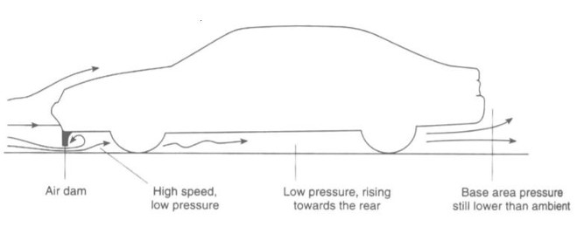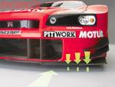

The flow attachment is very important because the drag created by the vacuum far   
exceeds that created by frontal pressure, and this can be attributed to the turbulence created by   
the detachment. That is why in the early years of automotive industry the cars used to be   
designed with long tail. This was done as to maintain the streamlines created by the flow,   
attached.

Turbulence generally affects the "rear vacuum" portion of the drag equation, but if we look at a protrusion from the race car such as a mirror, we see a compounding effect. For instance, the air flow detaches from the flat side of the mirror, which of course faces toward the back of the car. The turbulence created by this detachment can then affect the air flow to parts of the car which lie behind the mirror. Intake ducts, for instance, function best when the air entering them flows smoothly. Therefore, the entire length of the car really needs to be optimized to provide the least amount of turbulence at high speed.

Drag Coefficient

The shape of a car, as the aerodynamic theory above suggests, is largely responsible for how much drag the car has. Ideally, the car body should:

• Have a small grill, to minimize frontal pressure.

• Have minimal ground clearance below the grill, to minimize air flow under the car. In   
 combination to this, a raked underside with the rear of the car raised can create down

force.

• Have a steeply raked windshield to avoid pressure build up in front.

• Have a "Fastback" style rear window and deck, to permit the air flow to stay attached. • Have a converging "Tail" to keep the air flow attached.

Air dams (also called front spoiler):

❖ An air dam is a panel that reduces ground clearance at the front of the car below the   
 bumper

❖ The smaller gap forces flow to locally accelerate under the air dam reducing pressure   
 under the car and creating downforce

❖ Lower air volume flow to underbody reduces drag due to underbody roughness

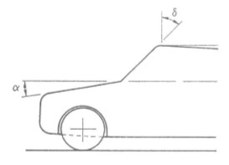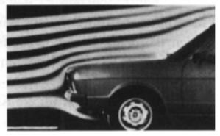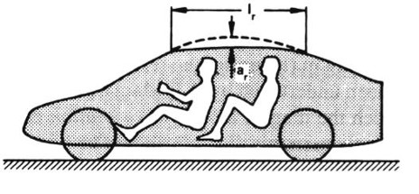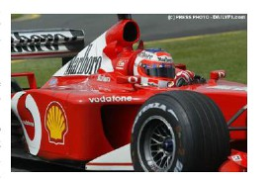

Splitter:

The splitter is a horizontal lip that   
brought the airflow to stagnation above the   
surface, causing an area of high pressure.   
Below the splitter the air is accelerated, causing   
the pressure to drop. This, combines with the   
high pressure over the splitter creates   
downforce.

Reduction of forebodydrag:

❖ The most significant drag reduction can be achieved by rounding up the vertical and   
 upper horizontal leading edges on the front face.

❖ Relatively small amendments can result considerable drag reduction.

❖ The drag reduction of front spoiler is large if its use is combined with rounded leading   
 edges.

Hood and Windshield Angle of Inclination:

❖ The hood angle (α) determines the pressure gradient   
 and plays a role in maintaining attached flow   
❖ The windshield angle, į (rake) plays a stronger role

by controlling point of attachment of flow to roof

Roofline Shape:

❖ Curved (cambered) roofline helps maintain   
 attached flow over the rear of the car

Scoops:

❖ Engine cooling

❖ Increases flow rate of air

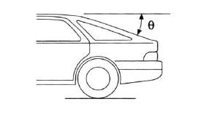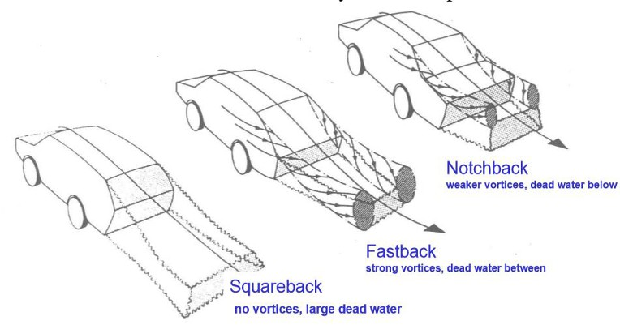

EFFECT OF CUT BACK ANGLE (Back Light Angle Or Rear Wind Shield Angle):

The rear window angle with horizontal is called the “cut back angle” or “back light   
angle”.

✓ The angle of inclination affects the trailing vortex location and strength

✓ The nature of the counter rotating vortex structure is controlled primarily by the   
 cut back angle.

✓ Vortices expend energy gives Drag. So the amount of drag force creation is   
 controlled by the cut back angle.

The airflow over the rear surfaces of the vehicle is more complex and the solutions required to minimize drag for practical shapes are less intuitive. The inclination of the screen may be sufficient to cause the flow to separate from the rear window although in many cases the separation is followed by flow re-attachment along the boot lid.

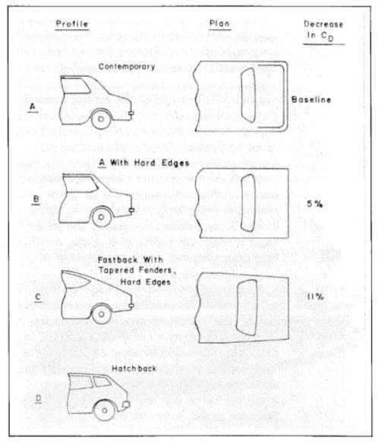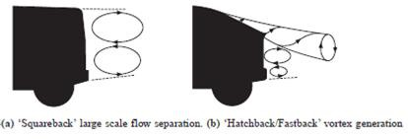

The first occurs for ‘squareback’ shapes and is characterized by a large, low pressure   
wake. Here the airflow is unable to follow the body surface around the sharp, rear corners. The   
drag that is associated with such flows depends upon the cross-sectional area at the tail, the   
pressure acting upon the body surface and, to a lesser extent, upon energy that is absorbed by the   
creation of eddies.

A very different flow structure arises if the rear surface slopes more gently as is the case for hatchback, fastback and most notchback shapes . The centreline pressure distribution that the surface air pressure over the rear of the car is significantly lower than that of the surroundings. Along the sides of the car the body curvature is much less and the pressures recorded here differ little from the ambient conditions.

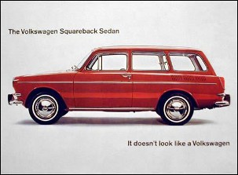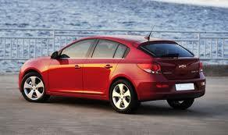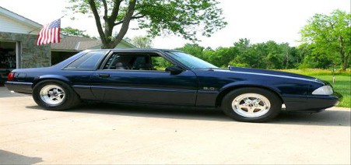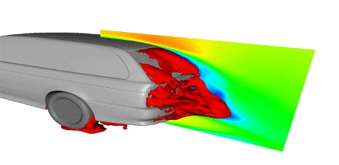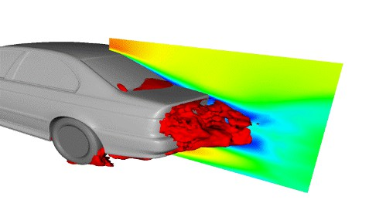

SQUARE BACK HATCH BACK

NOTCH BACK

The low pressure over the upper surface draws the relatively higher pressure air along the   
sides of the car upwards and leads to the creation of intense, conical vortices at the ‘C’ pillars.   
These vortices increase the likelihood of the upper surface flow remaining attached to the surface   
even at backlight angles of over 30 degrees. Air is thus drawn down over the rear of the car   
resulting in a reacting force that has components in both the lift and the drag directions. The   
backlight angle has been shown to be absolutely critical for vehicles of this type. demonstrates   
the change in the drag coefficient of a typical vehicle with changing backlight angle. As the   
angle increases from zero (typical squareback) towards 15 degrees there is initially a slight drag   
reduction as the effective base area is reduced. Further increase in backlight angle reverses this   
trend as the drag inducing influence of the upper surface pressures and trailing vortex creation

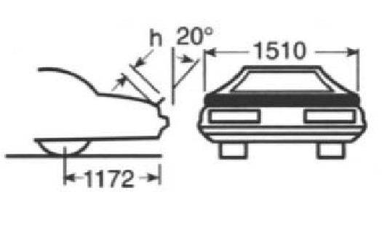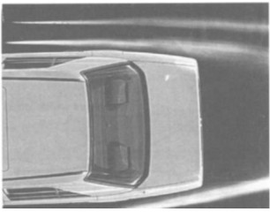

increase. As 300is approached the drag is observed to increase particularly rapidly as these

0 the drag dramatically drops to a much lower

value.

This sudden drop corresponds to the backlight angle at which the upper surface flow is no   
longer able to remain attached around the increasingly sharp top, rear corner and the flow reverts   
to a structure more akin to that of the initial squareback. In the light of the reasonably good   
aerodynamic performance of the squareback shape it is not surprising that many recent, small   
hatchback designs have adopted the square profiles that maximize interior space with little   
aerodynamic penalty.

Rear Spoilers:

❖ Rear spoiler act in a similar way than front, they spoils the airflow tumbling over the rear   
 edge of the car that causes a recirculation bubbles, this vortex doesn’t allow a good

underfloor flow increasing lift and instability.

❖ Can be free standing device or “deck strip”

❖ Causes increase in pressure just forward of the spoiler

Boat-Tailing (Tapering the rear end)

❖ Tapering of rear part results is reduction of the size of   
 rear separation bubble and increase of pressure

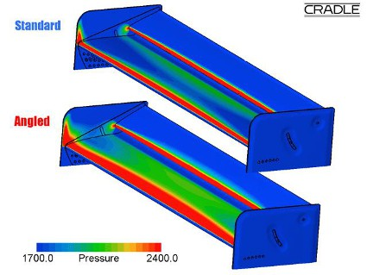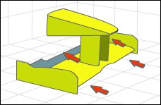

Aerodynamics of Race Car Front and rear wings:

The main focus in race cars is on the down force and drag. The relationship between drag and down force is especially important. Aerodynamic improvements in wings are directed at generating down force on the race car with a minimum of drag. Down force is necessary for maintaining speed through the corners.

A track with low speed corners requires a car   
setup with a high down force package. A high down   
force package is necessary to maintain speeds in the   
corners. This setup includes large front and rear   
wings. The front wings have additional flaps which   
are adjustable. The [rear wing](http://www.nas.nasa.gov/About/Education/Racecar/physics_rearwing.html) is made up of more   
than one section that maximizes down force.

• The front wing is important because it is   
 the first part of the car that makes contact

with the air.

• It affects the airflow in the full length of   
 the car and even tiny changes can have

huge effects on the overall performance.   
• Front wing is one of the elements that is   
 used for down force because it creates

high pressure area on top and hence large amount of down force.

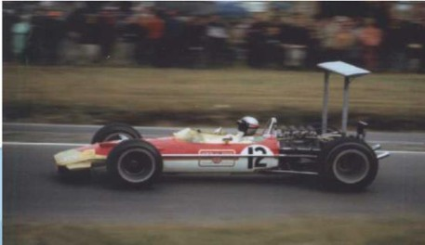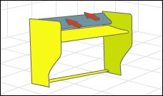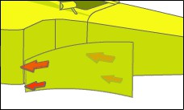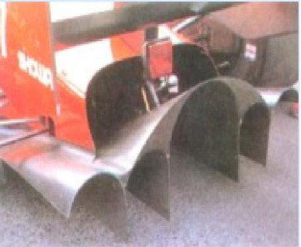

• The rear wing helps glue the rear   
 wheels to the track, but it also can

hugely increases drag (air residence against the body of the car).

Barge Boards:

Barge boards, or turning vanes,   
smooth out and separate the air that has been   
disrupted by the front wheels. They separate   
the flow into two parts - one is directed into   
the side pods to cool the engine; the other is   
diverted outside to reduce drag.

Wheels:

❖ Open-wheeled race car have a very   
 complicated aerodynamics due to the

large exposed wheels

❖ The flow behind wheels is completed   
 separated

Diffusers:

❖ The diffusers help to drive the low-pressure   
 from beneath the car. The most common one

is the upswept duct at the rear and below the   
bumper. The other type is located directly   
behind the splitter leading into the front   
wheel wheels. Aerodynamically, both of   
these diffusers achieve the same thing i.e.   
minimising pressure under the car.

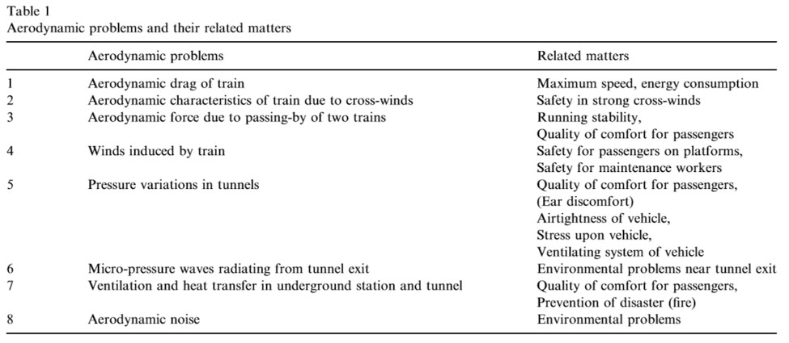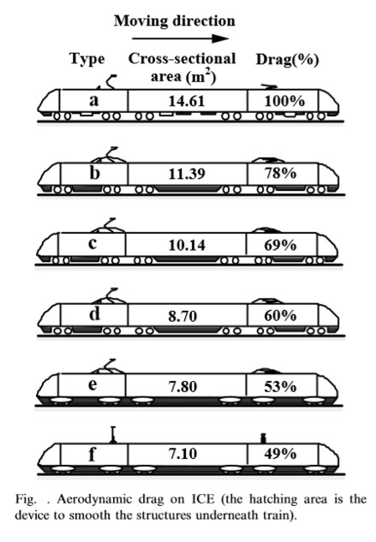

AERODYNAMICS OF TRAIN

Aerodynamic drag of train

The aerodynamic characteristics of train are   
quite different from those of airplane. There are   
many characteristic features in the aerodynamics of   
the high- speed railway train, in the points that the   
train length is, in general, very long, compared   
with the equivalent diameter of it, the train runs   
close to adjacent structures, passes through a   
confined tunnel, and intersecting with each other,   
the train runs along a fixed railway track, always   
interacting with ground, and the train can be

influenced by cross-winds. Thus, the

aerodynamics, which has been applied to airplane, may not be of help for a detailed understanding of the HST aerodynamics.

In general, a desirable train system should be aerodynamically stable and have low   
aerodynamic forces. These aerodynamic characteristics are closely associated with the   
aerodynamic drag of the running train. The aerodynamic drag on the traveling train is largely   
divided into mechanical and aerodynamic ones. Of both, the aerodynamic drag can influence the

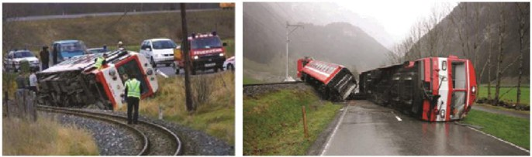

energy consumption of train. Thus, detailed understanding on the aerodynamic drag and its   
precise evaluation are of practicalimportance. It has been well known that the aerodynamic drag   
is proportional to the square of speed, while the mechanical drag is proportional to the speed.   
Compared with the mechanical drag, the portion of the aerodynamic drag becomes larger as the   
train speed increases. Thus, reduction of the aerodynamic drag on high-speed railway train is one   
of the essential issues for the development of the desirable train system. In the open air without   
any cross-wind effects, the total drag on the traveling train can be expressed by a sum of the   
aerodynamic and mechanical ones:

Where, DA and DM are the aerodynamic and mechanical drags, respectively,   
 a,b and c are the constants to be determined by the experiment,

V the train speed and

W the train weight.

In Eq., the mechanical drag, being proportional to the train weight, includes the sliding drag between rails and train wheels, and the rotating drag of the wheels. The measurement of the total drag on train and its precise prediction are not straightforward.

Cross-wind effects

The cross-wind effects on the traveling train can closely be associated with the traveling   
safety. The cross- winds can be more seriously influence when the train runs over a bridge.   
Heavier vehicles could improve the crosswind stability but on the contrary issues like lower   
energy consumption demand lighter vehicles, which at the same time would lead to benefits   
regarding track deteriorationand track maintenance. Since the aerodynamic forces are   
mostcritical on the leading vehicle of a train, the weight change from a locomotive -as the   
leading and heaviest vehicle of a loco-train - to a vehicle of a multiple unitincreases the demands   
on crosswind stability of trains. In addition, unsteady crosswindlike various gusts is becoming a   
major concern.

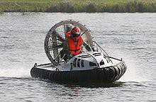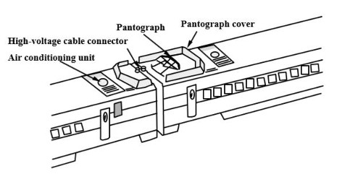

Aerodynamic noise due to train

For the assessment of aerodynamic   
noises produced by a traveling train in the open   
air, it can be often convenient to classify the   
noise sources. In addition to the aerodynamic   
noises due to the flows around the traveling   
train, there are many different noises which are

caused by train wheels, structures around track, pantograph system, etc. In order to reduce these   
noises, it is required to know how extent is each contribution to the noises. In general,   
aerodynamic noises are strongly dependent on the train speed U, being approximately   
proportional to U6-U8: Thus, the noise alleviation is of more practical importance when the train   
speed increases.

It can be found that the aerodynamic noises due to the traveling train are largely   
generated by the fore-body of the train, the connection part between trains, and the pantograph   
system.

The fore-body of a train is one of the noise sources. In usual, there are a lot of roughness   
on the fore-body surface. The aerodynamic noises are strongly dependent on the detailed   
configuration of the surface roughness and the entire shape of train fore-body as well. These   
geometrical configurations are associated with the wind speed along them and separation.

In practice, the pantograph system is composed of many bars with small diameters, which can play a musical instrument to create the aerodynamic noises. The pantograph system creates a number of vortices behind it. A pantograph cover can be used to reduce the aerodynamics noises generated by the pantograph system.

AERODYNAMICS OF HOVERCRAFT

A hovercraft, also known as an air-cushion   
vehicle or ACV, is a [craft](http://en.wikipedia.org/wiki/Craft_(vehicle)) capable of travelling over land,   
water, mud or ice and other surfaces.

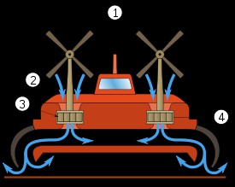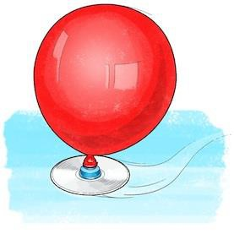

Hovercraft use blowers to produce a large volume of air   
below the hull that is slightly above atmospheric pressure. The   
pressure difference between the higher pressure air below the   
hull and lower pressure ambient air above it produces lift, which   
causes the hull to float above the running surface. For stability   
reasons, the air is typically blown through slots or holes around   
the outside of a disk or oval shaped platform, giving most   
hovercraft a characteristic rounded-rectangle shape. Typically

this cushion is contained within a flexible "skirt", which allows the vehicle to travel over small obstructions without damage.

1. Propellers, 2. Air, 3. Fan, 4. Flexible skirt

Aerodynamics:

Hovercraft float on a cushion of air that has been forced under the craft by a fan. This   
causes the craft to rise or lift. The amount of lift can range from 6" to 108" (152mm to 2,743mm)   
depending on the size of the hovercraft. The amount of total weight that a hovercraft can raise is   
equal to cushion pressure multiplied by the area of the hovercraft. To make the craft function   
more efficiently, it is necessary to limit the cushion air from escaping, so the air is contained by   
the use of what is called a hovercraft skirt. Fashioned from fabric, which allows a deep cushion

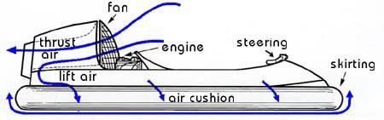

or clearance of obstacles, hovercraft skirts vary in style ranging from bags to cells (jupes) to separate fingered sections called segments.

Once "lifted" or "on cushion", thrust must be created to move the hovercraft forward.   
With many craft, this is generated by a separate engine from the one used to create the lift, but   
with some, the same engine is used for both. As the diagram above indicates, the fan-generated   
air stream is split so that part of the air is directed under the hull for lift, while most of it is used   
for thrust.

Now that the hovercraft has lift and thrust, it must be steered safely. This is achieved   
through the use of a system of rudders behind the fan, controlled by handlebars up front. Steering   
can also be controlled by the use of body weight displacement ... a skill which is achieved after   
practice.

***************************************

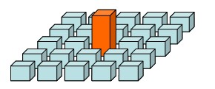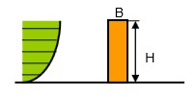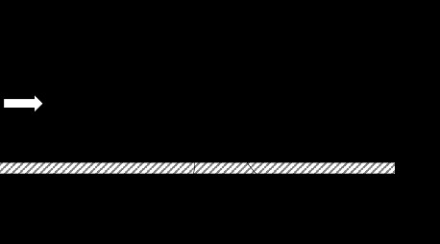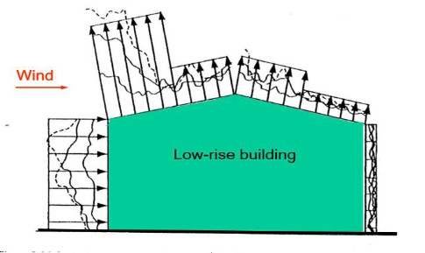

Unit III

Building Aerodynamics

LOW RISE BUILDINGS

❖ Low rise building is defined as an enclosed structure less than 50 feet (15 m) in height.

❖ Usually immersed with in atmospheric boundary layer [Where turbulent intensity is high,   
 interference and shelter effects are important but different to quantify]   
❖ Non engineered and lack of maintenance

❖ Wind loads on roof are important

❖ Internal pressure are important - especially for dominant openings  Resonant effects are negligible

❖ Must sustain most damages in severe wind storms

PRESSURE DISTRIBUTION ON LOW RISE BUILDINGS

Majority of the houses that are constructed all over the world are low-rise buildings.These buildings are constructed in different types of terrain and topography with various planforms.Measurements of the static pressure on low-rise building models in boundary layer wind tunnels provide vital information that can be used to design houses which are safer and more resistant to adverse weather conditions such as cyclones and hurricanes.

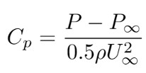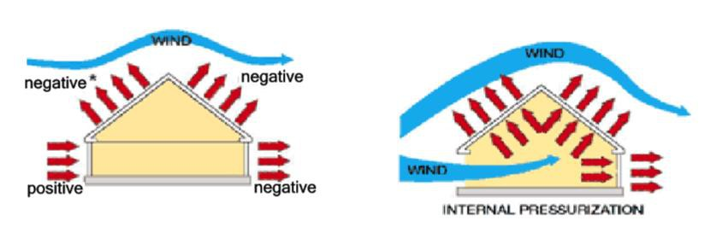

The values of static pressure are converted to non-dimensional pressure coefficient, Cp, which is defined as

Where,

P is the pressure at a given location   
P∞ is the free-stream static pressure   
U∞ is the free-stream velocity and   
ρ is the air density.

The intensity of internal pressure is directly related to the size of dominant openings and their location with respect to the direction of wind angle of attack.

➢ Peak positive internal pressure occurs when a dominant opening of the building faces the   
 incoming wind flow.

➢ Peak negative internal pressure occurs when a dominant opening of the building are in   
 parallel to the incoming wind flow.

➢ Dominant openings resulted in an increase internal pressure. For example, the opening of the   
 window together with ceiling hatch led to 45% increase on the net wind load on the

windward side of the gable roof and 20 % increase for hip roofs. This reinforces the need for keeping doors and windows covered with shutters during strong storms.

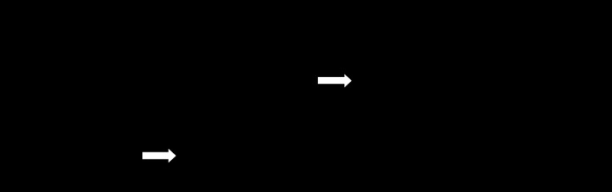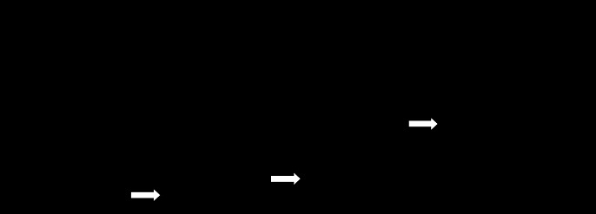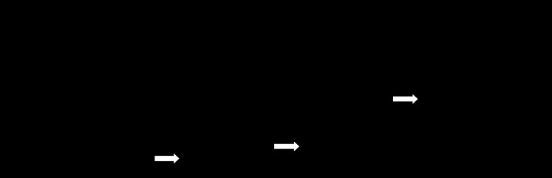

The point pressure measurements are processed with the help of a contour plotting to obtain surface contour plots on an entire surface of the building. The average values of Cp are estimated on all the faces of the gabled roof building models.

Mean pressure coefficients on pitched roofs 5o roof pitch:

No separation at ridge. Higher negative pressures for greater h/d. 12o roof pitch:

Second separation at ridge. Higher negative pressures for greater h/d. 18o roof pitch

Pressure on windward face is less negative at lower h/d

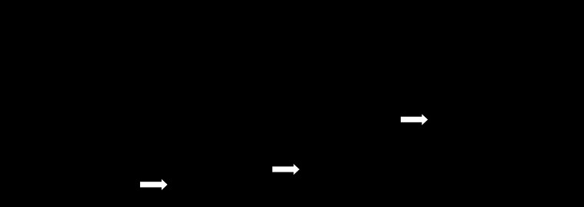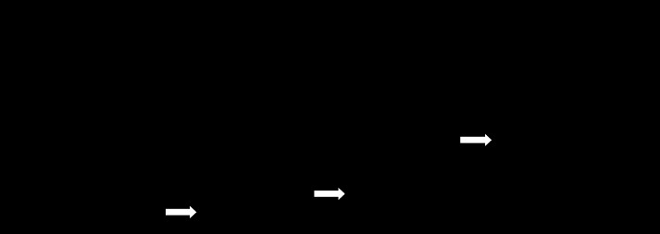

30o roof pitch:

Positive pressure on upwind face of roof for lower h/d.   
 Uniform negative pressure on downwind roof.

45o roof pitch:

High positive pressure on upwind face of roof at all h/d.   
 Uniform negative pressure on downwind roof.

Fluctuating and peak pressures at corners of roofs

Formation of conical vortices

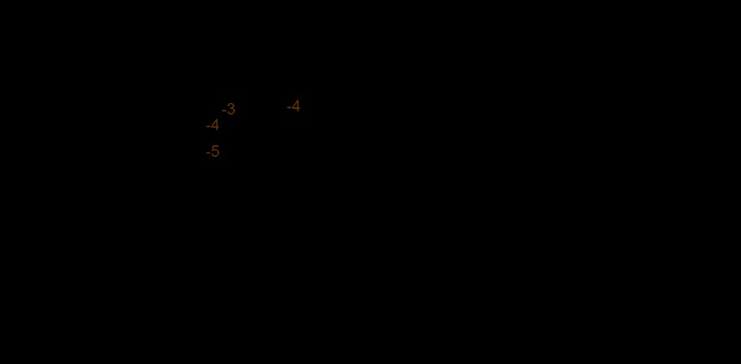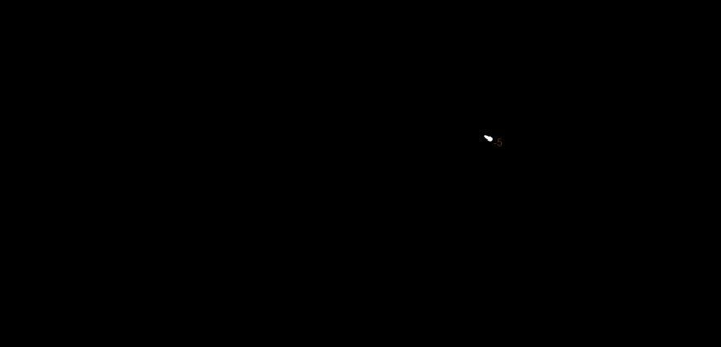

The variation of the minimum pressure coefficient over the roof of different building models with the roof pitch angle for any wind direction

Looking at the windward and the leeward portions of the roof, the peak suction over the   
leeward side is higher compared to that over the windward side with the difference between the   
two increasing with an increase in the roof pitch. It is clear from this figure that the worst suction   
reduces continuously when the roof pitch is increased. Interesting observations are made for the   
45◦ pitch building models. The minimum Cp value is positive for both the gabled and the hip

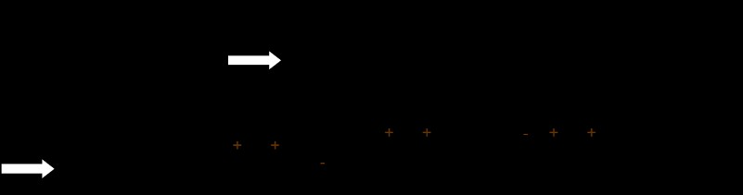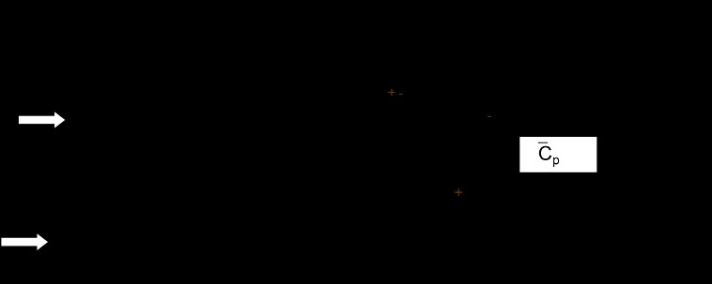

roof models. It is also interesting to note that there is a slight increase in the suction on the leeward side for the gabled roof compared to the 30◦ case.

Multi-span buildings

Note: Pitches less than 10 degrees are ‘aerodynamically flat’

Saw-tooth roofs - magnitude of negative pressures reduces downwind:

WIND FORCES ON BUILDINGS

Forces are classified as static and dynamic. Static loads are independent from time but dynamic loads are function of time. Usually, wind loads are dynamic loads. The design of buildings must account for wind loads, and these are affected by wind shear. For engineering purposes, a power law wind speed profile may be defined as follows:

Where,

Vz = speed of the wind at height;

Vg = gradient wind at gradient height α= exponential coefficient

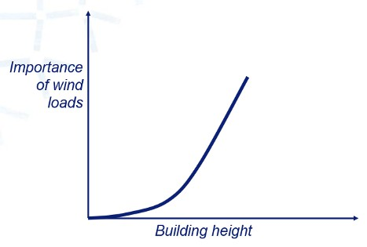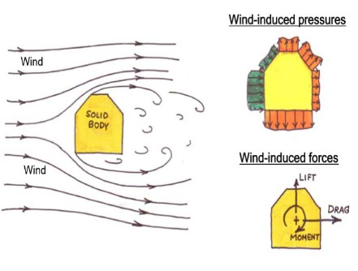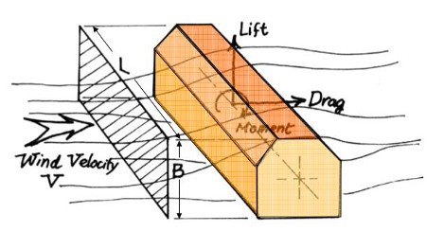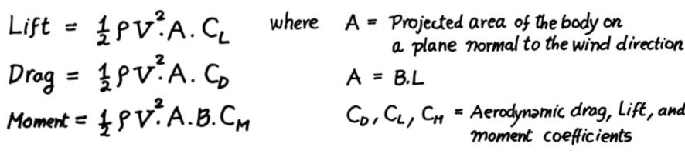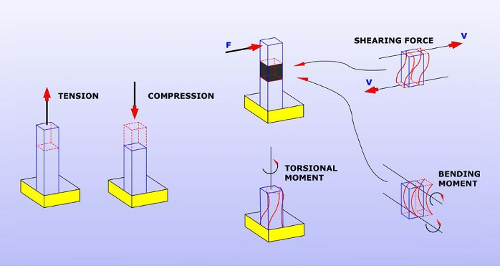

500

Zg = Height wind gradient

400

1/7

V Z

Zg

300

100

50

10

V

1/9.6

Z

Zg

EXPOSURE B - EXPOSURE C -

FOREST, SUBURB OPEN SOIL

Wind load induced oscillation

There are three forms of wind load induced motion as follows:-

a) Galloping - Galloping is transverse oscillations of some structures due to the development of aerodynamic forces which are in phase with the motion. It is characterized by the progressively increasing amplitude of transverse vibration with increase of wind speed.

b) Flutter - Flutter is unstable oscillatory motion of a structure due to coupling between   
aerodynamic force and elastic deformation of the structure. Perhaps the’ most common form is   
oscillatory motion due to combined bending and torsion. Long span suspension bridge decks or   
any member of a structure with large values of d/t ( where d is the depth of a structure or   
structural member parallel to wind stream and t is the least lateral dimension of a member ) are   
prone to low speed flutter.

c)Ovalling:This walled structures with open ends at one or both ends such as oil storage tanks,   
and natural draught cooling towers in which the ratio of the diameter of minimum lateral   
dimension to the wall thickness is of the order of 100 or more, are prone to ovalling oscillations.   
These oscillations are characterized by periodic radial deformation of the hollow structure.

ENVIRONMENTAL WINDS IN CITY BLOCKS

Survey of wind flow in the urban area, especially within tall building in two terms is very important:

(1) Tall buildings can cause undesirable intensification of wind flow in urban streets and open spaces (square).

(2) On the other hand also have the ability to avoid wind flow in urban spaces.

In both cases, depending on various conditions, wind flow or wind stagnation could be   
favorable or not favorable. So in the polluted urban environments, increased air flow to prevent   
stagnation and accumulation of the pollution is very useful while for pedestrian and visitors in   
open space are undesirable and uncomfortable. Generally buildings depending on how their   
exposure to wind flow, create dual effects including wind flow is increased or recession. Flow   
rate set points with a recession in the wind and the tall buildings can deal with the accumulation   
of air pollution on residents to stop. Also, despite these points can reduce the adverse   
environmental wind flow can be exploited. If the distance between buildings is appropriate, the

aerodynamic areas of each building to act individually and not interfere of wind flow in these areas, the impact of tall building on wind flow reaches minimum level. But if the distance between buildings is not appropriate the aerodynamic take effect, whatever set is denser and more compact, the behaviors of wind flow and the impact on the speed are required more complex analysis and apparent negative occurs.

Tall buildings effect on the air flow and pollution parameters is not distributed   
consequently the air pollution in cites are increasing. In addition to obstruction of visibility and   
confined spaces and also play a key role in changing winds direction. But regarding population   
growth of cities and land shortages and high prices make them inevitable. Other advantages of   
the towers can save energy and prevent pollution increases. Therefore, the appropriate principles   
and standards in height, properly locate them, the scale tall buildings, technical rules in making   
them, Immunization, Landscaping and creating green space around the towers, how exposure to   
towers for wind flow, appropriate distance to the other buildings, how to design them in terms of   
urban landscape must be considered to reduce the negative effects of tall buildings. In order to   
remove or reduce the environmental impact, create green spaces in floors and roofs of buildings   
are helpful to reduce environmental problems which is named environmentally friendly buildings   
and green architecture.

Today, tall building is a phenomenon that the world particularly large cities are facing.   
The tall buildings in order to exploit the land with having the negative affects in the environment   
create new problems including increasing congestion population, environmental pollution,   
reduce citizen access to fresh air and sunlight. However, regarding to population increasing and   
land shortage, tall buildings could not be avoided. This paper investigates the relationship of tall   
buildings with urban air pollution as well as the possible reducing of negative affects of tall   
building on environmental pollution with respect to geographical position, technical rules,   
immunization, green space, direct of wind, appropriate distance to other buildings, design in   
terms of visibility and landscape and urban appearance were reviewed. The study showed that   
the tall buildings cause increasing the air pollution in large urban area due to changing in wind   
and its direction and also congestion of tall buildings as a pollution sources. Therefore some   
techniques to design the tall building must be considered to reduce the negative affects of the tall



buildings on environmental pollution. Unfortunately the lack of the construction roles in term of environmental protection and also control of the rules in construction process causing the environmental pollution particularly air pollution. It is suggested that the re-evaluate of the rules with restricted control can improve the air quality in the large cities and also utilization of green spaces in floors and roofs of buildings as environmentally friendly buildings which are attempt to reduce environmental problems.

SPECIAL PROBLEMS OF TALL BUILDINGS

Wind is a phenomenon of great complexity because of   
the many flow situations arising from the interaction of wind   
with structures. Wind is composed of a multitude of eddies of   
varying sizes and rotational characteristics carried along in a   
general stream of air moving relative to the earth’s surface.   
These eddies give wind its gusty or turbulent character. The   
gustiness of strong winds in the lower levels of the atmosphere   
largely arises from interaction with surface features. The average

wind speed over a time period of the order of ten minutes or more, tends to increase with height,   
while the gustiness tends to decrease with height. The wind vector at a point may be regarded as   
the sum of the mean wind vector (static component) and a dynamic, or turbulence, component

A consequence of turbulence is that dynamic loading on a structure depends on the size of eddies. Large eddies, whose dimensions are comparable with the structure, give rise to well correlated pressures as they envelop the structure. On the other hand, small eddies result in pressures on various parts of a structure that become practically uncorrelated with distance of separation. Eddies generated around a typical structure are shown in Fig.

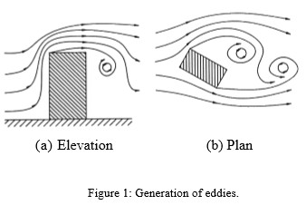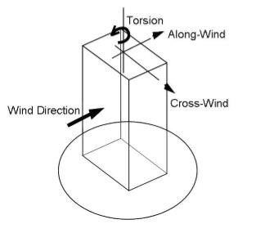

Some structures, particularly those that are tall or slender, respond dynamically to the   
effects of wind. The best known structural collapse due to wind was the Tacoma Narrows Bridge   
which occurred in 1940 at a wind speed of only about 19 m/s. It failed after it had developed a   
coupled torsional and flexural mode of oscillation. There are several different phenomena   
giving rise to dynamic response of structures in wind. These include buffeting, vortex shedding,   
galloping and flutter. Slender structures are likely to be sensitive to dynamic response in line   
with the wind direction as a consequence of turbulence buffeting. Transverse or cross-wind   
response is more likely to arise from vortex shedding or galloping but may also result from   
excitation by turbulence buffeting. Flutter is a coupled motion, often being a combination of   
bending and torsion, and can result in instability. For building structures flutter and galloping   
are generally not an issue. An important problem associated with wind- induced motion of   
buildings is concerned with human response to vibration and perception of motion. At this point   
it will suffice to note that humans are surprisingly sensitive to vibration to the extent that motions   
may feel uncomfortable even if they correspond to relatively low levels of stress and strain.   
Therefore, for most tall buildings serviceability considerations govern the design and not   
strength issues.

Vortex Shedding: The most common source of crosswind excitation is that associated with   
‘vortex shedding’. Tall buildings are bluff (as opposed to streamlined) bodies that cause the flow   
to separate from the surface of the structure, rather than follow the body contour. For a   
particular structure, the shed vortices have a dominant periodicity that is defined by the Strouhal   
number. Hence, the structure is subjected to a periodic cross pressure loading, which results in an   
alternating crosswind force. If the natural frequency of the structure coincides with the shedding

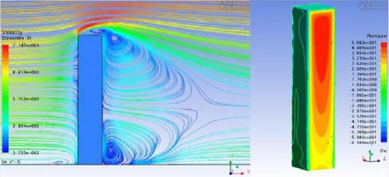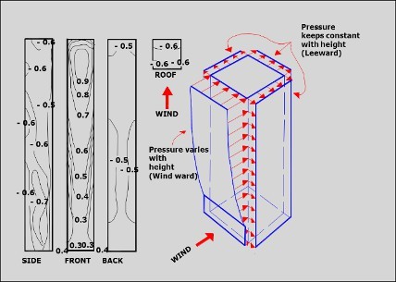

frequency of the vortices, large amplitude displacement response may occur and this is often   
referred to as the critical velocity effect. The asymmetric pressure distribution, created by the   
vortices around the cross section, results in an alternating transverse force as these vortices are   
shed. If the structure is flexible, oscillation will occur transverse to the wind and the conditions   
for resonance would exist if the vortex shedding frequency coincides with the natural frequency   
of the structure. This situation can give rise to very large oscillations and possibly failure.

Shedding frequency N is given by

Where,

S = Strouhal number   
U = wind speed   
b = building width

Pressure coefficients on high- rise buildings

BUILDING CODES

➢ Building codes are set of rules and regulation, provisions that must be observed in the design,   
 construction and maintenance of buildings.

➢ Purpose is to ensure that in a disaster:

o Lives are protected.

o Physical damage is limited.

o Structures critical to human welfare remain operational.

➢ Embody accumulated knowledge of leading scientists, engineers and building construction   
 experts that will produce structures that are ‘Fit for purpose’.

➢ Provide the first line of defence against damage from natural hazards and help ensure public   
 safety.

➢ Must be updated regularly to include new technological developments as well as new   
 information after a disaster.

o New Florida code after hurricane Andrew would have saved 60% of damage if   
 available prior.

o Buildings use 40% of a country's energy, so retrofitting older buildings for safety and   
 energy use is critical.

➢ Building codes are generally intended to be applied by architects and engineers although this   
 is not the case in the UK where Building Control Surveyors act as verifiers both in the public

and private sector (Approved Inspectors), but are also used for various purposes by safety   
inspectors, environmental scientists, real estate developers, contractors and subcontractors,   
manufacturers of building products and materials, insurance companies, facility managers,   
tenants, and others.

➢ There are often additional codes or sections of the same building code that have more   
 specific requirements that apply to dwellings and special construction objects such as

canopies, signs, pedestrian walkways, parking lots, and radio and television antennas.

Importance of Building Codes

➢ Building codes save lives

➢ Building codes protect your investment   
➢ Building codes save on insurance   
➢ Building codes increase disaster resilience   
➢ Building codes enhances building stock

51

BUILDING VENTILATION AERODYNAMICS

Ventilating is the process of "changing" or replacing air in any space to provide high indoor air quality (i.e. to control temperature, replenish oxygen, or remove moisture, odors, smoke, heat, dust, airborne bacteria, and carbon dioxide). Ventilation is used to remove unpleasant smells and excessive moisture, introduce outside air, to keep interior building air circulating, and to prevent stagnation of the interior air.

Ventilation includes both the exchange of air to the outside as well as circulation of air within   
the building. It is one of the most important factors for maintaining acceptable indoor air quality   
in buildings. Methods for ventilating a building may be divided into mechanical/forced and   
natural types.

"Mechanical" or "forced" ventilation is used to control indoor air quality. Excess   
humidity, odors, and contaminants can often be controlled via dilution or replacement with   
outside air. However, in humid climates much energy is required to remove excess moisture   
from ventilation air.

Natural ventilation is the ventilation of a building with outside air without the use of a fan   
or other mechanical system. It can be achieved with openable windows or trickle vents when the   
spaces to ventilate are small and the architecture permits. In more complex systems warm air in   
the building can be allowed to rise and flow out upper openings to the outside (stack effect) thus   
forcing cool outside air to be drawn into the building naturally through openings in the lower   
areas. These systems use very little energy but care must be taken to ensure the occupants'   
comfort. In warm or humid months, in many climates, maintaining thermal comfort solely via   
natural ventilation may not be possible so conventional air conditioning systems are used as   
backups. Air-side economizers perform the same function as natural ventilation, but use   
mechanical systems' fans, ducts, dampers, and control systems to introduce and distribute cool   
outdoor air when appropriate.

52

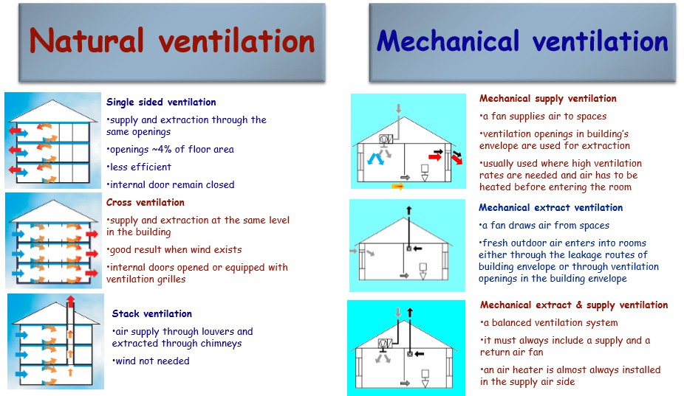

BUILDING ARCHITECTURAL AERODYNAMICS

Architectural aerodynamics gains importance with the effect of rain,snow and fire and their impact on design of buildings and their impact on usage.

In the absence of wind, rain and snow fall vertically downwards. The effect of wind is to   
give the rain drops and snowflakes a horizontal component of velocity.   
 There are three consequences of this horizontal movement. The first is on the building where the rain can now impinge on non-horizontal surfaces and so cause staining, or allow mosses and lichens to grow, or can cause damp to penetrate the walls to the detriment of its inhabitants. The second effect is on the comfort of people because the rain can penetrate beneath canopies and other protective devices. The third is a combination of building and people: in the past the materials of which buildings were made could absorb water, and during a storm, the surface of a large building would absorb tons of water, water which would be evaporated by the wind once the rain had stopped. Canopies are placed over entrance doors to provide local shelter from the rain to people entering or leaving.

53

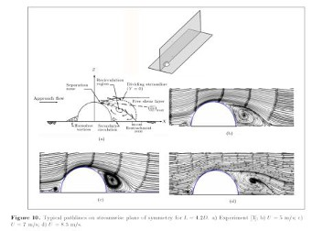

The basic approach for the containment of fire in a building, as far as the wind engineer is concerned, is that there shall be an internal volume at roof level, called a smoke reservoir, where the smoke from a fire can collect prior to being removed from the building. There are also considerations for false ceilings and escape routes.

The areas of openings in a fire situation should be sufficient to vent the smoke when there is no wind. This specifies the area of the openings which must work under buoyancy forces alone. The purpose of the wind engineer is to ensure that, under no circumstances, shall the wind inhibit this state of affairs.

Studies of fire situations are very similar to those for Ventilation with the exception that external flow is never allowed into smoke reservoirs. It is no good claiming that, on average, more air leaves a reservoir than enters it, because the air entering is cold, and when it mixes with the smoke, it will reduce the temperature of the smoke and cause it to lose its buoyancy, causing secondary flows which might bring the smoke into contact with people.

Tower and dome architecture:

Due to the structural efficiency and economic benefit, the hemispherical dome is a   
common structural geometry shape for large span sports stadium or for storage purposes. The   
curve shape makes the accurate estimation of the wind pressure fluctuations on a hemispherical   
dome a difficult task due to the Reynolds number effects. In the past years, there have been   
reports of collapse of curve shaped storage domes during strong wind. The wind induced   
structural failure could be attributed to inadequate wind resistant design and/or poor quality   
construction

Additional complexity arises for curved bodies   
(e.g. hemisphere and cylinders) because the location of a   
separation point cannot be identified purely based on the   
geometry. This leads to a strong dependency on   
Reynolds number, boundary layer thickness and the   
turbulence intensity level of the approaching flow. A

reduction in the maximum pressure coefficient is occurred because the rough surface promotes

54

the turbulent boundary layer over the dome and causes earlier separation over the dome. Consequently, the earlier separation over the dome reduced suction at the separation point, but led to more suction overall in the wake and increased drag.

**********************************

55

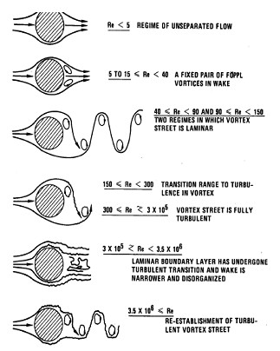

Unit IV

Flow Induced Vibrations

EFFECT OF REYNOLDS NUMBER ON WAKE FORMATION OF BLUFF SHAPES

A body moving through a fluid

experiences a drag force, which is usually   
divided into two components: frictional   
drag, and pressure drag. Frictional drag   
comes from friction between the fluid and   
the surfaces over which it is flowing. This

friction is associated with the

development of boundary layers, and it   
scales with Reynolds number as we have   
seen above. Pressure drag comes from the   
eddying motions that are set up in the   
fluid by the passage of the body. This   
drag is associated with the formation of a   
wake, which can be readily seen behind a   
passing boat, and it is usually less

sensitive to Reynolds number than the frictional drag. Formally, both types of drag are due to viscosity (if the body was moving through an aninviscid fluid there would be no drag at all), but the distinction is useful because the two types of drag are due to different flow phenomena. Frictional drag is important for attached flows (that is, there is no separation), and it is related to the surface area exposed to the flow. Pressure drag is important for separated flows, and it is related to the cross-sectional area of the body.

We can see the role played by friction drag (sometimes called viscous drag) and pressure   
drag (sometimes called form drag or profile drag) by considering an airfoil at different angles of   
attack. At [small angles of attack,](http://www.princeton.edu/~asmits/Bicycle_web/lift_stall.html#lift) the boundary layers on the top and bottom surface experience   
only mild pressure gradients, and they remain attached along almost the entire chord length. The

56

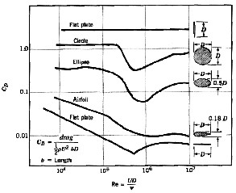

wake is very small, and the drag is dominated by the viscous friction inside the boundary layers.   
However, [as the angle of attack increases,](http://www.princeton.edu/~asmits/Bicycle_web/lift_stall.html#drag) the pressure gradients on the airfoil increase in   
magnitude. In particular, the adverse pressure gradient on the top rear portion of the airfoil may   
become sufficiently strong to produce a separated flow. This separation will increase the size of   
the wake, and the pressure losses in the wake due to eddy formation Therefore the pressure drag   
increases. At a higher angle of attack, a large fraction of the flow over the top surface of the   
airfoil may be separated, and the airfoil is said to be stalled. At this stage, the pressure drag is   
much greater than the viscous drag.

When the drag is dominated by   
viscous drag, we say the body is   
streamlined, and when it is dominated by   
pressure drag, we say the body is bluff.   
Whether the flow is viscous-drag dominated   
or pressure-drag dominated depends entirely   
on the shape of the body. A streamlined   
body looks like a fish, or an airfoil at small   
angles of attack, whereas a bluff body looks   
like a brick, a cylinder, or an airfoil at large

angles of attack. For streamlined bodies, frictional drag is the dominant source of air resistance. For a bluff body, the dominant source of drag is pressure drag. For a given frontal area and velocity, a streamlined body will always have a lower resistance than a bluff body. For example, the drag of a cylinder of diameter D can be ten times larger than a streamlined shape with the same thickness (see figure).

Cylinders and spheres are considered bluff bodies because at large Reynolds numbers the   
drag is dominated by the pressure losses in the wake. The variation of the drag coefficient with   
Reynolds number is shown in figure, and the corresponding flow patterns are shown in figure.   
We see that as the Reynolds number increases the variation in the drag coefficient (based on   
cross-sectional area) decreases, and over a large range in Reynolds number it is nearly constant.

57

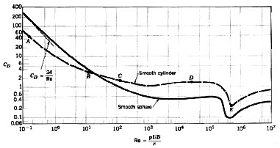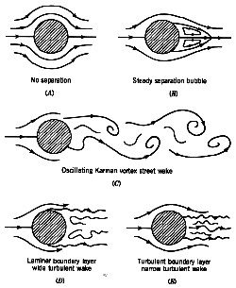

(a) Drag coefficient as a function of Reynolds number for smooth circular cylinders and smooth spheres

(b)Flow patterns for flow over a cylinder: (A) Reynolds number = 0.2; (B) 12; (C) 120; (D) 30,000; (E) 500,000. Patterns correspond to the points marked on figure 2.

At a Reynolds number between 10^5 and 10^6, the drag coefficient takes a sudden dip.   
The size of the wake decreases, indicating that the boundary layer separation on the cylinder or   
sphere occurs further along the surface than before. What has happened? The phenomenon is   
related to the differences between laminar and turbulent boundary layer. The boundary layer and   
its interaction with the local pressure gradient plays a major role in affecting the flow over a   
cylinder. In particular, near the shoulder, the pressure gradient changes from being negative   
(decreasing pressure) to positive (increasing pressure). The force due to pressure differences   
changes sign from being an accelerating force to being a retarding force. In response, the flow   
slows down. However, the fluid in the boundary layer has already given up some momentum   
because of viscous losses and viscous friction, and it does not have enough momentum to   
overcome the retarding force. Some fluid near the wall actually reverses direction, and the flow   
separates.

58

VORTEX INDUCED VIBRATIONS   
Vortices:

A vortex is defined as the motion ofmultitude of fluid particles around acommon center.

Types of vortices:

- Forced Vortex

- Free Vortex

Vortices in the Real World:

■ Vortices in the real world like Tornados, Whirlpool in rivers are often a combination of   
 free and forced vortices.

■ Forced vortex flow occurs at and near the center of the vortex while free vortex   
 conditions are approximated outside this region.

Flow-Induced Vibration:

■ The vibration caused by a fluid flowing around a body is known as flow-induced   
 vibration.

■ In the following examples, the vibration of the system continuously extracts energy from   
 the source, leading to larger and larger amplitudes of vibration.

Phenomena of Induced Vibration:

- Tall chimneys, Submarine periscopes, Electric transmission lines and nuclear fuel rods

are found to vibrate violently under certain conditions of fluid flow around them.

- Similarly, water and oil pipe lines and tubes in air compressors undergo sever vibrations

under certain conditions of fluid flow through them.

- In ice-covered electric transmission lines and the unstable vibration, known as flutter, of

air foil sections.

- High frequency vibration known as singing of transmission lines occurs due to the

phenomena of vortex shedding.

Why Vortex Shedding Phenomena:

■ Vortex shedding was the primary cause of failure of the Tacoma Narrows suspension   
 bridge in the state of Washington in 1940.

■ If the frequency of the vortex shedding is in resonance with the natural frequency of the   
 member that produces it, large amplitudes of vibrations with resulting large stresses can

develop.

59

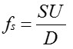

■ Experimental data show that regular vortex shedding occurs strongly in the range of   
 Reynolds number (Re) from about 60 to 5000.

■ Experiments shows also that the frequency of shedding is given in terms of Strouhal   
 number (St), and this in turn is a function of the Reynolds number.

■ Other cylindrical and two dimensional bodies can also shed vortices.

Vortex shedding dictated by the Strouhal number

Where,

fs is the shedding frequency, d is diameter and

U inflow speed

Additional VIV Parameters (Non-dimensional parameters)

➢ Reynolds Number

Re 

➢ Reduced Velocity

UD

v



inertialeffects   
viscouseffects

U

Vrn 

➢ Dimensional Amplitude

➢ Vortex Shedding Frequency

f

n

D

60

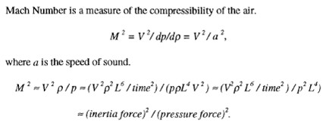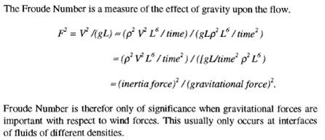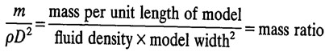

➢ Mach Number

➢ Froude Number

➢ Mass ratio

➢ Damping factor

➢ Reduced damping

➢ Fineness ratio

61

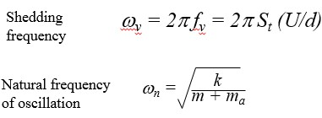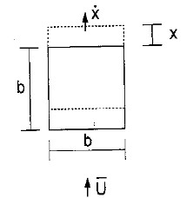

Lock-in

A cylinder is said to be “locked in” when the frequency of oscillation is equal to the frequency of vortex shedding. In this region the largest amplitude oscillations occur.

Types of in-stabilities:

|  |  |  |  |
| --- | --- | --- | --- |
| Name | Conditions | Type of motion | Type of section |
| Galloping | H1>0 | translational | Square section |
| ‘Stall’ flutter | A2>0 | rotational | Rectangle, H-  section |
| ‘Classical’ flutter | H2>0, A1>0 | coupled | Flat plate, airfoil |

Aerodynamic damping (along wind)

Consider a body moving with velocity in a flow of speed U

Relative velocity of air with respect to body = ~~U~~ 

Drag force (per unit length) =

1 1 2

DCD

1

2

ρ b(U )2Ca D

2

ρ bU2(1a 

U

)

CD

2

a  D a 

for small    
 mc kxD(t)

Transfer to left hand side of equation of motion:

Total damping term:c CDρa

U

Along-wind aerodynamic damping is positive

62

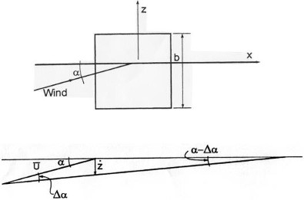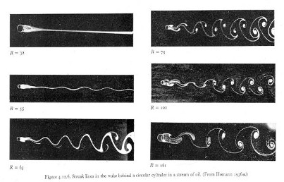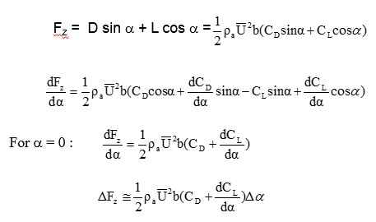

Galloping

❖ Galloping is a result of a wake instability.

❖ Galloping is a form of aerodynamic instability caused by negative aerodynamic damping   
 in the cross wind direction

Motion of body in z direction will generate an apparent reduction in angle of attack,  From vector diagram: Δα  /U

Aerodynamic force per unit length in z direction (body axes):

63

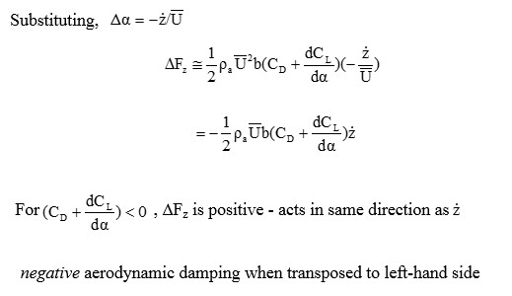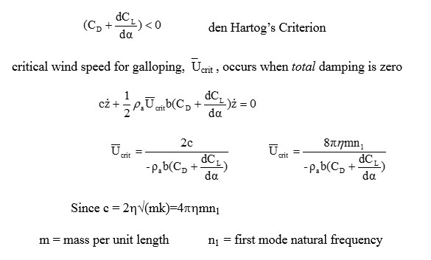

Cross sections prone to galloping:

❖ Square section (zero angle of attack)  D-shaped cross section

❖ Iced-up transmission line or guy cable  Flexible Cylinders

Galloping vs. VIV

• Galloping is low frequency

• Galloping is NOT self-limiting

• Once U >Ucriticalthen the instability occurs ir-regardless of frequencies.

64

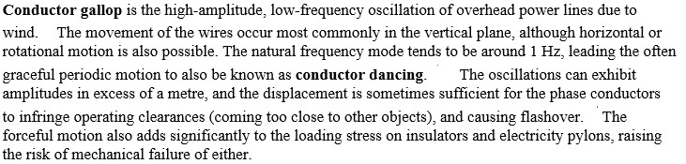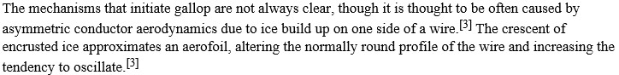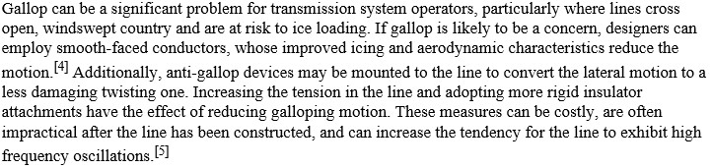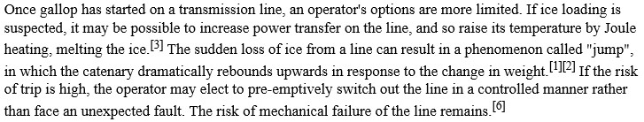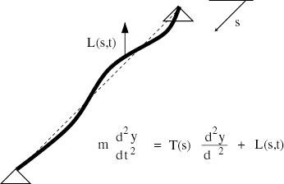

Conductor galloping/ transmission lines galloping

Main phenomena related to wind effects on cables/ropes vibration

❖ Vortex shedding: alternate formation of   
 vortices in the downstream wake of the cable.  Vibration due to turbulent wind (buffeting):

mainly related to forcing effects due to   
variation of wind speed both in module and   
direction.

65

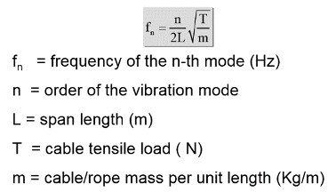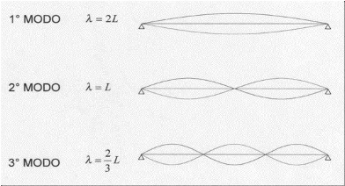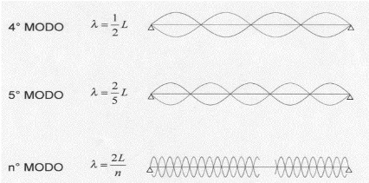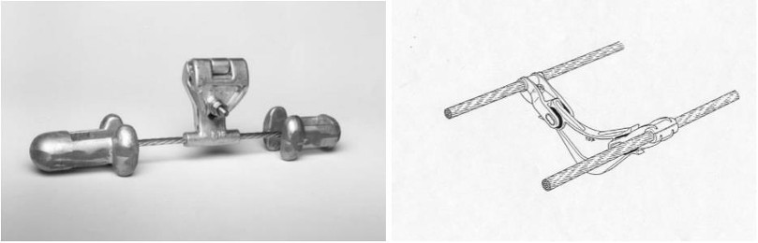

❖ Aero-elastic instability (galloping): irregular shape, due to ice deposits (ice galloping),   
 can lead to modification of cable profile, and unstable oscillations can occur.   
❖ Wake induced vibrations(bundle galloping): typical for cables fitted in bundles (grouped

in 2, 3, 4, or more formation), as occurs in electrical power transmission lines

Considering a cable or a rope, different natural frequencies exist. In the case of sag much less than the span length, are according to the formula:

Vibration modes of a taut cable

Vibrationscan be easily controlled by can be easily controlled by adding damping to the   
cable, in the form of adding damping to the cable, in the form of dampers and spacer dampers   
and spacer- -dampers. This is feasible for dampers. This is feasible for electric power   
transmission lines.

66

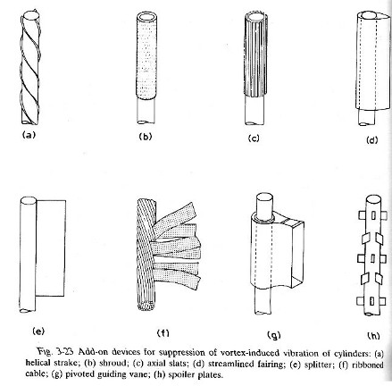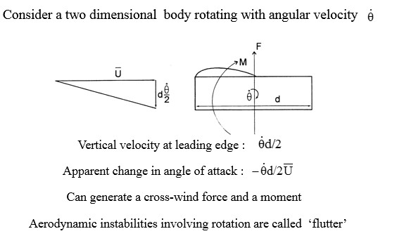

FLUTTER

Flutter is a dangerous phenomenon encountered in flexible structures subjected to   
aerodynamic forces. This includes aircraft, buildings, telegraph wires, stop signs, and bridges.   
Flutter occurs as a result of interactions between aerodynamics, stiffness, and inertial forces on a   
structure. In an aircraft, as the speed of the wind increases, there may be a point at which the   
structural damping is insufficient to damp out the motions which are increasing due to   
aerodynamic energy being added to the structure. This vibration can cause structural failure and   
therefore considering flutter characteristics is an essential part of designing an aircraft.

67

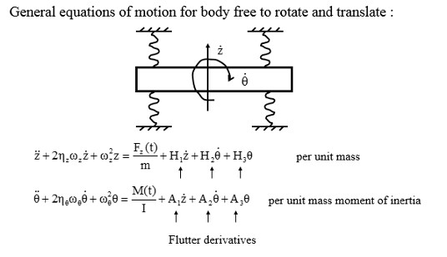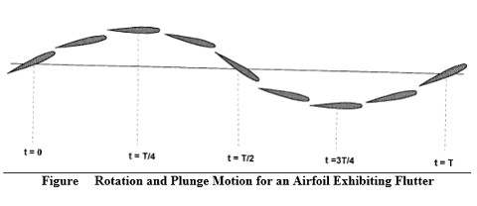

Flutter Motion

The basic type of flutter of aircraft wing is described here. Flutter may be initiated by a   
rotation of the airfoil (see t=0 in Figure 1). As the increased force causes the airfoil to rise, the   
torsional stiffness of the structure returns the airfoil to zero rotation (t=T/4 in Figure 1). The   
bending stiffness of the structure tries to return the airfoil to the neutral position, but now the   
airfoil rotates in a nose-down position (t=T/2 in Figure 1). Again the increased force causes the   
airfoil to plunge and the torsional stiffness returns the airfoil to zero rotation (t=3T/4). The cycle   
is completed when the airfoil returns to the neutral position with a nose-up rotation. Notice that   
the maximum rotation leads the maximum rise or plunge by 90 degrees (T/4). As time increases,   
the plunge motion tends to damp out, but the rotation motion diverges. If the motion is allowed   
to continue, the forces due to the rotation will cause the structure to fail.

This flutter is caused by the coalescence of two structural modes - pitch and plunge (or   
wing-bending) motion. This example wing has two basic degrees of freedom or natural modes   
of vibration: pitch and plunge (bending). The pitch mode is rotational and the bending mode is   
a vertical up and down motion at the wing tip. As the airfoil flies at increasing speed, the

68

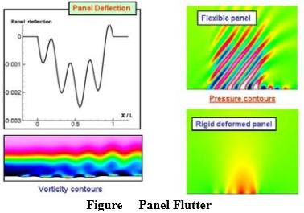

frequencies of these modes coalesce or come together to create one mode at the flutter frequency and flutter condition. This is the flutter resonance.

Types of Flutter

Airfoils are used in many places on an airplane. The most obvious is the wing, but airfoil   
shapes are also used in the tail, propellers and control surfaces such as ailerons, rudders and   
stabilizers. All of these conditions must be analyzed and tested to insure that flutter does not   
occur.

There is other flutter behavior that must be considered when designing aircraft: panel flutter, galloping flutter, stall flutter, limit cycle oscillations (LCO) or buzz, and propeller or engine whirl flutter. There can also be flutter due to stores mounted on the wing.

Panel flutter can occur when a surface is not adequately supported (think of the skin of an airplane acting like a drumhead). Figure 3 illustrates panel flutter motion.

Galloping flutter, or wake vortex flutter, was the cause of failure of the Tacoma Narrows Bridge. This phenomenon can be observed frequently along the roadside when telephone and power lines “gallop” due to strong winds. You may also observe car radio antenna aerials whipping under certain driving speeds. The cause of the galloping motion is formation of wake vortices downstream of the object. As shown in Figure 4, the vortices are shed alternately from one side of the object and then the other. These cause oscillatory forces and produce the back-and-forth motion. This type of flutter is an important design consideration for launch vehicles exposed to ground winds.

69

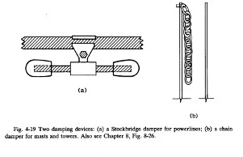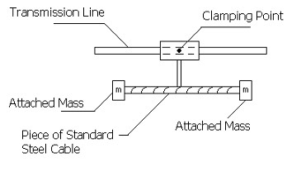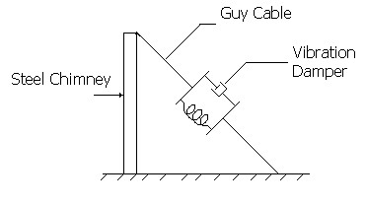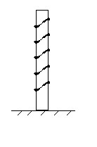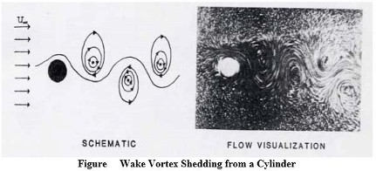

Stall flutter is a torsional mode of flutter that occurs on wings at high loading conditions near the stall speed. Because the airflow separates during stall, this single degree-of- freedom flutter cannot be explained by classical flutter theory.

Limit cycle oscillation (LCO) behavior is characterized by constant amplitude, periodic   
structural response at frequencies that are those of the aeroelastically-loaded structure. LCO is   
typically limited to a narrow region in Mach number or angle-of-attack signaling the onset of   
flow separation.

Engine whirl flutter is a precession-type instability that can occur on a flexibly mounted engine-propeller combination. The phenomenon involves a complex interaction of engine mount stiffness, gyroscopic torques of the engine and propeller combination, and the natural flutter frequency of the wing structure.

Prevention of galloping and flutter

This can be accomplished by following   
 ➢ Stable aerodynamic contours

➢ Stiffness or mass

➢ Damping

*************************

70

Unit V

Industrial Gas Turbines

Turbine

A turbine is a rotary mechanical device that extracts [energy](http://en.wikipedia.org/wiki/Energy) from a [fluid](http://en.wikipedia.org/wiki/Fluid) flow and   
converts it into useful [work.](http://en.wikipedia.org/wiki/Work_%28physics%29) A turbine is a [turbomachine](http://en.wikipedia.org/wiki/Turbomachinery) with at least one moving part called a   
rotor assembly, which is a shaft or drum with [blades](http://en.wikipedia.org/wiki/Turbine_blade) attached. Moving fluid acts on the blades so   
that they move and impart rotational energy to the rotor.

Operation theory

A working fluid contains [potential energy](http://en.wikipedia.org/wiki/Potential_energy) (pressure [head)](http://en.wikipedia.org/wiki/Head_%28hydraulic%29) and kinetic energy (velocity   
head). The fluid may be [compressible](http://en.wikipedia.org/wiki/Compressibility) or [incompressible.](http://en.wikipedia.org/wiki/Incompressible_fluid) Several physical principles are   
employed by turbines to collect this energy:

[Impulse](http://en.wikipedia.org/wiki/Impulse_%28physics%29) turbines change the direction of flow of a high velocity fluid or gas jet. The   
resulting impulse spins the turbine and leaves the fluid flow with diminished kinetic energy.   
There is no pressure change of the fluid or gas in the [turbine blades](http://en.wikipedia.org/wiki/Turbine_blade) (the moving blades), as in the   
case of a steam or gas turbine, all the pressure drop takes place in the stationary blades (the   
nozzles). Before reaching the turbine, the fluid's pressure head is changed to velocity head by   
accelerating the fluid with a [nozzle. Pelton wheels](http://en.wikipedia.org/wiki/Nozzle) and [de Laval turbines](http://en.wikipedia.org/wiki/Steam_turbine) use this process   
exclusively. Impulse turbines do not require a pressure casement around the rotor since the fluid   
jet is created by the nozzle prior to reaching the blades on the rotor. [Newton's second law](http://en.wikipedia.org/wiki/Newton%27s_laws_of_motion#Newton.27s_second_law)   
describes the transfer of energy for impulse turbines.

[Reaction](http://en.wikipedia.org/wiki/Reaction_%28physics%29) turbines develop [torque](http://en.wikipedia.org/wiki/Torque) by reacting to the gas or fluid's pressure or mass. The   
pressure of the gas or fluid changes as it passes through the turbine rotor blades. A pressure   
casement is needed to contain the working fluid as it acts on the turbine stage(s) or the turbine   
must be fully immersed in the fluid flow (such as with wind turbines). The casing contains and   
directs the working fluid and, for water turbines, maintains the suction imparted by the [draft](http://en.wikipedia.org/wiki/Draft_tube)   
[tube. Francis turbines](http://en.wikipedia.org/wiki/Draft_tube) and most [steam turbines](http://en.wikipedia.org/wiki/Steam_turbine) use this concept. For compressible working fluids,

71

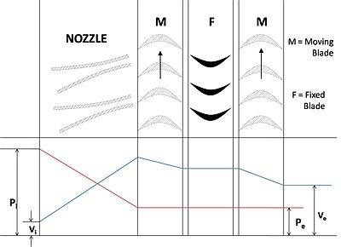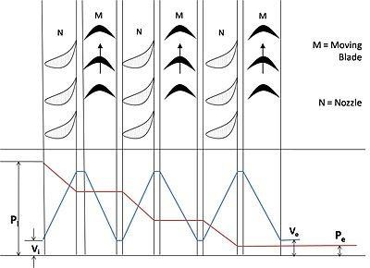

multiple turbine stages are usually used to harness the expanding gas efficiently. [Newton's third](http://en.wikipedia.org/wiki/Newton%27s_laws_of_motion#Newton.27s_third_law)   
[law](http://en.wikipedia.org/wiki/Newton%27s_laws_of_motion#Newton.27s_third_law) describes the transfer of energy for reaction turbines.

Types of compounding

In an Impulse turbine compounding can be achieved in the following three ways: -

1. Velocity compounding

2. Pressure compounding

3. Pressure-Velocity Compounding

In a Reaction turbine compounding can be achieved only by Pressure compounding.

Velocity compounding of Impulse Turbine

Pressure compounding of Impulse Turbine

72

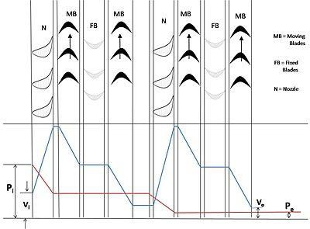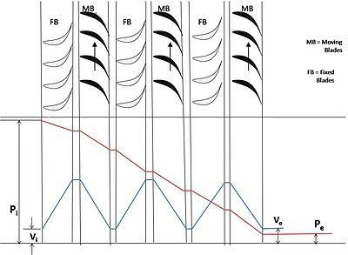

Pressure-Velocity compounded Impulse Turbine

Pressure compounding of Reaction Turbine

Types based on working fluid

• [Steam turbines](http://en.wikipedia.org/wiki/Steam_turbine) are used for the generation of electricity in thermal power plants, such as   
 plants using [coal, fuel oil](http://en.wikipedia.org/wiki/Coal) or [nuclear fuel.](http://en.wikipedia.org/wiki/Nuclear_fuel) They were once used to directly drive

mechanical devices such as ships' [propellers](http://en.wikipedia.org/wiki/Propeller) but most such applications now use   
reduction gears or an intermediate electrical step, where the turbine is used to generate   
electricity, which then powers an [electric motor](http://en.wikipedia.org/wiki/Electric_motor) connected to the mechanical load.

73

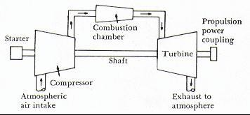

• [Gas turbines](http://en.wikipedia.org/wiki/Gas_turbine) are sometimes referred to as turbine engines. Such engines usually feature

an inlet, fan, compressor, combustor and nozzle (possibly other assemblies) in addition to one or more turbines.

• [Water turbines](http://en.wikipedia.org/wiki/Water_turbine)

o [Pelton turbine,](http://en.wikipedia.org/wiki/Pelton_wheel) a type of impulse water turbine.

o [Francis turbine,](http://en.wikipedia.org/wiki/Francis_turbine) a type of widely used water turbine.

o [Kaplan turbine,](http://en.wikipedia.org/wiki/Kaplan_turbine) a variation of the Francis Turbine.

o [Turgo turbine,](http://en.wikipedia.org/wiki/Turgo_turbine) a modified form of the Pelton wheel.

o [Cross-flow turbine,](http://en.wikipedia.org/wiki/Cross-flow_turbine) also known as Banki-Michell turbine, or Ossberger turbine.   
• [Wind turbine:](http://en.wikipedia.org/wiki/Wind_turbine) These normally operate as a single stage without nozzle and interstage   
 guide vanes.

GAS TURBINE

A gas turbine, also called a combustion turbine, is a type of [internal combustion engine.](http://en.wikipedia.org/wiki/Internal_combustion_engine) It   
has an upstream rotating [compressor](http://en.wikipedia.org/wiki/Gas_compressor) coupled to a downstream [turbine,](http://en.wikipedia.org/wiki/Turbine) and a combustion   
[chamber](http://en.wikipedia.org/wiki/Combustion_chamber) in-between.

The basic operation of the gas turbine is similar to that of the [steam power plant](http://en.wikipedia.org/wiki/Steam_power_plant) except   
that air is used instead of water. Fresh atmospheric air flows through a [compressor](http://en.wikipedia.org/wiki/Gas_compressor) that brings it   
to higher pressure. [Energy](http://en.wikipedia.org/wiki/Energy) is then added by spraying fuel into the air and igniting it so the   
combustion generates a high-temperature flow. This high-temperature high-pressure gas enters a   
turbine, where it expands down to the exhaust pressure, producing a shaft work output in the   
process. The turbine shaft work is used to drive the compressor and other devices such as an   
[electric generator](http://en.wikipedia.org/wiki/Electric_generator) that may be coupled to the shaft. The energy that is not used for shaft work   
comes out in the [exhaust gases,](http://en.wikipedia.org/wiki/Exhaust_gases) so these have either a high temperature or a high velocity. The   
purpose of the gas turbine determines the

design so that the most desirable energy   
form is maximized. Gas turbines are used   
to power [aircraft, trains, ships, electrical](http://en.wikipedia.org/wiki/Aircraft)   
[generators,](http://en.wikipedia.org/wiki/Electrical_generator) or even [tanks.](http://en.wikipedia.org/wiki/Tank)

74

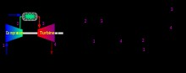

Classifications of gas turbines

➢ Open cycle gas turbine

➢ Closed cycle gas turbine

Theory of operation

In an ideal gas turbine, gases undergo three [thermodynamic](http://en.wikipedia.org/wiki/Thermodynamics) processes: an [isentropic](http://en.wikipedia.org/wiki/Isentropic)   
compression, an [isobaric](http://en.wikipedia.org/wiki/Isobaric_process) (constant pressure) combustion and an isentropic expansion. Together,   
these make up the [Brayton cycle.](http://en.wikipedia.org/wiki/Brayton_cycle)

In a practical gas turbine, mechanical energy is irreversibly transformed into heat when   
gases are compressed (in either a centrifugal or axial [compressor)](http://en.wikipedia.org/wiki/Gas_compressor), due to internal friction and   
turbulence. Passage through the [combustion chamber,](http://en.wikipedia.org/wiki/Combustor) where heat is added and the [specific](http://en.wikipedia.org/wiki/Specific_volume)   
[volume](http://en.wikipedia.org/wiki/Specific_volume) of the gases increases, is accompanied by a slight loss in pressure. During expansion   
amidst the stator and rotor blades of the turbine, irreversible energy transformation once again   
occurs.

If the device has been designed to power a shaft as with an industrial generator or a   
[turboprop,](http://en.wikipedia.org/wiki/Turboprop) the exit pressure will be as close to the entry pressure as possible. In practice it is   
necessary that some pressure remains at the outlet in order to fully expel the exhaust gases.

• Compressorr - Dynamically Compress air

• Combustor - Heat addition through chemical reaction

• Turbine - Run the compressor and used for various application

75

Advantages of gas turbine

• Very high [power-to-weight ratio,](http://en.wikipedia.org/wiki/Power-to-weight_ratio) compared to reciprocating engines;

• Smaller than most reciprocating engines of the same power rating.

• Moves in one direction only, with far less vibration than a reciprocating engine.

• Fewer moving parts than reciprocating engines.

• Greater reliability, particularly in applications where sustained high power output is

required

• Waste heat is dissipated almost entirely in the exhaust.

• Low operating pressures.

• High operation speeds.

• Low lubricating oil cost and consumption.

• Can run on a wide variety of fuels.

• Very low toxic emissions of CO and HC due to excess air, complete combustion and no

"quench" of the flame on cold surfaces

Disadvantages of gas turbine

• Cost is very high

• Less efficient than reciprocating engines at idle speed • Longer startup than reciprocating engines

• Less responsive to changes in power demand compared with reciprocating engines • Characteristic whine can be hard to suppress

Application

Thermal process industries, Petro-chemical industry, Aircrafts, Transportation and etc...

- electric power generation,

- mechanical drive systems,

- Supply of process heat and compressed air, pump drives for gas or liquid pipelines.

- jet propulsion,

- land and sea transport

76

SPECIAL FEATURES OF INDUSTRIAL AND STATIONARY GAS TURBINE AS COMPARED TO AIRCRAFT GAS TURBINE:

Industrial gas turbines differ from aeronautical designs in that the frames, bearings, and   
blading are of heavier construction. They are also much more closely integrated with the devices   
they power— often an [electric generator](http://en.wikipedia.org/wiki/Electric_generator)—and the secondary-energy equipment that is used to   
recover residual energy (largely heat).

➢ Long life

➢ Frontal area

➢ Space requirements ➢ Availability

➢ Thermal efficiency

➢ Pressure losses and other parameter of importance for the industry under consideration ➢ Continuous duty with large power requirements

The basic design parameters for heavy industrial gas turbine engines evolved from   
industrial steam turbines that have slower speeds, heavy rotors, and larger cases than jet engines   
to ensure longer life. These gas turbines are capable of burning the widest range of liquid or gas   
fuels.

The basic design parameters and technology used in aircraft turbines can be combined with some of the design aspects of heavy industrial gas turbines to produce a lighter-weight industrial turbine with a life approaching that of a heavy industrial gas turbine. These engines are called light industrial gas turbine engines.

Aircraft turbine engines or jet engines are designed with highly sophisticated construction   
for light weight specifically for powering aircraft. These designs require maximum horsepower   
or thrust with minimum weight and maximum fuel efficiency. Aircraft turbines have roller   
bearings and high firing temperatures requiring exotic metallurgy. They can be operated on a   
limited variation of fuels. When a jet engine is used in an industrial application, it must be   
coupled with an independent power turbine to produce shaft power. In the case of a [jet engine](http://en.wikipedia.org/wiki/Jet_engine)   
only enough pressure and energy is extracted from the flow to drive the compressor and other   
components. The remaining high pressure gases are accelerated to provide a jet that can, for   
example, be used to propel an aircraft.

**********************************

77