**AS-II QUE BANK**

**2 MARKS**

1. Define Principal axis, Neutral axis and give an expression to determine them.

If the two axes about which the product of inertia is found, are such, that the product of inertia becomes zero, the two axes are then called principal axes.

Ixy = 0

The product of inertia is zero.

*I xy* = ∫ *xydA* = *o*

(b)In a beam subjected to bending the line of zero stress; a transverse section of the longitudinal plane, or neutral surface, which passes through the centre of area of the section.

Where *α* =The angle of the straight line passing through the centroid G of the section, which is inclined with UU.

1. Explain how unsymmetrical bending is developed in a beam?

The section is symmetrical like I section, rectangular section, circular section, but he load-line is inclined to both the principal axes.

The section itself is unsymmetrical like angle section or a channel section and load line

1. Bending of a symmetric section subject to a skew load will be symmetric /un- symmetric Explain.

Un symmetric.

When the trace of the plane of the applied moment does not coincide with any of the principal axes of inertia then this type of bending is called un-symmetrical or non-uni-planar bending.

1. Define shear centre.

The point at which shear loads becomes zero is known as shear centre and it can be at intersection of two axis points.

1. Define pure bending of beam.

Pure bending is a condition of stress where a bending moment is applied to a beam without the simultaneous presence of axial, shear, or torsional forces. Pure bending occurs only under a constant bending moment (M) since the shear force (V), which is equal to , has to be equal to zero.

1. What is flexural torsional buckling?

Torsional buckling, and flexural-torsional buckling. This type of buckling can occur in any compression member that experiences a deflection caused by bending or flexure. Flexural buckling occurs about the axis with the largest slenderness ratio, and the smallest radius of gyration.

1. What is Wagner beam?

A beam with two stiffeners and a web. Such a beam can only support a transverse force that is parallel to a straight line drawn through the centroids of two stiffeners.

1. What are the functions of aircraft wing spar?

The spar carries flight loads and the weight of thewings while on the ground. ... Spars are also used in other aircraft aerofoil surfaces such as the tailplane and fin and serve a similar function, although the loads transmitted may be different from those of awing spar.

1. What are the assumptions made in Bredth batho theory?

* There is no torque and twisting moment at shear centre
* It has to obey hookes law.

1. What do you meant by crippling strength?

As the compressive load is increase the plate will buckle and it won't be efficient is carrying load. ... Failure of this structure will occur when the supported sides reaches compressive yield strength of the material. This yield strength can be think of as the crippling strength.

1. What are the loads acting on fuselage?

There are two types of loads are acting on fuselage

* Internal
* Pressurized cabins load
* Crew load
* External
* Pressure loads
* Gust loads
* Shear stress distributions

1. What is the significance of effective width?

The successive distance in between any two ribs and stringers in aircraft wing and fuselage section is known as effective width.

1. Define gust loads.

When an aircraft is hit by an upward gust (short blast of wind), its wing load is momentarily increased, thus increasing the bending moment on the wing. By making a careful structural design, such bending effect should also result in a twist such that the angle-of-attack is reduced, thus reducing the wing load.

1. What is semi-monocoque and monocoque?

A monocoque fuselage has its skin holding the skeleton structure together while the semi-monocoque has both the skin and the skeleton holding together. Semi-monocoque also has "stringers" running horizontally down the plane to help hold the frame together. The monocoque fuselage also cannot be used for airframes after a certain size (small aircraft with single engine), but the semi-monocoque has been used from single piston engines to commercial airliners.

A monocoque design would also have a safety risk involved if the skin was damaged because it is the load-bearing structure.

1. What do you meant by linearly elastic structure?

For a structure, this means the deformation is proportional to the loading, and deformations disappear on unloading. For a material, the concept is the same except strain substitutes for deformation, and stress substitutes for load.

**16 MARKS**

1. Derive an expression for deflection in unsymmetrical bending manner by using neutral axis method.
2. Find the direct stresses and deflection moments along the following section

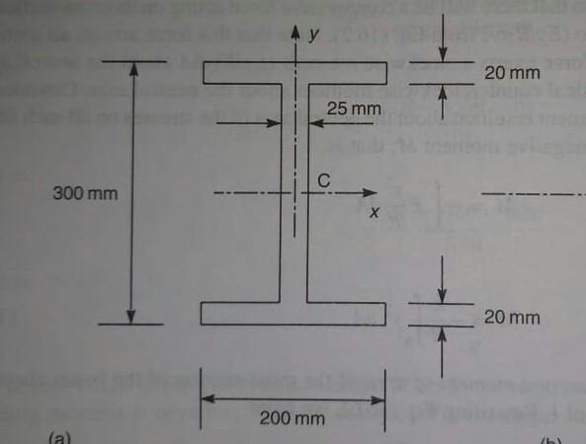

1. Derive an expression for shear flow distribution in open section beams
2. Define and derive Bredth-batho theory.

1. Define buckling and derive expression for transeverse loads.

1. Derive equation for bending of thin plates.
2. Draw V-n diagram and elobarate it.
3. Write a note on aircraft structural components.
4. Find out total stress acting on fuselage by using structural idealization method.

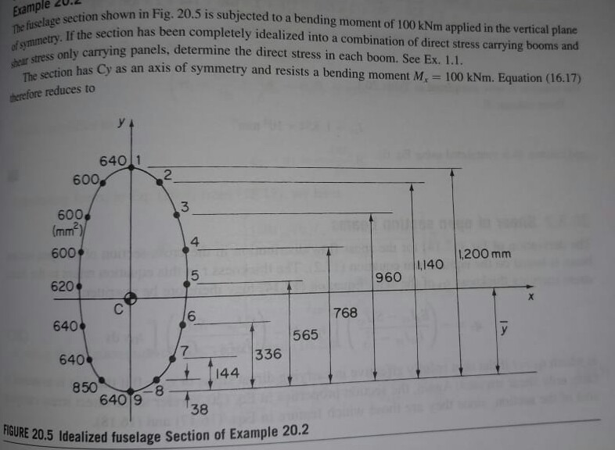

1. Find the shear centre for the following section

