CS6703 - Grid and Cloud Computing Department of IT

Unit I - Introduction

Part - A
1. Define cloud computing

Cloud computing is the delivery of computing as a service rather than a product, hereby shared resources, software, and information are provided to computers and other devices as a utility.

2. What is Distributed computing

This is a field of computer science/engineering that studies distributed systems. A distributed system consists of multiple autonomous computers, each having its own private memory, communicating through a computer network. Information exchange in a distributed system is accomplished through message passing. A computer program that runs in a distributed system is known as a distributed program. The process of writing distributed programs is referred to as distributed programming.

3. Difference between distributed and parallel computing.
Distributed |  |  |  | Parallel
Each processor has its own |  |  |  |  | All processors may have
private memory (distributed |  |  |  | access to a shared memory
memory). | Information |  | is | to | exchange | information
exchanged | by | passing |  | between processors.
messages | between |  | the
processors.
It is loosely coupled. |  |  |  | It is tightly coupled.
An important |  | goal | and | Large problems can often
challenge | of | distributed |  | be | divided | into smaller
systems | is | location |  | ones, which are then solved
transparency. |  |  |  | concurrently ("in parallel").
4. What is mean by service oriented architecture?

In grids/web services, Java, and CORBA, an entity is, respectively, a service, a Java object, and a CORBA distributed object in a variety of languages. These architectures build on the traditional seven Open Systems Interconnection (OSI) layers that provide the base networking abstractions. On top of this we have a base software environment, which would be .NET or Apache Axis for web services, the Java Virtual Machine for Java, and a broker network for CORBA.

5. What is High Performance Computing(HPC).

supercomputer sites and large data centers must provide high-performance computing services to huge numbers of Internet users concurrently.Because of this high demand, the Linpack Benchmark for high-performance computing (HPC) applications is no longer optimal for measuring system performance. The emergence of computing clouds instead demands high-throughput computing (HTC) systems built with parallel and distributed computing technologies. We have to upgrade data centers using fast servers, storage systems, and high-bandwidth networks. The purpose is to advance network-based computing and web services with the emerging new technologies.

6. Define peer-to-peer network.

The P2P architecture offers a distributed model of networked systems. Every node acts as both a client and a server, providing part of the system resources. Peer machines are simply client computers connected to the Internet. All client machines act autonomously to join or leave the system freely. This implies that no master-slave relationship exists among the peers. No central coordination or central database is needed.

- What are the Three New Computing Paradigms Radio-frequency identification (RFID), Global Positioning System (GPS),

Internet of Things (IoT).

- What is degree of parallelism and types

The degree of parallelism (DOP) is a metric which indicates how many operations can be or are being simultaneously executed by a computer. It is especially useful for describing the performance of parallel programs and multi-processor systems.
• | Bit-level parallelism (BLP) | • | Data-level parallelism (DLP)
• | Instruction-level parallelism (ILP) | • | Multicore | processors | and | chip
• | VLIW (very long instruction word) |  | multiprocessors (CMPs)
 |  | • Job-level parallelism (JLP)

9. What is Cyber-Physical Systems

A cyber-physical system (CPS) is the result of interaction between computational processes and the physical world. A CPS integrates ―cyber‖ (heterogeneous, asynchronous) with ―physical‖ (concurrent and information-dense) objects.
10. Define multi core CPU.

Advanced CPUs or microprocessor chips assume a multi-core architecture with dual, quad, six, or more processing cores. These processors exploit parallelism at ILP and TLP levels. CPU has reached its limit in terms of exploiting massive DLP due to the aforementioned memory wall problem

11. Define GPU.

A GPU is a graphics coprocessor or accelerator on a computer’s graphics card or video card. A GPU offloads the CPU from tedious graphics tasks in video editing applications. The GPU chips can process a minimum of 10 million polygons per second. GPU’s have a throughput architecture that exploits massive parallelism by executing many concurrent threads.

12. Clusters of Cooperative Computers

A computing cluster consists of interconnected stand-alone computers which work cooperatively as a single integrated computing resource.

13. What is single-system image (SSI)

An ideal cluster should merge multiple system images into a single-system image (SSI). Cluster designers desire a cluster operating system or some middleware to support SSI at various levels, including the sharing of CPUs, memory, and I/O across all cluster nodes.

14. What is Grid Computing

Grid computing is the collection of computer resources from multiple locations to reach a common goal. The grid can be thought of as a distributed system with non-interactive workloads that involve a large number of files. Grid computing is distinguished from conventional high performance computing systems such as cluster computing in that grid computers have each node set to perform a different task/application.

15. What is Computational Grids

A computing grid offers an infrastructure that couples computers,software/middleware, special instruments, and people and sensors together. The grid is often constructed across LAN, WAN, or Internet backbone networks at a regional, national, or global scale. Enterprises or organizations present grids as integrated computing resources.

16. What is Overlay Networks and its types

Overlay is a virtual network formed by mapping each physical machine with its ID, logically, through a virtual mapping . When a new peer joins the system, its peer ID is added as a node in the overlay network.

Two types of overlay networks:
1.Unstructured 2. Structured.

- Write the any three Grid Applications.
• Schedulers
• Resource Broker
• Load Balancing

- Difference between grid and cloud computing
 | Grid computing |  |  | cloud computing
 | Grids enable access to shared computing | Clouds enable access to leasedcomputing
 | power and storage capacity from your | power and storage capacity from your
 | desktop | desktop
 | In computing centres distributed across | The cloud providers private data centres
 | different sites, countries and continents | which are often centralised in a few
 |  | locations |  | with | excellent |  | network
 |  | connections and cheap electrical power.
 | Grids were designed to handle large sets | Clouds best support long term services
 | of limited duration jobs that produce or | and | longer |  | running | jobs | (E.g.
 | use large quantities of data (e.g. the LHC) | facebook.com)
19. What are the derivatives of grid computing?
There are 8 derivatives of grid computing. They are as follows:
 | a)Compute grid
 | b) Data grid
 | c) Science grid

- Access grid

- Knowledge grid
- Cluster grid
- Terra grid
- Commodity grid.

20. What is grid infrastructure?

Grid infrastructure forms the core foundation for successful grid applications. This infrastructure is a complex combination of number of capabilities and resources identified for the specific problem and environment being addressed.

- What are the Applications of High-Performance and High-Throughput Systems

1.Science and engineering- Scientific simulations, genomic analysis, etc.Earthquake prediction, global warming, weather forecasting, etc.

  - Business, education, services industry, and health care- Telecommunication, content delivery, e-commerce, etc.Banking, stock exchanges, transaction processing, etc.Air traffic control, electric power grids, distance education, etc.Health care, hospital automation, telemedicine, etc

  - Internet and web services,and government applications- Internet search, data centers, decision-making systems, etc.Traffic monitoring, worm containment, cyber security, etc.Digital government, online tax return processing, social networking, etc.

- What is Utility computing?

It is a service provisioning model in which a service provider makes computing resources and infrastructure management available to the customer as needed, and charges them for specific usage rather than a flat rate

23. What is SLA?

A service-level agreement (SLA) is a part of a standardized service contract where a service is formally defined. Particular aspects of the service – scope, quality, responsibilities – are agreed between the service provider and the service user. A common feature of an SLA is a contracted delivery time (of the service or performance)

Part - B
1. Describe about Evolution of Distributed computing.
Distributed computing is a field of computer science that studies distributed systems.

A distributed system is a model in which components located on networked computers communicate and coordinate their actions by passing messages The components interact with each other in order to achieve a common goal. Three significant characteristics of distributed systems are: concurrency of components, lack of a global clock, and independent failure of components. Examples of distributed systems vary from SOA-based systems to massively multiplayer online games to peer-to-peer applications.

A computer program that runs in a distributed system is called a distributed program, and distributed programming is the process of writing such programs. There are many alternatives for the message passing mechanism, including pure HTTP, RPC-like connectors and message queues.

HISTORY

The use of concurrent processes that communicate by message-passing has its roots in operating system architectures studied in the 1960s. The first widespread distributed systems were local-area networks such as Ethernet, which was invented in the 1970s.

ARPANET, the predecessor of the Internet, was introduced in the late 1960s, and ARPANET e-mail was invented in the early 1970s. E-mail became the most successful application of ARPANET, and it is probably the earliest example of a large-scale distributed application. In addition to ARPANET, and its successor, the Internet, other early worldwide computer networks included Usenet and FidoNet from the 1980s, both of which were used to support distributed discussion systems.

The study of distributed computing became its own branch of computer science in the late 1970s and early 1980s. The first conference in the field, Symposium on Principles of Distributed Computing (PODC), dates back to 1982, and its European counterpart International Symposium on Distributed Computing (DISC) was first held in 1985.

2. Explain in detail about Scalable computing over the Internet

A parallel and distributed computing system uses multiple computers to solve large-scale problems over the Internet. Thus, distributed computing becomes data-intensive and network-centric. identifies the applications of modern computer systems that practice parallel and distributed computing. These large-scale Internet applications have significantly enhanced the quality of life and information services in society today.

The Age of Internet Computing

Billions of people use the Internet every day. As a result, supercomputer sites and large data centers must provide high-performance computing services to huge numbers of Internet users concurrently.Because of this high demand, the Linpack Benchmark for high-performance computing (HPC) applications is no longer optimal for measuring system performance. The emergence of computing clouds instead demands high-throughput computing (HTC) systems built with parallel and distributed computing technologies We have to upgrade data centers using fast servers, storage systems, and high-bandwidth networks. The purpose is to advance network-based computing and web services with the emerging new technologies.

The Platform Evolution

Computer technology has gone through five generations of development, with each generation lasting from 10 to 20 years. Successive generations are overlapped in about 10 years. For instance, from 1950 to 1970, a handful of mainframes, including the IBM 360 and CDC 6400, were built to satisfy the demands of large businesses and government organizations. From 1960 to 1980, lower-cost minicomputers such as the DEC PDP 11 and VAX Series became popular among small businesses and on college campuses.

- From 1970 to 1990, we saw widespread use of personal computers built with VLSI microprocessors.

- From 1980 to 2000, massive numbers of portable computers and pervasive devices appeared inboth wired and wireless applications.
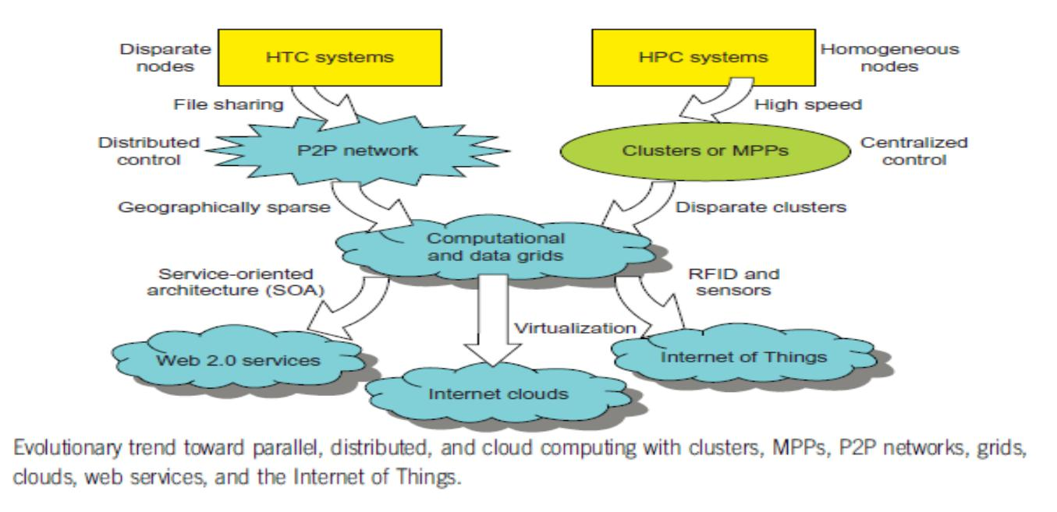

High-Performance Computing

The speed of HPC systems has increased from Gflops in the early 1990s to now Pflops in 2010. This improvement was driven mainly by the demands from scientific, engineering, and manufacturing communities

High-Throughput Computing

The development of market-oriented high-end computing systems is undergoing a strategic change

from an HPC paradigm to an HTC paradigm. This HTC paradigm pays more attention to high-flux computing. The main application for high-flux computing is in Internet searches and web

services by millions or more users simultaneously. The performance goal thus shifts to measure high throughput or the number of tasks completed per unit of time.

Three New Computing Paradigms

radio-frequency identification (RFID), Global Positioning System (GPS), and sensor technologies has triggered the development of the Internet of Things (IoT).

Computing Paradigm Distinctions

In general distributed computing is the opposite of centralized computing. The field of parallel computing overlaps with distributed computing to a great extent, and cloud computing overlaps with distributed, centralized, and parallel computing.

Centralized computing this is a computing paradigm by which all computer resources are centralized in one physical system. All resources (processors, memory, and storage) are fully shared and tightly coupled within one integrated OS. Many data centers and supercomputers are centralized systems, but they are used in parallel, distributed, and cloud computing applications

- Parallel computing in parallel computing, all processors are either tightly coupled with centralized shared memory or loosely coupled with distributed memory. Some authors refer to this discipline as parallel processing. Interprocessor communication is accomplished through shared memory or via message passing. A computer system capable of parallel computing is commonly known as a parallel computer . Programs running in a parallel computer are called parallel programs. The process of writing parallel programs is often

referred to as parallel programming .

- Distributed computing This is a field of computer science/engineering that studies distributed systems. A distributed system consists of multiple autonomous computers, each having its own private memory, communicating through a computer network. Information exchange in a distributed system is accomplished through message passing. A computer program that runs in a distributed system is known as a distributed program. The process of writing distributed programs is referred to as distributed programming.

- Cloud computing An Internet cloud of resources can be either a centralized or a distributed computing system. The cloud applies parallel or distributed computing, or both. Clouds can be built with physical or virtualized resources over large data centers that are centralized or distributed. Some authors consider cloud computing to be a form of utility computing or service computing .

The high-tech community prefer the term concurrent computing or concurrent programming. parallel computing and distributing computing, although biased practitioners may interpret them differently.Ubiquitous computing refers to computing with pervasive devices at any place and time using wired or wireless communication. The Internet of Things (IoT) is a networked connection of everyday objects including computers, sensors, humans, etc. The IoT is supported by Internet clouds to achieve ubiquitous computing with any object at any place and time. Finally, the term Internet computing is even broader and covers all computing paradigms over the Internet.

Distributed System Families

Since the mid-1990s, technologies for building P2P networks and networks of clusters have been consolidated into many national projects designed to establish wide area computing infrastructures, known as computational grids or data grids.

Meeting these goals requires yielding the following design objectives:

Efficiency measures the utilization rate of resources in an execution model by exploiting massive parallelism in HPC. For HTC, efficiency is more closely related to job throughput, data access, storage, and power efficiency.

- Dependability measures the reliability and self-management from the chip to the system and application levels. The purpose is to provide high-throughput service with Quality of Service (QoS) assurance, even under failure conditions.

- Adaptation in the programming model measures the ability to support billions of job requests over massive data sets and virtualized cloud resources under various workload and service models.

- Flexibility in application deployment measures the ability of distributed systems to run well in both HPC (science and engineering) and HTC (business) applications

Scalable Computing Trends and New Paradigms

Several predictable trends in technology are known to drive computing applications. In fact, designers and programmers want to predict the technological capabilities of future systems.

For instance, Jim Gray’s paper, ―Rules of Thumb in Data Engineering,‖ is an excellent example of how technology affects applications and vice versa. In addition, Moore’s law indicates that processor speed doubles every 18 months. Although Moore’s law has been proven valid over the last 30 years, it is difficult to say whether it will continue to be true in the future.

Degrees of Parallelism

when hardware was bulky and expensive, most computers were designed in a bit-serial fashion. In this scenario, bit-level parallelism (BLP) converts bit-serial processing to word-level processing gradually. users graduated from 4-bit microprocessors to 8-, 16-, 32-, and 64-bit CPUs. This led us to the next wave of improvement, known as instruction-levelparallelism (ILP), in which the processor executes multiple instructions simultaneously rather thanonly one instruction at a time. practiced ILP through pipelining, superscalar computing, VLIW (very long instruction word) architectures, and multithreading. ILP requires branch prediction, dynamic scheduling, speculation, and compiler support to work efficiently. Data-level parallelism (DLP) was made popular through SIMD (single instruction, multiple data) and vector machines using vector or array types of instructions. DLP requires even more hardware support and compiler assistance to work properly. Ever since the introduction of multicore processors and chip multiprocessors (CMPs), exploring task-level parallelism (TLP).A modern processor explores all of the aforementioned parallelism types. In fact, BLP, ILP, and As we move from parallel processing to distributed processing, increase in computing granularity to job-level parallelism (JLP). It is fair to say that coarse-grain parallelism is built on top of fine-grain parallelism.

Innovative Applications
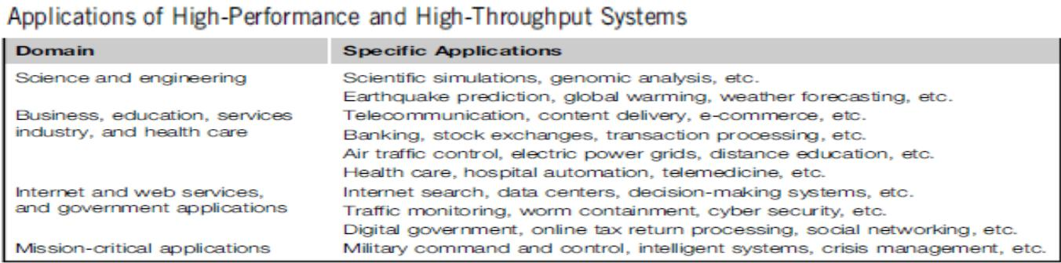

The Trend toward Utility Computing

All ubiquitous in daily life. Reliability and scalability are two major design objectives in these computing models.Second, they are aimed at autonomic operations that can be self-organized to support dynamic discovery.Finally, these paradigms are composable with QoS and SLAs (service-level agreements).

These paradigms and their attributes realize the computer utility vision.
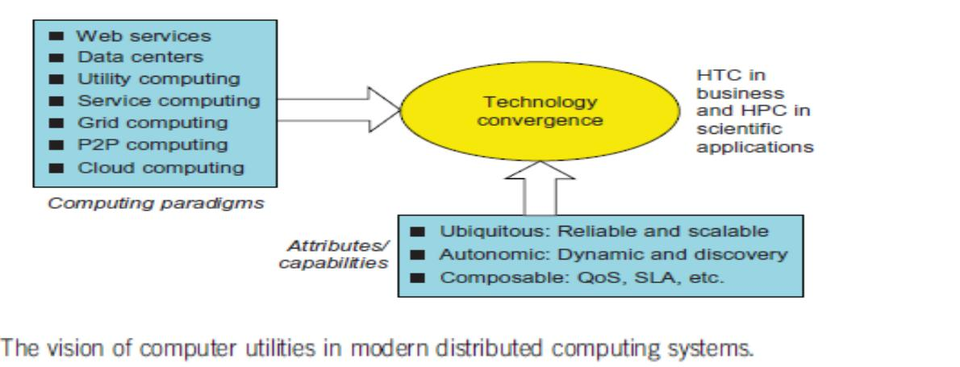

The Hype Cycle of New Technologies

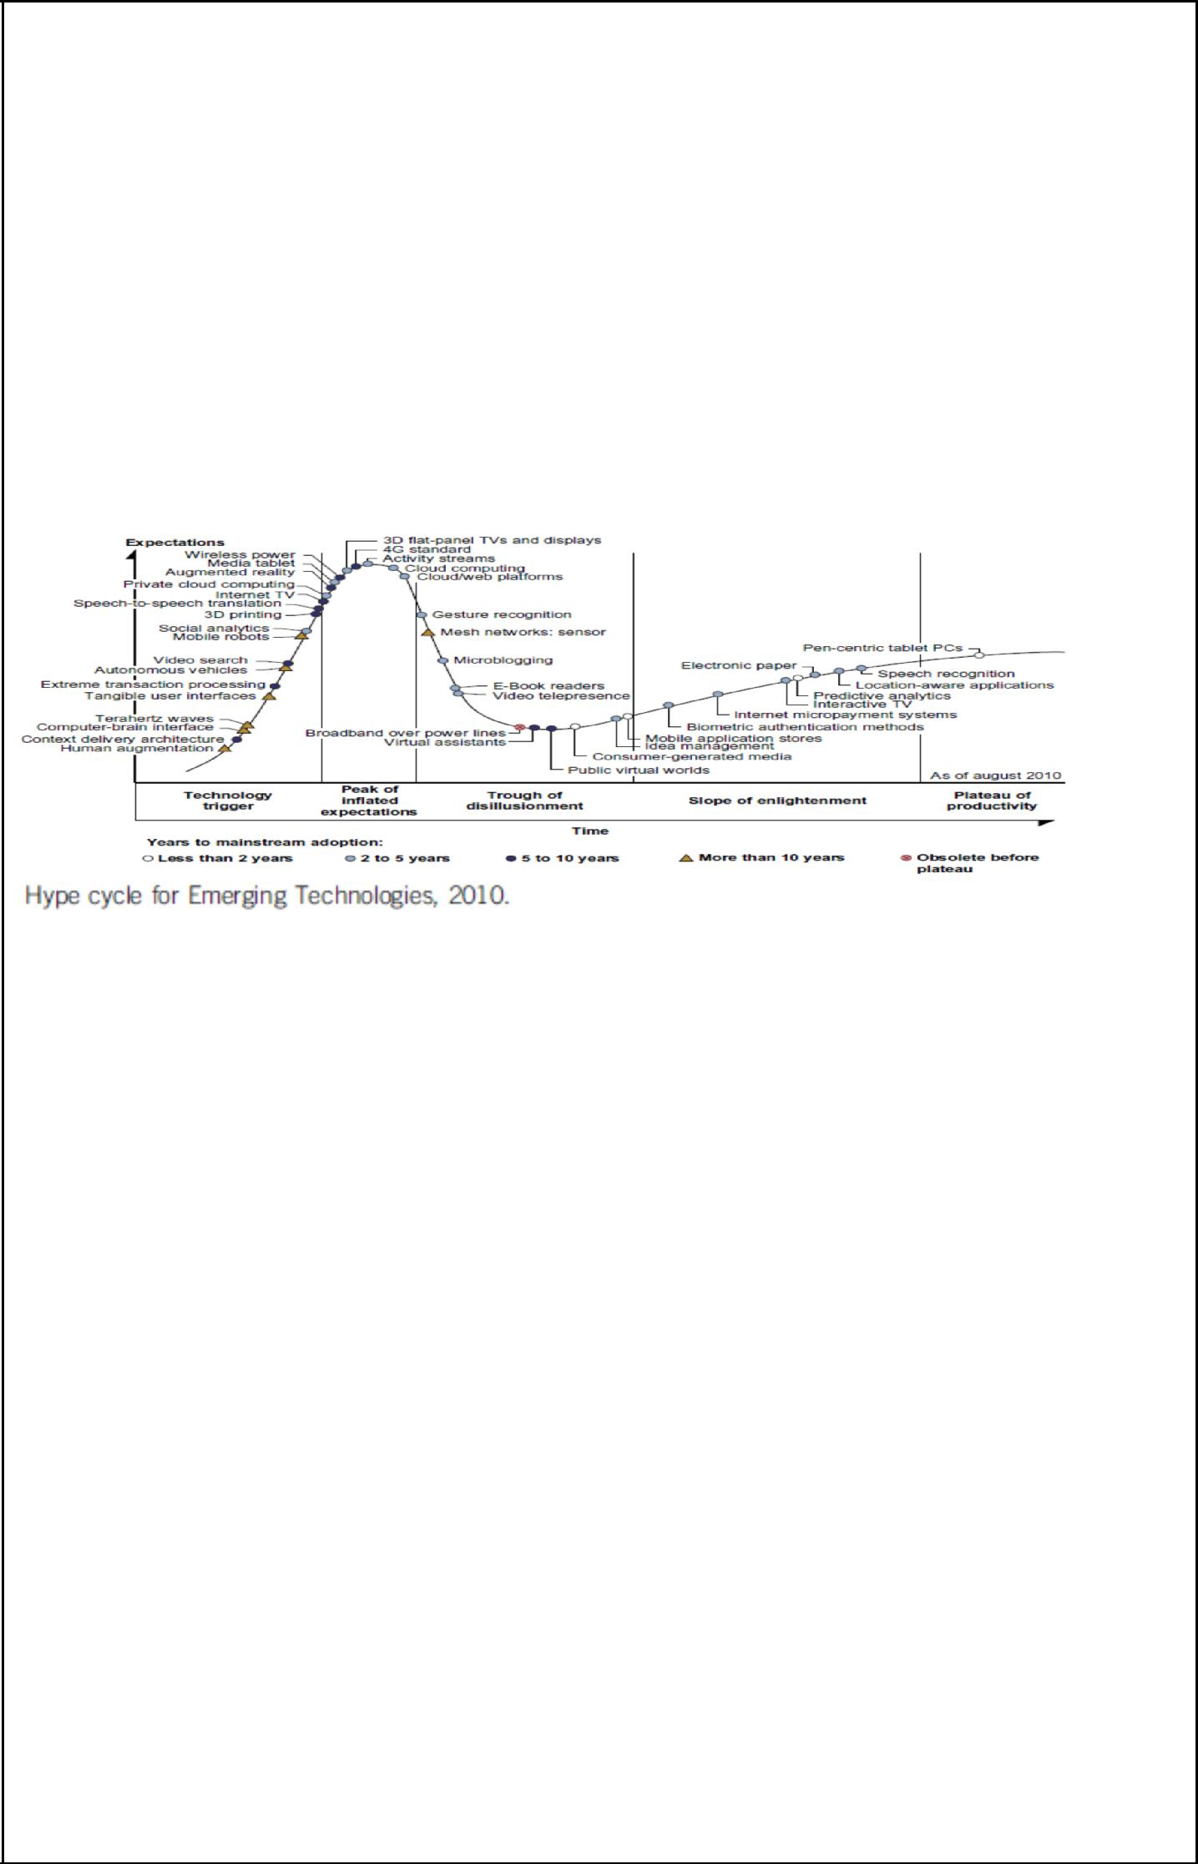

For example, at that time consumer-generated media was at the disillusionment stage, and it was predicted to take less than two years to reach its plateau of adoption. Internet micropayment systems were forecast to take two to five years to move from the enlightenment stage to maturity. It was believed that 3D printing would take five to 10 years to move from the rising expectation stage to mainstream adoption, and mesh network sensors were expected to take more than 10 years to move from the inflated expectation stage to a plateau of mainstream adoption.

The Internet of Things and Cyber-Physical Systems The Internet of Things

The traditional Internet connects machines to machines or web pages to web pages. The concept of the IoT was introduced in 1999 at MIT. The IoT refers to the networked interconnection of everyday objects, tools, devices, or computers. One can view the IoT as a wireless network of sensors that interconnect all things in our daily life.

Cyber-Physical Systems

A cyber-physical system (CPS) is the result of interaction between computational processes and the physical world. A CPS integrates ―cyber‖ (heterogeneous, asynchronous) with ―physical‖ (concurrent and information-dense) objects. A CPS merges the ―3C‖ technologies of computation, communication, and control into an intelligent closed feedback system between the physical world and the information world, a concept which is actively explored in the United States. The IoT emphasizes various networking connections among physical objects, while the CPS emphasizes exploration of virtual reality (VR) applications in the physical world.

3. Explain in detail about Multicore CPUs and Multithreading Technologies

The growth of component and network technologies over the past 30 years. They are crucial to the development of HPC and HTC systems. processor speed is measured in millions of instructions per second (MIPS) and network bandwidth is measured in megabits per second (Mbps) or gigabits per second (Gbps). The unit GE refers to 1 Gbps Ethernet bandwidth

Advances in CPU Processors

Advanced CPUs or microprocessor chips assume a multicore architecture with dual, quad, six, or more processing cores. These processors exploit parallelism at ILP and TLP levels. Processor speed growth is plotted in the upper curve in the diagram across generations of microprocessors or CMPs. We see growth from 1 MIPS for the VAX 780 in 1978 to 1,800 MIPS for the Intel Pentium 4 in 2002, up to a 22,000 MIPS peak for the Sun Niagara 2 in 2008. As the figure shows, Moore’s law has proven to be pretty accurate in this case. The clock rate for these processors increased from 10 MHz for the Intel 286 to 4 GHz for the Pentium 4 in 30 years.

The clock rate reached its limit on CMOS-based chips due to power limitations. At the time of this writing, very few CPU chips run with a clock rate exceeding 5 GHz. In other words, clock rate will not continue to improve unless chip technology matures. This limitation is attributed primarily to excessive heat generation with high frequency or high voltages. The ILP is highly exploited in modern CPU processors. ILP mechanisms include multiple-issue superscalar architecture, dynamic branch prediction, and speculative execution, among others. These ILP

techniques demand hardware and compiler support. In addition, DLP and TLP are highly explored in graphics processing units (GPUs) that adopt a many-core architecture with hundreds to thousands of simple cores
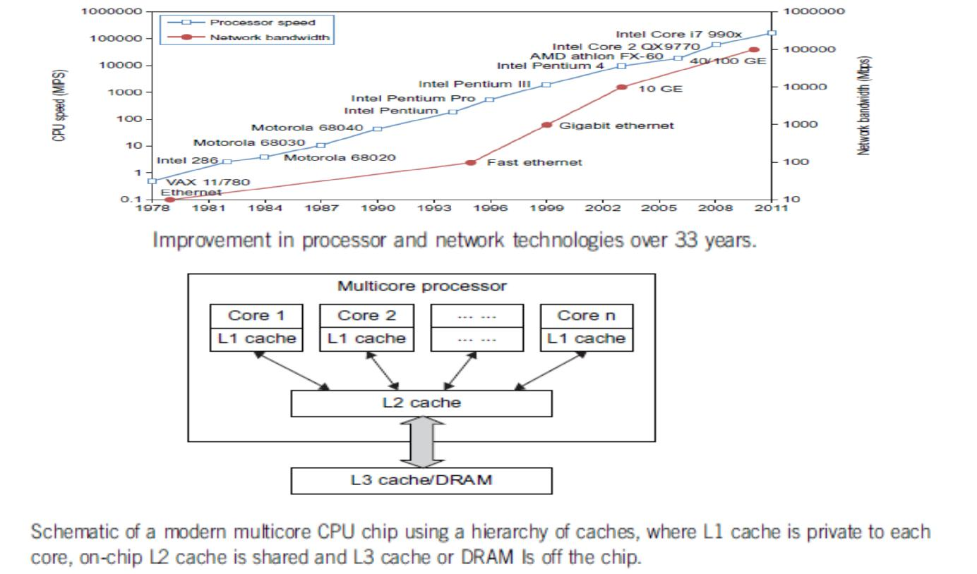

Both multi-core CPU and many-core GPU processors can handle multiple instruction threads at different magnitudes today. the architecture of a typical multicore processor. Each core is essentially a processor with its own private cache (L1 cache). Multiple cores are housed in the same chip with an L2 cache that is shared by all cores. In the future, multiple CMPs could be built on the same CPU chip with even the L3 cache on the chip. Multicore and multithreaded CPUs are equipped with many high-end processors, including the Intel i7, Xeon, AMD Opteron, Sun Niagara, IBM Power 6, and X cell processors. Each core could be also multithreaded. For example, the Niagara II is built with eight cores with eight threads handled by each core. This implies that the maximum ILP and TLP that can be exploited in Niagara is 64 (8 × 8 = 64). In 2011, the Intel Core i7 990x has reported 159,000 MIPS execution rate as shown in the uppermost square

Multicore CPU and Many-Core GPU Architectures

Multicore CPUs may increase from the tens of cores to hundreds or more in the future. But the CPU has reached its limit in terms of exploiting massive DLP due to the aforementioned memory wall problem. This has triggered the development of many-core GPUs with hundreds or more thin cores. Both IA-32 and IA-64 instruction set architectures are built into commercial CPUs. Now, x-86 processors have been extended to serve HPC and HTC systems in some high-end server processors.

Many RISC processors have been replaced with multicore x-86 processors and many-core GPUs in the Top 500 systems. This trend indicates that x-86 upgrades will dominate in data centers and supercomputers. The GPU also has been applied in large clusters to build supercomputers in MPPs. In the future, the processor industry is also keen to develop asymmetric or heterogeneous chip multiprocessors that can house both fat CPU cores and thin GPU cores on the same chip

Multithreading Technology

The dispatch of five independent threads of instructions to four pipelined datapaths (functional units) in each of the following five processor categories from left to right: a

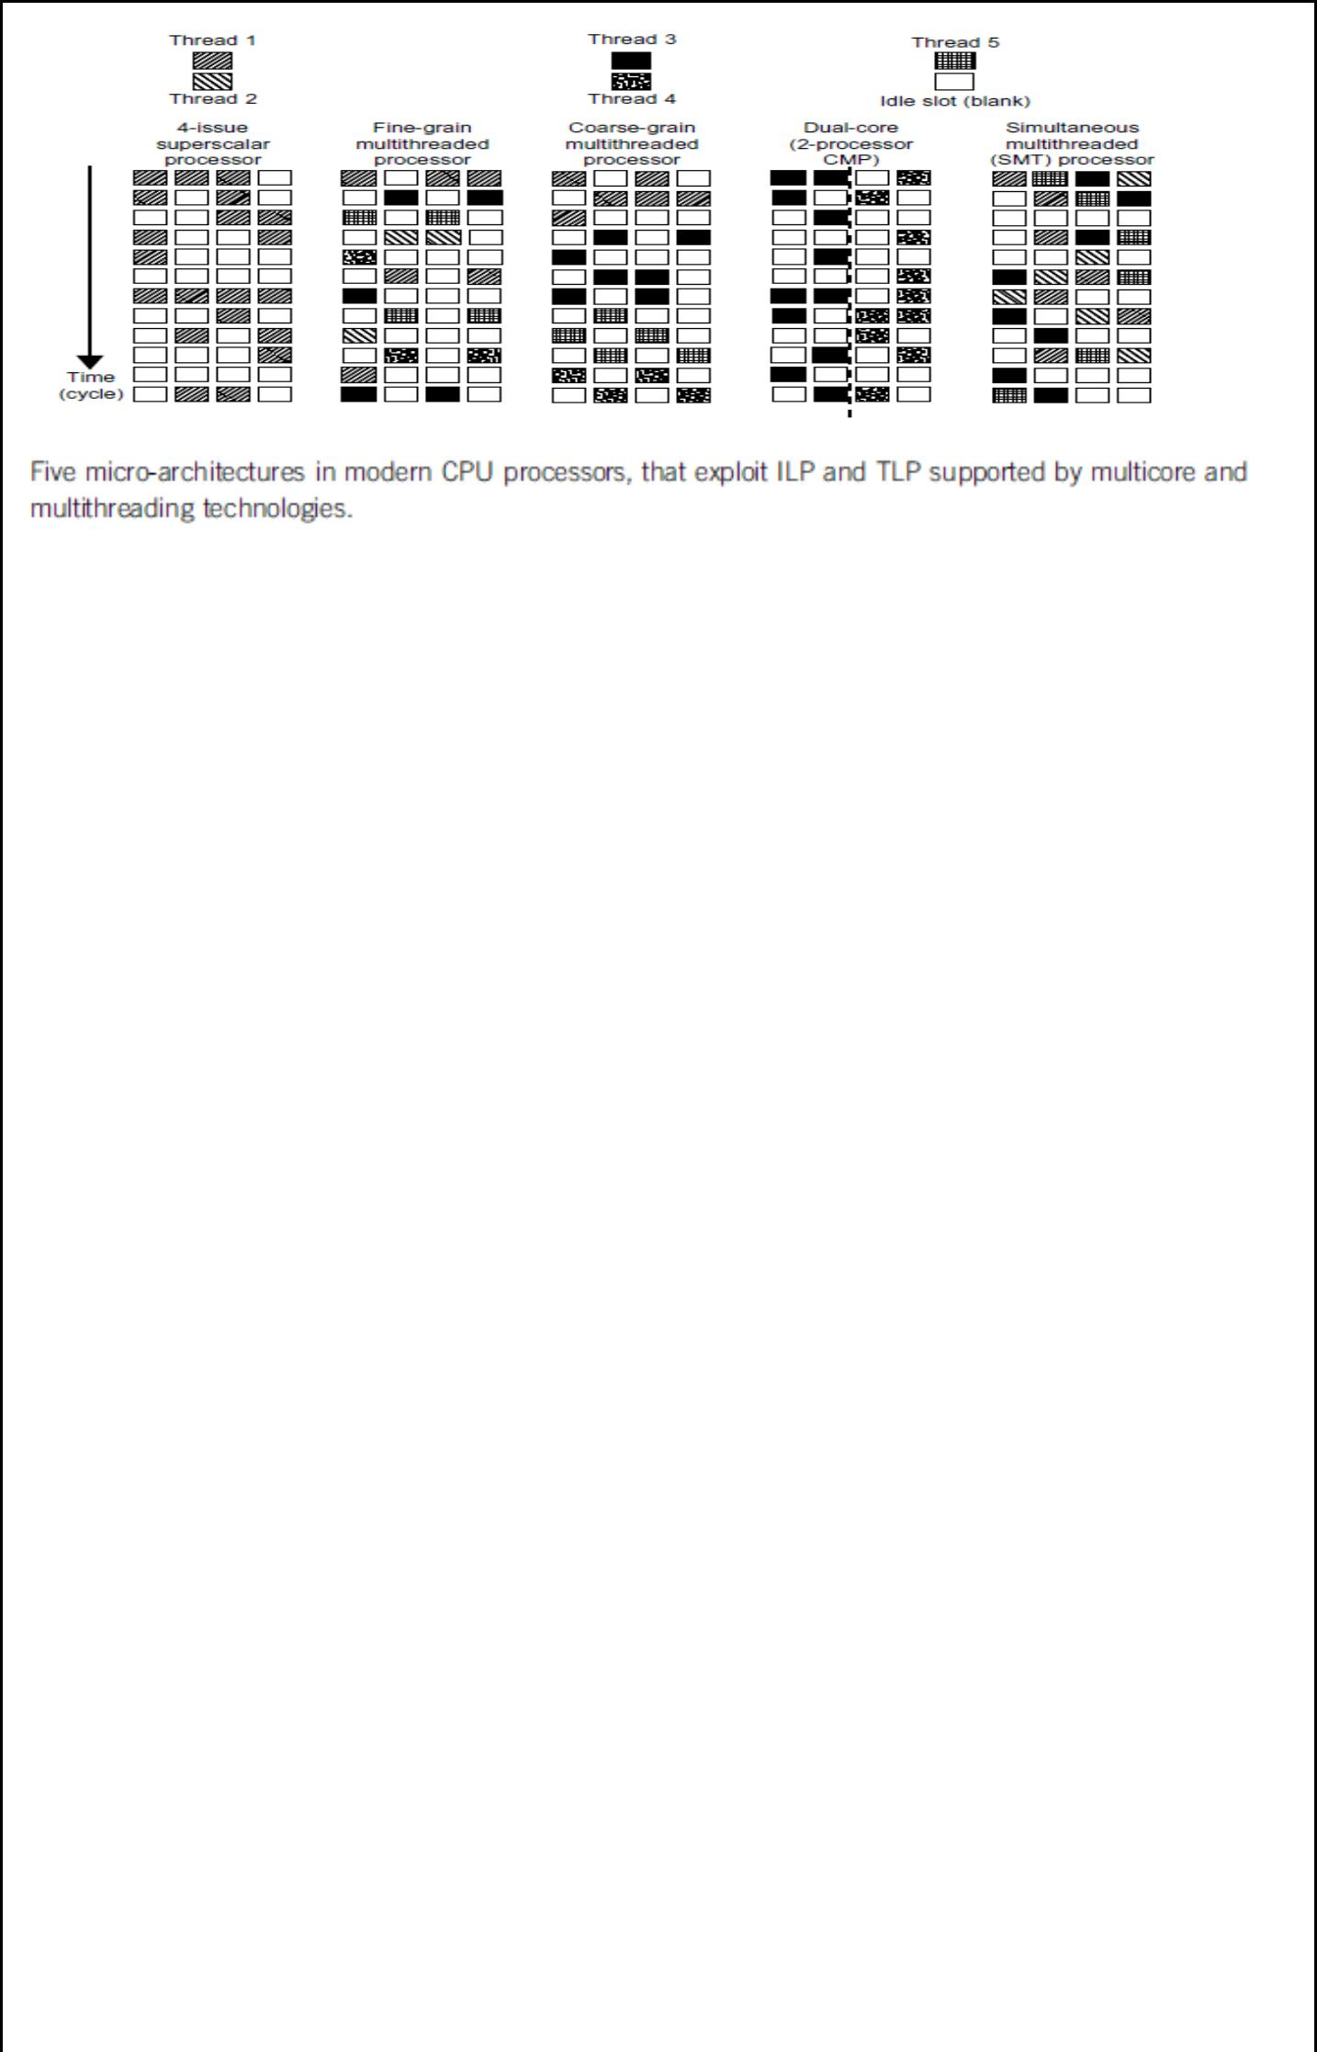

Four-issue superscalar processor, a fine-grain multithreaded processor, a coarse-grain multithreaded processor, a two-core CMP, and a simultaneous multithreaded (SMT) processor. The superscalar processor is single-threaded with four functional units. Each of the three multithreaded processors is four-way multithreaded over four functional data paths. In the dual-core processor, assume two processing cores, each a single-threaded two-way superscalar processor.

Instructions from different threads are distinguished by specific shading patterns for instructions from five independent threads. Typical instruction scheduling patterns are shown here. Only instructions from the same thread are executed in a superscalar processor. Fine-grain multithreading switches the execution of instructions from different threads per cycle. Course-grain multithreading executes many instructions from the same thread for quite a few cycles before switching to another thread. The multicore CMP executes instructions from different threads completely. The SMT allows simultaneous scheduling of instructions from different threads in the same cycle

These execution patterns closely mimic an ordinary program. The blank squares correspond to no available instructions for an instruction data path at a particular processor cycle. More blank cells imply lower scheduling efficiency. The maximum ILP or maximum TLP is difficult to achieve at each processor cycle. The point here is to demonstrate your understanding of typical instruction scheduling patterns in these five different micro-architectures in modern processors.

4. Explain in detail about GPU Computing to Exascale and Beyond

A GPU is a graphics coprocessor or accelerator mounted on a computer’s graphics card or video card. A GPU offloads the CPU from tedious graphics tasks in video editing applications. The world’s first GPU, the GeForce 256, was marketed by NVIDIA in 1999. These GPU chips can process a minimum of 10 million polygons per second, and are used in nearly every computer on the market today. Some GPU features were also integrated into certain CPUs. Traditional CPUs are structured with only a few cores. For example, the Xeon X5670 CPU has six cores. However, a modern GPU chip can be built with hundreds of processing cores.

GPUs have a throughput architecture that exploits massive parallelism by executing many concurrent threads slowly, instead of executing a single long thread in a conventional microprocessor very quickly. Lately, parallel GPUs or GPU clusters have been garnering a lot of attention against the use of CPUs with limited parallelism. General-purpose computing on GPUs, known as GPGPUs, have appeared in the HPC field. NVIDIA’s CUDA model was for HPC using GPGPUs.

How GPUs Work

Early GPUs functioned as coprocessors attached to the CPU. Today, the NVIDIA GPU has been upgraded to 128 cores on a single chip. Furthermore, each core on a GPU can handle eight threads of instructions. This translates to having up to 1,024 threads executed concurrently on a single GPU. This is true massive parallelism, compared to only a few threads that can be

handled by a conventional CPU. The CPU is optimized for latency caches, while the GPU is optimized to deliver much higher throughput with explicit management of on-chip memory Modern GPUs are not restricted to accelerated graphics or video coding. They are used in HPC systems to power supercomputers with massive parallelism at multicore and multithreading levels. GPUs are designed to handle large numbers of floating-point operations in parallel. In a way, the GPU offloads the CPU from all data-intensive calculations, not just those that are related to video processing. Conventional GPUs are widely used in mobile phones, game consoles, embedded systems, PCs, and servers. The NVIDIA CUDA Tesla or Fermi is used in GPU clusters or in HPC systems for parallel processing of massive floating-pointing data.

GPU Programming Model

The interaction between a CPU and GPU in performing parallel execution of floating-point operations concurrently. The CPU is the conventional multicore processor with limited parallelism to exploit. The GPU has a many-core architecture that has hundreds of simple processing cores organized as multiprocessors. Each core can have one or more threads. Essentially, the CPU’s floating-point kernel computation role is largely offloaded to the many-core GPU. The CPU instructs the GPU to perform massive data processing. The bandwidth must be matched between the on-board main memory and the on-chip GPU memory.
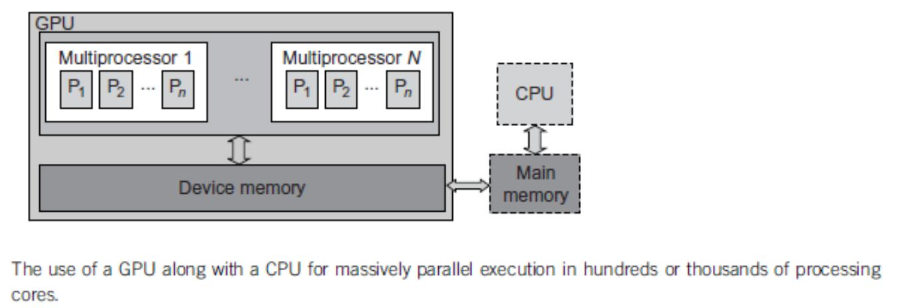

In November 2010, three of the five fastest supercomputers in the world (the Tianhe-1a, Nebulae, and Tsubame) used large numbers of GPU chips to accelerate floating-point computations. the architecture of the Fermi GPU, a next-generation GPU from NVIDIA. This is a streaming multiprocessor (SM) module. Multiple SMs can be built on a single GPU chip. The Fermi chip has 16 SMs implemented with 3 billion transistors. Each SM comprises up to 512 streaming processors (SPs), known as CUDA cores. The Tesla GPUs used in the Tianhe-1a have a similar architecture, with 448 CUDA cores.

All functional units and CUDA cores are interconnected by an NoC (network on chip) to a large number of SRAM banks (L2 caches). Each SM has a 64 KB L1 cache. The 768 KB unified L2 cache is shared by all SMs and serves all load, store, and texture operations. Memory controllers are used to connect to 6 GB of off-chip DRAMs. The SM schedules threads in groups of 32 parallel threads called warps. In total, 256/512 FMA (fused multiply and add) operations can be done in parallel to produce 32/64-bit floating-point results. The 512 CUDA cores in an SM can work in parallel to deliver up to 515 Gflops of double-precision results, if fully utilized. With 16 SMs, a single GPU has a peak speed of 82.4 Tflops. Only 12 Fermi GPUs have the potential to reach the Pflops performance thousand-core GPUs may appear in Exascale (Eflops or 1018
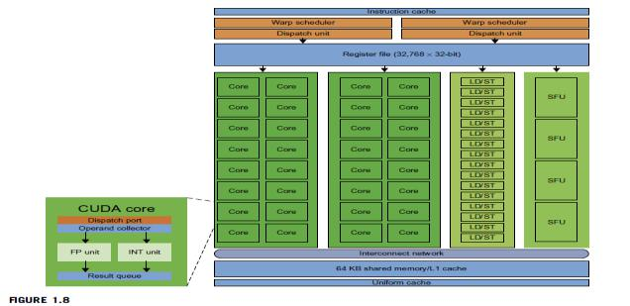

flops) systems. This reflects a trend toward building future MPPs with hybrid architectures of both types of processing chips. In a DARPA report published in September 2008, four challenges are identified for exascale computing: (1) energy and power, (2) memory and storage, (3) concurrency and locality, and (4) system resiliency
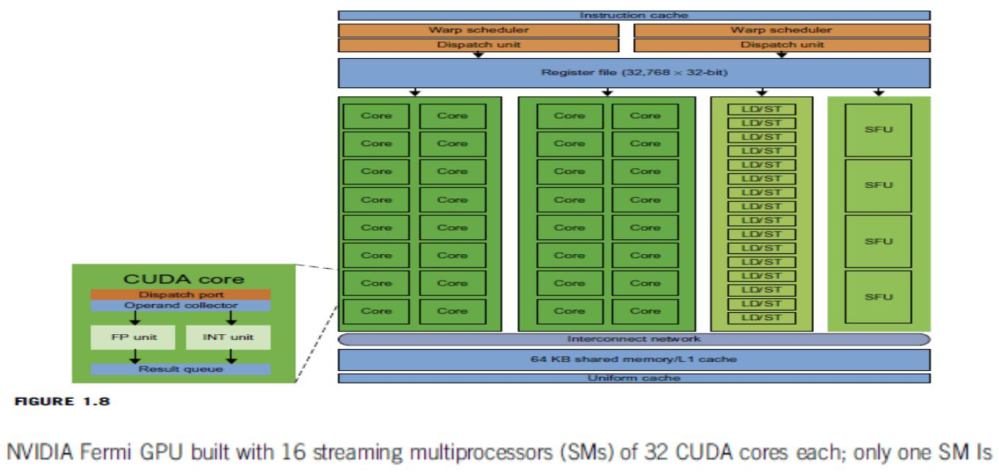

Power Efficiency of the GPU

Bill Dally of Stanford University considers power and massive parallelism as the major benefits of GPUs over CPUs for the future. By extrapolating current technology and computer architecture, it was estimated that 60 Gflops/watt per core is needed to run an exaflops system Power constrains what we can put in a CPU or GPU chip. Dally has estimated that the CPU chip consumes about 2 nJ/instruction, while the GPU chip requires 200 pJ/instruction, which is 1/10 less than that of the CPU. The CPU is optimized for latency in caches and memory, while the GPU is optimized for throughput with explicit management of on-chip memory.
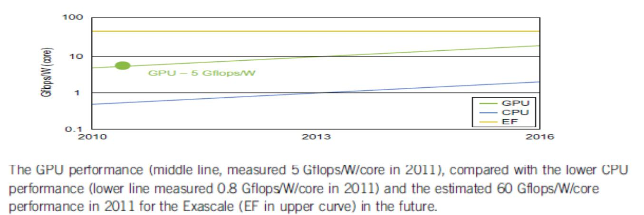

This may limit the scaling of future supercomputers. However, the GPUs may close the gap with the CPUs. Data movement dominates power consumption. One needs to optimize the storage hierarchy and tailor the memory to the applications. We need to promote self-aware OS and runtime support and build locality-aware compilers and auto-tuners for GPU based MPPs. This implies that both power and software are the real challenges in future parallel and distributed computing system

5. i)Describe about Virtual Machines and Virtualization Middleware

A conventional computer has a single OS image. This offers a rigid architecture that tightly couples application software to a specific hardware platform. Some software running well on one machine may not be executable on another platform with a different instruction set under a fixed OS. Virtual machines (VMs) offer novel solutions to underutilized resources, application inflexibility, software manageability, and security concerns in existing physical machines.

To build large clusters, grids, and clouds, we need to access large amounts of computing, storage, and networking resources in a virtualized manner.

In particular, a cloud of provisioned resources must rely on virtualization of processors, memory, and I/O facilities dynamically

Virtual Machines

The host machine is equipped with the physical hardware, as shown at the bottom of the figure. An example is an x-86 architecture desktop running its installed Windows OS, as shownin part

- of the figure. The VM can be provisioned for any hardware system. The VM is builtwith virtual resources managed by a guest OS to run a specific application. Between the VMs and the host platform, one needs to deploy a middleware layer called a virtual machine monitor (VMM).
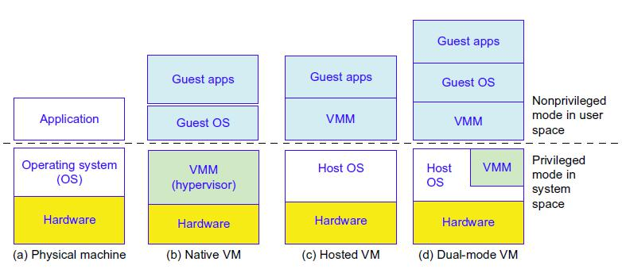

Shows a native VM installed with the use of a VMM called a hypervisor in privileged mode. For example, the hardware has x-86 architecture running the Windows system. The guest OS could be a Linux system and the hypervisor is the XEN system developed at Cambridge University. This hypervisor approach is also called bare-metal VM, because the hypervisor handles the bare hardware (CPU, memory, and I/O) directly. Another architecture is the host VM

The VM approach offers hardware independence of the OS and applications. The user application running on its dedicated OS could be bundled together as a virtual appliance that can be ported to any hardware platform. The VM could run on an OS different from that of the host computer.

VM Primitive Operations

The VMM provides the VM abstraction to the guest OS. With full virtualization, the VMM exports a VM abstraction identical to the physical machine so that a standard OS such as Windows 2000 or Linux can run just as it would on the physical hardware
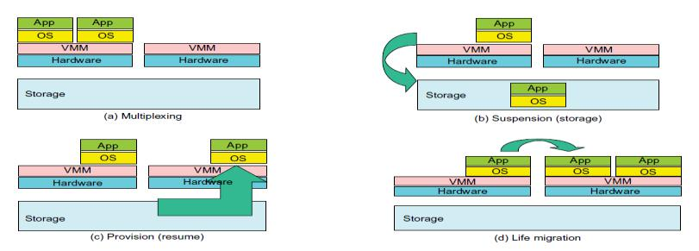

These VM operations enable a VM to be provisioned to any available hardware platform. They also enable flexibility in porting distributed application executions. Furthermore, the VM approach will significantly enhance the utilization of server resources

Virtual Infrastructures

Physical resources for compute, storage, and networking at the bottom of are mapped to the needy applications embedded in various VMs at the top. Hardware and software are then separated. Virtual infrastructure is what connects resources to distributed applications. It is a

dynamic mapping of system resources to specific applications. The result is decreased costs and increased efficiency and responsiveness.
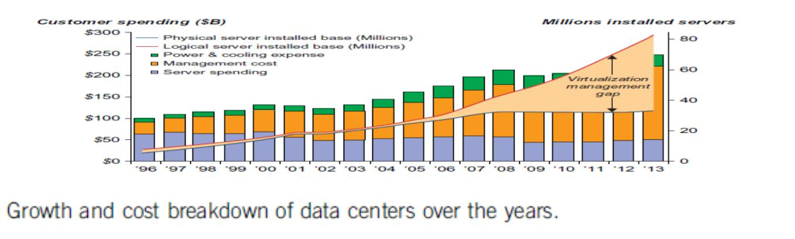

5. ii) Explain in detail about Data Center Virtualization for Cloud Computing .

Basic architecture and design considerations of data centers. Cloud architecture is built with commodity hardware and network devices. Almost all cloud platforms choose the popular x86 processors. Low-cost terabyte disks and Gigabit Ethernet are used to build data centers. Data center design emphasizes the performance/price ratio over speed performance alone. In other words, storage and energy efficiency are more important than shear speed performance.

Data Center Growth and Cost Breakdown

A large data center may be built with thousands of servers. Smaller data centers are typically built with hundreds of servers. The cost to build and maintain data center servers has increased over the years. Typically only 30 percent of data center costs goes toward purchasing IT equipment (such as servers and disks), 33 percent is attributed to the chiller, 18 percent to the uninterruptible power supply (UPS), 9 percent to computer room air conditioning (CRAC), and the remaining 7 percent to power distribution, lighting, and transformer costs. Thus, about 60 percent of the cost to run a data center is allocated to management and maintenance The server purchase cost did not increase much with time. The cost of electricity and cooling did increase from 5 percent to 14 percent in 15 years.

Low-Cost Design Philosophy

High-end switches or routers may be too cost-prohibitive for building data centers. Thus, using high-bandwidth networks may not fit the economics of cloud computing. using commodity x86 servers is more desired over expensive mainframes. The software layer handles network traffic balancing, fault tolerance, and expandability. Currently, nearly all cloud computing data centers use Ethernet as their fundamental network technology

Convergence of Technologies

cloud computing is enabled by the convergence of technologies in four areas: (1) hardware virtualization and multi-core chips, (2) utility and grid computing, (3) SOA, Web 2.0, and WS mashups, and (4) atonomic computing and data center automation. Hardware virtualization and multicore chips enable the existence of dynamic configurations in the cloud. Utility and grid computing technologies lay the necessary foundation for computing clouds Recent advances in SOA, Web 2.0, and mashups of platforms are pushing the cloud another step forward. Finally, achievements in autonomic computing and automated data center operations contribute to the rise of cloud computing.

Jim Gray once posted the following question: ―Science faces a data deluge. How to manage and analyze information?‖ This implies that science and our society face the same challenge of data deluge. Data comes from sensors, lab experiments, simulations, individual archives, and the web in all scales and formats. Preservation, movement, and access of massive data sets require generic tools supporting high-performance, scalable file systems, databases, algorithms, workflows, and visualization

On January 11, 2007, the Computer Science and Telecommunication Board (CSTB) recommended fostering tools for data capture, data creation, and data analysis. A cycle of interaction exists among four technical areas. First, cloud technology is driven by a surge of

interest in data deluge. Also, cloud computing impacts e-science greatly, which explores multicore and parallel computing technologies.

By linking computer science and technologies with scientists, a spectrum of e-science or e-research applications in biology, chemistry, physics, the social sciences, and the humanities has generated new insights from interdisciplinary activities

Iterative MapReduce extends MapReduce to support a broader range of data mining algorithms commonly used in scientific applications. The cloud runs on an extremely large cluster of commodity computers. Internal to each cluster node, multithreading is practiced with a large number of cores in many-core GPU clusters

6. Explain in detail about clusters of cooperative computers

A computing cluster consists of interconnected stand-alone computers which work cooperatively as a single integrated computing resource. In the past, clustered computer systems have demonstrated impressive results in handling heavy workloads with large data sets

Cluster Architecture

Architecture of a typical server cluster built around a low-latency, highbandwidth interconnection network. This network can be as simple as a SAN (e.g., Myrinet) or a LAN (e.g., Ethernet). To build a larger cluster with more nodes, the interconnection network can be built with multiple levels of Gigabit Ethernet, Myrinet, or InfiniBand switches. Through hierarchical construction using a SAN, LAN, or WAN, one can build scalable clusters with an increasing number of nodes. The cluster is connected to the Internet via a virtual private network (VPN) gateway. The gateway IP address locates the cluster. The system image of a computer is decided by the way the OS manages the shared cluster resources. Most clusters have loosely coupled node computers. All resources of a server node are managed by their own OS. Thus, most clusters have multiple system images as a result of having many autonomous nodes under different OS control.
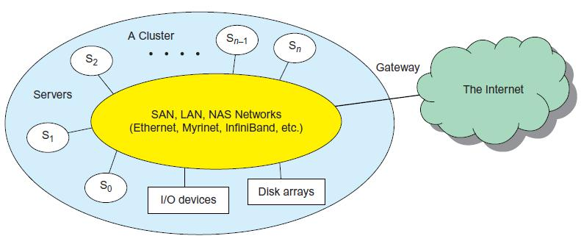

Single-System Image

An ideal cluster should merge multiple system images into a single-system image (SSI). Cluster designers desire a cluster operating system or some middleware to support SSI at various levels, including the sharing of CPUs, memory, and I/O across all cluster nodes.

An SSI is an illusion created by software or hardware that presents a collection of resources as one integrated, powerful resource. SSI makes the cluster appear like a single machine to the user. A cluster with multiple system images is nothing but a collection of independent computers.

Hardware, Software, and Middleware Support

Cluster design principles for both small and large clusters. Clusters exploring massive parallelism are commonly known as MPPs. Almost all HPC clusters in the Top 500 list are also MPPs. The building blocks are computer nodes (PCs, workstations, servers, or SMP), special

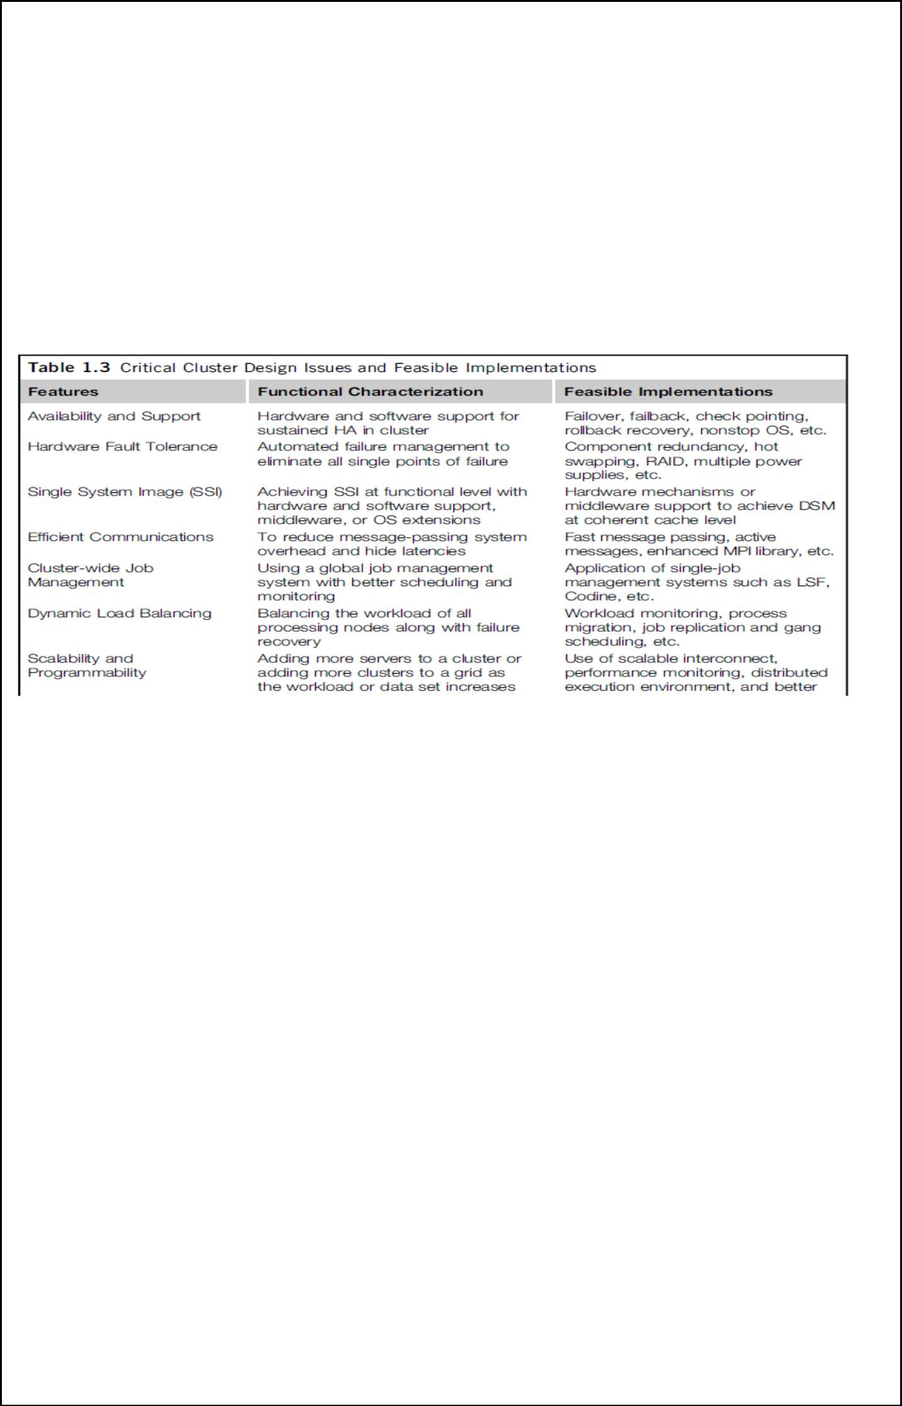

communication software such as PVM or MPI, and a network interface card in each computer node. Most clusters run under the Linux OS.

Special cluster middleware supports are needed to create SSI or high availability (HA).
Both sequential and parallel applications can run on the cluster, and special parallel
environments are needed to facilitate use of the cluster resources. For example, distributed
memory has multiple images. Users may want all distributed memory to be shared by all servers
by forming distributed
shared memory (DSM).

Major Cluster Design Issues

A cluster-wide OS for complete resource sharing is not available yet. Middleware or OS extensions were developed at the user space to achieve SSI at selected functional levels. Without this middleware, cluster nodes cannot work together effectively to achieve cooperative computing.

7. Explain in detail about Grid computing Infrastructures

Users have experienced a natural growth path from Internet to web and grid computing services. Internet services such as the Telnet command enables a local computer to connect to a remote computer.

Web service such as HTTP enables remote access of remote web pages. Grid computing is envisioned to allow close interaction among applications running on distant computers simultaneously.

Computational Grids

Like an electric utility power grid, a computing grid offers an infrastructure that couples computers, software/middleware, special instruments, and people and sensors together. The grid is often constructed

across LAN, WAN, or Internet backbone networks at a regional, national, or global scale Enterprises or organizations present grids as integrated computing resources. They can also be viewed as virtual platforms to support virtual organizations. The computers used in a grid are primarily workstations, servers, clusters, and supercomputers. Personal computers, laptops, and PDAs can be used as access devices to a grid system

Special instruments may be involved such as using the radio telescope in SETI@Home search of life in the galaxy and the austrophysics@Swineburne for pulsars. At the server end, the grid is a network.

Grid Families

Grid technology demands new distributed computing models, software/middleware support, network protocols, and hardware infrastructures. National grid projects are followed by industrial grid platform development by IBM, Microsoft, Sun, HP, Dell, Cisco, EMC, Platform Computing, and others. New grid service providers (GSPs) and new grid applications have emerged rapidly, similar to the growth of Internet and web services in the past two decades.

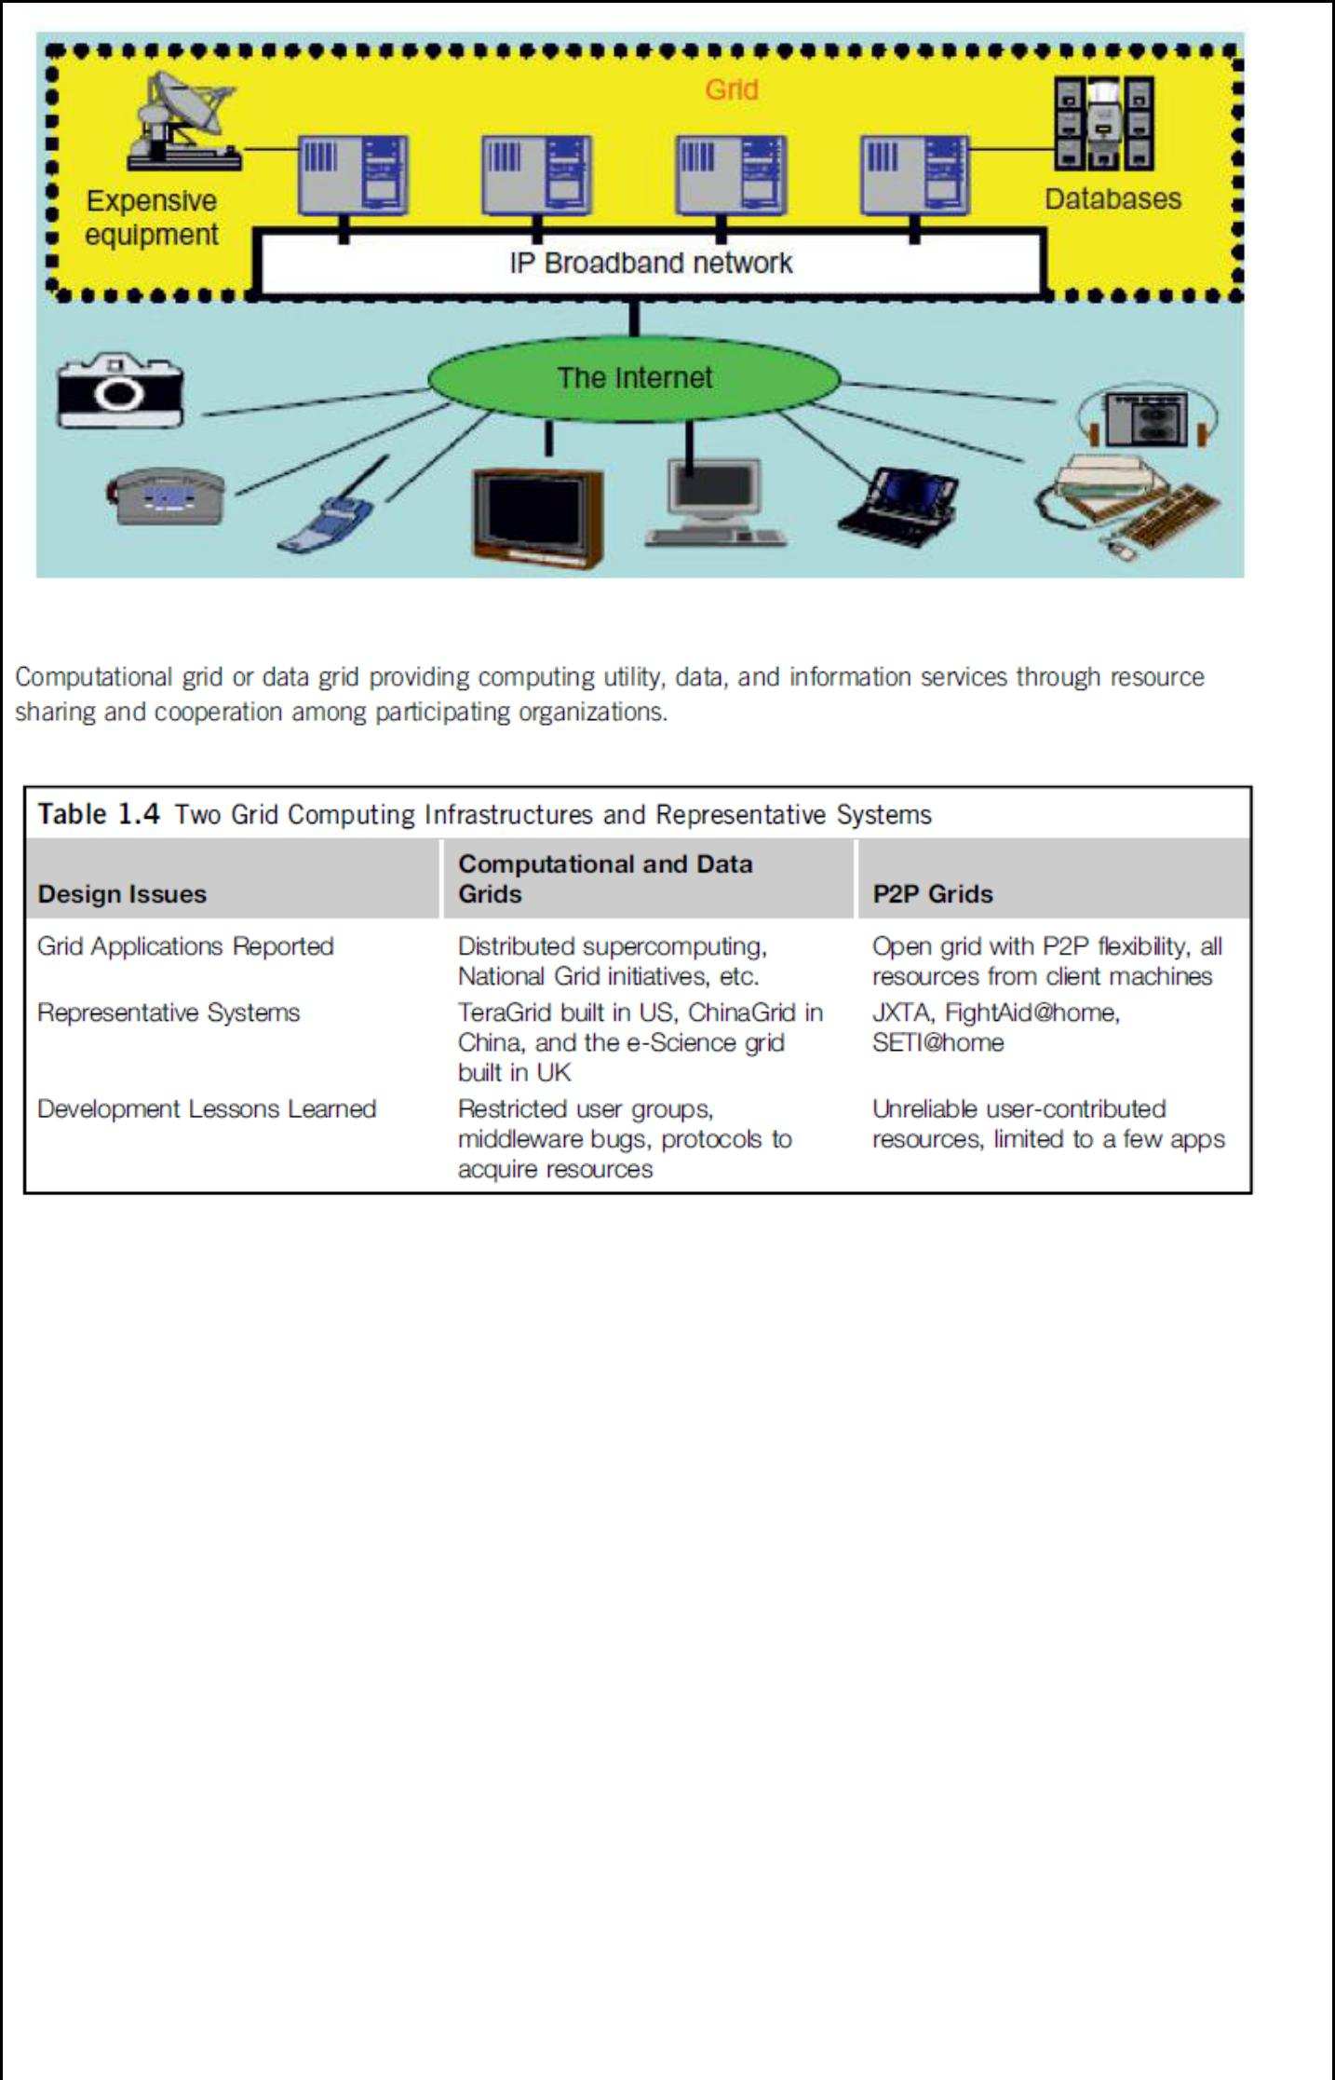

8. Explain in detail about service oriented architecture

In grids/web services, Java, and CORBA, an entity is, respectively, a service, a Java object, and a CORBA distributed object in a variety of languages. These architectures build on the traditional seven Open Systems Interconnection (OSI) layers that provide the base networking abstractions.

Layered Architecture for Web Services and Grids

The entity interfaces correspond to the Web Services Description Language (WSDL), Java method, and CORBA interface definition language (IDL) specifications in these example distributed systems. These interfaces are linked with customized, high-level communication systems: SOAP, RMI, and IIOP in the three examples. These communication systems support features including particular message patterns (such as Remote Procedure Call or RPC), fault recovery, and specialized routing the features in the Web Services Reliable Messaging (WSRM) framework mimic the OSI layer capability (as in TCP fault tolerance) modified to match the different abstractions (such as messages versus packets, virtualized addressing) at the entity levels. Security is a critical capability that either uses or reimplements the capabilities seen in concepts such as Internet Protocol Security (IPsec) and secure sockets in the OSI layers.

JNDI (Jini and Java Naming and Directory Interface) illustrating different approaches within the Java distributed object model. The CORBA Trading Service, UDDI (Universal Description, Discovery, and Integration), LDAP (Lightweight Directory Access Protocol), and ebXML (Electronic Business using eXtensible Markup Language) are other examples of discovery and information services described

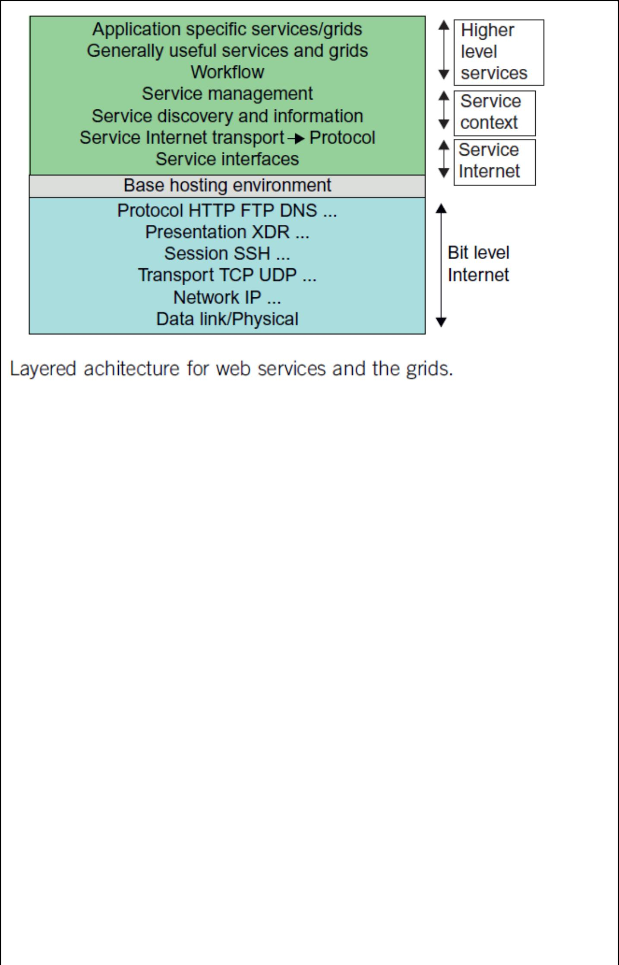

Web Services and Tools

Loose coupling and support of heterogeneous implementations make services more attractive than distributed objects. corresponds to two choices of service architecture: web services or REST systems (these are further discussed in . Both web services and REST systems have very distinct approaches to building reliable interoperable systems. In web services, one aims to fully specify all aspects of the service and its environment.

In CORBA and Java, the distributed entities are linked with RPCs, and the simplest way to build composite applications is to view the entities as objects and use the traditional ways of linking them together. For Java, this could be as simple as writing a Java program with method calls replaced by Remote Method Invocation (RMI), while CORBA supports a similar model with a syntax reflecting the C++ style of its entity (object) interfaces.

The Evolution of SOA

service-oriented architecture (SOA) has evolved over the years. SOA applies to building grids, clouds, grids of clouds, clouds of grids, clouds of clouds (also known as interclouds), and systems of systems in general. A large number of sensors provide data-collection services, denoted in the figure as SS (sensor service). A sensor can be a ZigBee device, a Bluetooth device, a WiFi access point, a personal computer, a GPA, or a wireless phone, among other things. Raw data is collected by sensor services.

The evolution of SOA: grids of clouds and grids, where ―SS‖ refers to a sensor service and ―fs‖ to a filter or transforming service Most distributed systems require a web interface or portal. For raw data collected by a large number of sensors to be transformed into useful information or knowledge, the data stream may go through a sequence of compute, storage, filter, and discovery clouds. Finally, the inter-service messages converge at the portal, which is accessed by all users
Grids versus Clouds

The boundary between grids and clouds are getting blurred in recent years. For web services, workflow technologies are used to coordinate or orchestrate services with certain specifications used to define critical business process models such as two-phase transactions

In general, a grid system applies static resources, while a cloud emphasizes elastic resources. For some researchers, the differences between grids and clouds are limited only in dynamic resource allocation based on virtualization and autonomic computing. Thus one may end up building with

a system of systems: such as a cloud of clouds, a grid of clouds, or a cloud of grids, or inter-clouds as a basic SOA architecture.
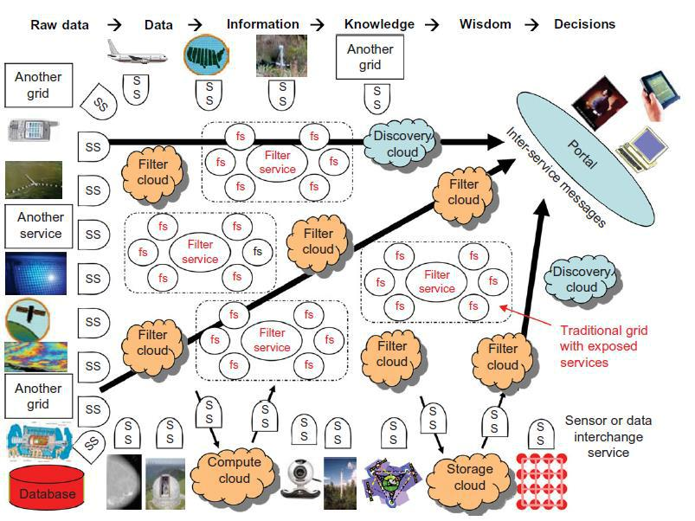

9. Explain in detail about Grid Architecture and standards

New architecture model and technology has been developed for the establishment and management of cross-organizational resource sharing. This new architecture, called grid architecture, identifies the basic components of a grid system. The grid architecture defines the purpose and functions of its components, while indicating how

these components interact with one another.7 The main focus of the architecture is on interoperability among resource providers and users in order to establish the sharing relationships. This interoperability, in turn, necessitates common protocols at each layer of the architectural model, which leads to the definition of a grid protocol architecture as shown in Figure.
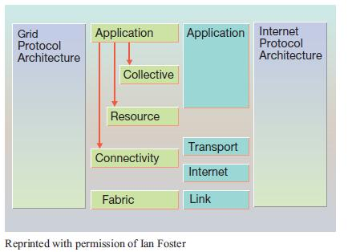

This protocol architecture defines common mechanisms, interfaces, schema, and protocols at each layer, by which users and resources can negotiate, establish, manage, and share resources. Figure 1 shows the component layers of the grid architecture and the capabilities of each layer. Each layer shares the behavior of the underlying component layers. The following describes the core features of each of these component layers, starting from the bottom of the stack and moving upward.

Fabric layer—The fabric layer defines the interface to local resources, which may be shared. This includes computational resources, data storage, networks, catalogs, software modules, and other system resources.

- Connectivity layer—The connectivity layer defines the basic communication and authentication protocols required for grid-specific networkingservice transactions.

- Resource layer—This layer uses the communication and security protocols (defined by the connectivity

layer) to control secure negotiation, initiation, monitoring, accounting, and payment for the sharing of functions of individual resources. The resource layer calls the fabric layer functions to access and control local resources. This layer only handles individual resources, ignoring global states and atomic actions across the resource collection

pool, which are the responsibility of the collective layer.

- Collective layer—While the resource layer manages an individual resource, the collective layer is responsible

for all global resource management and interaction with collections of resources. This protocol layer implements a wide variety of sharing behaviors using a small number of resource-layer and connectivity-layer protocols.

- Application layer—The application layer enables the use of resources in a grid environment through various collaboration and resource access protocols.

Thus far, our discussions have focused on the grid problem in the context of a virtual organization and the proposed grid computing architecture as a suggested solution to this problem. This architecture is designed for controlled resource sharing with improved interoperability among participants. In contrast, emerging architectures help the earlier-defined grid architecture quickly adapt to a wider (and strategically important) technology domain.

10. Explain in detail about Memory, Storage, and Wide-Area Networking
Memory Technology

Plots the growth of DRAM chip capacity from 16 KB in 1976 to 64 GB in 2011. This shows that memory chips have experienced a 4x increase in capacity every three years. Memory access time did not improve much in the past. In fact, the memory wall problem is getting worse as the processor gets faster. For hard drives, capacity increased from 260 MB in 1981 to 250 GB in 2004

The Seagate Barracuda XT hard drive reached 3 TB in 2011. This represents an approximately 10x increase in capacity every eight years. The capacity increase of disk arrays will be even greater in the years to come. Faster processor speed and larger memory capacity result in a wider gap between processors and memory

Disks and Storage Technology

Beyond 2011, disks or disk arrays have exceeded 3 TB in capacity. The lower curve in the disk storage growth in 7 orders of magnitude in 33 years. The rapid growth of flash memory and solid-state drives (SSDs) also impacts the future of HPC and HTC systems. The mortality rate of SSD is not bad at all. A typical SSD can handle 300,000 to 1 million write cycles per
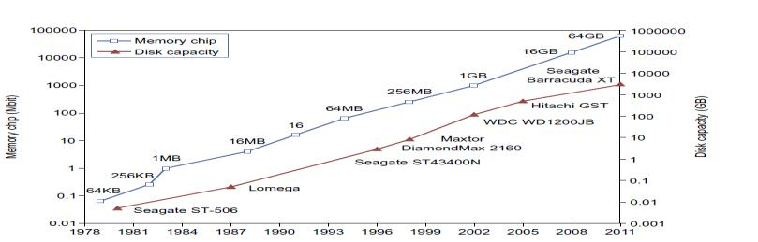

System-Area Interconnects

The nodes in small clusters are mostly interconnected by an Ethernet switch or a local area network (LAN). a LAN typically is used to connect client hosts to big servers. A storage area network (SAN) connects servers to network storage such as disk arrays. Network attached storage (NAS) connects client hosts directly to the disk arrays.

All three types of networks often appear in a large cluster built with commercial network components. If no large distributed storage is shared, a small cluster could be built with a multiport Gigabit Ethernet switch plus copper cables to link the end machines.

Wide-Area Networking

An increase factor of two per year on network performance was reported, which is faster than Moore’s law on CPU speed doubling every 18 months. The implication is that more computers will be used concurrently in the future. High-bandwidth networking increases the capability of building massively distributed systems.
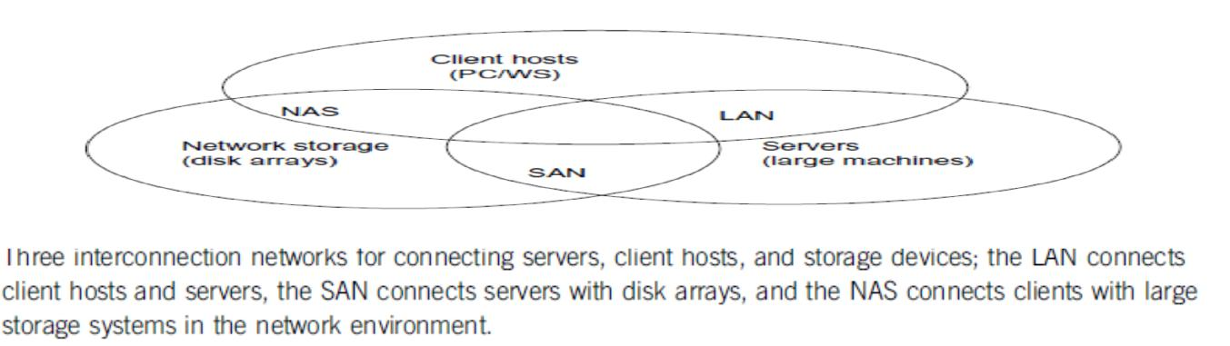

 |  | Unit – 2 – Grid Services
 |  | Part – A
1. List the OGSA grid service interfaces?
 | Port Type | Operation
 | Grid service | Find service data, Termination time and Destroy
 | Notification source | Subscribe to notification topic
 | Notification sink | Deliver notification
 | Registry | Register service and Unregister service
 | Factory | Create service
 | Handle map | Find by handle
2. Define Endpoint References in WSRF

The WSRF service addressing mechanism is defined in the WS-addressing standard and uses a term called an endpoint reference (EPR), which is an XML document that contains various information about the service and resource. Specifically, the endpoint reference includes both the service address (URI) and resource identification called a key.

3. What are the specifications of WSRF
WSRF is actually a collection of four specifications (standards):
  - WS-ResourceProperties — specifies how resource properties are defined and accessed
  - WS-ResourceLifetime — specifies mechanisms to manage resource lifetimes
  - WS-ServiceGroup — specifies how to group services or WS-Resources together
  - WS-BaseFaults — specifies how to report faults

- Define Globus 4 information services
Globus 4 information services collectively is called the Monitoring and Discovering System (MDS4 in
GT 4) and consists of a set of three WSRF information components:

• Index service
• Trigger service • WebMDS

from which a framework can be constructed for collecting and using information. The three components are part of the full GT4 package.

5. Define WebMDS.

WebMDS (Web Monitoring and Discovering System) is a servlet that provides a Web-based interface to display XML-based information such as resource property information, and as such can be a front-end to index services.

6. Write about the strategies of replication

The strategies of replication can be classified into method types: dynamic and static. For the static method, the locations and number of replicas are determined in advance and will not be modified. Dynamic strategies can adjust locations and number of data replicas according to changes in conditions.

7. Define data grid? List the Grid Data Access Models

A data grid is a set of structured services that provides multiple services like the ability to access alter and transfer very large amounts of geographically separated data, especially for research and collaboration purposes.

1. Monadic model | 2. Hierarchical model 3. Federation model | 4. Hybrid model

8. Define grid data access Federation model

This model is better suited for designing a data grid with multiple sources of data supplies. Sometimes this model is also known as a mesh model. The data sources are distributed to many different locations. Although the data is shared, the data items are still owned and controlled by their original owners. According to predefined access policies, only authenticated users are authorized to request data from any data source.

9. Write about Parallel Data Transfer

parallel data transfer opens multiple data streams for passing subdivided segments of a file simultaneously. Although the speed of each stream is the same as in sequential streaming, the total time to move data in all streams can be significantly reduced compared to FTP transfer.

10. Define Striped Data Transfer

Striped data transfer, a data object is partitioned into a number of sections, and each section is placed in an individual site in a data grid. When a user requests this piece of data, a data stream is created for each site, and all the sections of data objects are transferred simultaneously.

11. Write about Monadic access model

This is a centralized data repository model. All the data is saved in a central data repository. When users want to access some data they have to submit requests directly to the central repository. No data is replicated for preserving data locality. This model is the simplest to implement for a small grid.

12. Explain grid data access Hierarchical model

This is suitable for building a large data grid which has only one large data access directory. The data may be transferred from the source to a second-level center. Then some data in the regional center is transferred to the third-level center. After being forwarded several times, specific data objects are accessed directly by users.

- List the basic functionality requirements of grid service
  - Discovery and brokering

  - Metering and accounting

  - Data sharing

  - Deployment

  - Virtual organizations

  - Monitoring

  - Policy

- What are the security requirements of grid service
  - Multiple security infrastructures
  - Perimeter security solutions
  - Authentication, Authorization, and Accounting
  - Encryption
  - Application and Network-Level Firewalls
  - Certification

- List the System Properties Requirements of grid service

✓ Fault tolerance ✓ Disaster recovery

✓ Self-healing capabilities ✓ Strong monitoring

✓ Legacy application management ✓ Administration.
✓ Agreement-based interaction
✓ Grouping/aggregation of services

- What are the objectives of OGSA?
- Manage resources across distributed heterogeneous platforms
- Support QoS-oriented Service Level Agreements (SLAs).
- Provide a common base for autonomic management
- Define open, published interfaces and protocols for the interoperability of diverse resources.

17. Define grid service instance

A grid service instance is a (potentially taransient) service that conforms to a set of conventions, expressed as WSDL interfaces, extensions, and behaviors, for such purposes as lifetime management, discovery of characteristics, and notification.

18. Define grid service handle (GSH)

A grid service handle (GSH) can be thought of as a permanent network pointer to a particular grid service instance. The GSH does not provide sufficient information to allow a client to access the service instance; the client needs to ―resolve‖ a GSH into a grid service reference (GSR).

19. Define grid service reference (GSR).

The GSR contains all the necessary information to access the service instance. The GSR is not a ―permanent‖ network pointer to the grid service instance because a GSR may become invalid for various reasons; for example, the grid service instance may be moved to a different server.

20. What is meant by grid service description

A grid service description describes how a client interacts with service instances. This description is independent of any particular instance. Within a WSDL document, the grid service description is embodied in the most derived of the instance, along with its associated portTypes bindings, messages, and types definitions.

- List the XML lifetime declaration properties The three lifetime declaration properties are

  - ogsi:goodFrom
  - ogsi:goodUntil
  - ogsi:availableUntil

- Define Naming by Attributes in semantic name space

Attribute naming schemes associate various metadata with services and support retrieval via queries on attribute values. A registry implementing such a scheme allows service providers to publish the existence and properties of the services that they provide, so that service consumers can discover them.

23. Define naming by path in semantic name space

Path naming or directory schemes (as used, for example, in file systems) represent an alternative approach to attribute schemes for organizing services into a hierarchical name space that can be navigated.

Part – B
1. Explain in detail about Open Grid Services Architecture

The OGSA is an open source grid service standard jointly developed by academia and the IT industry under coordination of a working group in the Global Grid Forum (GGF). The standard was specifically developed for the emerging grid and cloud service communities. The OGSA is extended from web service concepts and technologies. The standard defines a common framework that allows businesses to build grid platforms across enterprises and business partners. The intent is to define the standards required for both open source and commercial software to support a global grid infrastructure

OGSA Framework

The OGSA was built on two basic software technologies: the Globus Toolkit widely adopted as a grid technology solution for scientific and technical computing, and web services (WS 2.0) as a popular standards-based framework for business and network applications. The OGSA is intended to support the creation, termination, management, and invocation of stateful, transient grid services via standard interfaces and conventions

OGSA Interfaces

The OGSA is centered on grid services. These services demand special well-defined application interfaces.

These interfaces provide resource discovery, dynamic service creation, lifetime management, notification, and manageability. These properties have significant implications regarding how a grid service is named, discovered, and managed
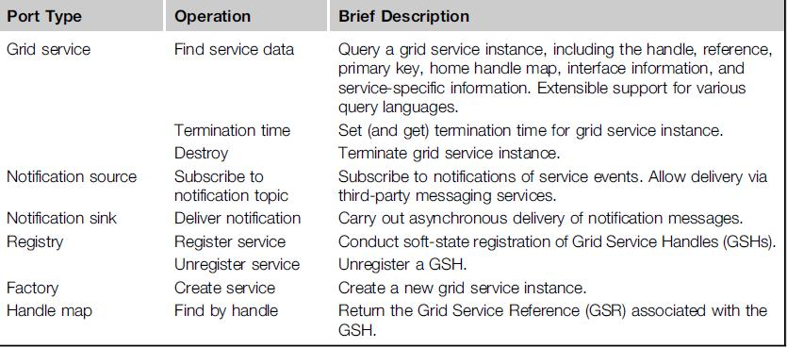

Grid Service Handle

A GSH is a globally unique name that distinguishes a specific grid service instance from all others. The status of a grid service instance could be that it exists now or that it will exist in the future.

These instances carry no protocol or instance-specific addresses or supported protocol bindings. Instead, these information items are encapsulated along with all other instance-specific information. In order to interact with a specific service instance, a single abstraction is defined as a GSR.

Grid Service Migration

This is a mechanism for creating new services and specifying assertions regarding the lifetime of a service. The OGSA model defines a standard interface, known as a factor, to implement this reference. This creates a requested grid service with a specified interface and returns the GSH and initial GSR for the new service instance.

If the time period expires without having received a reaffirmed interest from a client, the service instance can be terminated on its own and release the associated resources accordingly

OGSA Security Models

The grid works in a heterogeneous distributed environment, which is essentially open to the general public. We must be able to detect intrusions or stop viruses from spreading by implementing secure conversations, single logon, access control, and auditing for nonrepudiation.

At the security policy and user levels, we want to apply a service or endpoint policy, resource mapping rules, authorized access of critical resources, and privacy protection. At the Public Key Infrastructure (PKI) service level, the OGSA demands security binding with the security protocol stack and bridging of certificate authorities (CAs), use of multiple trusted intermediaries, and so on.
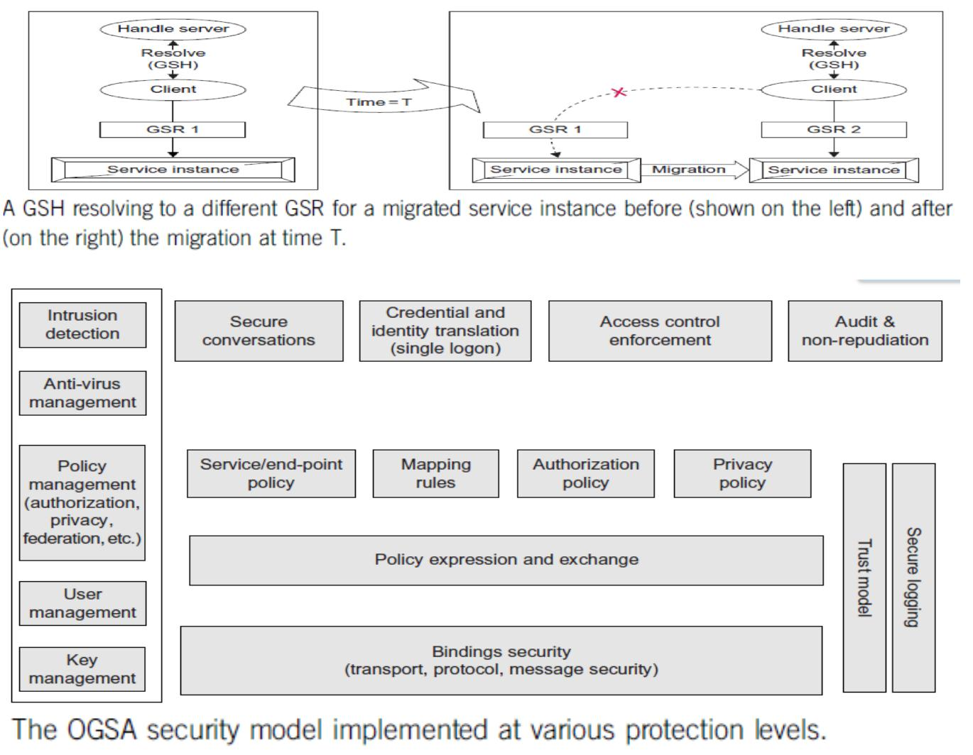

- Describe in detail about basic functionality requirements and System Properties Requirements
Basic functionality requirements

Discovery and brokering. Mechanisms are required for discovering and/or allocating services, data, and resources with desired properties. For example, clients need to discover network services before they are used, service brokers need to discover hardware and software availability, and service brokers must identify codes and platforms suitable for execution requested by the client

Metering and accounting. Applications and schemas for metering, auditing, and billing for IT infrastructure and management use cases. The metering function records the usage and duration, especially metering the usage of licenses. The auditing function audits usage and application profiles on machines, and the billing function bills the user based on metering.

Data sharing. Data sharing and data management are common as well as important grid applications. chanisms are required for accessing and managing data archives, for caching data and managing its consistency, and for indexing and discovering data and metadata.

Deployment. Data is deployed to the hosting environment that will execute the job (or made available in or via a high-performance infrastructure). Also, applications (executable) are migrated to the computer that will execute them

Virtual organizations (VOs). The need to support collaborative VOs introduces a need for mechanisms to support VO creation and management, including group membership services [58]. For the commercial data center use case [55], the grid creates a VO in a data center that provides IT resources to the job upon the customer’s job request.

Monitoring. A global, cross-organizational view of resources and assets for project and fiscal planning, troubleshooting, and other purposes. The users want to monitor their applications running on the grid. Also, the resource or service owners need to surface certain states so that the user of those resources or services may manage the usage using the state information

Policy. An error and event policy guides self-controlling management, including failover and provisioning. It is important to be able to represent policy at multiple stages in hierarchical systems, with the goal of automating the enforcement of policies that might otherwise be implemented as organizational processes or managed manually

System Properties Requirements

Fault tolerance. Support is required for failover, load redistribution, and other techniques used to achieve fault tolerance. Fault tolerance is particularly important for long running queries that can potentially return large amounts of data, for dynamic scientific applications, and for commercial data center applications.

Disaster recovery. Disaster recovery is a critical capability for complex distributed grid infrastructures. For distributed systems, failure must be considered one of the natural behaviors and disaster recovery mechanisms must be considered an essential component of the design.

Self-healing capabilities of resources, services and systems are required. Significant manual effort should not be required to monitor, diagnose, and repair faults.

Legacy application management. Legacy applications are those that cannot be changed, but they are too aluable to give up or to complex to rewrite. Grid infrastructure has to be built around them so that they can continue to be used

Administration. Be able to ―codify‖ and ―automate‖ the normal practices used to administer the environment. The goal is that systems should be able to selforganize and self-describe to manage low-level configuration details based on higher-level configurations and management policies specified by administrators.

Agreement-based interaction. Some initiatives require agreement-based interactions capable of specifying and enacting agreements between clients and servers (not necessarily human) and then composing those agreements into higher-level end-user structures Grouping/aggregation of services. The ability to instantiate (compose) services using some set

of existing services is a key requirement. There are two main types of composition techniques: selection and aggregation. Selection involves choosing to use a particular service among many services with the same operational interface

- Explain the following functionality requirements a) Security requirements

Security requirements

Grids also introduce a rich set of security requirements; some of these requirements are: Multiple security infrastructures. Distributed operation implies a need to interoperate with and manage multiple security infrastructures. For example,for a commercial data center application, isolation of customers in the same commercial data center is a crucial requirement; the grid should provide not only access control but also performance isolation.

Perimeter security solutions. Many use cases require applications to be deployed on the other side of firewalls from the intended user clients. Intergrid collaboration often requires crossing institutional firewalls.

Authentication, Authorization, and Accounting. Obtaining application programs and deploying them into a grid system may require authentication/authorization. In the commercial data center use case, the commercial data center authenticates the customer and authorizes the submitted request when the customer submits a job request.

Encryption. The IT infrastructure and management use case requires encrypting of the communications, at least of the payload

Application and Network-Level Firewalls. This is a long-standing problem; it is made particularly difficult by the many different policies one is dealing with and the particularly harsh restrictions at international sites.

Certification. A trusted party certifies that a particular service has certain semantic behavior. For example, a company could establish a policy of only using e-commerce services certified by Yahoo

b) Resource Management Requirements

Resource management is another multilevel requirement, encompassing SLA negotiation, provisioning, and scheduling for a variety of resource types and activities

Provisioning. Computer processors, applications, licenses, storage, networks, and instruments are all grid resources that require provisioning. OGSA needs a framework that allows resource provisioning to be done in a uniform, consistent manner.

Resource virtualization. Dynamic provisioning implies a need for resource virtualization mechanisms that allow resources to be transitioned flexibly to different tasks as required; for example, when bringing more Web servers on line as demand exceeds a threshold..

Optimization of resource usage while meeting cost targets (i.e., dealing with finite resources). Mechanisms to manage conflicting demands from various organizations, groups, projects, and users and implement a fair sharing of resources and access to the grid

Transport management. For applications that require some form of real-time scheduling, it can be important to be able to schedule or provision bandwidth dynamically for data transfers or in support of the other data sharing applications. In many (if not all) commercial applications, reliable transport management is essential to obtain the end-to-end QoS required by the application

Management and monitoring. Support for the management and monitoring of resource usage and the detection of SLA or contract violations by all relevant parties. Also, conflict management is necessary;

Processor scavenging is an important tool that allows an enterprise or VO to use to aggregate computing power that would otherwise go to waste

Scheduling of service tasks. Long recognized as an important capability for any information processing system, scheduling becomes extremely important and difficult for distributed grid systems.

Load balancing. In many applications, it is necessary to make sure make sure deadlines are met or resources are used uniformly. These are both forms of load balancing that must be made possible by the underlying infrastructure

Advanced reservation. This functionality may be required in order to execute the application on reserved resources.

Notification and messaging. Notification and messaging are critical in most dynamic scientific problems.

Logging. It may be desirable to log processes such as obtaining/deploying application programs because, for example, the information might be used for accounting. This functionality is represented as ―metering and accounting.‖

Workflow management. Many applications can be wrapped in scripts or processes that require licenses and other resources from multiple sources. Applications coordinate using the file system based on events

Pricing. Mechanisms for determining how to render appropriate bills to users of a grid.

4. Describe in detail about Practical view of OGSA/OGSI

OGSA aims at addressing standardization (for interoperability) by defining the basic framework of a grid application structure. Some of the mechanisms employed in the standards formulation of grid computing

The objectives of OGSA are
Manage resources across distributed heterogeneous platforms

Support QoS-oriented Service Level Agreements (SLAs). The topology of grids is often complex; the interactions between/among grid resources are almost invariably dynamic.

Provide a common base for autonomic management. A grid can contain a plethora of resources, along with an abundance of combinations of resource MPICH-G2: Grid-enabled message passing (Message Passing Interface)

_ CoG Kits, GridPort: Portal construction, based on N-tier architectures
_ Condor-G: workflow management
_ Legion: object models for grid computing
_ Cactus: Grid-aware numerical solver framework
Portals

_ N-tier architectures enabling thin clients, with middle tiers using grid functions _ Thin clients = web browsers

_ Middle tier = e.g., Java Server Pages, with Java CoG Kit, GPDK, GridPort utilities _ Bottom tier = various grid resources

_ Numerous applications and projects, e.g.,
_ Unicore, Gateway, Discover, Mississippi Computational Web Portal, NPACI Grid
Port, Lattice Portal, Nimrod-G, Cactus, NASA IPG Launchpad, Grid Resource
Broker
High-Throughput Computing and Condor
_ High-throughput computing
_ Processor cycles/day (week, month, year?) under nonideal circumstances
_ ―How many times can I run simulation X in a month using all available machines?‖

_ Condor converts collections of distributively owned workstations and dedicated clusters into a distributed high-throughput computing facility _ Emphasis on policy management and reliability
Object-Based Approaches
_ Grid-enabled CORBA
_ NASA Lewis, Rutgers, ANL, others
_ CORBA wrappers for grid protocols
_ Some initial successes
_ Legion
_ University of Virginia

_ Object models for grid components (e.g., ―vault‖ = storage, ―host‖ = computer) Cactus: Modular, portable framework for parallel, multidimensional simulations Construct codes by linking

_ Small core: management services

_ Selected modules: Numerical methods, grids and domain decomps, visualization and steering, etc.

_ Custom linking/configuration tools
_ Developed for astrophysics, but not astrophysics specific
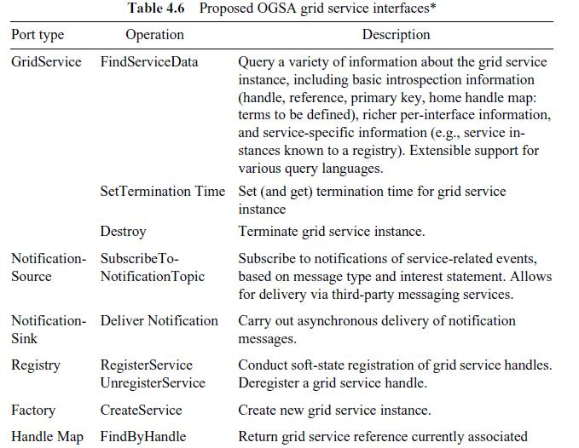

There are two fundamental requirements for describing Web services based on the OGSI

1.The ability to describe interface inheritance—a basic concept with most of the distributed object systems.

- The ability to describe additional information elements with the interface definitions.

- Explain in detail about Detailed view of OGSA/OGSI

Provides a more detailed view of OGSI based on the OGSI specification itself. For a more comprehensive description of these concepts, the reader should consult the specification OGSI defines a component model that extends WSDL and XML schema definition to incorporate the concepts of

Stateful Web services

_ Extension of Web services interfaces _ Asynchronous notification of state change _ References to instances of services _ Collections of service instances

_ Service state data that augment the constraint capabilities of XML schema definition Setting the Context

GGF calls OGSI the ―base for OGSA.‖ Specifically, there is a relationship between OGSI and distributed object systems and also a relationship between OGSI and the existing (and evolving) Web services framework

Relationship to Distributed Object Systems

Given grid service implementation is an addressable and potentially stateful instance that implements one or more interfaces described by WSDL portTypes. Grid service factories can be used to create instances implementing a given set of portType(s).

Client-Side Programming Patterns
Another important issue is

how OGSI interfaces are likely to be invoked from client applications. OGSI exploits an important component of the Web services framework: the use of WSDL to describe multiple protocol bindings, encoding styles, messaging styles (RPC versus document oriented), and so on, for a given Web service.
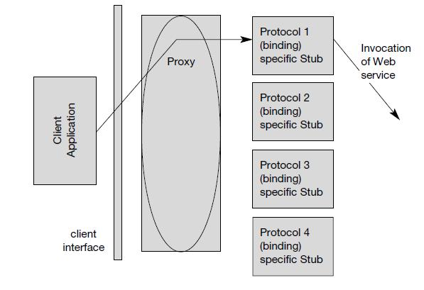



Client Use of Grid Service Handles and References

Client gains access to a grid service instance through grid service handles and grid service references. A grid service handle (GSH) can be thought of as a permanent network pointer to a particular grid service instance.
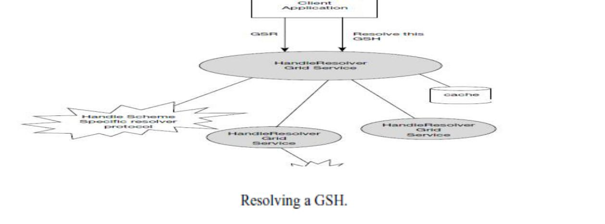

Relationship to Hosting Environment

OGSI does not dictate a particular service-provider-side implementation architecture. A variety of approaches are possible, ranging from implementing the grid service instance directly as an operating system process to a sophisticated server-side mponent model such as J2EE. In the former case, most or even all support for standard grid service behaviors (invocation, lifetime management, registration, etc.)
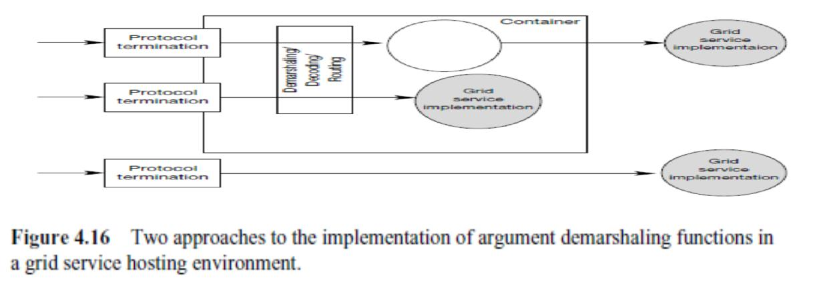

The Grid Service

The purpose of the OGSI document is to specify the (standardized) interfaces and behaviors that define a grid service

WSDL Extensions and Conventions

OGSI is based on Web services; in particular, it uses WSDL as the mechanism to describe the public interfaces of grid services.

Service Data

The approach to stateful Web services introduced in OGSI identified the need for a common mechanism to expose a service instance’s state data to service requestors for query, update, and change notification.

Motivation and Comparison to JavaBean Properties

OGSI specification introduces the serviceData concept to provide a flexible, properties- style approach to accessing state data of a Web service. The serviceData concept is similar to the notion of a public instance variable or field in object-oriented programming languages such as Java, Smalltalk, and C++.

Extending portType with serviceData

ServiceData defines a newportType child element named serviceData, used to define serviceData elements, or SDEs, associated with that portType. These serviceData element definitions are referred to as serviceData declarations, or SDDs.

serviceDataValues.

Each service instance is associated with a collection of serviceData elements: those serviceData elements defined within the various portTypes that form the service’s interface, and also, potentially, additional service

SDE Aggregation within a portType Interface Hierarchy

WSDL 1.2 has introduced the notion of multiple portType extension, and one can model that construct within the GWSDL namespace. A portType can extend zero or more other portTypes

Dynamic serviceData Elements

Although many serviceData elements are most naturally defined in a service’s interface definition, situations can

arise in which it is useful to add or move serviceData elements dynamically to or from an instance.

6. Short Notes on

a) Core Grid Service Properties
Service Description and Service Instance

One can distinguish in OGSI between the description of a grid service and an instance of a grid service:

A grid service description describes how a client interacts with service instances.

This description is independent of any particular instance. Within a WSDL document, the grid service description is embodied in the most derived portType

A grid service description may be simultaneously used by any number of grid service instances, each of which

_ Embodies some state with which the service description describes how to interact _ Has one or more grid service handles

_ Has one or more grid service references to it

Modeling Time in OGSI

The need arises at various points throughout this specification to represent time that is meaningful to multiple parties in the distributed Grid.

The GMT global time standard is assumed for grid services, allowing operations to refer unambiguously to absolute times. However, assuming the GMT time standard to represent time does not imply any particular level of clock synchronization between clients and services in the grid. In fact, no specific accuracy of synchronization is specified or expected by OGSI, as this is a service-quality issue

XML Element Lifetime Declaration Properties

Service Data elements may represent instantaneous observations of the dynamic state of a service instance, it is critical that consumers of serviceData be able to understand the valid lifetimes of these observations.

The three lifetime declaration properties are:
1.ogsi:goodFrom. Declares the time from which the content of the element is said to be valid.
This is typically the time at which the value was created.

- ogsi:goodUntil. Declares the time until which the content of the element is said to be valid. This property must be greater than or equal to the goodFrom time

3.ogsi:availableUntil. Declares the time until which this element itself is expected to be available, perhaps with updated values. Prior to this time, a client should be able to obtain an updated copy of this element

b) Grid Service Handles and Grid Service References

Client gains access to a grid service instance through grid service handles and grid service references. A grid service handle (GSH) can be thought of as a permanent network pointer to a particular grid service instance.

The client resolves a GSH into a GSR by invoking a HandleResolver grid service instance identified by some out-of-band mechanism. The HandleResolver can use various means to do the resolution
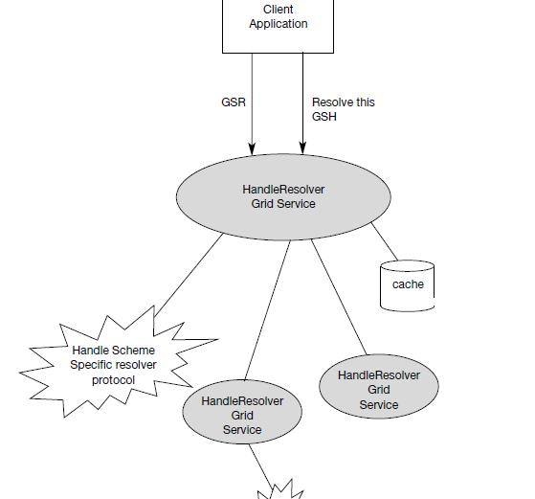

7. Explain in detail about Data-Intensive Grid Service Models

Applications in the grid are normally grouped into two categories: computation-intensive and dataintensive. For data-intensive applications, we may have to deal with massive amounts of data. For example, the data produced annually by a Large Hadron Collider may exceed several petabytes (1015 bytes). The grid system must be specially designed to discover, transfer, and manipulate these massive data sets. Transferring massive data sets is a time-consuming task. Efficient data management demands low-cost storage and high-speed data movement

Data Replication and Unified Namespace

This data access method is also known as caching, which is often applied to enhance data efficiency in a grid environment. By replicating the same data blocks and scattering them in multiple regions of a grid, users can access the same data with locality of references. Replication strategies determine when and where to create a replica of the data. The factors to consider include data demand, network conditions, and transfer cost

Grid Data Access Models

Multiple participants may want to share the same data collection. To retrieve any piece of data, we need a grid with a unique global namespace. Similarly, we desire to have unique file names. To achieve these, we have to resolve inconsistencies among multiple data objects bearing the same name Monadic model: This is a centralized data repository model, All the data is saved in a central data repository. When users want to access some data they have to submit requests directly to the central repository.

Hierarchical model: The hierarchical model,is suitable for building a large data grid which has only one large data access directory. The data may be transferred from the source to a second-level center.

Federation model: This data access model is better suited for designing a data grid with multiple sources of data supplies. Sometimes this model is also known as a mesh model. Hybrid model: This data access model. The model combines the best features of the hierarchical and mesh models. Traditional data transfer technology, such as FTP, applies for networks with lower bandwidth
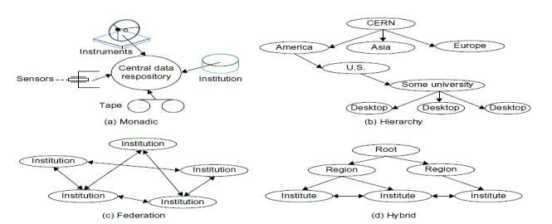



Parallel versus Striped Data Transfers

Compared with traditional FTP data transfer, parallel data transfer opens multiple data streams for passing subdivided segments of a file simultaneously. Although the speed of each stream is the same as in sequential streaming, the total time to move data in all streams can be significantly reduced compared to FTP transfer.

- Short notes on OGSA Service a) Metering Service

Different grid deployments may integrate different services and resources and feature different underlying economic motivations and models; however, regardless of these differences, it is a quasiuniversal requirement that resource utilization can be monitored, whether for purposes of cost allocation (i.e., charge back), capacity and trend analysis, dynamic provisioning, grid-service pricing, fraud and intrusion detection, and/or billing.

A grid service may consume multiple resources and a resource may be shared by multiple service instances. Ultimately, the sharing of underlying resources is managed by middleware and operating systems.

A metering interface provides access to a standard description of such aggregated data (metering serviceData). A key parameter is the time window over which measurements are aggregated. In commercial Unix systems, measurements are aggregated at administrator-defined intervals (chronological entry), usually daily, primarily for the purpose of accounting.

Several use cases require metering systems that support multitier, end-to-end flows involving multiple services. An OGSA metering service must be able to meter the resource consumption of configurable classes of these types of flows executing on widely distributed, loosely coupled server, storage, and network resources. Configurable classes should support, for example, a departmental charge-back scenario where incoming requests and their subsequent flows are partitioned into account classes determined by the department providing the service.

b) Service Groups and Discovery Services

GSHs and GSRs together realize a two-level naming scheme, with HandleResolver services mapping from handles to references; however, GSHs are not intended to contain semantic information and indeed may be viewed for most purposes as opaque. Thus, other entities (both humans and applications) need other means for

discovering services with particular properties, whether relating to interface, function, availability, location, policy

Attribute naming schemes associate various metadata with services and support retrieval via queries on attribute values. A registry implementing such a scheme allows service providers to publish the existence and properties of the services that they provide, so that service consumers can discover them

A ServiceGroup is a collection of entries, where each entry is a grid service implementing the rviceGroupEntry interface. The ServiceGroup interface also extends the GridService interface

It is also envisioned that many registries will inherit and implement the notificationSource interface so as to facilitate client subscription to register state changes

Path naming or directory schemes (as used, for example, in file systems) represent an alternative approach to attribute schemes for organizing services into a hierarchical name space that can be navigated. The two pproaches can be combined, as in LDAP.

c) Rating Service

A rating interface needs to address two types of behaviors. Once the metered information is available, it has to be translated into financial terms. That is, for each unit of usage, a price has to be associated with it. This step is accomplished by the rating interfaces, which provide operations that take the metered information and a rating package as input and output the usage in terms of chargeable amounts.

For example,

a commercial UNIX system indicates that 10 hours of prime-time resource and 10 hours on nonprime-time resource are consumed, and the rating package indicates that each hour of prime-time resource is priced at 2 dollars and each hour of nonprime- time resource is priced at 1 dollar, a rating service will apply the pricing indicated in the rating package

Furthermore, when a business service is developed, a rating service is used to aggregate the costs of the components used to deliver the service, so that the service owner can determine the pricing, terms, and conditions under which the service will be offered to subscribe

d) Other Data Services

A variety of higher-level data interfaces can and must be defined on top of the base data interfaces, to address functions such as: _ Data access and movement

_ Data replication and caching
_ Data and schema mediation
_ Metadata management and looking

Data Replication. Data replication can be important as a means of meeting performance objectives by allowing local computer resources to have access to local data. Although closely related to caching (indeed, a ―replica store‖ and a ―cache‖may differ only in their policies), replicas may provide different interfaces

Data Caching. In order to improve performance of access to remote data items, caching services will be employed. At the minimum, caching services for traditional flat file data will be employed. Caching of other data types, such as views on RDBMS data, streaming data, and application binaries, are also envisioned

Consistency—Is the data in the cache the same as in the source? If not, what is the coherence window? Different applications have very different requirements. _ Cache invalidation protocols—How and when is cached data invalidated? _ Write through or write back? When are writes to the cache committed back to the original data source?

Security—How will access control to cached items be handled? Will access control enforcement be delegated to the cache, or will access control be somehow enforced by the original data source? _ Integrity of cached data—Is the cached data kept in memory or on disk? How is it protected from unauthorized access? Is it encrypted

Schema Transformation. Schema transformation interfaces support the transformation of data from one schema to another. For example, XML transformations as specified in XSLT.

9. Explain in detail about Open Grid Services Infrastructure and Distributed Logging

The OGSI defines fundamental mechanisms on which OGSA is constructed. These mechanisms address issues relating to the creation, naming, management, and exchange of information among entities called grid services. The following list recaps the key OGSI features and briefly discusses their relevance to OGSA.

Grid Service descriptions and instances. OGSI introduces the twin concepts of the grid service description and grid service instance as organizing principles of distributed systems.

Grid Service descriptions and instances. OGSI introduces the twin concepts of the grid service description and grid service instance as organizing principles of distributed systems.

Naming and name resolution. OGSI defines a two-level naming scheme for grid service instances based on abstract, long-lived grid service handles that can be mapped by HandleMapper services to concrete but potentially lesslong- lived grid service references.

Fault model. OGSI defines a common approach for conveying fault information from operations.

Life cycle. OGSI defines mechanisms for managing the life cycle of a grid service instance, including both explicit destruction and soft-state lifetime management functions for grid service instances, and grid service factories that can be used to create instances implementing specified interfaces

Service groups. OGSI defines a means of organizing groups of service instances.

Distributed Logging

Distributed logging can be viewed as a typical messaging application in which message
producers generate log artifacts, (atomic expressions of diagnostic information) that may or may
not be used at a later time by other independent message consumers. OGSA-based logging can
leverage the notification mechanism available in
OGSI as the transport for messages.

Logging services provide the extensions needed to deal with the following issues: Decoupling. The logical separation of logging artifact creation from logging artifact consumption. The ultimate usage of the data (e.g., logging, tracing, management) is determined by the message consumer

Transformation and common representation. Logging packages commonly annotate the data that they generate with useful common information such as category, priority, time stamp, and location

Filtering and aggregation. The amount of logging data generated can be large, whereas the amount of data actually consumed can be small. Therefore, it can be desirable to have a mechanism for controlling the amount of data generated and for filtering out what is actually kept and where.

Configurable persistency. Depending on consumer needs, data may have different durability characteristics. For example, in a real-time monitoring application, data may become irrelevant quickly, but be needed as soon as it is generated; data for an auditing program may be needed months or even years after it was generated.

Consumption patterns. Consumption patterns differ according to the needs of the consumer application. For example, a real-time monitoring application needs to be notified whenever a particular event occurs, whereas a postmortem problem determination program queries historical data, trying to find known patterns.

- Short notes on

  - Job Agreement Service

The job agreement service is created by the agreement factory service with a set of job terms, including command line, resource requirements, execution environment, data staging, job control, scheduler directives, and accounting and notification term.

The job agreement service provides an interface for placing jobs on a resource manager (i.e., representing a machine or a cluster), and for interacting with the job once it has been dispatched to the resource manager. The job agreement service provides basic matchmaking capabilities between the requirements of the job and the underlying resource manager available for running the job.

The interfaces provided by the job agreement service are:
_ Manageability interface

_ Supported job terms: defines a set of service data used to publish the job terms supported by this job service, including the job definition (command line and application name), resource requirements, execution ironment, data staging, job control, scheduler directives, and accounting and notification terms.

_ Workload status: total number of jobs, statuses such as number of jobs running or pending and suspended jobs.

_ Job control: control the job after it has been instantiated. This would include the ability to suspend/resume, checkpoint, and kill the job.

b) Reservation Agreement Service

The reservation agreement service is created by the agreement factory service with a set of terms including time duration, resource requirement specification, and authorized user/project agreement terms. The reservation agreement service allows end users or a job agreement service to reserve resources under the control of a resource manager to guarantee their availability to run a job. The service allows reservations on any type of resource (e.g., hosts, software licenses, or network bandwidth). Reservations can be specific (e.g., provide access to host ―A‖ from noon to 5 PM), or more general (e.g., provide access to 16 Linux cpus on Sunday).

The reservation service makes use of information about the existing resource managers available and any policies that might be defined at the VO level, and will make use of a logging service to log reservations. It will use the resource manager adapter interfaces to make reservations and to delete existing reservations.

c) Base Data Services

OGSA data interfaces are intended to enable a service-oriented treatment of data so that data can be treated in the same way as other resources within the Web/grid services architecture

Four base data interfaces (WSDL portTypes) can be used to implement a variety of different data service behaviors:

- DataDescription defines OGSI service data elements representing key parameters of the data virtualization encapsulated by the data service.

- DataAccess provides operations to access and/or modify the contents of the data virtualization encapsulated by the data service.

- DataFactory provides an operation to create a new data service with a data virtualization derived from the data virtualization of the parent (factory) data service.

- DataManagement provides operations to monitor and manage the data service’s data virtualization, including (depending on the implementation) the data sources (such as database management systems) that underlie the data service.

Unit – 3 - Virtualization
Part – A
1. Define private cloud.

The private cloud is built within the domain of an intranet owned by a single organization. Therefore, they are client owned and managed. Their access is limited to the owning clients and their partners. Their deployment was not meant to sell capacity over the Internet through publicly accessible interfaces. Private clouds give local users a flexible and agile private infrastructure to run service workloads within their administrative domains.

2. Define public cloud.

A public cloud is built over the Internet, which can be accessed by any user who has paid for the service. Public clouds are owned by service providers. They are accessed by subscription. Many companies have built public clouds, namely Google App Engine, Amazon AWS, Microsoft Azure, IBM Blue Cloud, and Salesforce Force.com. These are commercial providers that offer a publicly accessible remote interface for creating and managing VM instances within their proprietary infrastructure.

3. Define hybrid cloud.

A hybrid cloud is built with both public and private clouds, Private clouds can also support a hybrid cloud model by supplementing local infrastructure with computing capacity from an external public cloud. For example, the research compute cloud (RC2) is a private cloud built by IBM.

4. List the essential characteristics of cloud computing
1. On-demand capabilities 2. Broad network access 3. Resource pooling

4. Rapid elasticity 5. Measured service

- List the design objectives of cloud computing.
  - Shifting Computing from Desktops to Datacenters
  - Service Provisioning and Cloud Economics
  - Scalability in Performance
  - Data Privacy Protection.
  - High Quality of Cloud Services.

- Define anything-as-a-service.

Providing services to the client on the basis on meeting their demands at some pay per use cost such as data storage as a service, network as a service, communication as a service etc. it is generally denoted as anything as a service (XaaS).

7. What is mean by SaaS?

The software as a service refers to browser initiated application software over thousands of paid customer. The SaaS model applies to business process industry application, consumer relationship management (CRM), Enterprise resource Planning (ERP), Human Resources (HR) and collaborative application.
8. What is mean by IaaS?

The Infrastructure as a Service model puts together the infrastructure demanded by the user namely servers, storage, network and the data center fabric. The user can deploy and run on multiple VM’s running guest OS on specific application.

9. What is PaaS?

The Platform as a Service model enables the user to deploy user built applications onto a virtualized cloud platform. It includes middleware, database, development tools and some runtime support such as web2.0 and java. It includes both hardware and software integrated with specific programming interface.

10. What is mean by Virtualization?

Virtualization is a computer architecture technology by which multiple virtual machines (VMs) are multiplexed in the same hardware machine. The purpose of a VM is to enhance resource sharing by many users and improve computer performance in terms of resource utilization and application flexibility.

11. Define virtual machine monitor.

A traditional computer runs with a host operating system specially tailored for its hardware architecture, After virtualization, different user applications managed by their own operating systems (guest OS) can run on the same hardware, independent of the host OS. This is often done by adding additional software, called a virtualization layer. This virtualization layer is known as hypervisor or virtual machine monitor (VMM).

- List the requirements of VMM.

  - VMM should provide an environment for programs which is essentially identical to the original machine.
  - Programs run in this environment should show, at worst, only minor decreases in speed.

  - VMM should be in complete control of the system resources. Any program run under a VMM should exhibit a function identical to that which it runs on the original machine directly.

- Define Host OS and Guest OS.

The guest OS, which has control ability, is called Domain 0, and the others are called Domain U. Domain 0 is a privileged guest OS of Xen. It is first loaded when Xen boots without any file system drivers being available. Domain 0 is designed to access hardware directly and manage devices.

- What are the responsibilities of VMM?
  - The VMM is responsible for allocating hardware resources for programs.

  - It is not possible for a program to access any resource not explicitly allocated to it.

  - It is possible under certain circumstances for a VMM to regain control of resources already allocated.

- Define CPU virtualization.

CPU architecture is virtualizable if it supports the ability to run the VM’s privileged and unprivileged instructions in the CPU’s user mode while the VMM runs in supervisor mode. When the privileged instructions including control- and behavior-sensitive instructions of a VM are executed, they are trapped in the VMM. In this case, the VMM acts as a unified mediator for hardware access from different VMs to guarantee the correctness and stability of the whole system.

16. Define memory virtualization.

Virtual memory virtualization is similar to the virtual memory support provided by modern operating systems. In a traditional execution environment, the operating system maintains mappings of virtual memory to machine memory using page tables, which is a one-stage mapping from virtual memory to machine memory. All modern x86 CPUs include a memory management unit (MMU) and a translation look aside buffer (TLB) to optimize virtual memory performance.

17. What is mean by I/O virtualization?

I/O virtualization involves managing the routing of I/O requests between virtual devices and the shared physical hardware. There are three ways to implement I/O virtualization:

  - full device emulation, Full device emulation is the first approach for I/O virtualization
  - para-virtualization
  - direct I/O.

- Distinguish the physical and virtual cluster. (Jan.2014)

A physical cluster is a collection of servers (physical machines) connected by a physical network such as a LAN. Virtual clusters have different properties and potential applications. There are three critical design issues of virtual clusters: live migration of virtual machines (VMs), memory and file migrations, and dynamic deployment of virtual clusters.

19. What is memory migration?

Moving the memory instance of a VM from one physical host to another can be approached in any number of ways. Memory migration can be in a range of hundreds of megabytes to a few gigabytes in a typical system today, and it needs to be done in an efficient manner. The Internet Suspend-Resume (ISR) technique exploits temporal locality as memory states are likely to have considerable overlap in the suspended and the resumed instances of a VM.

20. What is mean by host based virtualization?

An alternative VM architecture is to install a virtualization layer on top of the host OS. This host OS is still responsible for managing the hardware. The guest OSes are installed and run on top of the virtualization layer. Dedicated applications may run on the VMs. Certainly, some other applications can also run with the host OS directly.

21. Define KVM.

Kernel-Based VM:- This is a Linux para-virtualization system—a part of the Linux version 2.6.20 kernel. Memory management and scheduling activities are carried out by the existing Linux kernel. The KVM does the rest, which makes it simpler than the hypervisor that controls the entire machine. KVM is a hardware-assisted para-virtualization tool, which improves performance and supports unmodified guest OSes such as Windows, Linux, Solaris, and other UNIX variants

Part – B

- Explain the cloud computing service and deployment models of cloud computing Cloud computing service

Infrastructure as a Service (IaaS)

The infrastructure layer builds on the virtualization layer by offering the virtual machines as a service to users. Instead of purchasing servers or even hosted services, IaaS customers can create and remove virtual machines and network them together at will. Clients are billed for infrastructure services based on what resources are consumed. This eliminates the need to procure and operate physical servers, data storage systems, or networking resources.

Platform as a Service (PaaS)

The platform layer rests on the infrastructure layer’s virtual machines. At this layer customers do not manage their virtual machines; they merely create applications within an existing API or programing language. There is no need to manage an operating system, let alone the underlying hardware and virtualization layers. Clients merely create their own programs which are hosted by the platform services they are paying for.

Software as a Service (SaaS)

Services at the software level consist of complete applications that do not require development. Such applications can be email, customer relationship management, and other office productivity applications. Enterprise services can be billed monthly or by usage, while software as service offered directly to consumers, such as email, is often provided for free.

Deployment models of cloud computing
The Private Cloud

This model doesn’t bring much in terms of cost efficiency: it is comparable to buying, building and managing your own infrastructure. Still, it brings in tremendous value from a security point of view. During their initial adaptation to the cloud, many organizations face challenges and have concerns related to data security. These concerns are taken care of by this model, in which hosting is built and maintained for a specific client. The infrastructure required for hosting can be on-premises or at a third-party location. Security concerns are addressed through secure-access VPN or by the physical location within the client’s firewall system.

Public Cloud

The public cloud deployment model represents true cloud hosting. In this deployment model, services and infrastructure are provided to various clients. Google is an example of a public cloud. This service can be provided by a vendor free of charge or on the basis of a pay-per-user license policy. This model is best suited for business requirements wherein it is required to manage load spikes, host SaaS applications, utilize interim infrastructure for developing and testing applications, and manage applications which are consumed by many users that would otherwise require large investment in infrastructure from businesses.

Hybrid Cloud
This deployment model helps businesses to take advantage of secured applications and data

hosting on a private cloud, while still enjoying cost benefits by keeping shared data and applications on the public cloud. This model is also used for handling cloud bursting, which refers to a scenario where the existing private cloud infrastructure is not able to handle load spikes and requires a fallback option to support the load. Hence, the cloud migrates workloads between public and private hosting without any inconvenience to the users. Many PaaS deployments expose their APIs, which can be further integrated with internal applications or applications hosted on a private cloud, while still maintaining the security aspects. Microsoft Azure and Force.com are two examples of this model.

Community Cloud

In the community deployment model, the cloud infrastructure is shared by several organizations with the same policy and compliance considerations. This helps to further reduce costs as compared to a private cloud, as it is shared by larger group.Various state-level government departments requiring access to the same data relating to the local population or information related to infrastructure, such as hospitals, roads, electrical stations, etc., can utilize a community cloud to manage applications and data.Cloud computing is not a ―silver–bullet‖ technology; hence, investment in any deployment model should be made based on business requirements, the criticality of the application and the level of support required.

2. a. Compare public cloud with private cloud

A private cloud hosting solution, also known as an internal or enterprise cloud, resides on company’s intranet or hosted data center where all of your data is protected behind a firewall. This can be a great option for companies who already have expensive data centers because they can use their current infrastructure. However, the main drawback people see with a private cloud is that all management, maintenance and updating of data centers is the responsibility of the company. Over time, it’s expected that your servers will need to be replaced, which can get very expensive. On the other hand, private clouds offer an increased level of security and they share very few, if any, resources with other organizations.

The main differentiator between public and private clouds is that you aren’t responsible for any of the management of a public cloud hosting solution. Your data is stored in the provider’s data center and the provider is responsible for the management and maintenance of the data center. This type of cloud environment is appealing to many companies because it reduces lead times in testing and deploying new products. However, the drawback is that many companies feel security could be lacking with a public cloud. Even though you don’t control the security of a public cloud, all of your data remains separate from others and security breaches of public clouds are rare.

- b. Pros and Cons of cloud computing

Pros:

- Cloud Computing has lower software costs. With Cloud Computing a lot of software is paid on a monthly basis which when compared to buying the software in the beginning, software through Cloud Computing is often a fraction of the cost.

- Eventually your company may want to migrate to a new operating system, the associated costs to migrate to a new operating system, isoften less than in a traditional server environment.

- Centralized data- Another key benefit with Cloud Computing is having all the data (which could be for multiple branch offices or project sites) in a single location "the Cloud".

- Access from anywhere- never leave another important document back at the office. With Cloud computing and an Internet connection, your data are always nearby, even if you are on the other side of the world.

- Internet connection is a required for Cloud Computing. You must have an Internet connection to access your data.

Cons
1. Internet Connection Quality & Cloud Computing
Low Bandwidth -If you can only get low bandwidth Internet (like dial-up) then you should not

consider using Cloud Computing. Bandwidth is commonly referred to as "how fast a connection is" or what the "speed" of your Internet is. The bandwidth to download data may not be the same as it is to send data.

Unreliable Internet connection -If you can get high speed Internet but it is unreliable (meaning your connection drops frequently and/or can be down for long periods at a time), depending on your business and how these outages will impact your operations, Cloud Computing may not be for you (or you may need to look into a more reliable and/or additional Internet connection).

Your company will still need a Disaster Recovery Plan, and if you have one now, it will need to be revised to address the changes for when you are using Cloud Computing.

- Compare virtual and physical clusters. Explain how resource management done for virtual clusters.

A physical cluster is a collection of servers (physical machines) connected by a physical network such as a LAN. Virtual clusters have different properties and potential applications. There are three critical design issues of virtual clusters: live migration of virtual machines (VMs), memory and file migrations, and dynamic deployment of virtual clusters

Virtual clusters are built with VMs installed at distributed servers from one or more physical clusters. The VMs in a virtual cluster are interconnected logically by a virtual network across several physical networks. Below figure illustrates the concepts of virtual clusters and physical clusters. Each virtual cluster is formed with physical machines or a VM hosted by multiple physical clusters. The virtual cluster boundaries are shown as distinct boundaries.

The provisioning of VMs to a virtual cluster is done dynamically to have the following interesting properties:

  - The virtual cluster nodes can be either physical or virtual machines. Multiple VMs running with different OSes can be deployed on the same physical node.

    - A VM runs with a guest OS, which is often different from the host OS, that manages the resources in the physical machine, where the VM is implemented.

    - The purpose of using VMs is to consolidate multiple functionalities on the same server.
This will greatly enhance server utilization and application flexibility.

VMs can be colonized (replicated) in multiple servers for the purpose of promoting distributed parallelism, fault tolerance, and disaster recovery.

    - The size (number of nodes) of a virtual cluster can grow or shrink dynamically, similar to the way an overlay network varies in size in a peer-to-peer (P2P) network.

  - The failure of any physical nodes may disable some VMs installed on the failing nodes. But the failure of VMs will not pull down the host system.
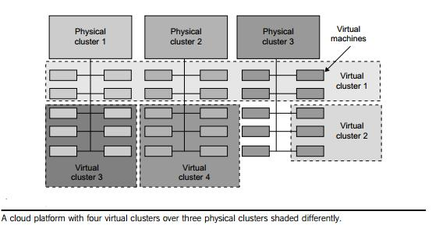

Below diagram shows the concept of a virtual cluster based on application partitioning or customization. The different colors in the figure represent the nodes in different virtual clusters. As a large number of VM images might be present, the most important thing is to determine how to store those images in the system efficiently. There are common installations for most users or applications, such as operating systems or user-level programming libraries. These software packages can be preinstalled as templates (called template VMs). With these templates, users can build their own software stacks. New OS instances can be copied from the template VM. User-

specific components such as programming libraries and applications can be installed to those instances.
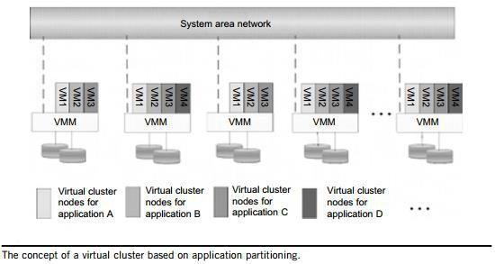

4. Explain the trust management in virtual clusters.

A VMM changes the computer architecture. It provides a layer of software between the operating systems and system hardware to create one or more VMs on a single physical platform. A VM entirely encapsulates the state of the guest operating system running inside it. Encapsulated machine state can be copied and shared over the network and removed like a normal file, which proposes a challenge to VM security. In general, a VMM can provide secure isolation and a VM accesses hardware resources through the control of the VMM, so the VMM is the base of the security of a virtual system. Normally, one VM is taken as a management VM to have some privileges such as creating, suspending, resuming, or deleting a VM.

Once a hacker successfully enters the VMM or management VM, the whole system is in
danger. A subtler problem arises in protocols that rely on the ―freshness‖ of their random number
source for generating session keys. Considering a VM, rolling back to a point after a random
number has been chosen, but before it has been used, resumes execution; the random number,
which must be ―fresh‖ for security purposes, is reused. With a stream cipher, two different
plaintexts could be encrypted under the same key stream, which could, in turn, expose both
plaintexts if the plaintexts have sufficient redundancy. Non-cryptographic protocols that rely on
freshness are also at risk. For example, the reuse of TCP initial sequence numbers can raise TCP
hijacking attacks.
VM-Based Intrusion Detection

Intrusions are unauthorized access to a certain computer from local or network users and intrusion detection is used to recognize the unauthorized access. An intrusion detection system (IDS) is built on operating systems, and is based on the characteristics of intrusion actions. A typical IDS can be classified as a host-based IDS (HIDS) or a network-based IDS (NIDS), depending on the data source. A HIDS can be implemented on the monitored system. When the monitored system is attacked by hackers, the HIDS also faces the risk of being attacked. A NIDS is based on the flow of network traffic which can’t detect fake actions. Virtualization-based intrusion detection can isolate guest VMs on the same hardware platform. Even some VMs can be invaded successfully; they never influence other VMs, which is similar to the way in which a NIDS operates. Furthermore, a VMM monitors and audits access requests for hardware and system software. This can avoid fake actions and possess the merit of a HIDS. There are two different methods for implementing a VM-based IDS: Either the IDS is an independent process in each VM or a high-privileged VM on the VMM; or the IDS is integrated into the VMM and has the same privilege to access the hardware as well as the VMM.

The VM-based IDS contains a policy engine and a policy module. The policy framework can monitor events in different guest VMs by operating system interface library and PTrace indicates trace to secure policy of monitored host. It’s difficult to predict and prevent all intrusions without delay. Therefore, an analysis of the intrusion action is extremely important after an intrusion occurs. At the time of this writing, most computer systems use logs to analyze attack actions, but it is hard to ensure the credibility and integrity of a log. The IDS log service is based on the operating system kernel. Thus, when an operating system is invaded by attackers, the log service should be unaffected.

Besides IDS, honeypots and honey nets are also prevalent in intrusion detection. They attract and provide a fake system view to attackers in order to protect the real system. In addition, the attack action can be analyzed, and a secure IDS can be built. A honeypot is a purposely defective system that simulates an operating system to cheat and monitor the actions of an attacker. A honeypot can be divided into physical and virtual forms. A guest operating system and the applications running on it constitute a VM. The host operating system and VMM must be guaranteed to prevent attacks from the VM in a virtual honeypot.

5. Explain the virtualization for data center automation.

The dynamic nature of cloud computing has pushed data center workload, server, and even hardware automation to whole new levels. Now, any data center provider looking to get into cloud computing must look at some form of automation to help them be as agile as possible in the cloud world.

New technologies are forcing data center providers to adopt new methods to increase efficiency, scalability and redundancy. Let’s face facts; there are numerous big trends which have emphasized the increased use of data center facilities. These trends include:

- More users
- More devices
- More cloud
- More workloads
- A lot more data

As infrastructure improves, more companies have looked towards the data center provider to offload a big part of their IT infrastructure. With better cost structures and even better incentives in moving towards a data center environment, organizations of all sizes are looking at colocation as an option for their IT environment.

With that, data center administrators are teaming with networking, infrastructure and cloud architects to create an even more efficient environment. This means creating intelligent systems from the hardware to the software layer. This growth in data center dependency has resulted in direct growth around automation and orchestration technologies.

Now, organizations can granularly control resources, both internally and in the cloud. This type of automation can be seen at both the software layer as well as the hardware layer. Vendors like BMC, ServiceNow, and Microsoft SCCM/SCOM are working towards unifying massive systems under one management engine to provide a single pain of glass into the data center workload environment
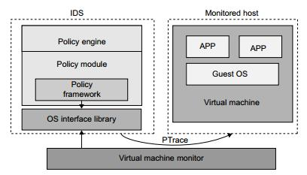

.

Furthermore, technologies like the Cisco UCS platform allow administrators to virtualize the hardware layer and create completely automated hardware profiles for new blades and servers. This hardware automation can then be tied into software-based automation tools like SCCM. Already we’re seeing direct integration between software management tools and the hardware layer.

Finally, from a cloud layer, platforms like CloudStack and OpenStack allow organizations to create orchestrated and automated fluid cloud environments capable of very dynamic scalability. Still, when a physical server or hardware component breaks – we still need a person to swap out that blade.

To break it down, it’s important to understand what layers of automation and orchestration are available now – and what might be available in the future. The automation and orchestration layers

Server layer. Server and hardware automation have come a long way. As mentioned earlier, there are systems now available which take almost all of the configuration pieces out of deploying a server. Administrators only need to deploy one server profile and allow new servers to pick up those settings. More data centers are trying to get into the cloud business. This means deploying high-density, fast-provisioned, servers and blades. With the on-demand nature of the cloud, being able to quickly deploy fully configured servers is a big plus for staying agile and very proactive.

Software layer. Entire applications can be automated and provisioned based on usage and resource utilization. Using the latest load-balancing tools, administrators are able to set thresholds for key applications running within the environment. If a load-balancer, a NetScaler for example, sees that a certain type of application is receiving too many connections, it can set off a process that will allow the administrator to provision another instance of the application or a new server which will host the app.

Virtual layer. The modern data center is now full of virtualization and virtual machines. In using solutions like Citrix’s Provisioning Server or Unidesk’s layering software technologies, administrators are able to take workload provisioning to a whole new level. Imagine being able to set a process that will kick-start the creation of a new virtual server when one starts to get over-utilized. Now, administrators can create truly automated virtual machine environments where each workload is monitored, managed and controlled.

Cloud layer. This is a new and still emerging field. Still, some very large organizations are already deploying technologies like CloudStack, OpenStack, and even OpenNebula. Furthermore, they’re tying these platforms in with big data management solutions like MapReduce and Hadoop. What’s happening now is true cloud-layer automation. Organizations can deploy distributed data centers and have the entire cloud layer managed by a cloud-control software platform. Engineers are able to monitor workloads, how data is being distributed, and the health of the cloud infrastructure. The great part about these technologies is that organizations can deploy a true private cloud, with as much control and redundancy as a public cloud instance.

Data center layer. Although entire data center automation technologies aren’t quite here yet, we are seeing more robotics appear within the data center environment. Robotic arms already control massive tape libraries for Google and robotics automation is a thoroughly discussed concept among other large data center providers. In a recent article, we discussed the concept of a ―lights-out‖ data center in the future. Many experts agree that eventually, data center automation and robotics will likely make its way into the data center of tomorrow. For now, automation at the physical data center layer is only a developing concept.

The need to deploy more advanced cloud solution is only going to grow. More organizations of all verticals and sizes are seeing benefits of moving towards a cloud platform. At the end of the day, all of these resources, workloads and applications have to reside somewhere. That somewhere is always the data center.

In working with modern data center technologies administrators strive to be as efficient and agile as possible. This means deploying new types of automation solutions which span the

entire technology stack. Over the upcoming couple of years, automation and orchestration technologies will continue to become popular as the data center becomes an even more core piece for any organization.

6. Explain implementation levels of virtualization in details.

Virtualization is computer architecture technology by which multiple virtual machines are multiplexed in the same hardware machine. The idea of VMs can be dated back to the 1960s. The purpose of a VM is to enhance resource sharing by many users and improve computer performance in terms of resource utilization and application flexibility. Hardware resources or software resources can be virtualized in various functional layers. Levels of virtualization implementation

A traditional computer runs with a host OS specially tailored for its hardware architecture. After virtualization different user applications managed by their own OS (Guest OS) can run on the same hardware, independent of the host OS. This is often done by adding additional software called virtualization layer. This virtualization layer is known as hypervisor or Virtual Machine

Monitor.

The main function of the software layer for virtualization is to virtualize the physical hardware of a host machine into virtual resources to be used by the VMs exclusively. Common virtualization layers include the instruction set architecture level, hardware level, OS Level, Library support level and application level.

Instruction set architecture

At the ISA level virtualization is performed by emulating a given ISA by the ISA of the host machine. For example, MIPS binary code can run on an 8086 based host machine with help of ISA emulation.

The basic emulation method is through code interpretation. An interpreter program interprets the source instructions to target instructions one by one. One source instruction may require tens or hundreds of native target instructions to perform its function.

Hardware Architecture

Hardware level virtualization is performed right on top of the bar hardware. On the one hand this approach generates a virtual hardware environment for a VM. On the other hand the process manages the underlying hardware through virtualization.

The idea is to virtualize a computers resources, such as its processors, memory and I/O devices OS Level

This refers to an abstraction layer between traditional OS and user application. OS level virtualization creates isolated containers on a single physical server and the OS instances to utilize the hardware and software in data centers.

Library Support Level

Most application use APIs exported by user level libraries rather than using lengthy system calls by the OS. Since most systems provide well documented APIs, such an interface becomes another candidate for virtualization. Virtualization with library interfaces is possible by controlling the communication link between applications and the rest of a system through API hooks.

User Application Level

Virtualization at the application level virtualizes an application as a VM. On a traditional OS, an application often runs as a process. Therefore, application level virtualization is known as process level virtualization. The most popular approach is to deploy high level language VMs.

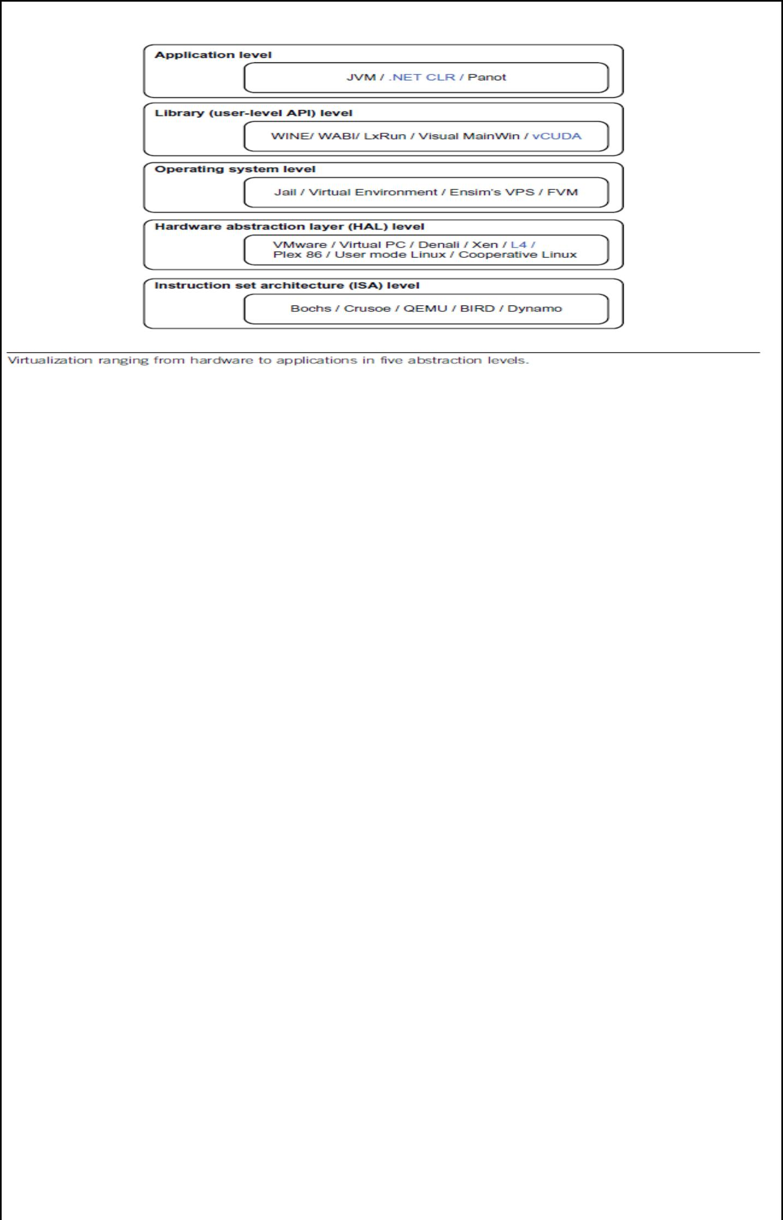

- Explain the virtualization of CPU, Memory and I/O devices Virtualization of CPU

A VM is a duplicate of an existing computer system in which a majority of the VM instructions are executed on the host processor in native mode. Thus, unprivileged instructions of VMs run directly on the host machine for higher efficiency. The critical instructions are divided into three categories.

  - Privileged instructions

  - Control sensitive instructions

  - Behaviour sensitive instructions

Privileged instructions execute in a privileged mode and will be trapped if executes outside this mode.

Control sensitive instructions attempt to change the configuration of resources used.

Behavior sensitive instructions have different behaviors depending on the configuration of resources, including the load and store operations over the virtual memory.

A CPU architecture is virtualizable if it supports the ability to run the VM’s privileged and unprivileged instructions in the CPU’s user mode while the VMM run in supervisor mode. When the privileged instructions including control and behavior sensitive instructions of a VM are executed they are trapped in the VMM.

RISC CPU architectures can be naturally virtualized because all control and behavior sensitive instructions are privileged instruction.

Hardware Assisted CPU virtualization

- Processors with virtualization technology have extra instruction set called virtual machine extensions or VMX.

- There are two modes to run under virtualization: root operation and non-root operation. Usually only the virtualization controlling software, called Virtual Machine Monitor (VMM), runs under root operation, while operating systems running on top of the virtual machines run under non-root operation. Software running on top of virtual machines is also called ‛guest software‚.

- To enter virtualization mode, the software should execute the VMXON instruction and then call the VMM software. Then VMM software can enter each virtual machine using the VMLAUNCH instruction, and exit it by using the VMRESUME. If VMM wants to shut down and exit virtualization mode, it executes the VMXOFF instruction.

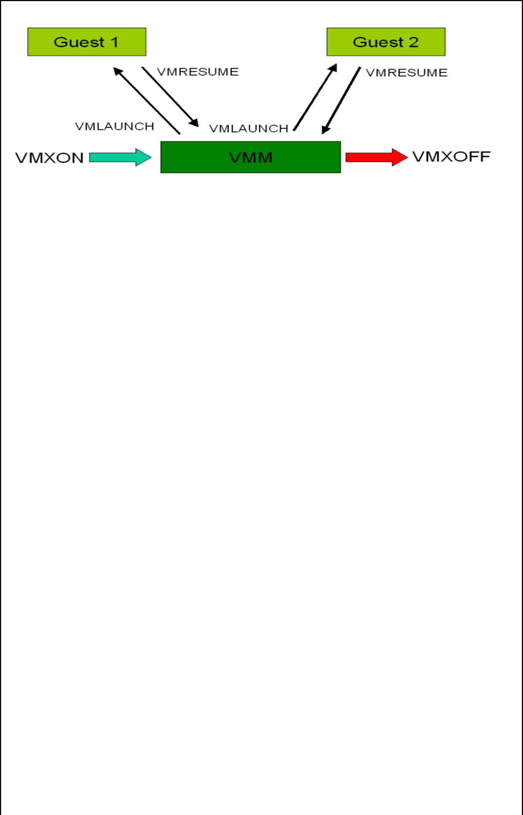

Memory Virtualization

Virtual memory virtualization is similar to the virtual memory support provided by modern operating systems. In a traditional execution environment the OS maintains mappings of virtual memory to machine memory using page tables, which is one stage mapping from virtual memory to machine memory. All modern x86 CPUs include a Memory management Unit and a translation Look-aside Buffer to optimize virtual memory performance. In virtual execution environment virtual memory virtualization involves sharing the physical system memory in RAM and dynamically allocating it to the physical memory of the VMs.

Guest OS sees flat ‚physical‛ address space.
Page tables within guest OS: • Translate from virtual to physical addresses.
Second-level mapping: • Physical addresses to machine addresses.
VMM can swap a VM’s pages to disk.
Traditional way is to have the VMM maintain a shadow of the VM’s page table.

The shadow page table controls which pages of machine memory are assigned to a given VM. When OS updates it’s page table, VMM updates the shadow
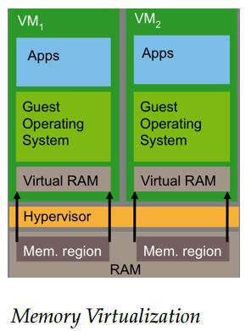

I/O Virtualization

Input/output (I/O) virtualization is a methodology to simplify management, lower costs and improve performance of servers in enterprise environments. I/O virtualization environments are created by abstracting the upper layer protocols from the physical connections.

The technology enables one physical adapter card to appear as multiple virtual network interface cards (vNICs) and virtual host bus adapters (vHBAs). Virtual NICs and HBAs function as conventional NICs and HBAs, and are designed to be compatible with existing operating systems, hypervisors, and applications. To networking resources (LANs and SANs), they appear as normal cards.

In the physical view, virtual I/O replaces a server’s multiple I/O cables with a single cable that provides a shared transport for all network and storage connections. That cable (or commonly two cables for redundancy) connects to an external device, which then provides connections to the data center networks.

Server I/O is a critical component to successful and effective server deployments, particularly with virtualized servers. To accommodate multiple applications, virtualized servers demand more network bandwidth and connections to more networks and storage. According to a survey, 75% of virtualized servers require 7 or more I/O connections per device, and are likely to require more frequent I/O reconfigurations.

In virtualized data centers, I/O performance problems are caused by running numerous virtual machines (VMs) on one server. In early server virtualization implementations, the number of virtual machines per server was typically limited to six or less. But it was found that it could safely run seven or more applications per server, often using 80 percentage of total server capacity, an improvement over the average 5 to 15 percentage utilized with non-virtualized servers.
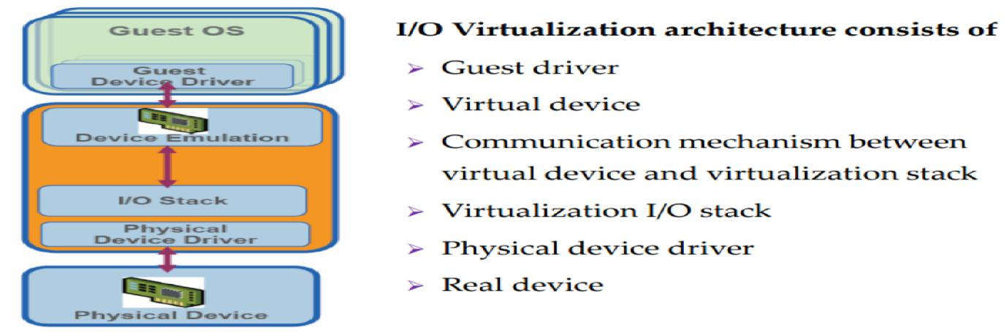

Virtualization I/O stack
Translates guest I/O addresses to host addresses
Handles inter VM communication
Multiplexes I/O requests from/to the physical device
Provides enterprise-class I/O features to the Guest

8. a. Para-Virtualization with Compiler Support

Para-virtualization needs to modify the guest operating systems. A para-virtualized VM provides special APIs requiring substantial OS modifications in user applications. Performance degradation is a critical issue of a virtualized system. No one wants to use a VM if it is much slower than using a physical machine. The virtualization layer can be inserted at different positions in a machine software stack. However, para-virtualization attempts to reduce the virtualization overhead, and thus improve performance by modifying only the guest OS kernel. The concept of a para-virtualized VM architecture. The guest operating systems are para-virtualized.
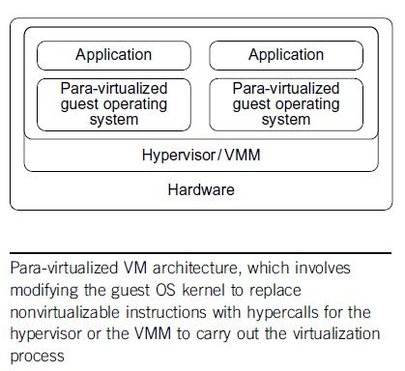

They are assisted by an intelligent compiler to replace the nonvirtualizable OS instructions by hypercalls as llustrated in below figure. The traditional x86 processor offers four instruction execution rings: Rings 0, 1, 2, and 3. The lower the ring number, the higher the privilege of instruction being executed. The OS is responsible for managing the hardware and the privileged instructions to execute at Ring 0, while user-level applications run at Ring 3.
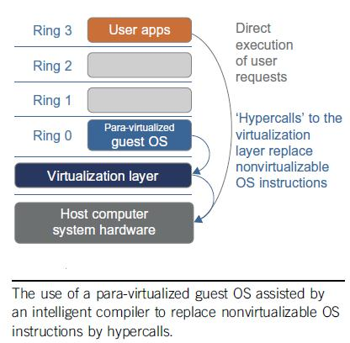

Para-Virtualization Architecture

When the x86 processor is virtualized, a virtualization layer is inserted between the hardware and the OS. According to the x86 ring definition, the virtualization layer should also be installed at Ring 0. Different instructions at Ring 0 may cause some problems. In above diagram, we show that para-virtualization replaces nonvirtualizable instructions with hypercalls that communicate directly with the hypervisor or VMM. However, when the guest OS kernel is modified for virtualization, it can no longer run on the hardware directly.

Although para-virtualization reduces the overhead, it has incurred other problems. First, its compatibility and portability may be in doubt, because it must support the unmodified OS as well. Second, the cost of maintaining para-virtualized OSes is high, because they may require deep OS kernel modifications. Finally, the performance advantage of para-virtualization varies greatly due to workload variations. Compared with full virtualization, para-virtualization is relatively easy and more practical. The main problem in full virtualization is its low performance in binary translation. To speed up binary translation is difficult. Therefore, many virtualization products employ the para-virtualization architecture. The popular Xen, KVM, and VMware ESX are good examples.

8. b. Binary Translation with Full Virtualization

Depending on implementation technologies, hardware virtualization can be classified into two categories:

Full virtualization and host-based virtualization. Full virtualization does not need to modify the host OS. It relies on binary translation to trap and to virtualize the execution of certain sensitive, nonvirtualizable instructions. The guest OSes and their applications consist of noncritical and critical instructions. In a host-based system, both a host OS and a guest OS are used. A virtualization software layer is built between the host OS and guest OS. These two classes of VM architecture are introduced next.

Full Virtualization

With full virtualization, noncritical instructions run on the hardware directly while critical instructions are discovered and replaced with traps into the VMM to be emulated by software. Both the hypervisor and VMM approaches are considered full virtualization. Why are only critical instructions trapped into the VMM? This is because binary translation can incur a large performance overhead. Noncritical instructions do not control hardware or threaten the security of the system, but critical instructions do. Therefore, running noncritical instructions on hardware not only can promote efficiency, but also can ensure system security.

Binary Translation of Guest OS Requests Using a VMM

This approach was implemented by VMware and many other software companies. VMware puts the VMM at Ring 0 and the guest OS at Ring 1. The VMM scans the instruction stream and identifies the privileged, control- and behavior-sensitive instructions. When these instructions are identified, they are trapped into the VMM, which emulates the behavior of these instructions. The method used in this emulation is called binary translation. Therefore, full virtualization combines binary translation and direct execution. The guest OS is completely decoupled from the underlying hardware. Consequently, the guest OS is unaware that it is being virtualized. The performance of full virtualization may not be ideal, because it involves binary translation which is rather time-consuming. In particular, the full virtualization of I/O-intensive applications is a really a big challenge. Binary translation employs a code cache to store translated hot instructions to improve performance, but it increases the cost of memory usage. At the time of this writing, the performance of full virtualization on the x86 architecture is typically 80 percent to 97 percent that of the host machine.
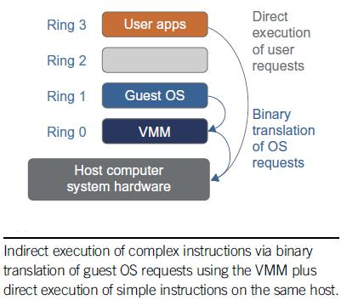

Host-Based Virtualization

An alternative VM architecture is to install a virtualization layer on top of the host OS. This host OS is still responsible for managing the hardware. The guest OSes are installed and run on top of the virtualization layer. Dedicated applications may run on the VMs. Certainly, some other applications can also run with the host OS directly. This hostbased architecture has some distinct advantages, as enumerated next. First, the user can install this VM architecture without modifying the host OS. The virtualizing software can rely on the host OS to provide device drivers and other low-level services. This will simplify the VM design and ease its deployment. Second, the host-based approach appeals to many host machine configurations. Compared to the hypervisor/VMM architecture, the performance of the host-based architecture may also be low. When an application requests hardware access, it involves four layers of mapping which downgrades performance significantly. When the ISA of a guest OS is different from the ISA of the underlying hardware, binary translation must be adopted. Although the host-based architecture has flexibility, the performance is too low to be useful in practice.

- Explain the characteristics and types of virtualization in cloud computing.

Virtualization is using computer resources to imitate other computer resources or whole computers. It separates resources and services from the underlying physical delivery environment.

Virtualization has three characteristics that make it ideal for cloud computing:

Partitioning: In virtualization, many applications and operating systems (OSes) are supported in a single physical system by partitioning (separating) the available resources.

Isolation: Each virtual machine is isolated from its host physical system and other virtualized machines. Because of this isolation, if one virtual-instance crashes, it doesn’t affect the other virtual machines. In addition, data isn’t shared between one virtual container and another.

Encapsulation: A virtual machine can be represented (and even stored) as a single file, so you can identify it easily based on the service it provides. In essence, the encapsulated process could be a business service. This encapsulated virtual machine can be presented to an application as a

complete entity. Therefore, encapsulation can protect each application so that it doesn’t interfere with another application.

Types:

Virtualization can be utilized in many different ways and can take many forms aside from just server virtualization. The main types include application, desktop, user, storage and hardware. Application virtualization allows the user to access the application, not from their workstation, but from a remotely located server. The server stores all personal information and other characteristics of the application, but can still run on a local workstation. Technically, the application is not installed, but acts like it is.

Desktop virtualization allows the users’ OS to be remotely stored on a server in the data center, allowing the user to then access their desktop virtually, from any location.

User virtualization is pretty similar to desktop, but allows users the ability to maintain a fully personalized virtual desktop when not on the company network. Users can basically log into their ―desktop‖ from different types of devices like smartphones and tablets. With more companies migrating to a BYOD policy, desktop and user virtualization are becoming increasingly popular.

Storage virtualization is the process of grouping the physical storage from multiple network storage devices so that it acts as if it’s on one storage device.

Hardware virtualization (also referred to as hardware-assisted virtualization) is a form of virtualization that uses one processor to act as if it were several different processors. The user can then run different operating systems on the same hardware, or more than one user can use the processor at the same time. This type of virtualization requires a virtual machine manager (VM) called a hypervisor.

10. Explain the NIST reference architecture of cloud computing in detail

The Conceptual Reference Model Figure 1 presents an overview of the NIST cloud computing reference architecture, which identifies the major actors, their activities and functions in cloud computing. The diagram depicts a generic high-level architecture and is intended to facilitate the understanding of the requirements, uses, characteristics and standards of cloud computing.
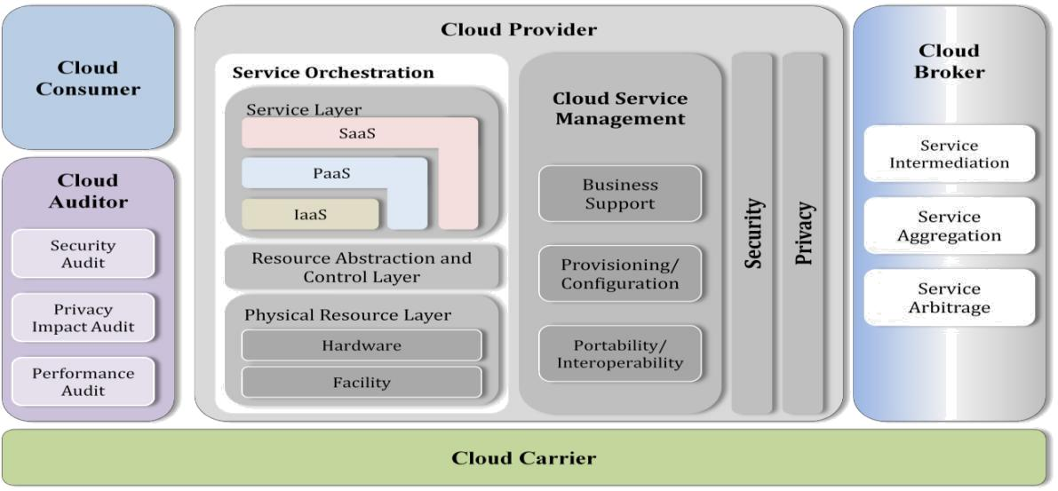

Figure 1: The Conceptual Reference Model

As shown in Figure 1, the NIST cloud computing reference architecture defines five major actors: cloud consumer, cloud provider, cloud carrier, cloud auditor and cloud broker. Each actor is an entity (a person or an organization) that participates in a transaction or process and/or performs tasks in cloud computing.

 |  | Actor |  |  |  | Definition
 |  | Cloud
 | Consumer |  |  | A person or organization that maintains a business relationship
 |  |  |  | with, and uses service from, Cloud Providers.
 |  | Cloud
 | Provider |  |  | A person, organization, or entity responsible for making a
 |  |  |  | service available to interested parties.
 |  | Cloud
 | Auditor |  |  | A party that can conduct independent assessment of cloud
 |  |  |  | services, information system operations, performance and
 |  |  |  | security of the cloud implementation.
 |  | Cloud Broker |  | An entity that manages the use, performance |  |  | and delivery of
 |  |  |  | cloud services, and negotiates relationships between Cloud
 |  |  |  | Providers and Cloud Consumers.
 |  | Cloud
 | Carrier |  |  | An intermediary that provides connectivity and transport of
 |  |  |  | cloud services from Cloud Providers to Cloud Consumers.
 |  |  |  |  | Unit – 4 – Progamming Model
 |  |  |  |  |  | Part – A
1. List out the grid middleware packages
 |  | Package |  |  |  | Description
 |  | BOINC |  |  | Berkeley Open Infrastructure for Network Computing.
 |  | UNICORE |  |  | Middleware developed by the German grid computing community
 |  | Globus (GT4) |  |  | A middleware library jointly developed by Argonne National Lab.
 |  | CGSP in ChinaGrid |  |  | The CGSP (ChinaGrid Support Platform) is a middleware library
 |  |  |  |  | developed by 20 top universities in China as part of the ChinaGrid
 |  |  |  |  | Project
 |  | Condor-G |  |  | Originally developed at the Univ. of Wisconsin for general distributed
 |  |  |  |  | computing, and later extended to Condor-G for grid job management.
 |  | Sun Grid Engine (SGE) |  |  | Developed by Sun Microsystems for business grid applications. Applied
 |  |  |  |  | to private grids and local clusters within enterprises or campuses.
2. Define MapReduce.
The mapreduce software framework provides an abstraction layer with the data flow and flow of control
of users and hides implementation of all data flow steps such as data partitioning mapping,
synchronization, communication and scheduling. The data flow is such framework is predefined the
abstraction layer provides two well defined interface in the form of two functions map and reduce.
3. What is the role of Map function?
Each Map function receives the input data split as a set of (key, value) pairs to process and produce the
intermediated (key, value) pairs.
4. What is the role of Reduce function?
The reduce worker iterates over the grouped (key, value) pairs, and for each unique key, it sends the key
and corresponding values to the Reduce function. Then this function processes its input data and stores
the output results in predetermined files in the user’s program.
5. List out the Hadoop core fundamental layers
The Hadoop core is divided into two fundamental layers: the MapReduce engine and HDFS. The
MapReduce engine is the computation engine running on top of HDFS as its data storage manager. HDFS
is a distributed file system inspired by GFS that organizes files and stores their data on a distributed
computing system.
6. What are the features of HDFS?
HDFS is not a general-purpose file system, as it only executes specific types of applications, it does not
need all the requirements of a general distributed file system. For example, security has never been
supported for HDFS systems.

- List the areas where HDFS cannot be used? Low-latency data access

Lots of small files
Multiple writers, arbitrary file modifications

- Why is a block in HDFS so large?

HDFS blocks are large compared to disk blocks, and the reason is to minimize the cost of seeks. By making a block large enough, the time to transfer the data from the disk can be made to be significantly larger than the time to seek to the start of the block. Thus the time to transfer a large file made of multiple blocks operates at the disk transfer rate.

9. Define Namenode in HDFS

The namenode manages the filesystem namespace. It maintains the filesystem tree and the metadata for all the files and directories in the tree. This information is stored persistently on the local disk in the form of two files: the namespace image and the edit log. The namenode also knows the datanodes on which all the blocks for a given file are located, however, it does not store block locations persistently, since this information is reconstructed from datanodes when the system starts.

10. Define Datanode in HDFS

Datanodes are the work horses of the filesystem. They store and retrieve blocks when they are told to (by clients or the namenode), and they report back to the namenode periodically with lists of blocks that they are storing.

11. What are the permission models for files and directories in HDFS

There are three types of permission: the read permission (r), the write permission (w) and the execute permission (x). The read permission is required to read files or list the contents of a directory. The write permission is required to write a file, or for a directory, to create or delete files or directories in it. The execute permission is ignored for a file since you can’t execute a file on HDFS (unlike POSIX), and for a directory it is required to access its children.

12. Define FUSE interface?

Filesystem in Userspace (FUSE) allows filesystems that are implemented in user space to be integrated as a Unix filesystem. Hadoop’s Fuse-DFS contrib module allows any Hadoop filesystem (but typically HDFS) to be mounted as a standard filesystem. You can then use Unix utilities (such as ls and cat) to interact with the filesystem, as well as POSIX libraries to access the filesystem from any programming language. Fuse-DFS is implemented in C using libhdfs as the interface to HDFS.

13. Define globbing in HDFS?

It is a common requirement to process sets of files in a single operation.. To enumerate each file and directory to specify the input, it is convenient to use wildcard characters to match multiple files with a single expression, an operation that is known as globbing.

14. How to process globs in hadoop filesystem?
Hadoop provides two FileSystem methods for processing globs:

public FileStatus[] globStatus(Path pathPattern) throws IOException
public FileStatus[] globStatus(Path pathPattern, PathFilter filter) throws IOException

The globStatus() methods returns an array of FileStatus objects whose paths match the supplied pattern, sorted by path. An optional PathFilter can be specified to restrict the matches further

15. How to delete file or directory in hadoop filesystem?
Use the delete() method on FileSystem to permanently remove files or directories:
public boolean delete(Path f, boolean recursive) throws IOException

If f is a file or an empty directory, then the value of recursive is ignored. A nonempty directory is only deleted, along with its contents, if recursive is true (otherwise an IOException is thrown).

16. Define iterative MapReduce.

It is important to understand the performance of different runtime and in particular to compare MPI and map reduce. The two major sources of parallel overhead are load imbalance and communication. The communication overhead in mapreduce can be high for two reasons.

  - Mapreduce read and writes files whereas MPI transfer information directly between nodes over the network.
  - MPI does not transfer all data from node to node.

- Define HDFS.

HDFS is a distributed file system inspired by GFS that organizes files and stores their data on a distributed computing system. The hadoop implementation of mapreduce uses the hadoop distributed file system as in underlying layer rather than GFS.

- List the characteristics of HDFS.
  - HDFS fault tolerance
  - Block replication
  - Relica placement
  - Heartbeat and block report messages
  - HDFS high throughput access to large dataset.

- What are the operations of HDFS?

The control flow of HDFS operation such as read and write can properly highlights role of the name node and data node in the managing operations. The control flow of the main operations of HDFS on file is further described to manifest the interaction between the users.

20. Define block replication.

The reliably store data in HDFS is the file blocks, it is replicated in this system. HDFS store a file as a set of blocks and each block is replicated and distributed across the whole cluster.

21. Define heart beat in Hadoop. What are the advantages of heart beat?

The heart beat are periodic messages sent to the name node by each data node in the cluster. Receipt of a heartbeat implies that data mode is functioning properly while each block report contains list of all blocks in a data mode. The name node receives such messages because it is the sole decision maker of all replicas in the system.

22. List out the functional modules in globus GT4 library

Service Functionality | Module | Functional Description
 | Name
Global Resource Allocation | GRAM | Grid Resource Access and Management (HTTP-
Manager |  | based)
Communication | Nexus | Unicast and multicast communication
Grid Security Infrastructure | GSI | Authentication and related security services
Monitory and Discovery | MDS | Distributed access to structure and state information
Service
Health and Status | HBM | Heartbeat monitoring of system components
Global Access of Secondary | GASS | Grid access of data in remote secondary storage
Storage
Grid File Transfer | GridFTP | Inter-node fast file transfer
23. Define Globus Resource Allocation Manager

Globus Resource Allocation Manager (GRAM) provides resource allocation, process creation, monitoring, and management services. GRAM implementations map requests expressed in a resource specification language (RSL) into commands to local schedulers and computers.

24. Define Monitoring and Discovery Service

The Monitoring and Discovery Service (MDS) is an extensible grid information service that combines data discovery mechanisms with the LDAP (LDAP defines a data model, query language, and other related protocols). MDS provides a uniform framework for providing and accessing system configuration and status information such as computer server configuration, network status, or the locations of replicated datasets.

Part- B
1. Explain in detail about Grid Middleware Packages

We first introduce some grid standards and popular APIs. Then we present the desired software support and middleware developed for grid computing.

Grid Standards and APIs

The Open Grid Forum (formally Global Grid Forum) and Object Management Group are two well-formed organizations behind those standards. we have also reported some grid standards including the GLUE for resource representation, SAGA (Simple API for Grid Applications), GSI (Grid Security Infrastructure), OGSI (Open Grid Service Infrastructure), and WSRE (Web Service Resource Framework).

Software Support and Middleware

Grid middleware is specifically designed a layer between hardware and the software. The middleware products enable the sharing of heterogeneous resources and managing virtual organizations created around the grid. Middleware glues the allocated resources with specific

user applications. Popular grid middleware tools include the Globus Toolkits (USA), gLight, UNICORE (German), BOINC (Berkeley), CGSP (China), Condor-G, and Sun Grid Engine, etc.

Package | Description
BOINC | Berkeley Open Infrastructure for Network Computing.
UNICORE | Middleware developed by the German grid computing community
Globus (GT4) | A middleware library jointly developed by Argonne National Lab.
CGSP in ChinaGrid | The CGSP (ChinaGrid Support Platform) is a middleware library
 | developed by 20 top universities in China as part of the ChinaGrid
 | Project
Condor-G | Originally developed at the Univ. of Wisconsin for general
 | distributed computing, and later extended to Condor-G for grid job
 | management.
Sun Grid Engine (SGE) | Developed by Sun Microsystems for business grid applications.
 | Applied to private grids and local clusters within enterprises or
 | campuses.
2. The Globus Toolkit Architecture

GT4 is an open middleware library forthe grid computing communities. These open source software libraries support many operational grids and their applications on an international basis. The toolkit addresses common problems and issues related to grid resource discovery, management, communication, security, fault detection, and portability. The software itself provides a variety of components and capabilities. The library includes a rich set of service implementations.
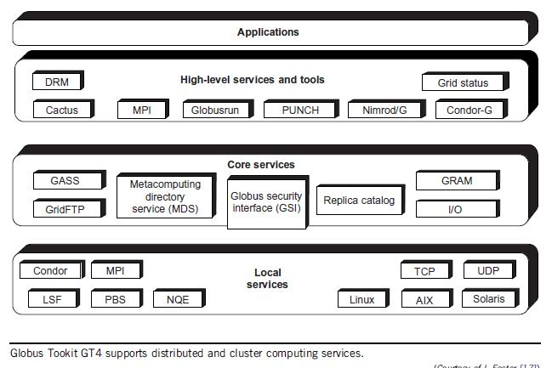

The GT4 Library

GT4 offers the middle-level core services in grid applications. The high-level services and tools, such as MPI, Condor-G, and Nirod/G, are developed by third parties for general-purpose distributed computing applications. The local services, such as LSF, TCP, Linux, and Condor, are at the bottom level and are fundamental tools supplied by other developers.

 | Service Functionality | Module Name | Functional Description
 | Global Resource | GRAM | Grid Resource Access and Management
 | Allocation Manager |  | (HTTP-based)
 | Communication | Nexus | Unicast and multicast communication
 | Grid Security | GSI | Authentication and related security services
 | Infrastructure
 | Monitory and Discovery | MDS | Distributed access to structure and state
 | Service |  | information
 | Health and Status | HBM | Heartbeat monitoring of system components
 | Global Access of | GASS | Grid access of data in remote secondary
 | Secondary Storage |  | storage
 | Grid File Transfer | GridFTP | Inter-node fast file transfer

Globus Job Workflow

A typical job execution sequence proceeds as follows: The user delegates his credentials to a delegation service. The user submits a job request to GRAM with the delegation identifier as a parameter. GRAM parses the request, retrieves the user proxy certificate from the delegation service, and then acts on behalf of the user. GRAM sends a transfer request to the RFT (Reliable File Transfer), which applies GridFTP to bring in the necessary files. GRAM invokes a local scheduler via a GRAM adapter and the SEG (Scheduler Event Generator) initiates a set of user jobs. The local scheduler reports the job state to the SEG. Once the job is complete, GRAM uses RFT and GridFTP to stage out the resultant files. The grid monitors the progress of these operations and sends the user a notification when they succeed, fail, or are delayed.
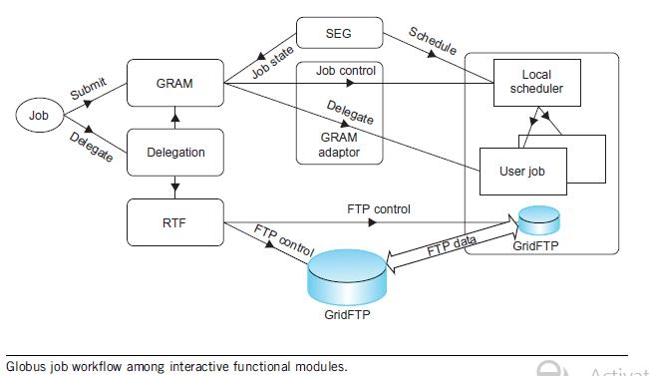

Client-Globus Interactions

GT4 service programs are designed to support user applications. There are strong interactions between provider programs and user code. GT4 makes heavy use of industry-standard web service protocols and mechanisms in service description, discovery, access, authentication, authorization, and the like. GT4 makes extensive use of Java, C, and Python to write user code. Web service mechanisms define specific interfaces for grid computing. Web services provide flexible, extensible, and widely adopted XML-based interfaces.
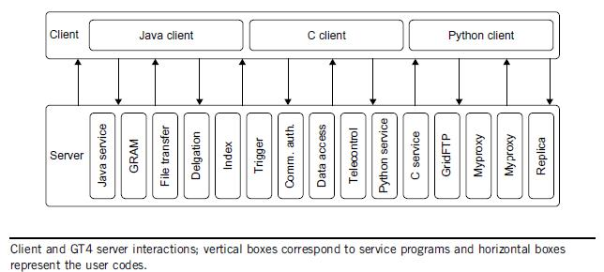

3. Explain the MapReduce technique

MapReduce is a programming model and an associated implementation for processing and generating large data sets with a parallel, distributed algorithm on a cluster. A MapReduce program is composed of a Map() procedure that performs filtering and sorting (such as sorting students by first name into queues, one queue for each name) and a Reduce() procedure that performs a summary operation (such as counting the number of students in each queue, yielding name frequencies). The "MapReduce System" (also called "infrastructure" or "framework") orchestrates the processing by marshalling the distributed servers, running the various tasks in parallel, managing all communications and data transfers between the various parts of the system, and providing for redundancy and fault tolerance.

The model is inspired by the map and reduce functions commonly used in functional programming, although their purpose in the MapReduce framework is not the same as in their original forms. The key contributions of the MapReduce framework are not the actual map and reduce functions, but the scalability and fault-tolerance achieved for a variety of applications by optimizing the execution engine once. As such, a single-threaded implementation of MapReduce (such as MongoDB) will usually not be faster than a traditional (non-MapReduce) implementation, any gains are usually only seen with multi-threaded implementations. Only when the optimized distributed shuffle operation (which reduces network communication cost) and fault tolerance features of the MapReduce framework come into play, is the use of this model beneficial. Optimizing the communication cost is essential to a good MapReduce algorithm.

MapReduce libraries have been written in many programming languages, with different levels of optimization. A popular open-source implementation that has support for distributed shuffles is part of Apache Hadoop. The name MapReduce originally referred to the proprietary Google technology, but has since been genericized.

Hadoop is an open-source framework for writing and running distributed applications that process very large data sets. There has been a great deal of interest in the framework, and it is very popular in industry as well as in academia. Hadoop cases include: web indexing, scientific simulation, social network analysis, fraud analysis, recommendation engine, ad targeting, threat analysis, risk modeling and other. Hadoop is core part of a cloud computing infrastructure and is being used by companies like Yahoo, Facebook, IBM, LinkedIn, and Twitter. The main benefits of Hadoop framework can be summarized as follows:

Accessible: it runs on clusters of commodity servers Scalable: it scales linearly to handle larger
data by adding nodes to the cluster
Fault-tolerant: it is designed with the assumption of frequent hardware failures
Simple: it allows user to quickly write efficiently parallel code
Global: it stores and analyzes data in its native format

Hadoop is designed for data-intensive processing tasks and for that reason it has adopted a move- code-to-data" philosophy. According to that philosophy, the programs to run, which are small in size, Are transferred to nodes that store the data. In that way, the framework achieves better performance and resource utilization. In addition, Hadoop solves the hard scaling problems caused by large amounts of complex data. As the amount of data in a cluster grows, new servers can be incrementally and inexpensively added to store and analyze it.

Hadoop has two major subsystems: the Hadoop Distributed File System (HDFS) and a distributed data processing framework called MapReduce. Apart from these two main components, Hadoop has grown into a complex ecosystem, including a range of software systems. Core related applications that are built on top of the HDFS are presented in figure and a short description per project is given in table.

MapReduce is a framework for processing parallelizable problems across huge datasets using a large number of computers (nodes), collectively referred to as a cluster (if all nodes are on the same local network and use similar hardware) or a grid (if the nodes are shared across geographically and administratively distributed systems, and use more heterogenous hardware). Processing can occur on data stored either in a filesystem (unstructured) or in a database (structured). MapReduce can take advantage of locality of data, processing it on or near the storage assets in order to reduce the distance over which it must be transmitted.

- "Map" step: Each worker node applies the "map()" function to the local data, and writes the output to a temporary storage. A master node orchestrates that for redundant copies of input data, only one is processed.

- "Shuffle" step: Worker nodes redistribute data based on the output keys (produced by the "map()" function), such that all data belonging to one key is located on the same worker node.

- "Reduce" step: Worker nodes now process each group of output data, per key, in parallel.

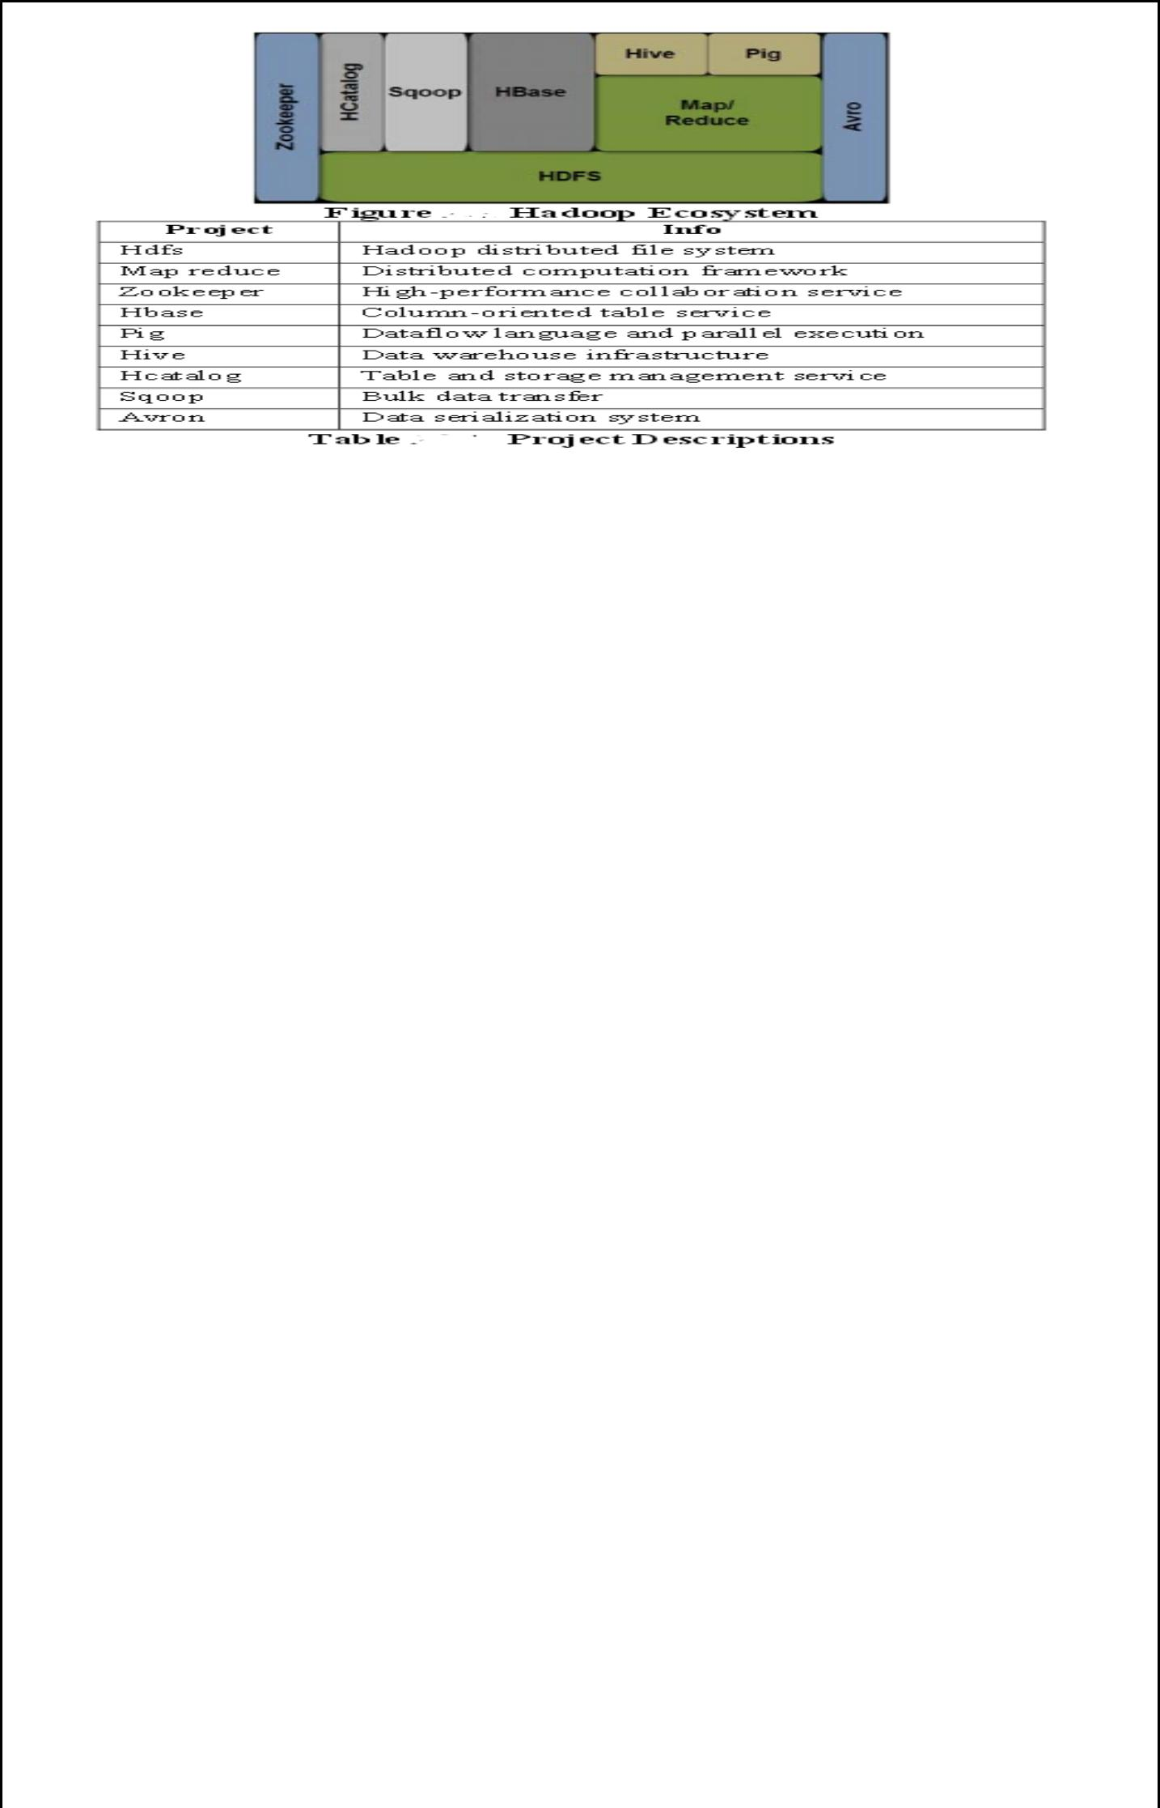

4. Explain the architecture of MapReduce in Hadoop?

The Hadoop MapReduce MRv1 framework is based on a centralized master/slave architecture. The architecture utilizes a single master server (JobTracker) and several slave servers (TaskTracker's). Please see Appendix A for a discussion on the MapReduce MRv2 framework. The JobTracker represents a centralized program that keeps track of the slave nodes, and provides an interface infrastructure for job submission. The TaskTracker executes on each of the slave nodes where the actual data is normally stored. In other words, the JobTracker reflects the interaction point among the users and the Hadoop framework. Users submit MapReduce jobs to the JobTracker, which inserts the jobs into the pending jobs queue and executes them (normally) on a FIFO basis (it has to be pointed out that other job schedulers are available - see Hadoop Schedulers below). The JobTracker manages the map and reduce task assignments with the TaskTracker's. The TaskTracker's execute the jobs based on the instructions from the JobTracker and handle the data movement between the maps and reduce phases, respectively. Any map/reduce construct basically reflects a special form of a Directed Acyclic Graph (DAG). A DAG can execute anywhere in parallel, as long as one entity is not an ancestor of another entity. In other words, parallelism is achieved when there are no hidden dependencies among shared states. In the MapReduce model, the internal organization is based on the map function that transforms a piece of data into entities of [key, value] pairs. Each of these elements is sorted (via their key) and ultimately reaches the same cluster node where a reduce function is used to merge the values (with the same key) into a single result (see code below). The Map/Reduce DAG is organized as depicted in Figure.
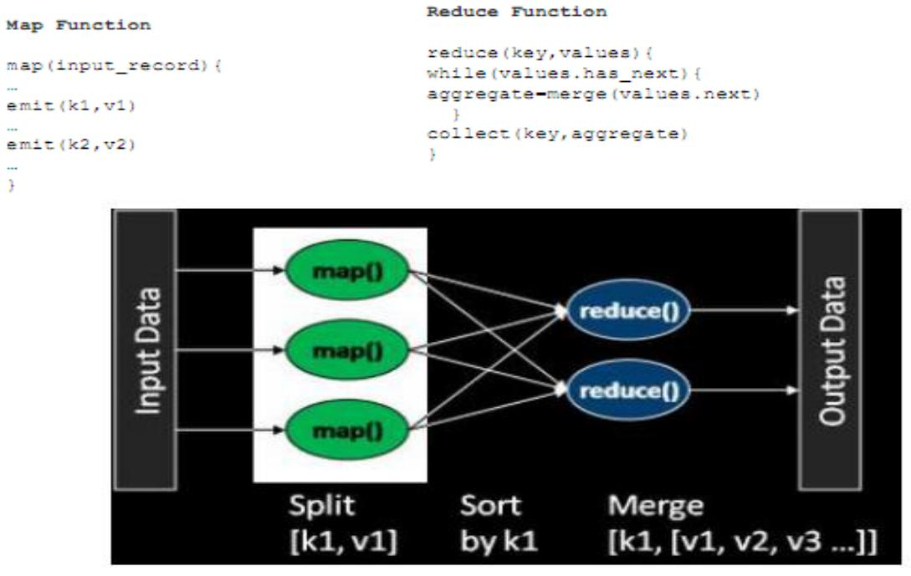

The Hadoop MapReduce framework is based on a pull model, where multiple TaskTracker's communicate with the JobTracker requesting tasks (either map or reduce tasks). After an initial setup phase, the JobTracker is informed about a job submission. The JobTracker provides a job ID to the client program, and starts allocating map tasks to idle TaskTracker's requesting work items (see below Figure). Each TaskTracker contains a defined number of task slots based on the capacity potential of the system. Via the heartbeat protocol, the JobTracker knows the number of free slots in the TaskTracker (the TaskTracker's send heartbeat messages indicating the free slots

- true for the FIFO scheduler). Hence, the JobTracker can determine the appropriate job setup for a TaskTracker based on the actual availability behavior. The assigned TaskTracker will fork a MapTask to execute the map processing cycle (the MapReduce framework spawns 1 MapTask for each InputSplit generated by the InputFormat). In other words, the MapTask extracts the input data from the splits by using the RecordReader and InputFormat for the job, and it invokes the user provided map function, which emits a number of [key, value] pairs in the memory buffer.

After the MapTask finished executing all input records, the commit process cycle is initiated by flushing the memory buffer to the index and data file pair. The next step consists of merging all the index and data file pairs into a single construct that is (once again) being divided up into local directories. As some map tasks are completed, the JobTracker starts initiating the reduce tasks phase. The TaskTracker's involved in this step download the completed files from the map task nodes, and basically concatenate the files into a single entity. As more map tasks are being completed, the JobTracker notifies the involved TaskTracker's, requesting the download of the additional region files and to merge the files with the previous target file. Based on this design, the process of downloading the region files is interleaved with the on-going map task procedures.
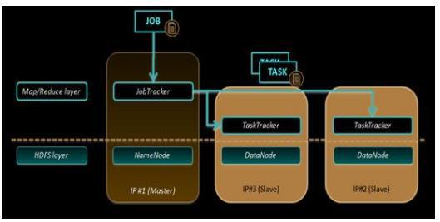

Eventually, all the map tasks will be completed, at which point the JobTracker notifies the involved TaskTracker's to proceed with the reduce phase. Each TaskTracker will fork a ReduceTask (separate JVM's are used), read the downloaded file (that is already sorted by key), and invoke the reduce function that assembles the key and aggregated value structure into the final output file (there is one file per reducer node). Each reduce task (or map task) is single threaded, and this thread invokes the reduce [key, values] function in either ascending or descending order. The output of each reducer task is written to a temp file in HDFS. When the reducer finishes processing all keys, the temp file is atomically renamed into its final destination file name.

As the MapReduce library is designed to process vast amounts of data by potentially utilizing hundreds or thousands of nodes, the library has to be able to gracefully handle any failure scenarios. The TaskTracker nodes periodically report their status to the JobTracker that oversees the overall job progress. In scenarios where the JobTracker has not been contacted by a TaskTracker for a certain amount of time, the JobTracker assumes a TaskTracker node failure and hence, reassigns the tasks to other available TaskTracker nodes. As the results of the map phase are stored locally, the data will no longer be available if a TaskTracker node goes offline.

In such a scenario, all the map tasks from the failed node (regardless of the actual completion percentage) will have to be reassigned to a different TaskTracker node that will re-execute all the newly assigned splits. The results of the reduce phase are stored in HDFS and hence, the data is globally available even if a TaskTracker node goes offline. Hence, in a scenario where during the reduce phase a TaskTracker node goes offline, only the set of incomplete reduce tasks have to be reassigned to a different TaskTracker node for re-execution.

5. Explain the dataflow and control flow of MapReduce

MapReduce is the heart of Hadoop. It is a programming model designed for processing large volumes of data in parallel by dividing the work into a set of independent tasks.

The framework possesses the feature of data locality. Data locality means movement of algorithm to the data instead of data to algorithm. When the processing is done on the data algorithm is moved across the DataNodes rather than data to the algorithm. The architecture is so constructed because Moving Computation is Cheaper than Moving Data.

It is fault tolerant which is achieved by its daemons using the concept of replication.The daemons associated with the MapReduce phase are job-tracker and task-trackers.

Map-Reduce jobs are submitted on job-tracker. The JobTracker pushes work out to available TaskTracker nodes in the cluster, striving to keep the work as close to the data as possible. A heartbeat is sent from the TaskTracker to the JobTracker every few minutes to check its status whether the node is dead or alive. Whenever there is negative status, the job tracker assigns the task to another node on the replicated data of the failed node stored in this node.
Let’s see how the data flows:

MapReduce has a simple model of data processing: inputs and outputs for the map and reduce functions are key-value pairs. The map and reduce functions in Hadoop MapReduce have the following general form:

map: (K1, V1) → list(K2, V2)
reduce: (K2, list(V2)) → list(K3, V3)

Now before processing it needs to know on which data to process, this is achieved with the InputFormat class. InputFormat is the class which selects file from HDFS that should be input to the map function. An InputFormat is also responsible for creating theinput splits and dividing them into records. The data is divided into number of splits (typically 64/128mb) in HDFS. An input split is a chunk of the input that is processed by a single map.

InputFormat class calls the getSplits() function and computes splits for each file and then sends them to the jobtracker, which uses their storage locations to schedule map tasks to process them on the tasktrackers. On a tasktracker, the map task passes the split to the createRecordReader() method on InputFormat to obtain a RecordReader for that split. The RecordReader loads data from its source and converts into key-value pairs suitable for reading by mapper. The default InputFormat is TextInputFormat which treats each value of input a new value and the associated key is byte offset.

A RecordReader is little more than an iterator over records, and the map task uses one to generate record key-value pairs, which it passes to the map function. We can see this by looking at the Mapper’s run() method:

public void run(Context context) throws IOException, InterruptedException { setup(context);

while (context.nextKeyValue()) {
map(context.getCurrentKey(), context.getCurrentValue(), context);
}
cleanup(context);
}

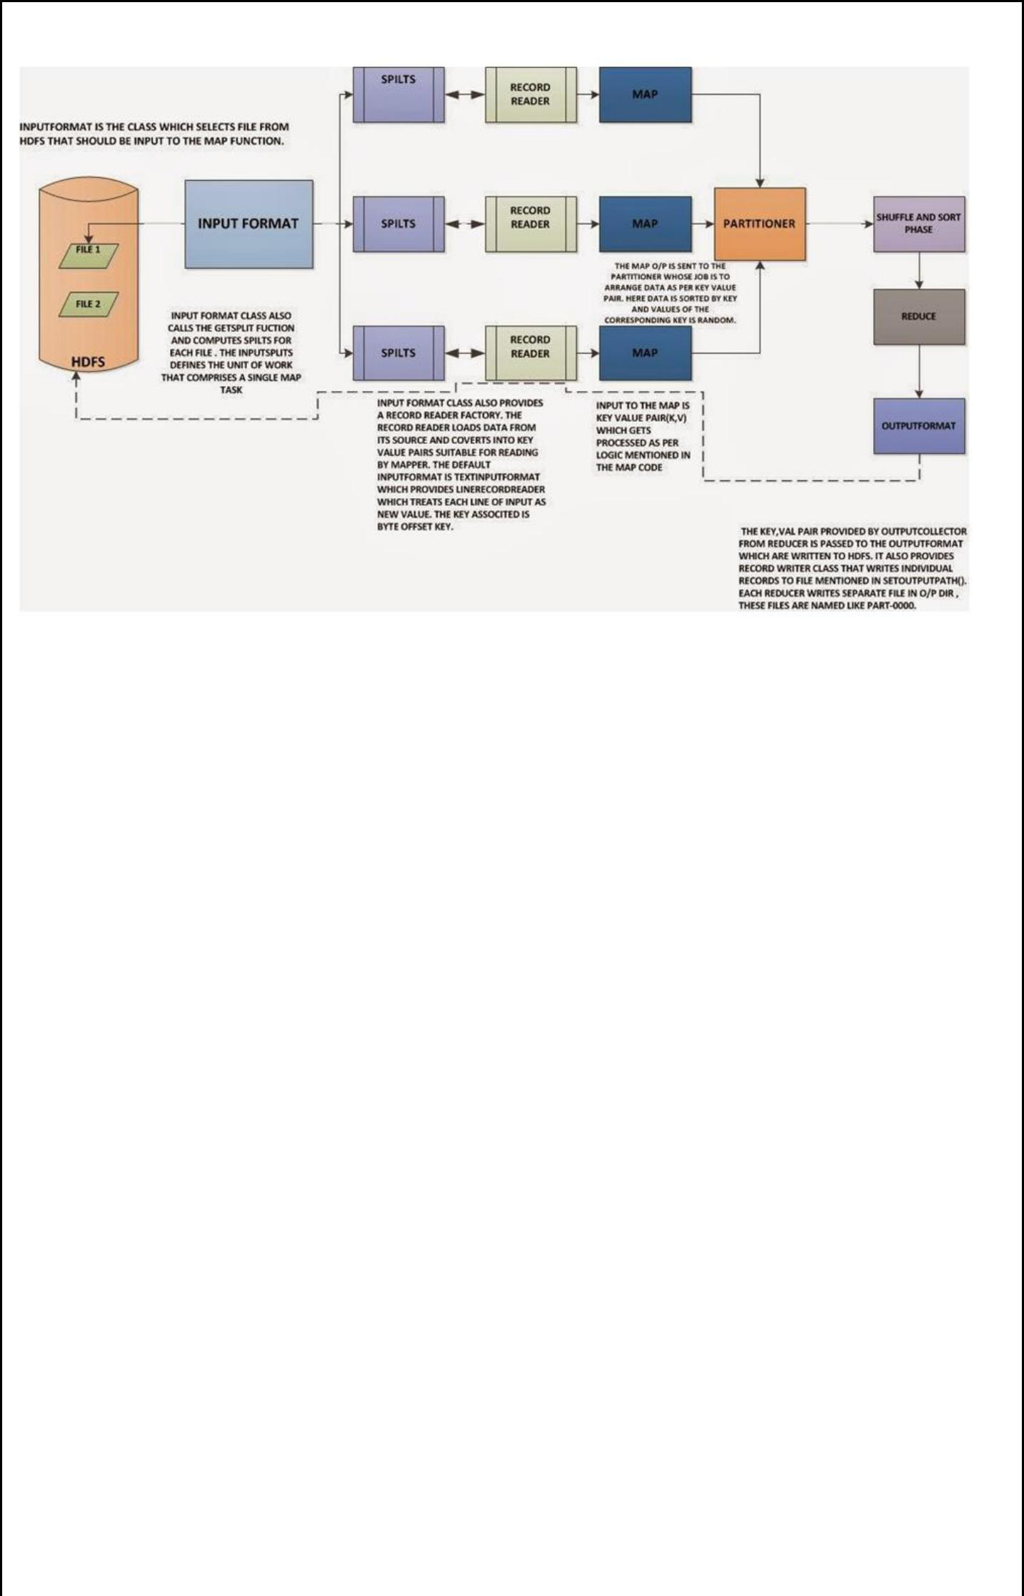

After running setup(), the nextKeyValue() is called repeatedly on the Context, (which delegates to the identically-named method on the the RecordReader) to populate the key and value objects for the mapper. The key and value are retrieved from the Record Reader by way of the Context, and passed to the map() method for it to do its work. Input to the map function which is the key-value pair (K, V) gets processed as per the logic mentioned in the map code.

When the reader gets to the end of the stream, the nextKeyValue() method returns false, and the map task runs its cleanup() method.

The output of the mapper is sent to the partitioner. Partitioner controls the partitioning of the keys of the intermediate map-outputs. The key (or a subset of the key) is used to derive the partition, typically by a hash function. The total number of partitions is the same as the number of reduce tasks for the job. Hence this controls which of the m reduce tasks the intermediate key (and hence the record) is sent for reduction. The use of partitioners is optional.

6. Describe in detail about dataflow of file read in HDFS

To get an idea of how data flows between the client interacting with HDFS, the namenode and the datanode, consider the below diagram, which shows the main sequence of events when reading a file.
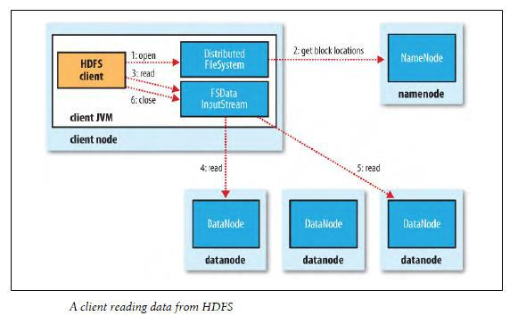

The client opens the file it wishes to read by calling open() on the FileSystem object, which for HDFS is an instance of DistributedFileSystem (step 1). DistributedFileSystem calls the namenode, using RPC, to determine the locations of the blocks for the first few blocks in the file (step 2). For each block, the namenode returns the addresses of the datanodes that have a copy of that block. Furthermore, the datanodes are sorted according to their proximity to the client. If the client is itself a datanode (in the case of a MapReduce task, for instance), then it will read from the local datanode.

The DistributedFileSystem returns a FSDataInputStream to the client for it to read data from. FSDataInputStream in turn wraps a DFSInputStream, which manages the datanode and namenode I/O. The client then calls read() on the stream (step 3). DFSInputStream, which has stored the datanode addresses for the first few blocks in the file, then connects to the first (closest) datanode for the first block in the file. Data is streamed from the datanode back to the client, which calls read() repeatedly on the stream (step 4). When the end of the block is reached, DFSInputStream will close the connection to the datanode, then find the best datanode for the next block (step 5). This happens transparently to the client, which from its point of view is just reading a continuous stream. Blocks are read in order with the DFSInputStream opening new connections to datanodes as the client reads through the stream. It will also call the namenode to retrieve the datanode locations for the next batch of blocks as needed. When the client has finished reading, it calls close() on the FSDataInputStream (step 6).

One important aspect of this design is that the client contacts datanodes directly to retrieve data, and is guided by the namenode to the best datanode for each block. This design allows HDFS to scale to large number of concurrent clients, since the data traffic is spread across all the datanodes in the cluster. The namenode meanwhile merely has to service block location requests (which it stores in memory, making them very efficient), and does not, for example, serve data, which would quickly become a bottleneck as the number of clients grew.

7. Describe in detail about dataflow of file write in HDFS

The case we’re going to consider is the case of creating a new file, writing data to it, then closing the file

.
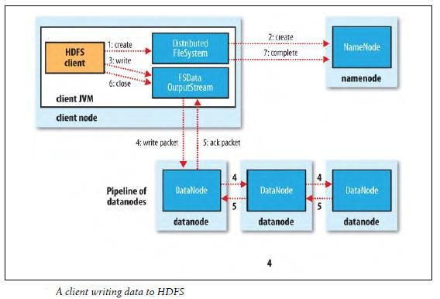

The client creates the file by calling create() on DistributedFileSystem (step 1). DistributedFileSystem makes an RPC call to the namenode to create a new file in the filesystem’s namespace, with no blocks associated with it (step 2). The namenode performs various checks to make sure the file doesn’t already exist, and that the client has the right permissions to create the file. If these checks pass, the namenode makes a record of the new file; otherwise, file creation fails and the client is thrown an IOException. The DistributedFileSystem returns a SDataOutputStream for the client to start writing data to. Just as in the read case, FSDataOutputStream wraps a DFSOutputStream, which handles communication with the datanodes and namenode.

As the client writes data (step 3), DFSOutputStream splits it into packets, which it writes to an internal queue, called the data queue. The data queue is consumed by the DataStreamer, whose responsibility it is to ask the namenode to allocate new blocks by picking a list of suitable datanodes to store the replicas. The list of datanodes forms a pipeline—we’ll assume the replication level is 3, so there are three nodes in the pipeline. The DataStreamer streams the packets to the first datanode in the pipeline, which stores the packet and forwards it to the second datanode in the pipeline. Similarly, the second datanode stores the packet and forwards it to the third (and last) datanode in the pipeline (step 4). DFSOutputStream also maintains an internal queue of packets that are waiting to be acknowledged by datanodes, called the ack queue. A packet is removed from the ack queue only when it has been acknowledged by all the datanodes in the pipeline (step 5).

If a datanode fails while data is being written to it, then the following actions are taken, which are transparent to the client writing the data. First the pipeline is closed, and any packets in the ack queue are added to the front of the data queue so that datanodes that are downstream from the failed node will not miss any packets. The current block on the good datanodes is given a new identity, which is communicated to the namenode, so that the partial block on the failed datanode will be deleted if the failed datanode recovers later on. The failed datanode is removed from the pipeline and the remainder of the block’s data is written to the two good datanodes in the pipeline. The namenode notices that the block is under-replicated, and it arranges for a further replica to be created on another node. Subsequent blocks are then treated as normal.

When the client has finished writing data it calls close() on the stream (step 6). This action flushes all the remaining packets to the datanode pipeline and waits for acknowledgments before contacting the namenode to signal that the file is complete (step7). The namenode already knows which blocks the file is made up of (via Data Streamer asking for block allocations), so it only has to wait for blocks to be minimally replicated before returning successfully.

8. Explain Reading Data from a Hadoop URL and Deleting Data

The Hadoop’s FileSystem class: the API for interacting with one of Hadoop’s filesystems. While we focus mainly on the HDFS implementation, DistributedFileSystem, in general you should strive to write your code against the FileSystem abstract class, to retain portability across filesystems. This is very useful when testing your program.

One of the simplest ways to read a file from a Hadoop filesystem is by using a java.net.URL object to open a stream to read the data from. The general idiom is:

try {
in = new URL("hdfs://host/path").openStream();

- process in } finally { IOUtils.closeStream(in);
}

There’s a little bit more work required to make Java recognize Hadoop’s hdfs URL scheme. This is achieved by calling the setURLStreamHandlerFactory method on URL with an instance of FsUrlStreamHandlerFactory. This method can only be called once per JVM, so it is typically executed in a static block. This limitation means that if some other part of your program perhaps a third-party component outside your control sets RLStreamHandlerFactory, you won’t be able to use this approach for reading data from Hadoop. The next section discusses an alternative. A program for displaying files from Hadoop filesystems on standard output, like the Unix cat command.

We make use of the handy IOUtils class that comes with Hadoop for closing the stream in the finally clause, and also for copying bytes between the input stream and the output stream (System.out in this case). The last two arguments to the copyBytes method are the buffer size used for copying, and whether to close the streams when the copy is complete. We close the input stream ourselves, and System.out doesn’t need to be closed.



Deleting Data

Use the delete() method on FileSystem to permanently remove files or directories: public boolean delete(Path f, boolean recursive) throws IOException. If f is a file or an empty directory, then the value of recursive is ignored. A nonempty directory is only deleted, along with its contents, if recursive is true (otherwise an IOException is thrown).

9.(a). File pattern in HDFS

It is a common requirement to process sets of files in a single operation. For example, a MapReduce job for log processing might analyze a month worth of files, contained in a number of directories. Rather than having to enumerate each file and directory to specify the input, it is convenient to use wildcard characters to match multiple files with a single expression, an operation that is known as globbing. Hadoop provides two FileSystem methods for processing globs:

public FileStatus[] globStatus(Path pathPattern) throws IOException
public FileStatus[] globStatus(Path pathPattern, PathFilter filter) throws IOException

The globStatus() methods returns an array of FileStatus objects whose paths match the supplied pattern, sorted by path. An optional PathFilter can be specified to restrict the matches further.
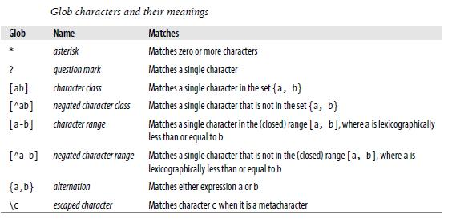

Hadoop supports the same set of glob characters as Unix bash.

Imagine that logfiles are stored in a directory structure organized hierarchically by date.
So, for example, logfiles for the last day of 2007 would go in a directory named /2007/12/31.
Suppose that the full file listing is:
/2007/12/30
/2007/12/31
/2008/01/01
/2008/01/02

9. (b) Pathfilter

Glob patterns are not always powerful enough to describe a set of files you want to access. For example, it is not generally possible to exclude a particular file using a glob pattern. The listStatus() and globStatus() methods of FileSystem take an optional PathFilter, which allows programmatic control over matching:

package org.apache.hadoop.fs;
public interface PathFilter
{
boolean accept(Path path);
}

PathFilter is the equivalent of java.io.FileFilter for Path objects rather than File objects.
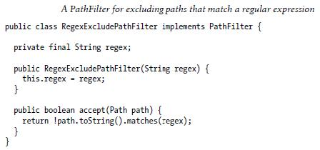

The filter passes only files that don’t match the regular expression. We use the filter in conjunction with a glob that picks out an initial set of files to include: the filter is used to refine the results. For example:

fs.globStatus(new Path("/2007/*/*"), new RegexExcludeFilter("^.*/2007/12/31$"))

Will expand to /2007/12/30. Filters can only act on a file’s name, as represented by a Path. They can’t use a file’s properties, such as creation time, as the basis of the filter. Nevertheless, they can perform matching that neither glob patterns nor regular expressions can achieve.

10. Explain in detail about command line interface in HDFS

There are many other interfaces to HDFS, but the command line is one of the simplest, and to many developers the most familiar. We are going to run HDFS on one machine, so first follow the instructions for setting up Hadoop in pseudo-distributed mode.Later you’ll see how to run on a cluster of machines to give us scalability and fault tolerance.

There are two properties that we set in the pseudo-distributed configuration that deserve further explanation. The first is fs.default.name, set to hdfs://localhost/, which is used to set a default filesystem for Hadoop. Filesystems are specified by a URI, and here we have used a hdfs URI to configure Hadoop to use HDFS by default. The HDFS daemons will use this property to determine the host and port for the HDFS namenode. We’ll be running it on localhost, on the default HDFS port, 8020. And HDFS clients will use this property to work out where the namenode is running so they can connect to it.

We set the second property, dfs.replication, to one so that HDFS doesn’t replicate filesystem blocks by the usual default of three. When running with a single datanode, HDFS can’t replicate blocks to three datanodes, so it would perpetually warn about blocks being under-replicated. This setting solves that problem.

Basic Filesystem Operations

The filesystem is ready to be used, and we can do all of the usual filesystem operations such as reading files, creating directories, moving files, deleting data, and listing directories. You can type hadoop fs -help to get detailed help on every command. Start by copying a file from the local filesystem to HDFS:

- hadoop fs -copyFromLocal input/docs/quangle.txt hdfs://localhost/user/tom/quangle.txt

This command invokes Hadoop’s filesystem shell command fs, which supports a number of subcommands—in this case, we are running -copyFromLocal. The local file quangle.txt is copied to the file /user/tom/quangle.txt on the HDFS instance running on localhost. In fact, we could have omitted the scheme and host of the URI and picked up the default, hdfs://localhost, as specified in core-site.xml.

- hadoop fs -copyFromLocal input/docs/quangle.txt /user/tom/quangle.txt

We could also have used a relative path, and copied the file to our home directory in HDFS, which in this case is /user/tom:

- hadoop fs -copyFromLocal input/docs/quangle.txt quangle.txt
Let’s copy the file back to the local filesystem and check whether it’s the same:
- hadoop fs -copyToLocal quangle.txt quangle.copy.txt
- md5 input/docs/quangle.txt quangle.copy.txt

MD5 (input/docs/quangle.txt) = a16f231da6b05e2ba7a339320e7dacd9 MD5 (quangle.copy.txt) = a16f231da6b05e2ba7a339320e7dacd9

The MD5 digests are the same, showing that the file survived its trip to HDFS and is back intact.

Finally, let’s look at an HDFS file listing. We create a directory first just to see how it is displayed in the listing:

- hadoop fs -mkdir books
- hadoop fs -ls .
Found 2 items
drwxr-xr-x - tom supergroup 0 2009-04-02 22:41 /user/tom/books
-rw-r--r-- 1 tom supergroup 118 2009-04-02 22:29 /user/tom/quangle.txt

The information returned is very similar to the Unix command ls -l, with a few minor differences. The first column shows the file mode. The second column is the replication factor of the file (something a traditional Unix filesystems does not have). Remember we set the default replication factor in the site-wide configuration to be 1, which is why we see the same value here. The entry in this column is empty for directories since the concept of replication does not apply to them—directories are treated as metadata and stored by the namenode, not the datanodes. The third and fourth columns show the file owner and group. The fifth column is the size of the file in bytes, or zero for directories. The six and seventh columns are the last modified date and time. Finally, the eighth column is the absolute name of the file or directory.

Unit – 5 - Security
Part – A
- What are the challenges of grid sites
  - The first challenge is integration with existing systems and technologies.

  - The second challenge is interoperability with different hosting environments.

  - The third challenge is to construct trust relationships among interacting hosting environments.

- Define Reputation-Based Trust Model

In a reputation-based model, jobs are sent to a resource site only when the site is trustworthy to meet users’ demands. The site trustworthiness is usually calculated from the following information: the defense capability, direct reputation, and recommendation trust.

3. Define direct reputation

Direct reputation is based on experiences of prior jobs previously submitted to the site. The reputation is measured by many factors such as prior job execution success rate, cumulative site utilization, job turnaround time, job slowdown ratio, and so on. A positive experience associated with a site will improve its reputation. On the contrary, a negative experience with a site will decrease its reputation.

4. What are the major authentication methods in the grid?

The major authentication methods in the grid include passwords, PKI, and Kerberos. The password is the simplest method to identify users, but the most vulnerable one to use. The PKI is the most popular method supported by GSI.

5. List the types of authority in grid

The authority can be classified into three categories: attribute authorities, policy authorities, and identity authorities. Attribute authorities issue attribute assertions; policy authorities issue authorization policies; identity authorities issue certificates. The authorization server makes the final authorization decision.

6. Define grid security infrastructure

The Grid Security Infrastructure (GSI), formerly called the Globus Security Infrastructure, is a specification for secret, tamper-proof, delegatable communication between software in a grid computing environment. Secure, authenticatable communication is enabled using asymmetric encryption.

7. What are the functions present in GSI

GSI may be thought of as being composed of four distinct functions: message protection, authentication, delegation, and authorization.

8. List the protection mechanisms in GSI

GSI allows three additional protection mechanisms. The first is integrity protection, by which a receiver can verify that messages were not altered in transit from the sender. The second is encryption, by which messages can be protected to provide confidentiality. The third is replay prevention, by which a receiver can verify that it has not.

9. What is the primary information of GSI

GSI authentication, a certificate includes four primary pieces of information: (1) a subject name, which identifies the person or object that the certificate represents; (2) the public key belonging to the subject;

- the identity of a CA that has signed the certificate to certify that the public key and the identity both belong to the subject; and (4) the digital signature of the named CA.

10. Define blue pill
The blue pill is malware that executes as a hypervisor to gain control of computer resources.

The hypervisor installs without requiring a restart and the computer functions normally, without
degradation of speed or services, which makes detection difficult.

- What are the host security threats in public IaaS
  - Stealing keys used to access and manage hosts (e.g., SSH private keys)
  - Attacking unpatched, vulnerable services listening on standard ports (e.g., FTP, SSH)
  - Hijacking accounts that are not properly secured (i.e., no passwords for standard accounts)
  - Attacking systems that are not properly secured by host firewalls

  - Deploying Trojans embedded in the software component in the VM or within the VM image (the OS) itself

- List the Public Cloud Security Limitations

- There are limitations to the public cloud when it comes to support for custom security features. Security requirements such as an application firewall, SSL accelerator, cryptography, or rights management using a device that supports PKCS 12 are not supported in a public SaaS, PaaS, or IaaS cloud.

- Any mitigation controls that require deploymentof an appliance or locally attached peripheral devices in the public IaaS/PaaS cloud are not feasible.

13. Define Data lineage

Data lineage is defined as a data life cycle that includes the data's origins and where it moves over time. It describes what happens to data as it goes through diverse processes. It helps provide visibility into the analytics pipeline and simplifies tracing errors back to their sources.

14. Define Data remanence

Data remanence is the residual representation of data that has been in some way nominally erased or removed.

- What are the IAM processes operational activities.
  - Provisioning

  - Credential and attribute management

  - Entitlement management

  - Compliance management

  - Identity federation management

- What are the functions of Cloud identity administrative

Cloud identity administrative functions should focus on life cycle management of user identities in the cloud—provisioning, deprovisioning, identity federation, SSO, password or credentials management, profile management, and administrative management. Organizations that are not capable of supporting federation should explore cloud-based identity management services.

17. List the factors to manage the IaaS virtual infrastructure in the cloud

  - Availability of a CSP network, host, storage, and support application infrastructure.

  - Availability of your virtual servers and the attached storage (persistent and ephemeral) for compute services
  - Availability of virtual storage that your users and virtual server depend on for storage Service

  - Availability of your network connectivity to the Internet or virtual network connectivity to IaaS services.

  - Availability of network services

- What is meant by the terms data-in-transit

It is the process of the transfer of the data between all of the versions of the original file, especially when data may be in transit on the Internet. It is data that is exiting the network via email, web, or other Internet protocols.

- List the IAM process business category
  - User management

  - Authentication management
  - Authorization management
  - Access management
  - Data management and provisioning
  - Monitoring and auditing

- What are the key components of IAM automation process?
✓ User Management, New Users
✓ User Management, User Modifications ✓ Authentication Management
✓ Authorization Management
Part – B
1. Trust Models for Grid Security

A user job demands the resource site to provide security assurance by issuing a security demand (SD). On the other hand, the site needs to reveal its trustworthiness, called its trust index (TI). These two parameters must satisfy a security-assurance condition: TI ≥ SD during the job mapping process. When determining its security demand, users usually care about some typical attributes. These attributes and their values are dynamically changing and depend heavily on the trust model, security policy, accumulated reputation, self-defense capability, attack history, and site vulnerability.

Three challenges are outlined below to establish the trust among grid sites

The first challenge is integration with existing systems and technologies. The resources sites in a grid are usually heterogeneous and autonomous. It is unrealistic to expect that a single type of security can be compatible with and adopted by every hosting environment. At the same time, existing security infrastructure on the sites cannot be replaced overnight. Thus, to be successful, grid security architecture needs to step up to the challenge of integrating with existing security architecture and models across platforms and hosting environments.

The second challenge is interoperability with different ―hosting environments.‖ Services are often invoked across multiple domains, and need to be able to interact with one another. The interoperation is demanded at the protocol, policy, and identity levels. For all these levels, interoperation must be protected securely. The third challenge is to construct trust relationships among interacting hosting environments. Grid service requests can be handled by combining resources on multiple security domains. Trust relationships are required by these domains during the end-to-end traversals. A service needs to be open to friendly and interested entities so that they can submit requests and access securely.

The grid aims to construct a large-scale network computing system by integrating distributed, heterogeneous, and autonomous resources. The security challenges faced by the grid are much greater than other computing systems. Before any effective sharing and cooperation occurs, a trust relationship has to be established among participants. A Generalized Trust Model

At the bottom, we identify three major factors which influence the trustworthiness of a resource site. An inference module is required to aggregate these factors. Followings are some existing inference or aggregation methods. An intra-site fuzzy inference procedure is called to

assess defense capability and direct reputation. Defense capability is decided by the firewall, intrusion detection system (IDS), intrusion response capability, and anti-virus capacity of the individual resource site. Direct reputation is decided based on the job success rate, site utilization, job turnaround time, and job slowdown ratio measured. Recommended trust is also known as secondary trust and is obtained indirectly over the grid network. Reputation-Based Trust Model

In a reputation-based model, jobs are sent to a resource site only when the site is
trustworthy to meet users’ demands. The site trustworthiness is usually calculated from the
following information: the defense capability, direct reputation, and recommendation trust. The
defense capability refers to the site’s ability to protect itself from danger. It is assessed according
to such factors as intrusion detection, firewall, response capabilities, anti-virus capacity, and so
on. Direct reputation is based on experiences of prior jobs previously submitted to the site. The
reputation is measured by many factors such as prior job execution success rate, cumulative site
utilization, job turnaround time, job slowdown ratio, and so on. A positive experience associated
with a site will improve its reputation. On the contrary, a negative experience with a site will
decrease its reputation.

A Fuzzy-Trust Model

The job security demand (SD) is supplied by the user programs. The trust index (TI) of a resource site is aggregated through the fuzzy-logic inference process over all related parameters. Specifically, one can use a two-level fuzzy logic to estimate the aggregation of numerous trust parameters and security attributes into scalar quantities that are easy to use in the job scheduling and resource mapping process. The TI is normalized as a single real number with 0 representing
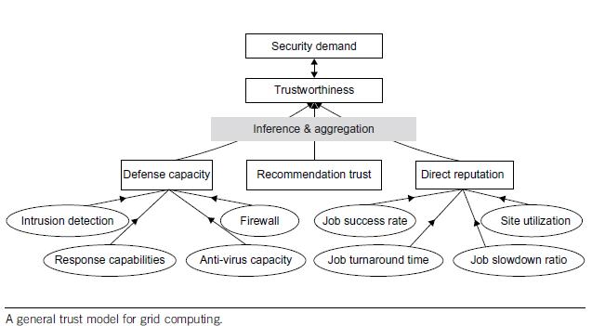

the condition with the highest risk at a site and 1 representing the condition which is totally risk-free or fully trusted. The fuzzy inference is accomplished through four steps: fuzzification, inference, aggregation, and defuzzification. The second salient feature of the trust model is that if a site’s trust index cannot match the job security demand (i.e., SD > TI), the trust model could deduce detailed security features to guide the site security upgrade as a result of tuning the fuzzy system.

2. Authentication and Authorization Methods

The major authentication methods in the grid include passwords, PKI, and Kerberos. The password is the simplest method to identify users, but the most vulnerable one to use. The PKI is the most popular method supported by GSI. To implement PKI, we use a trusted third party, called the certificate authority (CA). Each user applies a unique pair of public and private keys. The public keys are issued by the CA by issuing a certificate, after recognizing a legitimate user. The private key is exclusive for each user to use, and is unknown to any other users. A digital certificate in IEEE X.509 format consists of the user name, user public key, CA name, and a secrete signature of the user. The following example illustrates the use of a PKI service in a grid environment.

Authorization for Access Control

The authorization is a process to exercise access control of shared resources. Decisions can be made either at the access point of service or at a centralized place. Typically, the resource is a host that provides processors and storage for services deployed on it. Based on a set predefined policies or rules, the resource may enforce access for local services. The central authority is a

special entity which is capable of issuing and revoking polices of access rights granted to remote accesses. The authority can be classified into three categories: attribute authorities, policy authorities, and identity authorities. Attribute authorities issue attribute assertions; policy authorities issue authorization policies; identity authorities issue certificates. The authorization server makes the final authorization decision.

Three Authorization Models

Three authorization models are shown in diagram. The subject is the user and the resource refers to the machine side. The subject-push model is shown at the top diagram. The user conducts handshake with the authority first and then with the resource site in a sequence. The resource-pulling model puts the resource in the middle. The user checks the resource first. Then the resource contacts its authority to verify the request, and the authority authorizes at step 3. Finally the resource accepts or rejects the request from the subject at step 4. The authorization agent model puts the authority in the middle. The subject check with the authority at step 1 and the authority makes decisions on the access of the requested resources. The authorization process is complete at steps 3 and 4 in the reverse direction.
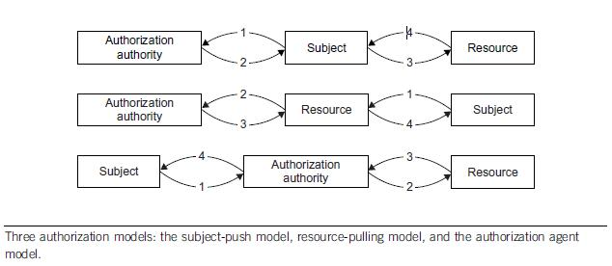

3. Explain in detail about Grid Security Infrastructure

GSI is a portion of the Globus Toolkit and provides fundamental security services needed to support grids, including supporting for message protection, authentication and delegation, and authorization. GSI enables secure authentication and communication over an open network, and permits mutual authentication across and among distributed sites with single sign-on capability. No centrally managed security system is required, and the grid maintains the integrity of its members’ local policies. GSI supports both message-level security, which supports the WS-Security standard and the WS-Secure Conversation specification to provide message protection for SOAP messages, and transport-level security, which means authentication via TLS with support for X.509 proxy certificates.

GSI Functional Layers

GT4 provides distinct WS and pre-WS authentication and authorization capabilities. Both build on the same base, namely the X.509 standard and entity certificates and proxy certificates, which are used to identify persistent entities such as users and servers and to support the temporary delegation of privileges to other entities, respectively. As shown in diagram, GSI may be thought of as being composed of four distinct functions: message protection, authentication, delegation, and authorization.
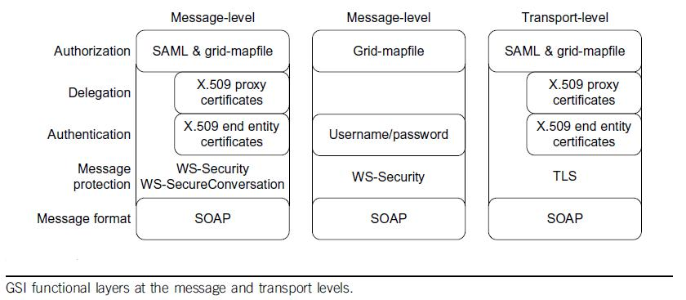

Transport-Level Security

Transport-level security entails SOAP messages conveyed over a network connection protected by TLS. TLS provides for both integrity protection and privacy (via encryption). Transport-level security is normally used in conjunction with X.509 credentials for authentication, but can also be used without such credentials to provide message protection without authentication, often referred to as ―anonymous transport-level security.‖ In this mode of operation, authentication may be done by username and password in a SOAP message

GSI also provides message-level security for message protection for SOAP messages by implementing the WS-Security standard and the WS-Secure Conversation specification. The WS-Security standard from OASIS defines a framework for applying security to individual SOAP messages; WS-Secure Conversation is a proposed standard from IBM and Microsoft that allows for an initial exchange of messages to establish a security context which can then be used to protect subsequent messages in a manner that requires less computational overhead (i.e., it allows the trade-off of initial overhead for setting up the session for lower overhead for messages).

GSI conforms to this standard. GSI uses these mechanisms to provide security on a per-message basis, that is, to an individual message without any preexisting context between the sender and receiver (outside of sharing some set of trust roots). GSI, as described further in the subsequent section on authentication, allows for both X.509 public key credentials and the combination of username and password for authentication; however, differences still exist. With username/password, only the WS-Security standard can be used to allow for authentication; that is, a receiver can verify the identity of the communication initiator.

GSI allows three additional protection mechanisms. The first is integrity protection, by which a receiver can verify that messages were not altered in transit from the sender. The second is encryption, by which messages can be protected to provide confidentiality. The third is replay prevention, by which a receiver can verify that it has not received the same message previously. These protections are provided between WS-Security and WS-Secure Conversation. The former applies the keys associated with the sender and receiver’s X.509 credentials. The X.509 credentials are used to establish a session key that is used to provide the message protection.

Authentication and Delegation

GSI has traditionally supported authentication and delegation through the use of X.509 certificates and public keys. As a new feature in GT4, GSI also supports authentication through plain usernames and passwords as a deployment option. We discuss both methods in this section. GSI uses X.509 certificates to identify persistent users and services.

As a central concept in GSI authentication, a certificate includes four primary pieces of information: (1) a subject name, which identifies the person or object that the certificate represents; (2) the public key belonging to the subject; (3) the identity of a CA that has signed the certificate to certify that the public key and the identity both belong to the subject; and (4) the digital signature of the named CA. X.509 provides each entity with a unique identifier (i.e., a distinguished name) and a method to assert that identifier to another party through the use of an asymmetric key pair bound to the identifier by the certificate.

Trust Delegation

To reduce or even avoid the number of times the user must enter his passphrase when several grids are used or have agents (local or remote) requesting services on behalf of a user, GSI provides a delegation capability and a delegation service that provides an interface to allow clients to delegate (and renew) X.509 proxy certificates to a service. The interface to this service is based on the WS-Trust specification. A proxy consists of a new certificate and a private key. The key pair that is used for the proxy, that is, the public key embedded in the certificate and the private key, may either be regenerated for each proxy or be obtained by other means. The new certificate contains the owner’s identity, modified slightly to indicate that it is a proxy. The new certificate is signed by the owner, rather than a CA

4. Explain cloud infrastructure security at application level

We will limit our discussion to web application security: web applications in the cloud accessed by users with standard Internet browsers, such as Firefox, Internet Explorer, or Safari, from any computer connected to the Internet.

Application-Level Security Threats

The existing threats exploit well-known application vulnerabilities including cross-site scripting (XSS), SQL injection, malicious file execution, and other vulnerabilities resulting from programming errors and design flaws. Armed with knowledge and tools, hackers are constantly scanning web applications (accessible from the Internet) for application vulnerabilities.

It has been a common practice to use a combination of perimeter security controls and network- and host-based access controls to protect web applications deployed in a tightly controlled environment, including corporate intranets and private clouds, from external hackers.

Web applications built and deployed in a public cloud platform will be subjected to a high threat level, attacked, and potentially exploited by hackers to support fraudulent and illegal activities. In that threat model, web applications deployed in a public cloud (the SPI model) must be designed for an Internet threat model, and security must be embedded into the Software Development Life Cycle (SDLC)
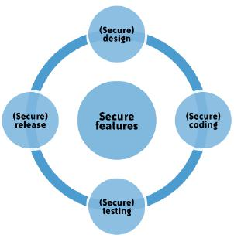

DoS and EDoS

Additionally, you should be cognizant of application-level DoS and EDDoS attacks that can potentially disrupt cloud services for an extended time. These attacks typically originate from compromised computer systems attached to the Internet.

Application-level DoS attacks could manifest themselves as high-volume web page reloads, XML* web services requests (over HTTP or HTTPS), or protocol-specific requests supported by a cloud service. Since these malicious requests blend with the legitimate traffic, it is extremely difficult to selectively filter the malicious traffic without impacting the service as a whole

DoS attacks on pay-as-you-go cloud applications will result in a dramatic increase in your cloud utility bill: you’ll see increased use of network bandwidth, CPU, and storage consumption. This type of attack is also being characterized as economic denial of sustainability (EDoS)

End User Security

A customer of a cloud service, are responsible for end user security tasks—security procedures to protect your Internet-connected PC—and for practicing ―safe surfing.‖ Protection measures include use of security software, such as anti-malware, antivirus, personal firewalls, security patches, and IPS-type software on your Internet-connected computer.

The new mantra of ―the browser is your operating system‖ appropriately conveys the message that browsers have become the ubiquitous ―operating systems‖ for consuming cloud services. All Internet browsers routinely suffer from software vulnerabilities that make them vulnerable to end user security attacks. Hence, our recommendation is that cloud customers take appropriate steps to protect browsers from attacks. To achieve end-to-end security in a cloud, it is essential for customers to maintain good browser hygiene. The means keeping the browser

(e.g., Internet Explorer, Firefox, Safari) patched and updated to mitigate threats related to browser vulnerabilities.

Currently, although browser security add-ons are not commercially available, users are encouraged to frequently check their browser vendor’s website for security updates, use the auto-update feature, and install patches on a timely basis to maintain end user security.

SaaS Application Security

The SaaS model dictates that the provider manages the entire suite of applications delivered to users. Therefore, SaaS providers are largely responsible for securing the applications and components they offer to customers. Customers are usually responsible for operational security functions, including user and access management as supported by the provider.

Extra attention needs to be paid to the authentication and access control features offered by SaaS CSPs. Usually that is the only security control available to manage risk to information. Most services, including those from Salesforce.com and Google, offer a web-based administration user interface tool to manage authentication and access control of the application.

Cloud customers should try to understand cloud-specific access control mechanisms— including support for strong authentication and privilege management based on user roles and functions—and take the steps necessary to protect information hosted in the cloud. Additional controls should be implemented to manage privileged access to the SaaS administration tool, and enforce segregation of duties to protect the application from insider threats. In line with security standard practices, customers should implement a strong password policy—one that forces users to choose strong passwords when authenticating to an application.

PaaS Application Security
PaaS vendors broadly fall into the following two major categories:

- Software vendors (e.g., Bungee, Etelos, GigaSpaces, Eucalyptus)
- CSPs (e.g., Google App Engine, Salesforce.com’s Force.com, Microsoft Azure, Intuit
QuickBase)

A PaaS cloud (public or private) offers an integrated environment to design, develop, test, deploy, and support custom applications developed in the language the platform supports.

PaaS application security encompasses two software layers:
- Security of the PaaS platform itself (i.e., runtime engine)
- Security of customer applications deployed on a PaaS platform

PaaS CSPs (e.g., Google, Microsoft, and Force.com) are responsible for securing the platform software stack that includes the runtime engine that runs the customer applications. Since PaaS applications may use third-party applications, components, or web services, the third-party application provider may be responsible for securing their services. Hence, customers should understand the dependency of their application on all services and assess risks pertaining to third-party service providers.

IaaS Application Security

IaaS cloud providers (e.g., Amazon EC2, GoGrid, and Joyent) treat the applications on customer virtual instances as a black box, and therefore are completely agnostic to the operations and management of the customer’s applications.

The entire stack—customer applications, runtime application platform (Java, .NET, PHP, Ruby on Rails, etc.), and so on— runs on the customer’s virtual servers and is deployed and managed by customers. To that end, customers have full responsibility for securing their applications deployed in the IaaS cloud.

Web applications deployed in a public cloud must be designed for an Internet threat model, embedded with standard security countermeasures against common web vulnerabilities. In adherence with common security development practices, they should also be periodically tested for vulnerabilities, and most importantly, security should be embedded into the SDLC. Customers are solely responsible for keeping their applications and runtime platform patched to protect the system from malware and hackers scanning for vulnerabilities to gain unauthorized access to their data in the cloud. It is highly recommended that you design and implement applications with a ―least-privileged‖ runtime model

Developers writing applications for IaaS clouds must implement their own features to handle authentication and authorization. In line with enterprise identity management practices, cloud applications should be designed to leverage delegated authentication service features supported by an enterprise Identity Provider (e.g., OpenSSO, Oracle IAM, IBM, CA) or third-party identity service provider (e.g., Ping Identity, Symplified, TriCipher). Any custom implementations of Authentication, Authorization, and Accounting (AAA) features can become a weak link if they are not properly implemented, and you should avoid them when possible.

5. Describe in detail about provider data and its security

Customers should also be concerned about what data the provider collects and how the CSP protects that data. Additionally, your provider collects and must protect a huge amount of security-related data.

Storage

For data stored in the cloud (i.e., storage-as-a-service), we are referring to IaaS and not data associated with an application running in the cloud on PaaS or SaaS. The same three information security concerns are associated with this data stored in the cloud (e.g., Amazon’s S3) as with data stored elsewhere: confidentiality, integrity, and availability.

Confidentiality

When it comes to the confidentiality of data stored in a public cloud, you have two potential concerns. First, what access control exists to protect the data? Access control consists of both authentication and authorization.

CSPs generally use weak authentication mechanisms (e.g., username + password), and the authorization (―access‖) controls available to users tend to be quite coarse and not very granular. For large organizations, this coarse authorization presents significant security concerns unto itself. Often, the only authorization levels cloud vendors provide are administrator authorization (i.e., the owner of the account itself) and user authorization (i.e., all other authorized users)—with no levels in between (e.g., business unit administrators, who are authorized to approve access for their own business unit personnel).

If a CSP does encrypt a customer’s data, the next consideration concerns what encryption algorithm it uses. Not all encryption algorithms are created equal. Cryptographically, many algorithms provide insufficient security. Only algorithms that have been publicly vetted by a formal standards body (e.g., NIST) or at least informally by the cryptographic community should be used. Any algorithm that is proprietary should absolutely be avoided.

Symmetric encryption involves the use of a single secret key for both the encryption and decryption of data. Only symmetric encryption has the speed and computational efficiency to handle encryption of large volumes of data. It would be highly unusual to use an asymmetric algorithm for this encryption use case.

Although the example in diagram is related to email, the same concept (i.e., a single shared, secret key) is used in data storage encryption.
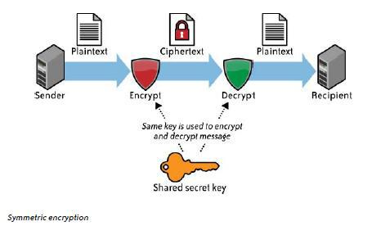

Although the example in diagram is related to email, the same concept (i.e., a public key and a private key) is not used in data storage encryption.

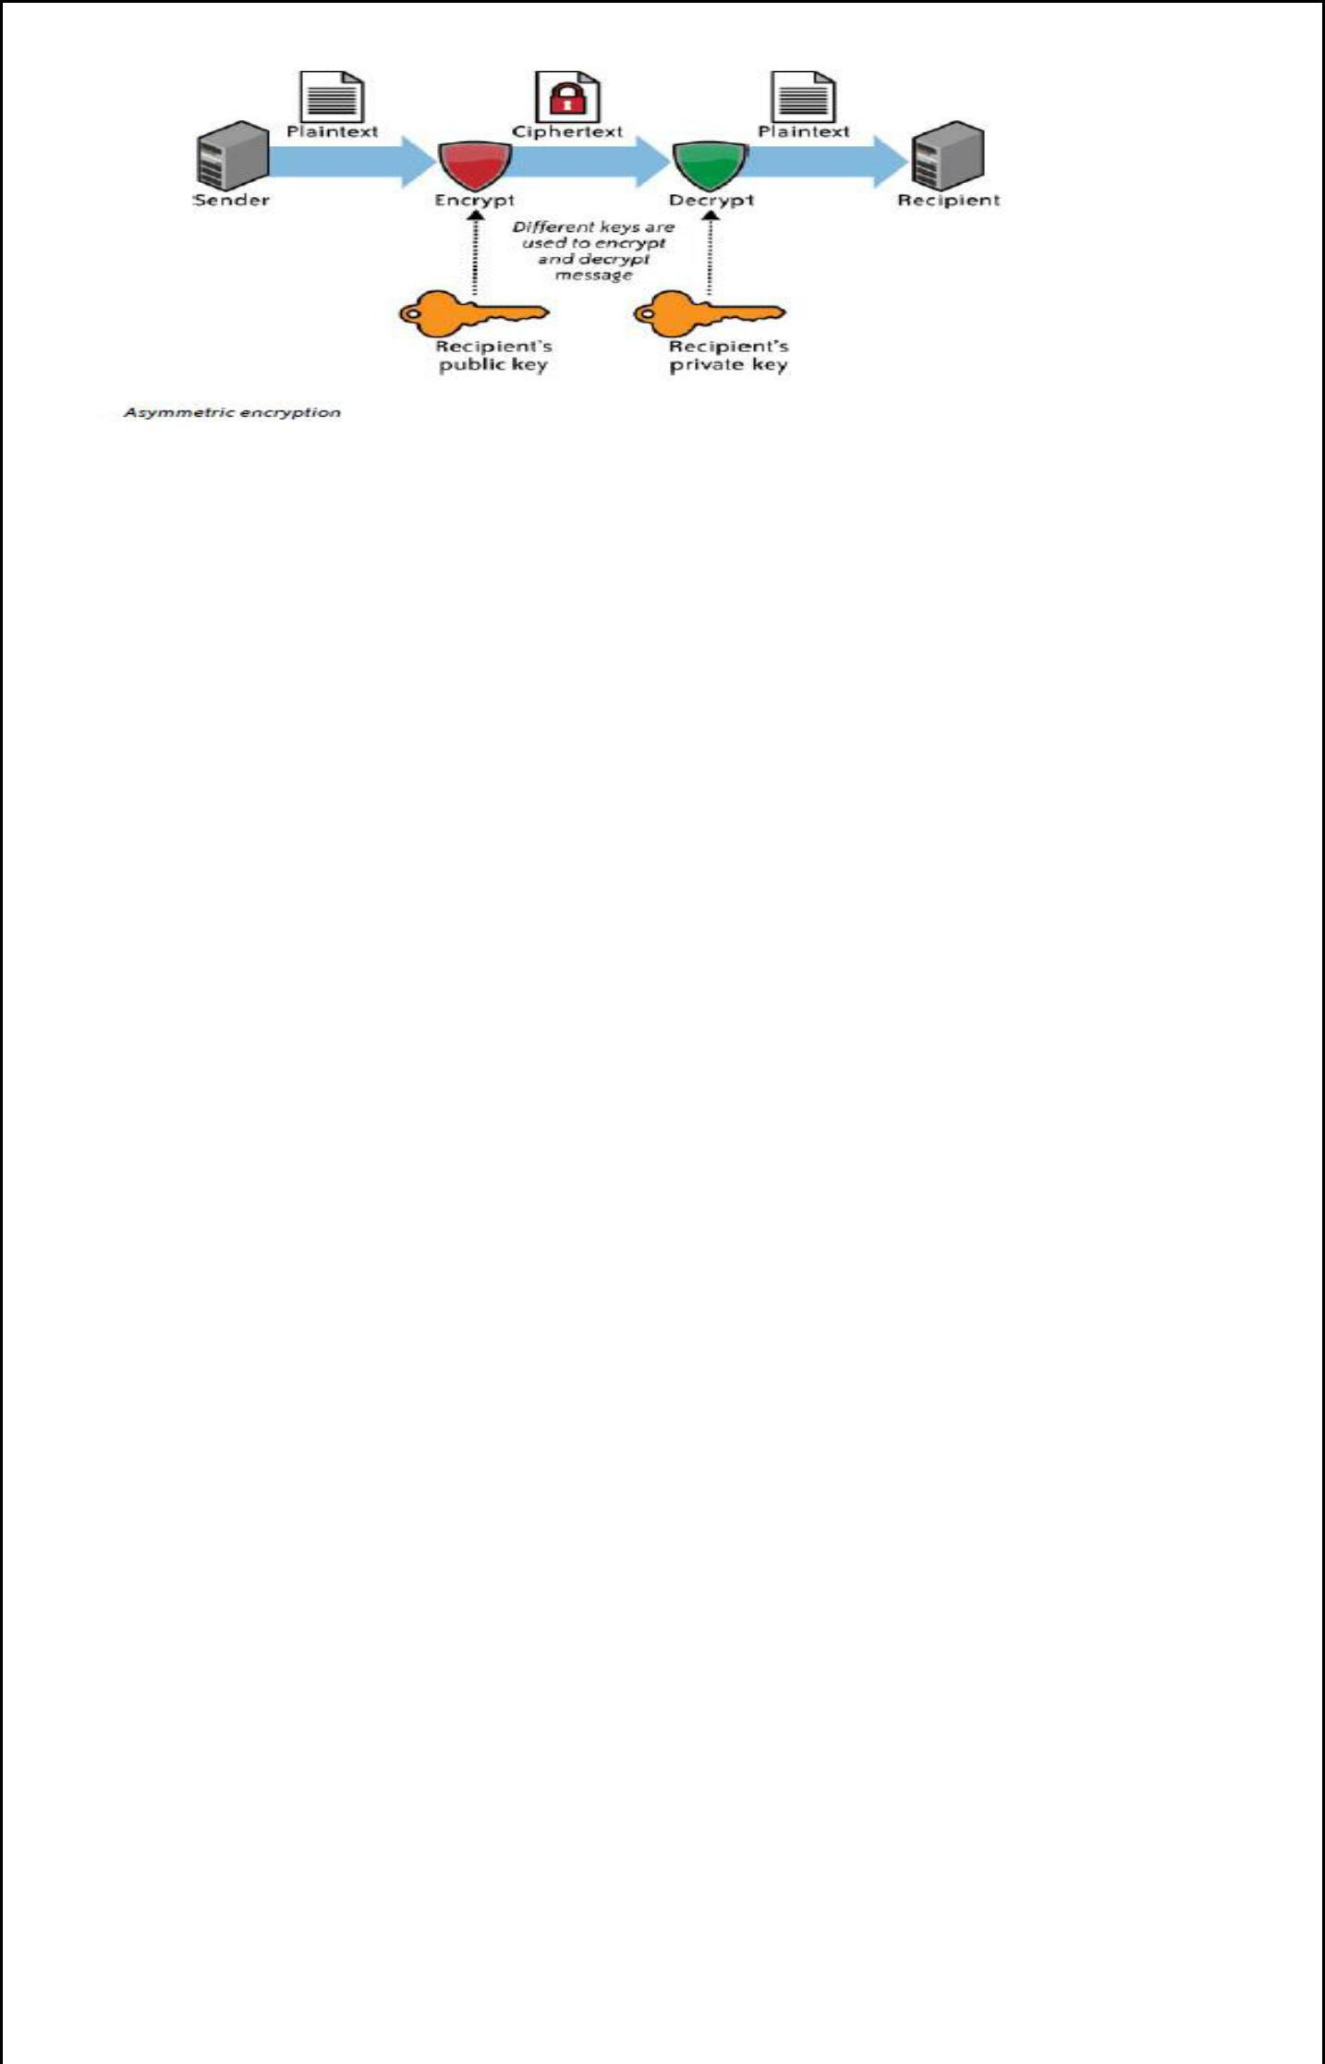

Integrity

Confidentiality does not imply integrity; data can be encrypted for confidentiality purposes, and yet you might not have a way to verify the integrity of that data. Encryption alone is sufficient for confidentiality, but integrity also requires the use of message authentication codes (MACs). The simplest way to use MACs on encrypted data is to use a block symmetric algorithm (as opposed to a streaming symmetric algorithm) in cipher block chaining (CBC) mode, and to include a one-way hash function.

Another aspect of data integrity is important, especially with bulk storage using IaaS. Once a customer has several gigabytes (or more) of its data up in the cloud for storage, how does the customer check on the integrity of the data stored there? There are IaaS transfer costs associated with moving data into and back down from the cloud,* as well as network utilization (bandwidth) considerations for the customer’s own network. What a customer really wants to do is to validate the integrity of its data while that data remains in the cloud—without having to download and reupload that data.

Availability

Assuming that a customer’s data has maintained its confidentiality and integrity, you must also be concerned about the availability of your data. There are currently three major threats in this regard—none of which are new to computing, but all of which take on increased importance in cloud computing because of increased risk.

The first threat to availability is network-based attacks
The second threat to availability is the CSP’s own availability.

Cloud storage customers must be certain to ascertain just what services their provider is actually offering. Cloud storage does not mean the stored data is actually backed up. Some cloud storage providers do back up customer data, in addition to providing storage. However, many cloud storage providers do not back up customer data, or do so only as an additional service for an additional cost.

All three of these considerations (confidentiality, integrity, and availability) should be encapsulated in a CSP’s service-level agreement (SLA) to its customers. However, at this time, CSP SLAs are extremely weak—in fact, for all practical purposes, they are essentially worthless. Even where a CSP appears to have at least a partially sufficient SLA, how that SLA actually gets measured is problematic. For all of these reasons, data security considerations and how data is actually stored in the cloud should merit considerable attention by customers.

6. Explain identity and access management functional architecture
We’ll present the basic concepts and definitions of IAM functions for any service:

Authentication

Authentication is the process of verifying the identity of a user or system. Authentication usually connotes a more robust form of identification. In some use cases, such as service-to-service interaction, authentication involves verifying the network service requesting access to information served by another service.

Authorization

Authorization is the process of determining the privileges the user or system is entitled to once the identity is established. —in other words, authorization is the process of enforcing policies.

Auditing

In the context of IAM, auditing entails the process of review and examination of authentication, authorization records, and activities to determine the adequacy of IAM system controls, to verify compliance with established security policies and procedures (e.g., separation of duties), to detect breaches in security services (e.g., privilege escalation), and to recommend any changes that are indicated for countermeasures.

IAM Architecture

Standard enterprise IAM architecture encompasses several layers of technology, services, and processes. At the core of the deployment architecture is a directory service (such as LDAP or Active Directory) that acts as a repository for the identity, credential, and user attributes of the organization’s user pool. The directory interacts with IAM technology components such as authentication, user management, provisioning, and federation services that support the standard IAM practice and processes within the organization. It is not uncommon for organizations to use several directories that were deployed for environment-specific reasons (e.g., Windows systems using Active Directory, Unix systems using LDAP) or that were integrated into the environment by way of business mergers and acquisitions.

The IAM processes to support the business can be broadly categorized as follows:

User management
Activities for the effective governance and management of identity life cycles

Authentication management

Activities for the effective governance and management of the process for determining that an entity is who or what it claims to be

Authorization management

Activities for the effective governance and management of the process for determining entitlement rights that decide what resources an entity is permitted to access in accordance with the organization’s policies.

Access management

Enforcement of policies for access control in response to a request from an entity (user, services) wanting to access an IT resource within the organization

Data management and provisioning

Propagation of identity and data for authorization to IT resources via automated or manual processes

Monitoring and auditing

Monitoring, auditing, and reporting compliance by users regarding access to resources within the organization based on the defined policies.

IAM processes support the following operational activities:
Provisioning

This is the process of on-boarding users to systems and applications. These processes provide users with necessary access to data and technology resources. The term typically is used in reference to enterprise-level resource management.

Credential and attribute management

These processes are designed to manage the life cycle of credentials and user attributes— create, issue, manage, revoke—to minimize the business risk associated with identity impersonation and inappropriate account use. Credentials are usually bound to an individual and are verified during the authentication process. The processes include provisioning of attributes, static (e.g., standard text password) and dynamic (e.g., one-time password) credentials that comply with a password standard (e.g., passwords resistant to dictionary attacks), handling password expiration, encryption management of credentials during transit and at rest, and access policies of user attributes

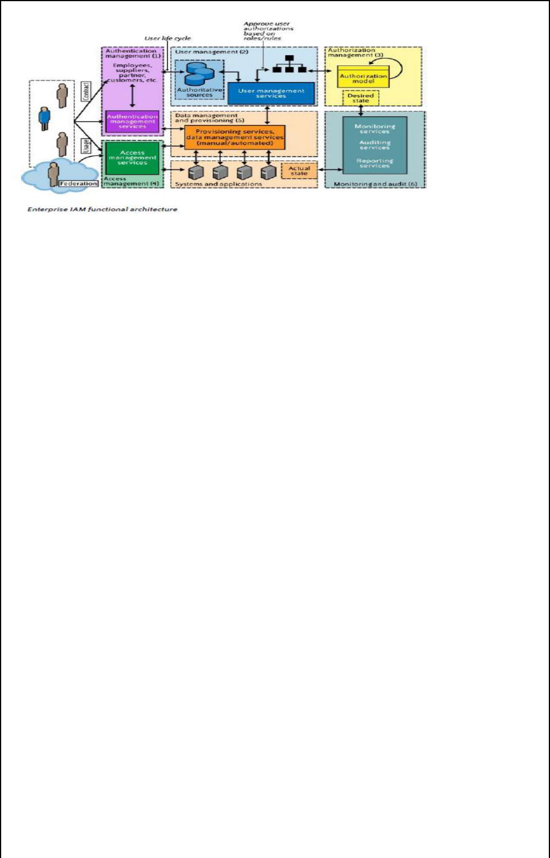

Entitlement management

Entitlements are also referred to as authorization policies. The processes in this domain address the provisioning and deprovisioning of privileges needed for the user to access resources including systems, applications, and databases.

Compliance management

This process implies that access rights and privileges are monitored and tracked to ensure the security of an enterprise’s resources. The process also helps auditors verify compliance to various internal access control policies, and standards that include practices such as segregation of duties, access monitoring, periodic auditing, and reporting.

Identity federation management

Federation is the process of managing the trust relationships established beyond the internal network boundaries or administrative domain boundaries among distinct organizations. A federation is an association of organizations that come together to exchange information about their users and resources to enable collaborations and transactions

Centralization of authentication (authN) and authorization (authZ)

A central authentication and authorization infrastructure alleviates the need for application developers to build custom authentication and authorization features into their applications. Furthermore, it promotes a loose coupling architecture where applications become agnostic to the authentication methods and policies. This approach is also called an ―externalization of authN and authZ‖ from applications.
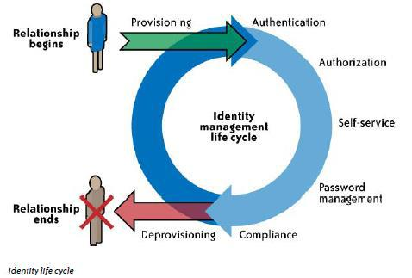

7. Explain user management functions in the cloud
User management functions in the cloud can be categorized as follows:

- Cloud identity administration
- Federation or SSO
- Authorization management
- Compliance management

Cloud Identity Administration

Cloud identity administrative functions should focus on life cycle management of user identities in the cloud—provisioning, deprovisioning, identity federation, SSO, password or credentials management, profile management, and administrative management. Organizations that are not capable of supporting federation should explore cloud-based identity management services.

By federating identities using either an internal Internet-facing IdP or a cloud identity management service provider, organizations can avoid duplicating identities and attributes and storing them with the CSP. Given the inconsistent and sparse support for identity standards among CSPs, customers may have to devise custom methods to address user management functions in the cloud. Provisioning users when federation is not supported can be complex and laborious.

Federated Identity (SSO)

Organizations planning to implement identity federation that enables SSO for users can take one of the following two paths (architectures):

- Implement an enterprise IdP within an organization perimeter.
- Integrate with a trusted cloud-based identity management service provider.

Enterprise identity provider

In this architecture, cloud services will delegate authentication to an organization’s IdP. In this delegated authentication architecture, the organization federates identities within a trusted circle of CSP domains. A circle of trust can be created with all the domains that are authorized to delegate authentication to the IdP. In this deployment architecture, where the organization will provide and support an IdP, greater control can be exercised over user identities, attributes, credentials, and policies for authenticating and authorizing users to a cloud service.
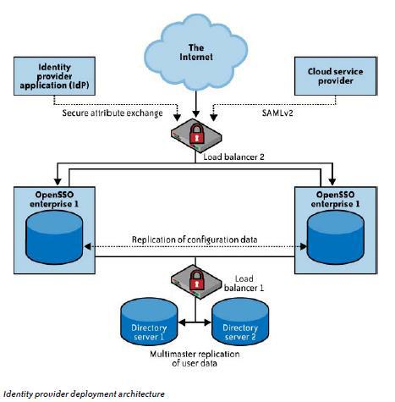

Identity management-as-a-service

In this architecture, cloud services can delegate authentication to an identity management-as-a- service (IDaaS) provider. In this model, organizations outsource the federated identity management technology and user management processes to a third-party service provider. In essence, this is a SaaS model for identity management, where the SaaS IdP stores identities in a ―trusted identity store‖ and acts as a proxy for the organization’s users accessing cloud services.

The identity store in the cloud is kept in sync with the corporate directory through a provider proprietary scheme (e.g., agents running on the customer’s premises synchronizing a subset of an organization’s identity store to the identity store in the cloud using SSL VPNs). Once the IdP is established in the cloud, the organization should work with the CSP to delegate authentication to the cloud identity service provider. The cloud IdP will authenticate the cloud users prior to them accessing any cloud services

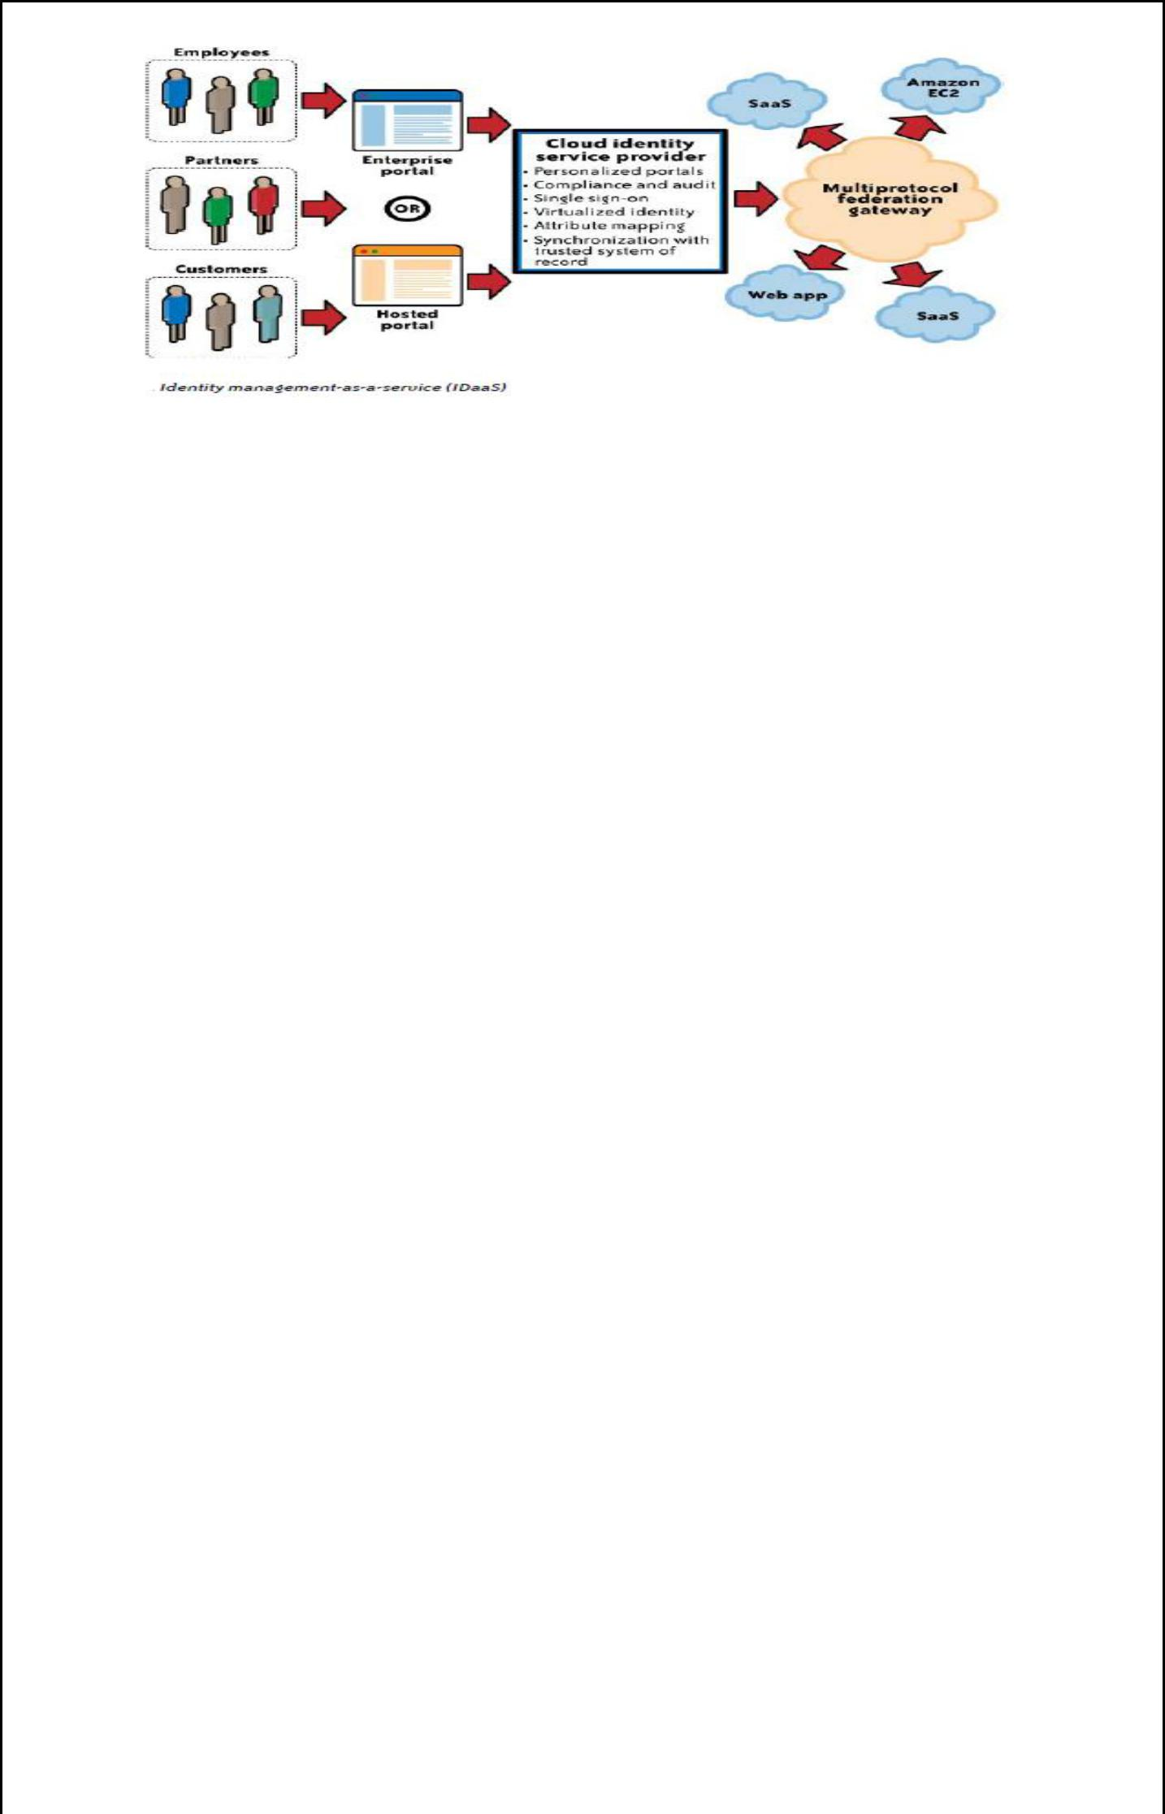

Cloud Authorization Management

Most cloud services support at least dual roles (privileges): administrator and end user. It is a normal practice among CSPs to provision the administrator role with administrative privileges. These privileges allow administrators to provision and deprovision identities, basic attribute profiles, and, in some cases, to set access control policies such as password strength and trusted networks from which connections are accepted.

As we mentioned earlier, XACML is the preferred standard for expressing and enforcing authorization and user authentication policies. As of this writing, we are not aware of any cloud services supporting XACML to express authorization policies for users.

IAM Support for Compliance Management

As much as cloud IAM architecture and practices impact the efficiency of internal IT processes, they also play a major role in managing compliance within the enterprise. Properly implemented IAM practices and processes can help improve the effectiveness of the controls identified by compliance frameworks.

IAM practices and processes offer a centralized view of business operations and an automated process that can stop insider threats before they occur. However, given the sparse support for IAM standards such as SAML (federation), SPML (provisioning), and XACML (authorization) by the CSP, you should assess the CSP capabilities on a case-by-case basis and institute processes for managing compliance related to identity (including attribute) and access management.

8. (a) PaaS Availability management

In a typical PaaS service, customers (developers) build and deploy PaaS applications on top of the CSP-supplied PaaS platform. The PaaS platform is typically built on a CSP owned and managed network, servers, operating systems, storage infrastructure, and application components (web services). Given that the customer PaaS applications are assembled with CSP-supplied application components and, in some cases, third-party web services components (mash-up applications), availability management of the PaaS application can be complicated

PaaS applications may rely on other third-party web services components that are not part of the PaaS service offerings; hence, understanding the dependency of your application on third-party services, including services supplied by the PaaS vendor, is essential. PaaS providers may also offer a set of web services, including a message queue service, identity and authentication service, and database service, and your application may depend on the availability of those service components.

App Engine resource is measured against one of two kinds of quotas: a billable quota or a fixed quota.

Billable quotas are resource maximums set by you, the application’s administrator, to prevent the cost of the application from exceeding your budget. Every application gets an amount of each billable quota for free. You can increase billable quotas for your application by enabling billing, setting a daily budget, and then allocating the budget to the quotas. You will be charged only for the resources your app actually uses, and only for the amount of resources used above the free quota thresholds.

Fixed quotas are resource maximums set by the App Engine to ensure the integrity of the system. These resources describe the boundaries of the architecture, and all applications are expected to run within the same limits. They ensure that another app that is consuming too many resources will not affect the performance of your app.

Customer Responsibility

The PaaS application customer should carefully analyze the dependencies of the application on the third-party web services (components) and outline a holistic management strategy to manage and monitor all the dependencies.

PaaS platform service levels

Customers should carefully review the terms and conditions of the CSP’s SLAs and understand the availability constraints.

Third-party web services provider service levels

When your PaaS application depends on a third-party service, it is critical to understand the SLA of that service.

PaaS Health Monitoring
The following options are available to customers to monitor the health of their service:

- Service health dashboard published by the CSP
- CSP customer mailing list that notifies customers of occurring and recently occurred outages

- RSS feed for RSS readers with availability and outage information

- Internal or third-party-based service monitoring tools that periodically check your PaaS application, as well as third-party web services that monitor your application

8. (b) IaaS Availability management

Availability considerations for the IaaS delivery model should include both a computing and storage (persistent and ephemeral) infrastructure in the cloud. IaaS providers may also offer other services such as account management, a message queue service, an identity and authentication service, a database service, a billing service, and monitoring services. Managing your IaaS virtual infrastructure in the cloud depends on five factors:

- Availability of a CSP network, host, storage, and support application infrastructure. This factor depends on the following:

  - CSP data center architecture, including a geographically diverse and fault-tolerance architecture.

  - Reliability, diversity, and redundancy of Internet connectivity used by the customer and the CSP.

  - Reliability and redundancy architecture of the hardware and software components used for delivering compute and storage services.

  - Availability management process and procedures, including business continuity processes established by the CSP.

- Availability of your virtual servers and the attached storage (persistent and ephemeral) for compute services

- Availability of virtual storage that your users and virtual server depend on for storage service. This includes both synchronous and asynchronous storage access use cases. Synchronous storage access use cases demand low data access latency and continuous availability, whereas asynchronous use cases are more tolerant to latency and availability.

- Availability of your network connectivity to the Internet or virtual network connectivity to IaaS services. In some cases, this can involve virtual private network (VPN) connectivity between your internal private data center and the public IaaS cloud

- Availability of network services, including a DNS, routing services, and authentication services required to connect to the IaaS service.

IaaS Health Monitoring
- Service health dashboard published by the CSP.

- CSP customer mailing list that notifies customers of occurring and recently occurred outages.

  - Web console or API that publishes the current health status of your virtual servers and network.

- (a) What Are the Key Privacy Concerns in the Cloud?

These concerns typically mix security and privacy. Here are some additional considerations to be aware of:

Access

Data subjects have a right to know what personal information is held and, in some cases, can make a request to stop processing it. This is especially important with regard to marketing activities; in some jurisdictions, marketing activities are subject to additional regulations and are almost always addressed in the end user privacy policy for applicable organizations. In the cloud, the main concern is the organization’s ability to provide the individual with access to all personal information, and to comply with stated requests.

Compliance

What are the privacy compliance requirements in the cloud? What are the applicable laws, regulations, standards, and contractual commitments that govern this information, and who is responsible for maintaining the compliance? How are existing privacy compliance requirements impacted by the move to the cloud? Clouds can cross multiple jurisdictions;

Storage

Where is the data in the cloud stored? Was it transferred to another data center in another country? Is it commingled with information from other organizations that use the same CSP? Privacy laws in various countries place limitations on the ability of organizations to transfer some types of personal information to other countries. When the data is stored in the cloud, such a transfer may occur without the knowledge of the organization, resulting in a potential violation of the local law.

Retention

How long is personal information (that is transferred to the cloud) retained? Which retention policy governs the data? Does the organization own the data, or the CSP? Who enforces the retention policy in the cloud, and how are exceptions to this policy (such as litigation holds) managed?

Destruction

How does the cloud provider destroy PII at the end of the retention period? How do organizations ensure that their PII is destroyed by the CSP at the right point and is not available to other cloud users? How do they know that the CSP didn’t retain additional copies? Cloud storage providers usually replicate the data across multiple systems and sites—increased availability is one of the benefits they provide. This benefit turns into a challenge when the organization tries to destroy the data—can you truly destroy information once it is in the cloud? Did the CSP really destroy the data, or just make it inaccessible to the organization? Is the CSP keeping the information longer than necessary so that it can mine the data for its own use?

Audit and monitoring

How can organizations monitor their CSP and provide assurance to relevant stakeholders that privacy requirements are met when their PII is in the cloud?

Privacy breaches

How do you know that a breach has occurred, how do you ensure that the CSP notifies you when a breach occurs, and who is responsible for managing the breach notification process (and costs associated with the process)? If contracts include liability for breaches resulting from negligence of the CSP, how is the contract enforced and how is it determined who is at fault?

9. (b). SaaS Availability Management

SaaS service providers are responsible for business continuity, application, and infrastructure security management processes. This means the tasks your IT organization once handled will now be handled by the CSP. Some mature organizations that are aligned with industry standards, such as ITIL, will be faced with new challenges of governance of SaaS services as they try to map internal service-level categories to a CSP.

Customer Responsibility

Customers should understand the SLA and communication methods (e.g., email, RSS feed, website URL with outage information) to stay informed on service outages. When possible, customers should use automated tools such as Nagios or Siteuptime.com to verify the availability of the SaaS service. As of this writing, customers of a SaaS service have a limited number of options to support availability management. Hence, customers should seek to understand the availability management factors, including the SLA of the service, and clarify with the CSP any gaps in SLA exclusions and service credits when disruptions occur.

SaaS Health Monitoring
The following options are available to customers to stay informed on the health of their service:

- Service health dashboard published by the CSP. Usually SaaS providers, such as Salesforce.com, publish the current state of the service, current outages that may impact customers, and upcoming scheduled maintenance services on their website

- The Cloud Computing Incidents Database (CCID).
- Customer mailing list that notifies customers of occurring and recently occurred outages.

- Internal or third-party-based service monitoring tools that periodically check SaaS provider health and alert customers when service becomes unavailable

- RSS feed hosted at the SaaS service provider.

10. Explain cloud infrastructure security at network level

Although your organization’s IT architecture may change with the implementation of a private cloud, your current network topology will probably not change significantly. If you have a private extranet in place (e.g., for premium customers or strategic partners), for practical purposes you probably have the network topology for a private cloud in place already. The security considerations you have today apply to a private cloud infrastructure, too. And the security tools you have in place (or should have in place) are also necessary for a private cloud and operate in the same way.
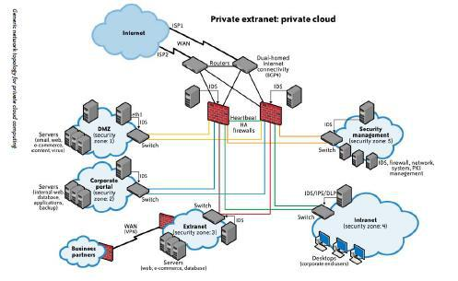

If you choose to use public cloud services, changing security requirements will require changes to your network topology. You must address how your existing network topology interacts with your cloud provider’s network topology. There are four significant risk factors in this use case:

- Ensuring the confidentiality and integrity of your organization’s data-in-transit to and from your public cloud provider

- Ensuring proper access control (authentication, authorization, and auditing) to whatever resources you are using at your public cloud provider

- Ensuring the availability of the Internet-facing resources in a public cloud that are being used by your organization, or have been assigned to your organization by your public cloud providers

- Replacing the established model of network zones and tiers with domains

Ensuring Data Confidentiality and Integrity

Some resources and data previously confined to a private network are now exposed to the Internet, and to a shared public network belonging to a third-party cloud provider. Although use

of HTTPS (instead of HTTP) would have mitigated the integrity risk, users not using HTTPS (but using HTTP) did face an increased risk that their data could have been altered in transit without their knowledge.

Ensuring Proper Access Control

Since some subset of these resources (or maybe even all of them) is now exposed to the Internet, an organization using a public cloud faces a significant increase in risk to its data. The ability to audit the operations of your cloud provider’s network (let alone to conduct any realtime monitoring, such as on your own network), even after the fact, is probably non-existent. You will have decreased access to relevant network-level logs and data, and a limited ability to thoroughly conduct investigations and gather forensic data.

However, the issue of ―non-aged‖ IP addresses and unauthorized network access to resources does not apply only to routable IP addresses (i.e., resources intended to be reachable directly from the Internet). The issue also applies to cloud providers’ internal networks for customer use and the assignment of non-routable IP addresses.

Ensuring the Availability of Internet-Facing Resources

There are deliberate attacks as well. Although prefix hijacking due to deliberate attacks is far less common than misconfigurations, it still occurs and can block access to data. According to the same study presented to NANOG, attacks occur fewer than 100 times per month. Although prefix hijackings are not new, that attack figure will certainly rise, and probably significantly, along with a rise in cloud computing.

DNS attacks are another example of problems associated with this third risk factor. In fact, there are several forms of DNS attacks to worry about with regard to cloud computing. Although DNS attacks are not new and are not directly related to the use of cloud computing, the issue with DNS and cloud computing is an increase in an organization’s risk at the network level because of increased external DNS querying.

