**DHANALAKSHMI SRINIVASAN COLLEGE OF ENGINEERING AND TECHNOLOGY**

**Mamallapuram, Chennai-603104.**

**DEPARTMENT OF MECHANICAL ENGINEERING**

**QUESTION BANK**



**Subject Code:** ME8793 **Year / Semester**: IV / VIII

**Subject Name:** Process Planning and Cost Estimation

**UNIT I - INTRODUCTION TO PROCESS PLANNING**

**PART A**

1. **What is process Planning?(Nov/Dec 2016)**

Process planning comprises the selection and sequencing of processes and operations to transform a chosen raw material into a finished component. It is the act of preparing detailed work instructions to produce a component. Process planning is employed in discrete part manufacture, namely job, batch and mass/flow manufacturing.

# What functions are involved in the design and manufacture of a product and what do they contribute?

Marketing and sales, Design and Manufacturing at the design and development stage, are then passed to the manufacturing function, these will be used to prepare the detailed work instructions required to manufacture the product. Marketing is responsible for assessing the current market trends and needs and generating new product ideas and to generate specifications for the further development of existing products .

# State the responsibility of Marketing and Sales?

Marketing is responsible for assessing the current market trends and needs and generating new product ideas. Also based on the market assessment, marketing is responsible for generating specifications for the further development of existing products. The role of sales is to generate interest in the products being manufactured and obtain firm orders.

# What is bilateral tolerance? Give examples.( Nov/Dec 2017)

The amount that the size of a machine part is allowed to vary above or below a basic dimension; for example, 3.650 ±0.003 centimeters indicates a tolerance of ± 0.003 centimeter.

# How to validate the design and establish the required manufacturing facilities?

Prototype of the product will be developed to help validate the design and establish which manufacturing facilities are required.

# Briefly explain how process planning interfaces design and manufacturing

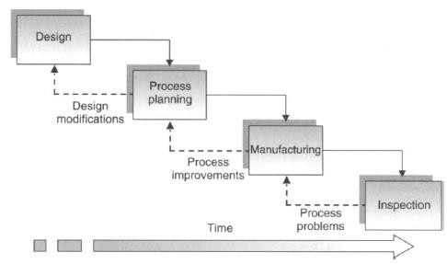The product and process requirements generated at the design and development stage, are then passed to the manufacturing function. These will be used to prepare the detailed work instructions required to manufacture the product. These will then be passed to the manufacturing facility for execution. Therefore, although the design and manufacturing functions are separated, the process planning activity links them as shown in figure. Thus, process planning is

the design/ manufacture interface in this sequential approach.

# What is meant by Concurrent or Simultaneous Engineering?

Concurrent engineering, also known as simultaneous engineering, is a method of designing and developing products, in which the different stages run simultaneously, rather than consecutively. It decreases product development time and also the time to market, leading to improved productivity and reduced costs.

# List the functions of cross-functional team?

The functions of such cross-functional teams include - ensuring all team members understand enough about the product - functions to be able to contribute to the design decisions - determining the appropriate design and manufacturing methods to use - relating all product functions to manufacturing methods.

# What is meant by DFM/A?

Design for Manufacturing and Assembly is concerned with understanding the interactions between the various parts of the manufacturing organization and using this to optimize the design and manufacture of product with regards to cost, quality and productivity The use of DFM/A usually involves the application of various quantitative techniques for rating the design

# What are the skills and knowledge should be possessed by the manufacturing engineer.(Nov/Dec 2019)

The manufacturing engineer must possess a variety of skills and knowledge. These have been identified as

* + an ability to interpret engineering drawings;
  + knowledge of materials for manufacture;
  + knowledge of manufacturing processes;
  + knowledge of jigs and fixtures;
  + an ability to use reference material, for example, manufacturers, machining data, tooling data, etc.;
  + knowledge of the relative costs of materials, processes and tooling;
  + an ability to calculate manufacturing parameters and costs;
  + knowledge of inspection/QA procedures and specifications.

# What are the main activities undertaken during process planning?

The list of activities undertaken during process planning is Drawing interpretation, Material evaluation and process selection, Selection of machines and tooling, Setting process parameters, Work holding devices, Selecting quality assurance methods, Costing, Preparing the process planning documentation.

# What is meant by interpretation of drawing?

The interpretation of the drawing will include assessing the part geometry, dimensions and associated tolerances, geometric tolerances, surface finish specifications, the material specification and the number of parts required. From this interpretation, the critical processing factors can be identified and give some indication of candidate manufacturing processes.

# What is meant by routing sheet?

The routing sheet, as its name suggests, specifies the route the raw material follows through the manufacturing environment. It usually lists the production equipment and tooling to be used. It is normal practice for the routing sheet to follow the material through the manufacturing shop floor providing 'travel' information for the operators.

# What is meant by operation lists?

Once the routing of a component has been established, the detailed plan for every operation can be prepared using an operations list. This specifies in more detail each individual operation. It is usual for an operations list to be prepared for each workstation listed on the routing sheet, although it may sometimes cover a group of machines in a work cell. Although the content of an operations sheet will vary from organization to organization, it will typicallyinclude details of tooling (including work holding devices), feeds and speeds, set-up and operation times.

# State the input and outputs of process planning?

1. **List the seven wastes of production?**

Seven waste of Production process is which are overproduction, waiting, transporting, inappropriate processing, unnecessary inventory, unnecessary motion and defects.

# List the functions of Quality Assurance?

Functions of a quality assurance are by ensuring that products meet certain thresholds of acceptability. QA department can plan, direct or coordinate **quality assurance** programs and formulate **quality** control policies. QA department also work to improve an organization's efficiency and profitability by reducing waste.

# Name the various methods of process planning?( April/May 2019)

* + Manual Process Planning - Traditional approach - Workbook approach

- Computer - Aided Process Planning - Variant approach - Generative approach

1. **List the Advantages and disadvantages of manual process planning.(Nov/Dec 2019) Advantages** of manual process planning are that it is a low-cost task and is flexible, in terms that the system can be changed easily

**Disadvantage -**Excessive clerical conten**t,** Lack of consistency in planning, Late design modifications and Changing technology.

# List the Advantages and disadvantages of CAPP

The advantages of such CAPP systems are considered to be

* less time spent on process planning;
* less reliance on the knowledge and experience of the process planner;
* more efficient use of manufacturing resources leading to various improvements ;
* improved productivity;
* improved accuracy and consistency of process plans.

# State the main components of Generative System?

The main components of a generative system are,

* a part description that defines the geometry including geometric and dimensional tolerances and surface finish specifications;
* a subsystem that defines the process parameters based on reference data and process analysis;
* a subsystem that identifies and sequences the individual operations using the means described above;
* a database of information on the production equipment available;
* a report generator to produce the process plan.

# Define Process, Operation and Cut

**Process:** A process is the basic unit for compiling a process plan. It can be defined as a procedure in which one or more operators machine one or more work pieces on one machine or workstation

**Operation:** An operator on is the sub-unit of a process and is a basic part of the process. Each operation is usually accomplished without changing the cutting conditions or machining parameters. A process will consist of a number of operations.

**Cut:** A cut is the sub-unit of an operation and is a basic part of an operation. It is defined as a procedure during which the cutting tool passes the work piece surface only once.

# State the significance of Process Planning

Process planning provides a valuable interface between the design and manufacture functions. It is also closely linked with both industrial engineering and quality engineering functions, with both of these providing numerous input data. Finally, process planning is the first stage in manufacturing or production planning, and as such is an integral part of the manufacturing planning and control function.

1. **What is meant by Interchangeability and how does the use of standard parts relate to it? Interchangeability:** The concept behind interchangeable manufacture is that parts, and in particular mating parts, are manufactured in a manner that allows any one of a batch of parts to be used with any other appropriate mating part in a sub-assembly or assembly. It is not meant to be identical parts, but they are made within certain agreed tolerances. Thus, interchangeable manufacture requires:

* the permissible variation of each dimension to be agreed (i.e. dimensional tolerances)
* the mating condition of each pair of mating parts to be agreed

The use of standard parts is used in the event of service and repair, replacements of parts, which are made within certain agreed tolerances. And standard parts should be easily sourced. The use of standard parts, it may be that more than one part can be used and there may be equivalent parts that can be used.

# List the advantages of the use of standard parts?

* The use of standard parts has a number of distinct advantages over the use of unique parts.
* They are more widely available and should be of a known capability and reliability.
* Standard parts will be cheaper, also due to their widespread use and availability.
* It is easily sourced.

# What is meant by Standardization?

The use of standardization in manufacturing usually involves five key steps

* identifying and using preferred numbers and sizes;
* identifying which dimensions should be included with tolerance;
* setting the tolerance values;
* designing suitable measurement and inspection tools and procedures;
* specifying these requirements in the design specification.

# State the significance of identification of the critical processing factors.(Nov/Dec 2016)

It is the first step towards identifying the appropriate manufacturing processes to be employed. The drawing interpretation forms the basis for this and there are three distinct analysis and outputs from this. These are the geometry analysis, the manufacturing information analysis and the material evaluation. These analyses will include considering the geometric shape, dimensions and associated tolerances, geometric tolerances, surface finish specifications, the raw material size and the number of parts required. The correlation of the output from these analyses allows the critical processing factors to be formulated. These are a list of requirements that the manufacturing process or processes selected must meet.

# Name the various approach of Material Selection Process

* The design and development of a new product;
* The modification of an existing product,
* The case-history method.

# State the Material Evaluation Procedure.

This evaluation should focus on three main areas are,

* Shape or geometry considerations;
* Material property requirements;
* Manufacturing considerations.

# What are the general guidelines for process planning?

These include:

* establishing one datum as soon as processing commences and using this as a reference for all subsequent operations;
* creating as many surfaces as possible at the same setting (i.e. without clamping and unclamping) to maximize dimensional accuracy;
* avoiding the use of secondary surface data as much as possible;
* precision operations, for example, those producing high-quality surface finishes, should be carried out last to reduce the possibility of damage;
* inspection operations should be included at appropriate intervals to minimize scrap and rework.

# State the significance of process planning?

Process planning provides a valuable interface between the design and manufacture functions. It is also closely linked with both industrial engineering and quality engineering functions, with both of these providing numerous input data. Finally, process planning is the first stage in manufacturing or production planning, and as such is an integral part of the manufacturing planning and control function.

# Name the various Operating requirements for tool selection.

Work piece material, Operation, Part geometry and tooling data.

# List the important factors that determines the tool performance.(Nov/Dec 2017)

Tool material, Tool geometry and cutting fluids, Machining parameters.

# How is surface finish indicated on an engineering drawing?(Nov/Dec 2018, 2019)

Surface finish is indicated on an engineering drawing, with variety of information that included with the symbol like, the manufacturing process or treatment to be used, the sampling length (the length over which the surface finish has to be measured), the direction of lay (the direction of cutting), the

machining allowance (how much material is to be left for removal by machining) and the surface finish required of the machining process.

# What are the three analyses carried out during the drawing interpretation?

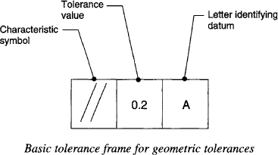The three analysis carried out during the drawing interpretation is

1. the geometry analysis,
2. the manufacturing information analysis and
3. the material evaluation.

# What is a geometrical tolerance and how is it defined? How does it relate to a dimensional tolerance?

Geometrical tolerances limit the shape of a component to certain limits. and dimensional tolerances restrict size to certain limits. Geometrical tolerance frame is usually divided into two or more sections. These will contain a geometrical tolerance symbol in the first section followed by a tolerance value in the second. With some geometrical tolerances, there will be one or even maybe two further sections with letters identifying a datum or datums for the object being dimensioned.

# Name the various Material Selection Methods?

There are a number of commonly used methods, selection with computer-aided databases; performance indices; decision matrices; selection with expert systems; value analysis (particularly for materials substitution); failure analysis; cost-benefit analysis.

# List the objectives of Process Planning.(Nov/Dec 2017,2018)

1. Provides guidelines for all function of an organisation ii)Ensures better utilization of organization.
2. To gain economy in operation
3. To help in coordination and control
4. To offset uncertainty and change.

# What are the details required for process planning?(April/May 2018)

Engineering Drawing of the product, Materials ,Manufacturing Processes, Fixtures, jigs, reference data, tooling, machining data, associated cost, quality assurance and methods for standards are required on the process planning activity.

# Give a procedure for process planning for the manufacture of a component in machine shop. (2021)

The different steps involved in process planning are: 1. Preparation of Working Drawing

2. Make or Buy Decision, 3. Process Selection, 4. Machine Capacity, 5. Process and Equipment Selection Procedure, 6. Selection of Material, Jigs, etc., 7. Preparation of Documents.

# Study the drawing shown below and interpret any one of the geometrical tolerances. (2021)

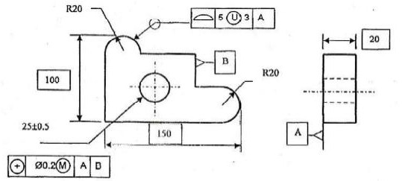

|  |  |
| --- | --- |
| **Geometrical Tolerance** | **Symbol** |
| Boxed Dimension: |  |
| Datum indication: |  |
| Circular or cylindrical tolerance: |  |
| Location ( position) : |  |

**PART - B**

# Explain the basic steps of the design and development of a new product approach for material selection process. (April/May 2019)

1. **Explain the basic steps to the material selection process and stages of material evaluation procedure in detail. (Nov/Dec 2016) (April/May 2019)**

# Explain Process Planning activities in detail and documentation involved in preparation of Process Plan. (Nov/Dec 2016)(Nov/Dec 2017)(Nov/Dec 2019)

1. **Explain the main functions of Product design and manufacture and its interface in detail?**

# Explain the Design and Manufacturing Cycle in detail.

1. **Explain the various methods of Process Planning methods in detail. (Nov/Dec 2016)(April/May 2018)**

# Describe the main types of drawing employed in engineering in detail.

1. **Explain the various steps in Process Planning and Process Planning functions in context with Production Planning in detail.(Nov/Dec 2017,2018)**

# Explain the various machine selection and Tooling selection method in detail.(Nov/Dec 2017,2018)

1. **Explain the various Process Selection Methods and general guide lines for process sequencing. (Nov/Dec 2016)(Nov/Dec 2017)**

# What are the various constraints in tool selection? (Nov/Dec 2016)

1. **Why is process planning required to estimate cost? State its advantages. Discuss in detail the methods how computer can be used in cost estimations.(April/May 2018)**

# Explain the two basic approaches in computer aided process planning.(Nov/Dec 2019)

**PART- C**

# The bearing housing shown in Fig. below has to be manufactured and the process planner has been given the detail drawing for the part. The drawing specifies that the part material is cast iron and the batch size is 250. The general tolerance is ±0.5 and the general surface finish is N9.Interpret the drawing.

1. **Consider the simple component illustrated in Figure. An analysis of the geometry, based on the matrix in Figure, indicates that this type of component would be produced by milling the slots and drilling the holes. The production of both the slots and the holes can be carried out on a milling machine. Therefore, determine the sequence of operations to produce these features on a milling machine if the billet is 200 X 120 X 65 mm. Interpret the drawing.(April/May 2018)**

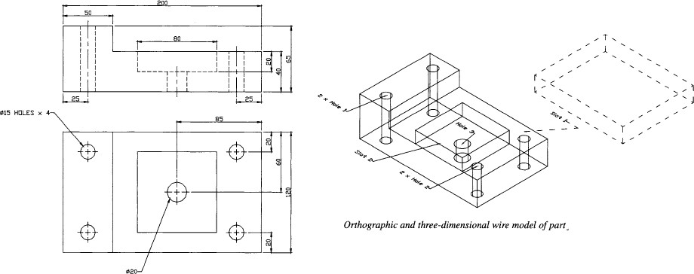

# Analyze and explain the various factors affecting the process plan selection.

1. **Interpret the dimensional tolerance symbols, form tolerance feature control frames and surface finish symbols for the given component.(2021)**

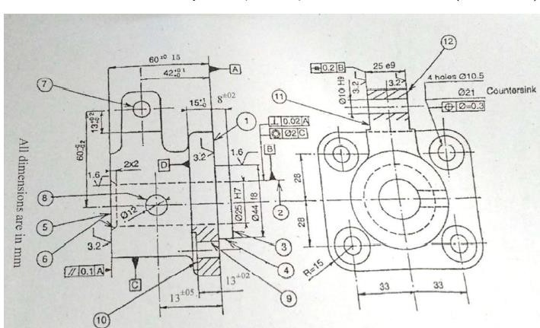

**UNIT II PROCESS PLANNING ACTIVITIES PART - A**

1. **Name the various process parameters to be considered in machining?(Nov/Dec 2016)**

The cutting speed, feed rate and depth of cut are the various process parameters are considered during machining.

# What is meant by cutting speed?

The cutting speed for a machining operation refers to the speed at which the cutting edge of the tool passes over the surface of the workpiece. It is invariably also referred to as the surface speed. It is always considered as the maximum relative speed between the tool and the work piece and is usually quoted in meters per minute (m/min). cutting speed Vc is subsequently used to calculate the time taken for the operation, that is, the machining time T

# What is meant by surface cutting speed?

The cutting speed for a machining operation refers to the speed at which the cutting edge of the tool passes over the surface of the work piece. It is invariably also referred to as the surface speed. It is in meters per minute (m/min).

1. **Why is the diameter halved when calculating speeds for facing and parting off in turning?** The diameter is varying across the cutting operation of facing and parting off in turning hence the average diameter should be used.

# What is meant by the cutting time ratio when considering shaping and planing machines?

For shaping and planing, operations, the tool is only cutting on the forward stroke, hence the name, cutting stroke. Therefore, the speed of the return stroke is required in order to calculate the proportion of time the tool is actually cutting. This is known as the cutting stroke or cutting time ratio C.

# What are the basic principles of design of Jigs and Fixtures? (April/May 2019)

Rigidity, Foolproof Design, clearance, Location etc.

# What general advice can be followed when determining suitable cutting speeds for specific types of operations such as finishing and roughing?

General advice for cutting speed of finishing and roughing, the high end of the range will be for light finishing and the lower ends for the likes of roughing cuts.

# State the two objectives of QMS?

The quality management system should have two objectives (1)To define performance standards for all activities compatible with the products being manufactured, the customer's requirements and doing so at minimum cost; (2) To operate on the basis of continuous improvement to maintain a competitive advantage.

# For shaping and planing, what is the significance of the number of strokes with regard to the cutting speed?

Cutting speed for shaping and planing is defined as the average speed of the tool during the cutting stroke and depends on the number of strokes per minute Ns and the length of the stroke L.

# What is meant by a feed rate?

The feed rate of a machining operation is defined as the speed at which the cutting tool penetrates the work piece. This is usually stated in either millimeter per spindle revolution (mm/rev) or as millimeter per minute (mm/min).

# When quoting feed rates for milling cutters, why is it preferable for manufacturers to state them in mm/tooth?

The manufacturers of milling cutters state recommended feed rates in mm/rev (fr), mmmin-1 (fro) or mm/tooth (ft). When feeds are quoted in mm/rev or mm/min, they usually refer to specific cutters in the manufacturers range and cannot be generally applied. Therefore, for general use feed rates quoted in mm/tooth are more suitable.

# Why is the feed rate for drills related to the drill size?

When the feed rate of the drill increases the drill size is also increases. It should be noted that as the depth of the hole being drilled increases, the speeds and feeds should be reduced.

# What is meant by a cross-feed and what processes does it relate to?

It is the distance moved across the work piece. The feed rates fs are generally expressed in mm/stroke.

# A small driveshaft is produced using a CNC lathe. The machine operator's hourly rate is Rs.8.30 per hour The time taken to machine the driveshaft is 15 min. The order is for 1500 units. Calculate the direct labour cost for producing the drive shafts.

Hourly rate = Rs.8.30

Direct labour hours = 1500 x (15/60) h = 375 h Direct labour cost = Hourly rate x Direct labour hours

=Rs.8.30 X 375

= Rs.3112.50

# Define Quality Assurance.

Planned and systematic actions focused on providing confidence that quality requirements will be fulfilled.

# What is meant by the depth of cut and what are the most important factors that affect the depth of cut possible when machining?

For turning and boring the depth of cut is defined as the radial distance that the cutting edge is set from the outer diameter, while for milling it is simply the distance the tool projects beneath the original surface. A general definition is that the depth of cut can be defined as the difference between the original surface and that being produced by the cutting tool.

# What are the general recommendations for cutting depths for turning and boring?

For the purposes of generalizing the depth of cut that can be used, turning operations can be considered as either roughing or finishing operations. General recommendations for depth of cut for roughing are 6 mm and for finishing, 0.4 mm.

# What are the general recommendations for cutting depths for milling?

Milling operations can be classified into one of four basic operations for the purposes of discussing depth of cut. These are slab milling, face milling, slot milling and end milling. Again, general guidelines for both face and slot milling recommend a cutting depth of 1-4mm, while end milling depths should be around 1-2mm.

# What is the maximum depth of cut possible when drilling?

The maximum depth of cut for drilling is generally considered to be half the feed rate fr of the tool and the minimum considered to be 0.3 mm

# Why is it important to calculate machining times?

The machining time will determine the output for the components being machined and have a huge bearing on the cost of manufacture.

# What is the function of work holding device? (Nov/Dec 2016)

The main purpose of any work holding device is to position and hold a work piece in a precise location while the manufacturing operation is being performed.

# Identify and describe the four basic elements of a work holder.

* + Locating elements - that allow the work piece to be positioned correctly.
  + Structural elements- that can withstand the forces applied during the manufacturing operation.
  + Clamping elements -that can withstand the forces applied during the manufacturing operation and maintain the position of the work piece.
  + Fixing elements - that attach the work holder to the machine.

# Give the general classification of work holding devices.

Vices, clamps and abutments, chucks, collets, centers, mandrels, face plates.

# What are the main reasons for the use of jigs and fixtures? (Nov/Dec 2016)(Nov/Dec 2017)

* + components can be produced quicker
  + greater interchangeability is obtained due to repeatability of manufacture which subsequently reduces assembly time;
  + accuracy can be easily obtained and maintained
  + Unskilled or semi-skilled labour may be used on a machine, resulting in reduced manufacturing costs.

# Write short notes on jigs.(Nov/Dec 2018)

A jig is a specially designed and built work holding device, usually made of metal, and performs three basic functions , (a) holding the component (b) providing guidance for the cutting tools to determine the location dimension for the machining of a feature. (c) positively locating the component so that subsequent components are machined in the same manner.

# How jigs are classified ?

Jigs can usually be generally classified as either drilling jigs or boring jigs and are used for operations such as drilling, reaming, tapping, chamfering, counter boring, countersinking and boring operations.

# What is fixture? and state its function. .(Nov/Dec 2016,2018)

A fixture is similar to a jig and can be defined as a special-purpose work- holding device used during machining or assembly .However, fixtures are generally of heavier construction than jigs and also usually fixed to the machine table. Fixtures are used in a variety of processes including milling, broaching, planing, grinding and turning. The main function of a fixture is to positively locate the work piece.

# How does the fixture differ from jig?

Jigs will guide the cutting tool during machining processes, But fixtures ,unlike a jig, no guidance is provided for cutting tools during machining processes.

# What costs are associated with manufacturing?

Elements of manufacturing cost: -Direct labour cost, Indirect labour cost , Equipment depreciation cost

Elements of Product Selling Price – Over head cost, Design cost, manufacturing cost.

# How does the process planner use cost data?

Throughout the analysis procedure, the planner will compile a manufacturing cost estimate for the product/component. These estimates must be made to allow management to

determine the potential profitability of a product. The main costs that the process planner is concerned with are those related to the production costs and product volumes themselves. The estimate of manufacturing costs is too high, the company may decide to shelve production of a potentially profitable product. On the other hand, if the estimate is too low, the company will end up producing a non-profit making product.

# A planer is capable of 15 strokes per minute over a stroke length of 2m. The cutting time ratio for the machine is 4:3. Determine cutting speed

1. **A planer is capable of 15 strokes per minute over a stroke length of 2m. It has been refurbished and upgraded and it is now claimed that speeds of up to 80m/min are possible with a cutting time ratio of 3:2. How many strokes per minute is the machine capable of?**

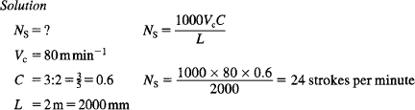

# What is meant by overhead absorption rate?



1. **Give the example for various indirect costs . Indirect materials:**

Lubriating oil, Maintenance materials, Plant spares.

# Indirect Labour:

Shopfloor supervision, Maintenance, Storemen

# Indirect Expenses:

Factory rent, Factory rates , Plant insurance

# Differentiate between Route sheet and process sheet.(Nov/Dec 2018)

Route sheet or process sheet is the map or the blueprint of the manufacturing process in a production unit, providing the precise route or sequence to be followed. A process sheet describes the series of actions to be performed to achieve a particular task in the manufacturing or production process.

# List out the factors to be considered in selection of process parameters.(April/May 2019)

Cutting speed, Feed rate, and depth of cut.

# What are the basic principles of design of Jigs and Fixtures? (April/May 2019)

Rigidity, Foolproof Design, clearance, Location etc.

# What is the use of quality assurance? (Nov/Dec 2019)

Quality assurance (QA) is a way of preventing mistakes and defects in manufactured products and avoiding problems when delivering products or services to customers; which ISO 9000 defines as "part of quality management focused on providing confidence

that quality requirements will be fulfilled".

# List the factors in selection of Jigs and Fixtures.(Nov/Dec 2019)

The general factors to be considered when designing jig and fixture are shape, material and state of work part, pre- machined surface tolerance, type of operations and the machine tools used, work piece handling, ergonomics and safety considerations.

# Differentiate between Route sheet and operation sheet.( 2021)

A route sheet is a document which lists the exact sequence of operations needed to complete the job. An operations sheet is a document that lists all details of the operations needed to complete the part or assembly.

**PART – B**

1. **Discuss in detail about steps in design of jigs and fixtures. (Nov/Dec 2016)**

# (i). An inserted tooth face milling cutter has 8 teeth. It is to be used to mill a surface using a spindle speed of 1250 rpm and a feed rate of 0.3mm/tooth. Calculate the feed rate in m/min

**(ii). A planer is capable of 15 strokes per minute over a stroke length of 2m. The cutting time ratio for the machine is 4:3. Determine cutting speed. The feed per stroke fs is quoted as 2 mm/stroke. What is the feed rate in mm/min?**

# Explain in detail about the Principles and practice of location and clamping in jigs and fixtures.

1. **(i). Explain the marginal costing in detail.**

# (ii). A particular product has been made in the cost centre and the data given from the cost centre is given below: Total budgeted overhead for period = Rs.8000, Total direct labour hours = 625 Total machine hours = 1600, Total direct wages = Rs.3125, Direct materials =

**Rs.19, Direct labour hours = 10, Machine hours = 25, Direct wages (labour**

# cost) = Rs.55, If it has been decided to use the machine hour OAR, calculate, OAR for all the three bases, the production cost. Calculate the OARs for all three bases for which there is data.

1. **The top surface of the aluminum alloy component shown in Fig. is to be milled by slab milling. It will be machined by a 20mm HSS cutter with eight cutting teeth at a constant surface speed of 45 m/min. The depth of cut is 4 mm and the milling machine**

# is capable of spindle speeds of up to 3000 rpm. Determine: (i) if the mill is capable of machining the component at the required surface speed; (ii) the total machining time for the component if the mill is capable.

1. **A component of width 950mm and length 1400mm is to be machined on the planing machine, The planer has been refurbished and upgraded and it is now claimed that speeds of up to 80m/min are possible with a cutting time ratio of 3:2, with a cutting speed of 80m/min. How long will it take to machine the component surface**

# The top surface of the Aluminium alloy component shown in above figure is to be milled by vertical milling machine with a Φ25mm carbide face cutter with 10 teeth. This will be performed at a constant speed of 80mmin -1. The machine to be used is capable of

# spindle speeds of 4000 rpm. The two Φ2Omm holes in the component in above figure are being drilled on the vertical milling machine with a carbide drill. Determine: (i) if the mill is capable of machining the component at the required surface speed; (ii) the total machining time for the component if the mill is capable (iii) the time to machine both holes.(April /May 2018)

1. **It is decided to consider carrying out the machining in Example 6.9 using a vertical milling machine with a Φ25mm carbide face cutter with 10 teeth. This will be**

# performed at a constant speed of 80m/min. The machine to be used is capable of spindle speeds of 4000 rpm. Determine: (i) if the mill is capable of machining the component at the required surface speed; (ii) the total machining time for the component if the mill is capable.

1. **(i) Explain the Break Even analysis in detail with derivation.**

# (ii).A component can be produced with equal ease on either a capstan lathe or on a single spindle cam operated automatic lathe. Find the break-even quantity QE if the following information is known.

|  |  |  |
| --- | --- | --- |
|  | **Capstan Lathe** | **Automatic Lathe** |
| **(a)Tooling cost** | **Rs. 30.00** | **Rs. 30.00** |
| **(b)Cost of cams** | **—** | **Rs. 150.00** |
| **(c)Material cost/Component** | **Rs. 0.25** | **Rs. 0.25** |
| **(d)Operating labour cost** | **Rs. 2.50/hour** | **Rs. 1.00/hour** |
| **(e)Cycle time/Component** | **5 minutes** | **1 minute** |
| **(f)Setting up labour cost** | **Rs. 4.00/hour** | **Rs. 4.00/hour** |
| **(g)Setting up time** | **1 hour** | **8 hours** |
| **(h)Machine overheads** | **300 % of (d)** | **1000 % of (d)** |
| **(setting and operating)** |  | **(Nov / Dec 2015)** |

1. **What are the different types of inspection methods? Write Briefly about them. (Nov/Dec 2016)**

# Explain the importance of selection of the right quality assurance method during manufacturing.(April/May 2018)

1. **Explain the factors to be considered in selection of process parameters.(April/May 2018)**

# List out the set of documents required for process planning.(Nov/Dec 2018).

1. **i) What are the six basic factors must be considered while selecting measuring instruments.(Nov/Dec 2018)**

# ii) Explain what is meant by ‘six degrees of freedom’with neat sketch.(Nov/Dec 2018) 15.Discuss the following “ there are number of patterns that a process control chart exhibit

**that indicate a process is out of control without any points outside the control limits”. (April/May 2019)**

# Describe the various quality assurance methods.(Nov/Dec 2019)

1. **Explain the economics of Process planning.(Nov/Dec 2019)**

**PART-C**

1. **Calculate the spindle speed required to turn a 75 mm diameter shoulder on a low-carbon steel component using a high-speed steel tool. What is the percentage increase in cutting speed if a carbide tool is used instead?**

# Consider the component in figure. The component is to be made from mild steel with carbide tooling at a constant surface speed of l00m/min on a lathe with a maximum spindle speed of 1500rev/min. The machining allowance is 2 mm. Determine: (i) if the lathe iscapable of turning the component at the required surface speed; (ii) the total machining time for the component if the lathe is capable.(Nov/Dec 2017)

# Calculate the maximum surface speeds for facing, turning all surfaces and parting off. The maximum spindle speed of the lathe being used is 600rpm for the part diagram that shown in figure.(April/May 2019)

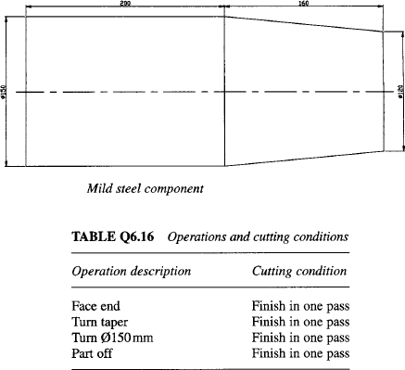

1. **Prepare the operation and Route sheet for the component shown in fig. (2021)**

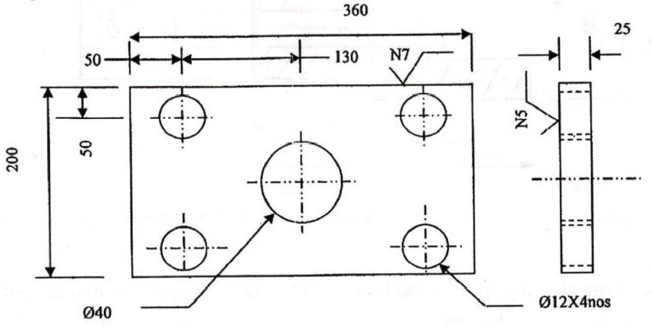

**UNIT III- INTRODUCTION TO COST ESTIMATION PART - A**

1. **Define Cost estimation.(Nov/Dec2012)**

A: Cost estimating may be defined as the process of determining the probable cost of the product before the start of its manufacture.

# Define Costing.(Nov/Dec 2012, May/June 2013)(April/May 2015) (Nov/Dec 2015) (Nov/Dec 2016)

Costing may be defined as a system of accounts which systematically and accurately records every expenditure in order to determine the cost of a product after knowing the different expenses incurred in various department.

# What meant by target cost? (Nov/Dec 2014)

Maximum amount of cost that can be incurred on a product and with it firm can still a earn the required profit margin from the product at the particular selling price.

# Brief the importance of the cost estimating.

Only accurate cost estimating can enable the factory owner to make vital decisions such as manufacturing and selling policies. Both over estimating and under-estimating are dangerous for a concern.

# List a few objectives of the cost estimation? (May/June 2012) (April/May 2015)(Nov/Dec 2019)

* 1. To establish the selling price of a product for a quotation or contract, so as to ensure reasonable profit to the company. ii) To verify the quotations submitted by the vendors. iii) To take make or buy decision**(iv)** To ascertain whether the proposed product can be manufactured and marketed profitably

# What are the functions of cost estimation? (May/June 2013)

1. Cost estimates are required to submit accurate *tenders* for getting the contracts 2.Cost estimates are required for the manufacturer to *choose* from various *methods of*

*production*, the one which is likely to be most economical.

1. Cost estimates are required for fixing the *selling price* of a product.
2. Cost estimates give the *detailed* information of all the operation and their costs, thus setting a standard to be achieved in actual practice
3. Cost estimates enable the management to plan for *procurement* of raw materials, tools, etc, and to arrange the necessary capital, as it gives detailed requirement.

# What are the methods of estimation?

* 1. Conference method ii) Comparison method and (iii) Detailed analysis method

# What is meant by conceptual cost estimating? (Nov/Dec 2014)

It is estimating during the conceptual design stage. In the conceptual design stage, the geometry of parts and materials have not been specified, unless they dictate essential product functions, the costs associated with a change in the design are low and the incurred

costs are only 5 to 7% of the total cost whereas the committed costs are 75 to 85% of the total cost.

# What is the process of conference method?

Here a coordinator from either accounting, or estimating collects these costs and applies overhead factors to develop a total manufacturing cost for the product. This is *not* often supported by detailed paper work, standard data or mathematical calculations. The degree of accuracy of this method depends upon the availability of specifications, samples and drawings.

# What is meant by the comparison method?

The costs of *similar* parts are applied to the product and are adjusted to suit variations in the work piece, materials and labour cost. This method of estimating is based on accumulation of past experience and data.

# What method is used for estimation when time is a constraint?

Conference method and Comparison method are used when time is a constraint.

# What is detailed analysis method in cost estimation?

The detailed analysis involves: (a) Calculation of all raw material usage including scrap, allowances and salvage material. (b) Processing each individual component, determining the production time for each operation, the equipment required (c) Tools, gauges and special fixtures or dies (d) Inspection and testing equipment (e) Packing and shipping requirements.

This method consumes a lot of time; however it is the most reliable one.

# What do you mean by a realistic estimate.(Nov/Dec 2012) (May/June 2012)(April/May 2019)

If the estimated cost of the product proves later on, to be almost sane as the actual cost of that product it is a realistic estimate.

# Define parametric estimating. (Nov/Dec 2012) (April/May 2019)

Parametric estimating is the act of estimating cost or time by the application of mathematical formulas. These formulas can be as simple as multiplies or as complex as regression models.

# What is departmental costing?

This method is adopted in determining the cost of the output of each department separately for the manufacture of the standardized products. This method is applied in industries like steel industry, automobile industry, etc. where each department is producing independently one or more components.

# Define job costing?

Concerned with finding the cost of each individual job or contract. The total cost for each order is obtained from the daily cost sheet. E.g.: Ship building, Building contract

# Define Batch costing? (April/May 2015)

Batch costing is a form of job costing. A batch of components is taken as a job

# What do you mean by multiple cost method?(Nov/Dec 2012 ,Nov/Dec 2013))

Multiple costing is used when many different finished products are made. Many components are made which are subsequently assembled into the completed article, which

may be bicycles, cars etc. Costs have to be ascertained for operations, processes, units and jobs, buildings together until total cost is found.

# Write some examples for operating cost method.

In transport services, water works, electricity boards, railways, etc. Cost is determined on the basis of operating expenses. That is, charges are made as passenger per km,per kw- hr, tonne- km, etc.

# What is preliminary estimate?

This is based on incomplete data. These estimates are based on assumptions and general information supplied by either the sales or engineering groups, especially in areas of incomplete data.

# What is final estimate?

This is based on complete data for a product and hence it is the most accurate estimate. Here a detailed estimate is made for every component, assembly, sub-assembly. However, this type of estimate is not justified as it involves huge costs, which is not justified.

# What is Labour Cost?

Labour cost = Estimated labour time needed to produce the product x Cost of labour per hour

# What is meant by direct material cost? (May/June 2012, May/June 2013)

Direct material cost is one which becomes the part of the product. It is the material which is consumed in the manufacturing of a product. It can be measured and charged directly to the cost of the product.

# What is meant by indirect material cost?

Indirect material is one which cannot be traced as a part of the product. It’s the material required for maintaining and operating the plant but cannot be a part of the product. Examples: Grease, lubricating oil, coolants used.

# Who are called direct labour?

Direct labour are the workers who actually work or process different materials either manually or with the help of machines. They are also called as productive labour, process labour, operating labour.

# Who are called Indirect labour?

Indirect labour is the non-productive staffs that help the productive labour in performing their duties. Examples: Supervisors, inspectors, foreman, store keepers, time keepers.

# The lengths of one edge of C.I. cube is 25cm.Calculate its weight, if the density of the material is 7.2 g/cc.

Given: a=25cm; density =7.2 g/cc

Therefore, volume =Area of base X Height = a**3= 253=** 15625 cm**3**

Weight of the cube = Volume x Density **=** 15625 x 7.2**=** 112.5 kg

# What are Establishment on-cost expenses?

It includes the expenses are incurred for general administration and management for efficient and proper functioning of the enterprise. Administrative expenses are also called as Office expenses and Establishment on-cost.

1. **Write the formula to find out material cost. (Nov/Dec 2015)** Material cost = Weight of the material **x** Cost per unit weight Weight of the material = volume x density of the material

# What are the methods available for allocation of overhead expenses?(Nov/Dec 2018)

The different methods of allocation of overhead expenses are:

a. Percentage on prime cost, Percentage on direct labor cost, Percentage on direct material cost, b.By hourly rate, Man hour rate, Machine hour rate, Combination of man-hour and machine hour rate, By unit rate, Unit rate method.

# Write the formula for allocation by percentage of prime cost for overhead.

% of overhead = (Total overhead cost/Total prime cost) x 100

# Write the formula for allocation by machine hour rate for overhead.

Machine hour rate = (total overhead cost/ total productive machine hours)

# A Production shop had its production overheads of Rs.12000/- and the production for the period in terms of direct labour was 24,000 hrs. find the overhead for a job requiring 20 labour hrs.

Rate of overhead=12000/24000=1/2 ; Overhead for 20 labour hrs=1/2*20=10/-

# Define depreciation/Causes of depreciation.(April/May 2018)

Depreciation is defined as the reduction in the value, or the effective economic life of a product arising from the passage of time, use or abuse, wear and tear, influence of the elements, or the cessation of demand for use.

# What are the various methods of calculating depreciation.

Straight line method, Diminishing Balance method, sinking fund method, Annuity charging method, The insurance policy method, Regular revaluation method, Machine-hour basis method, The sum of the year’s Digit method.

# A machine is purchased for Rs 40,000. The estimated life of machine is 15 years and scrap value Rs 15000.If the rate of interest on the depreciation fund is charged at 5%, calculate the rate of depreciation by sinking fund method.

D=R(C-S)/(1+R)^N-1 : Substituting the values, D= Rs.1157.40/-

# A machine costing Rs 2,00,000 has a residual value of Rs 1,00,000 after 10 years of service. The estimated rate of production is 8 units per hour. Using the production unit method calculate the rate of depreciation. Assume a 50 week year and 46 hours week.

Rate of Depreciation= Value of Asset/Number of units of production

=2,00,000-1,00,000/10x50x46x8=Rs.0.5435 per unit

1. **What is meant by overhead expenses. (May/June 2012)(April/May 2015) (Nov/Dec 2016)** Those are the expenses which includes Factory expenses, administrative expenses, selling expenses, distribution expenses.

# Classify the allowances considered in cost estimation.(Nov/Dec 2017)

* Relaxation allowance
* Contingency allowances
* Process allowances
* Interference allowances
* Special allowances

# Distinguish between cost estimation and cost accounting.( Nov/Dec 2017,2018)

|  |  |  |
| --- | --- | --- |
| **Point of comparison** | **Cost Estimating** | **Cost Accounting** |
| **Type of cost** | Expected cost | Actual cost |
| **Duration of process** | Before production of a product | Starts with the issue of order  for production of product and ends after its dispatch for sales |
| **Nature of quality**  **of person** | A qualified  technical | Qualified Accounts person |
| **Main Objectives** | Set standard for actual cost, set up market price, to decide on to make or buy, to facilitate in filling of tenders or quotations | Comparison of cost with estimates, to know wastes if any, budget preparation, output targets, legal obligations |

1. **What is activity based costing?(April/May 2018)**

Activity-based costing (ABC) is a [costing](https://en.wikipedia.org/wiki/Costing) methodology that identifies activities in an organization and assigns the cost of each activity with resources to all products and services according to the actual consumption by each. This model assigns more [indirect costs](https://en.wikipedia.org/wiki/Indirect_costs)([overhead](https://en.wikipedia.org/wiki/Overhead_(business))) into [direct costs](https://en.wikipedia.org/wiki/Direct_costs) compared to conventional costing.

# What are the elements of costing? (April/May 2018)(Nov/Dec 2019)

The cost of a product consists of the following cost components or elements. Direct Material, Direct Labour, Direct Expenses, Factory Overhead, Selling and Distribution and Administrative Overhead.

1. **What is the need to include allowances in cost estimation?** (**2021)**

Allowances are used to increase the accuracy of the cost estimate. It is worth mentioning that, by definition, an allowance is based on unknown measurement. This is why the cost

estimator should use caution and not become too optimistic when assessing the cost estimate accuracy based on the use of allowances.

**Part B**

1. **(i) Explain in detail about the types of estimates and how it is done? (Dec 2015 / May 2015) (ii)What is meant by analytical estimating? Write its procedure, advantages, limitations and applications. (Nov/Dec 2013)**

# List and explain in detail about the components of a job estimate?(Nov/Dec 2012, Nov/Dec 2013) (May/Jun 2013)( Nov/Dec 2017,2018)

**3.(i) Explain the step by step cost estimation procedure in detail and prepare a sample cost estimate form. (Nov/Dec 2012)(April/May 2015) (Nov/Dec 2016)(Nov/Dec 2019)**

# (ii) List and explain in detail about the objectives of cost accounting? (Nov/Dec 2015)

1. **(i) What are the methods of costing? Explain in detail. (May /June 2012, May/Jun 2013) (Nov/Dec 2016)**

# (ii) Write down the step by step procedure for estimating the direct material cost. (April/May 2015)

1. **Name the various elements of cost. Explain each element in detail with examples and about allowances in cost estimation. (May /June 2012, Nov/Dec 2015, April/May 2015)**

# Explain the objective of Cost estimating.(April/May 2019)

1. **(i) The direct material used is Rs.1000 and direct wages of Rs.443 for the manufacture of certain items. Calculate factory cost (a) when the on-cost is to be 60% of prime cost, and (b)When the on-cost is to be 90% of direct productive labour cost.**

# (ii) A certain piece of work is produced by a firm in batches of 100. The direct material cost for that 100 workpiece is Rs. 160 and the direct labor cost is Rs. 200. Factory on cost is

**35% of the total material and labour cost. Overhead charges are 20% of the factory cost. Calculate the prime cost and factory cost. If the management wants to make a profit of 10% on gross cost, determine the selling price of each article.**

# An isometric view of the work piece is shown in figure. What will be the weight of the material required to produce it. The density of material is 2.681gm/cc. Find also the material cost, if its rate is 13.60 per kg.

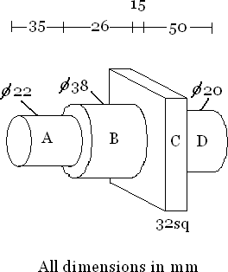

1. **The dimensioned figure shows a lathe centre. Estimate the weight and cost of material for the same, if the material weighs 7.868 gm/cc density and the material cost is Rs11.45 per kg.**

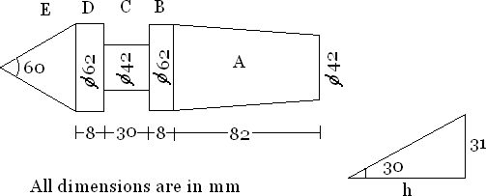

# (i) The total on-cost of a firm for a period of 8 months is Rs. 75,000. The firm employs 35 workers and an average working day per month is 23 days. 10% of total time is allowed for various allowances. Calculate the share of overheads to be allocated to a product requiring 9/2 man hours. Take 8 hrs of work per day.

**(ii) A C.I factory employs 25 persons. It consumes material worth Rs.35,000 pays workers at the rate of Rs.5 per hour and incurs total overheads of Rs. 20,000. In a particular month (25 days) workers had an overtime of 150 hrs and were paid double than the normal rate. Find (i)the total cost and (ii)the man hour rate of overheads. Assume an 8 hrs working days.**

# (i) What are the types of estimates. (ii) Differentiate between estimating and costing. (iii)Describe the various methods of allocation of overhead expenses? (Jun 2013 / Dec 2015

**/ Dec 2012) .(Nov/Dec 2016)**

# 12.(i) What are the three methods used in conceptual cost estimation? Explain any two methods briefly.(Nov/Dec 2014)(April/May 2019)

**(ii) Explain the various time allowances which should be considered for calculating labour cost. (May/Jun 2013)(April/May 2015)**

# 13. A factory has 15 lathes of same make and capacity and 5 shapers of same make and capacity.Lathes occupy 30m 2 area while shapers occupy 15m 2 area. During the calendar year, factoryexpenses for this section are as follows.

**Building rent and depreciation = Rs. 5000 Indirect labor and material = Rs. 15000 Insurance = Rs. 2000**

# Depreciation charges of lathe = Rs. 5000 Depreciation charges of shaper = Rs. 3000 Power consumptions for lathes = Rs. 2000 Power consumptions for shapers = Rs. 1000

**Find out the machine hour rate for lathe and shapers, if all the lathes and shapers work for 25,000 and 8000 hours respectively.(Nov/Dec 2012)(Nov/Dec 2019)**

**PART-C**

**1 (i). A manufacturer is making 100 units of an item per hr and incurs the following expenses: Direct Material cost Rs 35 ; Direct labour cost Rs 200;**

# Direct Expenses Rs 75 ; Factory on cost 150% of labour cost; Office on cost 30% of factory cost

**Find out the selling price for a profit of 15% on the selling price. (Nov/Dec 2015,2018) (ii).A sub-contracting manufacturer produces components for the automotive industry. One of these is a small brass bush (see Fig.), for which the following data applies:**

|  |  |
| --- | --- |
| **Costs: Φ35 brass bar :** | **Rs.19.02/m** |
| **Machinist's hourly rate** | **: Rs.9.45** |
| **Storeman's hourly rate** | **: Rs.4.98** |
| **Production overheads :** | **Rs.1102** |
| **Marketing/admin.** | **: Rs.852** |
| **Batch size** | **: 15 000** |
| **Other: Cut and prepare material per batch (storeman) :** | **198 h** |
| **Machining time per unit** | **: 2 min 15 s** |

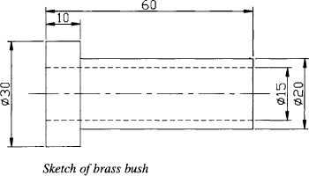

# Determine: (a) the direct material cost; (b) the direct labour cost; (c) the prime cost; (d) the total cost; (e) the cost per unit; (f) the selling price if the profit has to be 15 per cent.

1. **Fabricatious Ltd manufactures steel benches for industrial and medical applications. The following data applies to one of their products:**

# Material requirements

**Bench top 1250 X 625 x 6 mm plate (1 off)**

# Strut 1250 x 25 x 25 x 3 mm angle (2 off)

**Strut 625 x 25 x 25 x 3 mm angle (2 off)**

# Legs 750 x 25 X 25 X 3 mm angle (4 off)

**Costs 2500 x 1250 x 6 mm plate Rs. 83.43**

# 25 X25 X 3 mm angle iron :Rs 1.03/m Welder's hourly rate :Rs.12.50 Stores/finishing hourly rate .Rs.4.98

**Jigs/fixtures :Rs 189**

# Other: Cut prepare material per unit (stores) :35 min Fabrication time (welder) :30 min

**Finishing time (finishing) :45 min**

# Batch size 60

**The company has the following costs centers and their associated overheads:**

|  |  |  |
| --- | --- | --- |
| **Department** | **Budgeted overhead** | **Overhead absorption basis** |
| **Stores** | **Rs.15300** | **1200 labour hours** |
| **Fabrication** | **Rs.31200** | **2600 labour hours** |
| **Finishing** | **Rs.11400** | **800 labour hours** |

# The overheads for sales, marketing, administration and R&D are calculated based on 20 per cent of the production cost. Using the above data, determine: (a) the direct labour cost; (b) the direct material cost; (c) the prime cost; (d) the production cost; (e) the total cost. Using the information from the previous problem, determine: (a) the material cost per unit; (b) the unit cost; (c) the unit selling price if the profit required is 20 per cent.

1. **Explain any one method of calculating depreciation cost with an example.(Nov/Dec 2016)**

# 

# UNIT IV-PRODUCTION COST ESTIMATION

**PART A**

# Write the formulae to find out area and perimeter for ellipse.

Area = πab , Perimeter = π(a+b)

# What is forging and give its classification?

Forging is defined as the process in which the desired shape and size of an object is obtained through the plastic deformation of the metal of the object. It is classified as hot forging and cold forging.

# What are the various types of forging?

Smith forging, Drop forging, Press forging, Machine forging, Roll forging

# What is Smith forging?

In smith forging, also known as hand forging, the component is made by hammering the heated material on an anvil. The hammering may be done by hand or machine.

# What is Drop forging?

The forging is done by using the impressions machined on a pair of die blocks. The upper half of the die is raised and allowed to drop on the heated metal placed over the lower half of the die.

The metal is thus squeezed into required shape.

# What is Press forging?

In this method the metal is squeezed into desired shape in dies using presses. Instead of rapid impact blows of hammer, pressure is applied slowly. This method is used for producing accurate forgings.

# What is upset forging?

In machine forging or upset forging the metal is shaped by making it to flow at right angles to the normal axis. The heated bar stock is held between two dies and the protruding end is hammered using another die. In upset forging the cross-section of the metal is increased with a corresponding reduction in its length.

# What is Roll forging?

Roll forging is used to draw out sections of bar stock, *i.e.,* reducing the cross-section and increasing the length. Special roll forging machines, with dies of decreasing cross-section are used for roll forging.

# What are the various losses associated with forging? (Nov/Dec 2016)

Shear loss, Tong hold loss, scale loss, Flash loss, sprue loss.

# What is Shear Loss?

The blank required for forging a component is cut from billets or long bars.The material equal to the product of thickness of sawing blade and cross-section of bar is lost for each cut. Similarly, if the small pieces left at the end are not of full length, these also go as waste. Shear loss is generally taken as 5 percent of net weight.

# What is scale loss?

As the forging process is performed at very high temperature, the Oxygen from air forms iron oxide by reacting with hot surface. This iron oxide forms a thin film called scale, and falls off from surface at each stroke of hammer. Scale loss is taken as 6 percent of net weight.

# What is tong hold loss?

While performing forging operations, some length of the stock (at one end) is required for holding the stock in the tong. This small extra length will be removed after completion of the work piece. This is known as tong hold loss.

Tong hold loss = area of cross section of the bar x length of the hold

# What is Flash loss? (April/May 2019)

When dies are used for forging, some metal comes out of the die at the parting line of the top and bottom halves of the die. This extra metal is called flash. Flash is generally taken as 20 mm wide and 3 mm thick. The circumference of component at parting line multiplied by

cross-sectional area of flash gives the volume of flash. The flash loss in weight is then calculated by multiplying the volume of flash by density of the material.

# Write the formula for flash loss. (Nov/Dec 2013)

Flash loss = volume of flash x density of the material

# What is sprue loss?

When the component is forged by holding the stock with tongs, the tonghold and metal in the die are connected by a portion of metal called the sprue or runner. This is cut off when product is completed. Sprue loss is taken as 7 percent of net weight.

# Write the formula for volume of flash.

Volume of flash = circumference of component at parting time x cross section area of flash Cross sectional area of flash = flash thickness x flash width

# 17.A butt joint between two square metal plates of 250 x 250 cm is made using electric arc welding. If the rate of welding is 5metre/hr, calculate the time required to complete ten such welding operations.

Time required to make 10 welds = (Length of weld/rate of welding) x 10 = (2.5/5) x 10= 5 hours or 300 min.

# List out the names of gas welding techniques.

Leftward or forward welding and Rightward or backward welding

# What is Leftward or forward welding? (Nov/Dec 2016)(April/May 2018)

In this method, welding is started from right hand side of the joint and proceeds towards left. This method is used for welding plates upto 5 mm thick. No edge preparation is required in case of the plates of thickness upto 3 mm.

# What is Rightward or backward welding. (April/May 2018)

This method is adopted for welding thicker plates. Welding proceeds from left to right. The flame is directed towards the deposited metal and rate of cooling is very slow.

# Write the formula for direct material cost for manufacturing pattern.

Direct material cost =gross weight of the pattern including pattern allowances x cost per unit weight.

# Define Roll forging.(Nov/Dec 2017)

Roll forging is a forging technique used to reduce the thickness of a metal bar, while simultaneously increasing its length. A good candidate for roll forging is cylindrical piece of metal. The roll forging process begins with the heating of the metal to be shaped.

1. **Name the various sections in foundry shop.(Nov/Dec 2018)**

Pattern making, Sand mixing and preparation, Mould and core making, Mould Assembly and handling, Melting and pouring, Fettling and finishing, Heat Treatment, Inspection and Testing.

1. **Give the formula for calculating the cost of power consumed in arc welding.(Nov/Dec2018)**

Power cost = [VA]/1000 x [t/60] x [1/eff] x [1/r] x c

1. **How is the cost of material required for casting calculated?(Apil/May 2019)**

The main elements of casting cost are material, labour, energy, tooling and overheads. These are primarily driven by product and process parameters. The cast metal and part weight forms the basis of material cost. Energy cost is estimated based on the casting weight, yield, pouring temperature and melting equipment.

1. **Define Production cost.(Nov/Dec 2019)**

Production costs refer to the costs incurred from manufacturing a product or providing a service that generates revenue for that company. Production costs can include a variety of expenses, such as labor, raw materials, consumable manufacturing supplies, and general overhead.

1. **What is man hour and machine hour rate?(Nov/Dec 2019)**

A man-hour or person-hour is the amount of work performed by the average worker in one hour. It is used for estimation of the total amount of uninterrupted labor required to perform a task.

A machine hour rate for a specific machine cost centre is computed by dividing the total overhead estimated or incurred for that machine divided by actual or estimated machine hours.

**Part B**

* 1. **A square bar of 3 cm side and 25 cm length is to be hand forged into a hexagonal bar of side of 1.5 cm. Find length of the hexagonal bar ignoring metal losses. Density remains**

# same. (Nov/Dec 2015)

* 1. 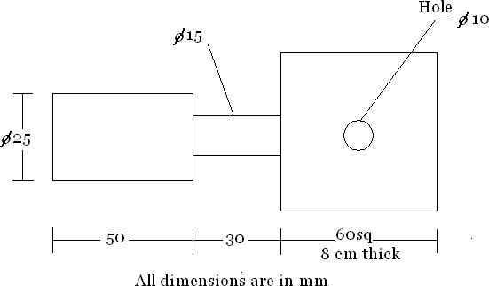**Calculate the net weight and gross weight for the manufacture of 500 levers shown in figure. The material weighs 7.8 g/cc and the total losses account for 25% of net weight of the lever. Also calculate (i) length of 3 cm diameter required per component (ii) the cost of forging 500 pieces if material cost Rs. 8 per kg, labor costs Rs. 1.20 per piece and overheads are 25% of material cost.**

# A gas engine flywheel is shown in figure. Determine the weight of the flywheel if the material weighs 7.2 g/cc.

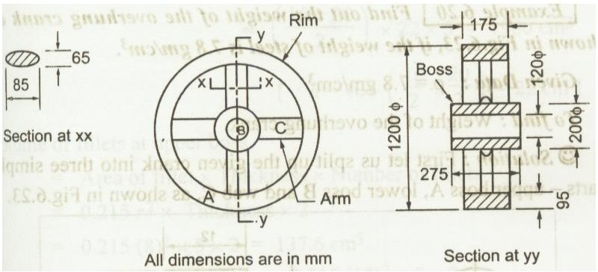

* 1. 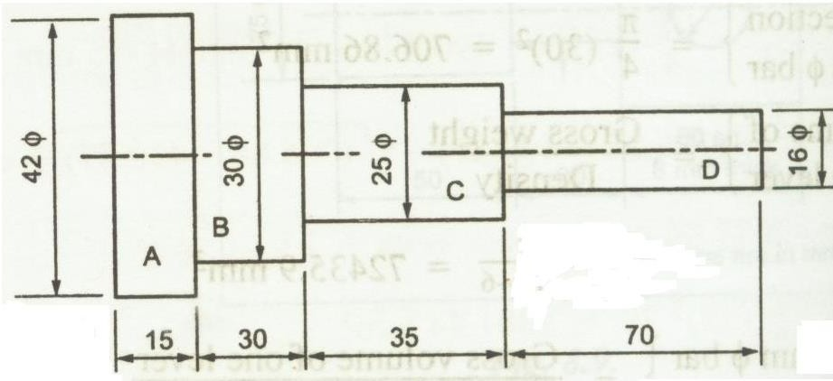**750 stepped spindles are to be made by machine forging. Estimate the net weight, gross weight and number of bars required if mild steel are available in 4 mm length and 25 mm diameter. Take the density of M.S bar 7.6 gm/cc. consider all the possible forging losses.**

# All dimensions are in mm

* 1. **150 pieces of shafts as shown in figure are to be forged from the raw stock of 2cm dia**

# .Estimate the cost incurred assuming that material cost =Rs5.20 per metre. Cost of forging

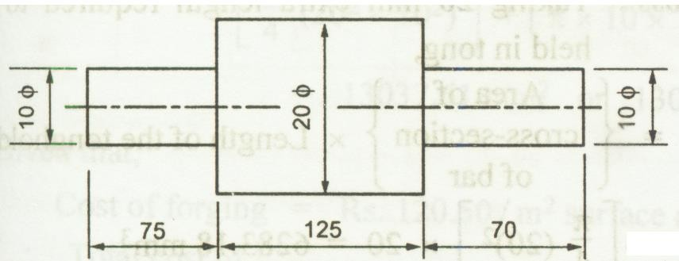**= Rs120.50 per sq.m of surface area to be forged. Overhead expenses to be 100% of the cost of forging .Consider all losses. .(Nov/Dec 2016)**

# All dimensions are in mm

* 1. **What is the material cost of welding two plates of size 300mm length and 150mm width and 8mm thickness to make a piece 300 x300 mm approximately. Use rightward technique with no edge preparation cost .Take overall cost of oxygen as Rs.0.70 per cu m,cost of acetylene at Rs 7 per cum ,Cost of filler metal Rs 2.50 per kg and 1Cu.Cm of filler metal weighs**

# 11.28 gms .Assume dia of filler rod = 4mm . Filler rod used per metre of weld = 3.4 m .Rate of welding = 2.1 m/hr.Consumption of oxygen = Consumption of acetylene = 7.1 Cu.m/hr

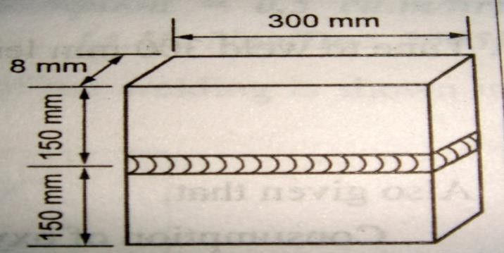

* 1. **Estimate the material cost for welding 2 flat pieces of M.S 15x16x1 cm size at an angle of 90 by gas welding .Neglect edge preparation cost and assume Cost of O2 = Rs 10/cu.m,cost of C2H2= Rs60/cu.m,density of filler metal = 7 gm/cc; Cost of filler metal = Rs12/kg;Filler rod dia = 5 mm , filler rod required 4.5 mm / m of weld, welding time**

# is 30 min /m of welding, consumption of O2 = 0.7cu.m/hr and consumption of C2H2 = 0.5 cu.m/hr.

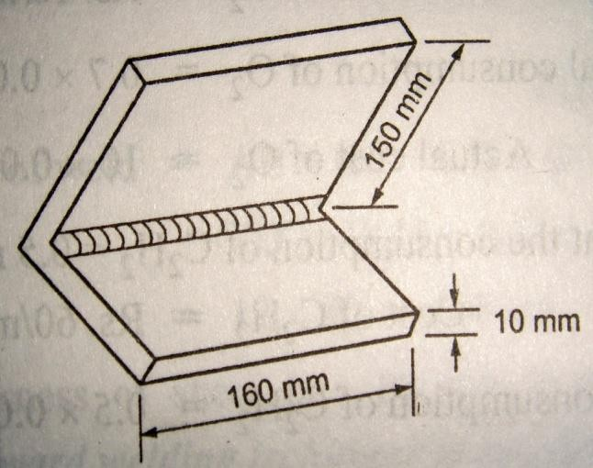

* 1. **A lap joint is to be prepared in 9.5 mm M.S. sheet using flat welding position and 6 mm electrode Current used is 250 A and voltage is 30 V.Welding speed is 12 m/Hr and 0.3 Kg of metal is deposited per metre length of joint.Labour cost Rs 1.5 per hour ,power Rs 0.20 per KWhr and electrode Rs 4 per Kg Effeciency of machine is 50% and operating factor is 60 % Calculate the cost of labour , power and electrode per metre of weld.**

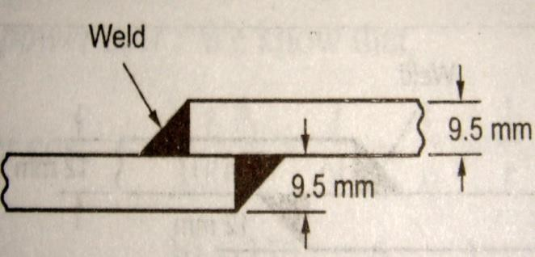

# An open water tank of size 75cm x 60cm x 50cm is made by gas welding from a 4 mm thick metallic sheet .Estimate the time require for welding a tank .Neglect other factors. Rate of welding = 5m/hr

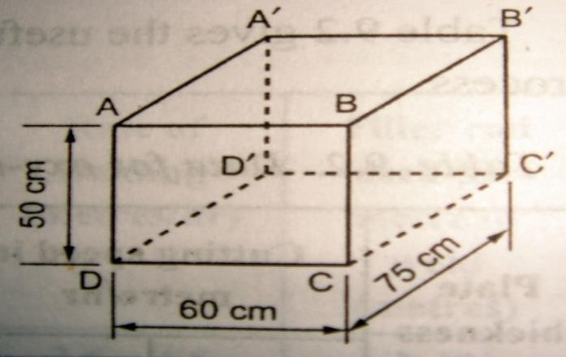

* 1. 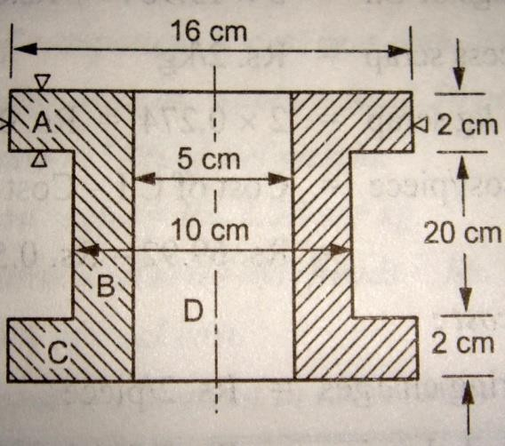**Estimate the total cost of 20 CI flanged pipe casting shown in figure, assuming the following data, Cost of CI=Rs.5/kg, cost of process scrap Rs.2/kg, process scrap 2% of net weight of casting , moulding and pouring charges = Rs.2/piece ,casting removal and cleaning = Rs0.5/piece ,administrative overheads = 5% factory cost ,selling overheads = 70%administrarive overheads**

# A small fuse box 300mm long , 20 mm wide and 60 mm deep with a 30 mm deep is to be manufactured in grey iron .The average thickness is 4.5 mm .The pattern supplied by the customer is of loose type, hence bench moulding is to be followed . Estimate the selling price per piece, assume the following data: (i)Cost of iron at the cupola sprout = Rs1.2 per kg (ii)Cost of process scrap return = Rs 55 paise per kg (iii)Administrative on cost = Rs 3.2 per hour (iv) Profit margin = 16% (v) Density = 7.3 gm/cc , (vi) Process scrap = 20% of net weight . Other expenditure details are included in the table. Find selling price per piece.

|  |  |  |  |
| --- | --- | --- | --- |
| **Operation** | **Time per piece** | **Labour charges**  **per minute** | **Works on cost per**  **hour** |
| **Moulding and pouring** | **16 min** | **Rs. 1.50** | **Rs.4.50** |
| **Shot blasting** | **6 min** | **Rs. 0.25** | **Rs. 4.00** |
| **Fettling** | **4 min** | **Rs. 0.10** | **Rs. 3.25** |

* 1. **A foundry unit produces tractor components as cast. Calculate the selling price of producing a component weighing 50 kgs from the following data (i) Material of the component is cast iron with density = 7.2gm/cc (ii) Cost of molten iron at cupola=Rs2.5**

# per kg (iii) Process scrap = 17% of net weight (iv) Scrap return value = Rs 1.1per kg (v) Administrative and sales overheads = Rs 5 per piece(vi) Profit 10%of total cost (vii) other expenditure is given in table below

|  |  |  |  |
| --- | --- | --- | --- |
| **Operation** | **Time per**  **component (min)** | **Labour cost per**  **component(Rs)** | **Shop overheads**  **per hour(Rs)** |
| **Moulding and pattern making** | **6** | **2.6** | **4.25** |
| **Core making** | **8** | **2.4** | **3.5** |
| **Fettling and cleaning** | **10** | **2.75** | **3** |

* 1. **Calculate the welding cost for a cylindrical boiler drum 2.5 x 1 m diameter which is made from 15 mm thick MS plates. Both the ends are closed along the longitudinal seam and welding is done both inner and outer side. Assume the following, rate of welding = 2 m/hr on inner side and 2.5 m/ hr on our side, length of electrode required**

# is.5 m/ meter of weld length, cost of electrode is 0.60 /m, power consumed= 4KWh/ m of weld, power charge =Rs.3/kWh, Labour charge = Rs.40/ hr, other overheads = 30% of prime cost, discarded electrodes = 5%, fatigue and setting up time = 6% of welding time. (Nov/Dec 2017),(April/May 2018)

* 1. **Calculate the total costof CI cap as shown in fig from the following data.cost of molten iron at cupola spout = Rs. 30 per kg, process scrap = 17 % of net wt of casting, process srap value = Rs 5 per kg, Administrative overhead charges = Rs 2 per kg of metal poured. Density of material used = 7.2 gm/cc. The other expenditure details are**

|  |  |  |  |
| --- | --- | --- | --- |
| **Operation** | **Time per**  **component (min)** | **Labour cost per**  **component(Rs)** | **Shop overheads**  **per hour(Rs)** |
| **Moulding and Pouring** | **10** | **30** | **30** |
| **Core making** | **4** | **10** | **30** |
| **Fettling and cleaning** | **6** | **10** | **30** |

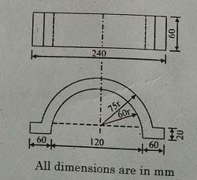

# 23.Calculate the cost of forging a crank shaft as shown in Fig. The forging is to be made out of a bar stock of 50 mm and following data is available.(April/May 2019)

**Material price = Rs. 80/kg, Direct Labour charge = Rs. 23 per pcs,**

# Overheads = 150 % of material cost,

**Density =7.5 gm/cc,**

# Losses = 28 % net weight. All dimensions in mm.

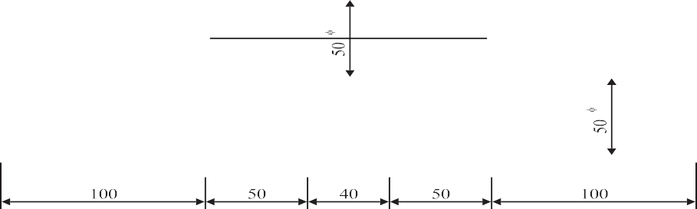

# A lap welded joint is to be made as shown in Fig. Estimate the cost of weld from the following data .(April/May 2019)

|  |  |  |  |
| --- | --- | --- | --- |
| **Thickness of plate** | **=** | | **10 mm** |
| **Length of joint** | **=** | | **1 m** |
| **Electrode diameter** | **=** | | **6 mm** |
| **Minimum arc voltage** | **=** | | **30 Volts** |
| **Current used Welding speed**  **Electrode used per meter of weld Labour rate**  **Power rate Electrode rate**  **Efficiency of welding m/c Connecting ratio**  **Overhead charges** | **=**  **=** | **250 Amperes**  **= 10 meters/hour**  **0.350 kgs**  **= Rs. 40 per hour**  **= Rs. 8 per kWh**  **= Rs. 55 per kg**  **= 60 percent**  **= 0.5**  **= 40 percent of direct charges** | |

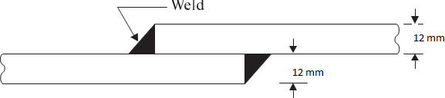

1. **Calculate the cost of welding from the following data .(Nov/Dec 2019)**

|  |  |  |
| --- | --- | --- |
| **Thickness of plate** | **=** | **12 mm** |
| **Form of Joint** | **=** | **60°V** |
| **Root gap** | **=** | **2 mm** |
| **Length of joint** | **=** | **2 m** |
| **Electrode diameter** | **=** | **3.5 to 4.0 mm** |
| **Electrode Length** | **=** | **350 mm** |
| **Electrode used per meter of weld for** |  |  |
| **100 percent efficiency & 50 mm stub length** | **=** | **10 nos. of 3.5 mm dia & 24** |
| **nos. 14 mm dia** | | |
| **Average Deposition** | **=** | **80 %** |
| **Melting time per electrode** | **=** | **1.3 min for 3.5 mm dia** |
|  |  | **1.5 min for 4 mm dia** |
| **Connecting ratio** | **=** | **2** |
| **Hourly welding rate** | **=** | **Rs.40** |

# Overhead charges = 40 percent of welding cost

1. **Calculate the production cost per crank shaft for a 4 stroke oil engine from the following data. (Nov/Dec 2019)**

|  |  |  |
| --- | --- | --- |
| **Charges per forging per Kg** | **=** | **Rs.2.5** |
| **Wrought iron used per week @ Rs. 10 /Kg** | **=** | **3 tonnes** |
| **Wages of Operator** | **=** | **Rs.50/day** |
| **No of Operators employed** | **=** | **4** |
| **Cartage/day** | **=** | **Rs.250** |
| **Depreciation of Machine and tools** | **=** | **Rs.500/month** |
| **Wages of Helper** | **=** | **Rs.30/day** |
| **No. of Helpers** | **=** | **4** |
| **Salary of Supervisor** | **=** | **Rs. 5000/month** |
| **Packing Charges for 12 shafts** | **=** | **40** |
| **Electric Charges** | **=** | **Rs.1300/month** |
| **Salary Manager and Maintenance Staff** | **=** | **Rs.14000/month** |

# If 1500 crank shafts are produced per month and factory runs 26 days a month, what should be the selling price of each shaft to earn a profit of 20 % of the factory cost.(Nov/Dec 2019)

**PART-C**

# i) What are the various losses considered while calculating the material cost of a forged component. Explain.(Nov/Dec 2018)

**ii) List the various sections that will normally be found in a foundry shop. Nov/Dec 2017**

# List the various elements to be considered while calculating the cost of a welded joint. (Nov/Dec 2016)

1. **Generalize the meaning of tong hold loss in forging. (Nov/Dec 2016)**

# UNIT V-MACHINING TIME CALCULATION

**PART A**

# What is manufacturing cost of a product?

Manufacturing cost = Factory cost + Administrative expenses

# Write the formula for selling price and market price.

Selling Price = Total Cost + Profit, : Market price =Selling price + Discount

# Write the formulae to find time taken per cut in milling.(Nov/Dec 2019)

Time taken per cut = (Length of job + Added table travel) / [(Feed/rev) x (r.p.m)]

# What are the factors to be considered by the estimator while calculating the time required for a particular job?

Set up time, Operation time: Handling time, Machining time, Tear down time, Miscellaneous allowances, Personal allowances, Fatigue allowances, Contingency allowances, Process allowances, Interference allowances, Special allowances

# What is set up time?

It is the time required for settling and fixing the jobs and tools on the machine. It includes the time to study the drawings, blue prints, etc.

# What is tear down time?(Nov/Dec 2017,2018)

It is time taken to remove job, tools, and other auxiliary equipment from the machine after the last element of the operation has been completed.

# What are miscellaneous allowances?

This is the additional time allowed to perform the work over and above the basic time. To obtain the standard time, proper allowances must be added depending upon the working conditions.

# Write the formulae to find out time taken for tapping operation.

Time taken for tapping = length traveled by tap/( feed/rev)x(r.p.m) = (L+ D/2) / Pitch x r.p.m

# Write the formulae to find out time taken for returning tap.

Time taken for returning the tap is taken as ½ of the time required for pushing it in the work piece. Total time for tapping = 3/2 (L+ D/2) / Pitch x r.p.m

# A machinist manufactures 25 jobs in 7 hours. If this time includes the time for setting his machine, calculate the machinist’s efficiency. Take the allowed standard setting time and standard production time per piece as 45 min and 10 min respectively.

Standard time for manufacturing 25 jobs = standard setup time + standard production time for 25 jobs. = 45 + (25*10) = 295 min

Machinist’s efficiency = Standard time x 100= (295/420) x 100 = 70.24%

Actual time

# What are the terms used in study of machining time?

Length of cut , Feed, Depth of cut, Cutting speed

# What is Length of cut?

It is the distance travelled by the tool to machine the work piece and is calculated as Length of cut = L = Approach length + Length of work piece to be machined + Over travel

1. **What is feed?**

Feed is the distance that a tool travels along the work or the work travels w.r.t. the tool for each revolution of the work-piece or cutter.

1. **What is depth of cut?**

It is the difference between unfinished dimension and finished dimension of the job. For example, in case of turning, depth of cut is the difference between radius of the bar before and after taking the cut. The feed and depth of cut for a particular operation depend on the material to be machined, surface finish required and tool used.

# What is cutting speed?(April/May 2015) (Nov/Dec 2016)

Cutting speed is the speed at which the cutting edge of tool passes over the job and it is usually expressed in meters per minute. The cutting speed depends on the cutting tool material, the work piece material and the operation.

1. **What is undercutting?**

In undercutting, also called internal relief, a previously bored hole is made larger along the same axis and is within the longitudinal limits of the main bore. Internal relieving time is calculated by the same formula as for turning.

1. **What is external relief?**

The external relief is the removal of material from a previously turned surface along the same axis and within the limits of turned area. The method of calculating the time for external relief is same as for turning.

# What is boring?

Boring is the operation of enlarging or finishing an internal hole which has been previously drilled.

# What is reaming?

It is the process of removing small amount of material from a previously drilled hole or bored hole perfecting the hole.

# What is machining time? (Nov/Dec 2016)

It is the time from the tool touches the work to the tool leaves the component after completion of operation.

# Give the formula for estimation of machining time for drilling.(Nov/Dec 2017)

T=Time for drilling

L= length of the drill hole N= drilling speed

F=feed T= L/f *N

# What are the typical data required for cutting time calculation in shaping? (April/May 2018)

The typical data required for cutting time calculation in shaping are total length of table travel, Number of strokes per minute, and feed of the job.

# Write the steps involved in cutting time calculation.(April/May 2018)

* 1. The actual length of job is found.(adding approach and over run to length of job)(L+A+O) 2.Spindle speed N is calculated from cutting velocity,(V=πDN/1000)

3. Number of passes required for cutting is measure.(n=D-d/2t) 4.Finally the cutting time is calculated(T=L x n/f x N)

1. **What is interference allowance?(April/May 2019)**

Interference allowance is the allowance given to the operator, when the operator is looking after two or more machines and one or more stop working while he is busy with some machine.

1. **In general, while calculating machining times, allowances are used. Why is it important? (April/May 2019)**

The allowances are considered or provided to compensate the worker/operator for the

production interruptions that may occur due to his personnel legitimate needs or the factors beyond his controls. For example the delay may occur due to operators personnel needs such as drinking water, taking tea, going to toilet etc., unavoidable delays like waiting for tools, materials or equipment, maintenance of machine and periodic inspection of parts/materials.

1. **What are the elements of machining time? (Nov/Dec 2019)**

The basic elements of machining are workpiece, tool and chip. For any cutting action, it is necessary to have relative motion between tool and workpiece.

1. **What are the different types of Milling operations? (Nov/Dec 2019)(2021)**

Face Milling, Slab milling, profile milling, keyway cutting, slotting.

**PART B**

1. **What is the machining time to turn the dimensions given in figure.The material is brass , the cutting speed with H.S.S tool being 60 m/min and the feed is 7.5mm/rev, depth of cut is 3 mm per pass.**

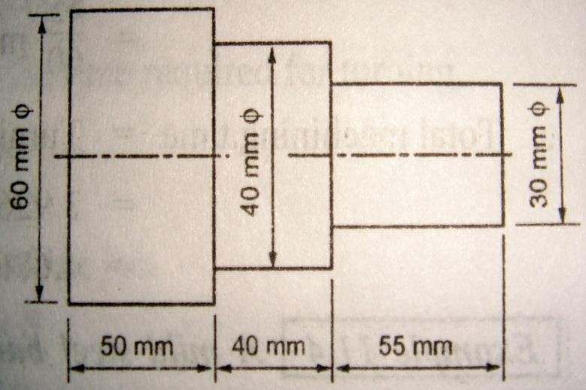

# A 150 mm thick laminated plate consists of 90 mm thick steel plate and 60 mm thick brass plate .A 20 mm dia hole is to be drilled through this plate .Estimate the total time taken for drilling if , cutting speed for steel = 25 m/min , cutting speed for brass = 50 m/min ,feed of 20 mm drill for steel = 0.2 mm/rev , feed of 20 mm drill for brass = 0.25 mm/rev.

1. **Calculate the drilling and tapping time for producing threads in a mild steel of 25 mm thickness. The size of H.S.S drill to be used is 20 mm and the number of threads to be cut is**

# 3 per cm. Taking cutting speed and feed for drill as 20 m/min and 0.25 mm/rev

**respectively, tapping speed as 5m/min.Neglect the time taken for setting up and approaching and over travelling of tools**

# It is required to produce a hole 15 mm in dia and 10 cm deep through the mild steel piece. Estimate the time taken for completing the hole in the following two cases(i)The hole is drilled by a 15 mm drill .Assume the cutting speed for the mild steel to be 30

**m/min and the feed for 15 mm drill to e 0.2 mm/rev.(ii)First, a 10 mm hole is drilled which is then brought to accurate size by boring . Assume the cutting speed for boring**

# and drilling to be 30m/min. The feed for 10mm drill to be 0.15 mm/rev and the feed for the boring operation to be 0.13mm/rev.

1. **Find the time required on a shaper to machine a plate 1100*500mm , if the cutting speed is 16 m/min.The ratio of return stroke time to cutting stroke time is 2 : 3 .The clearance at each end is 20 mm along the length and 15 mm on width .Two cuts are required , one roughing cut with cross feed of 2 mm per stroke and one finishing cut with feed of 1.25 mm per stroke.(Nov/Dec 2017)(Nov/Dec 2019)**

# Estimate the time taken to prepare a job from M.S.stock bar 4 cm in dia and 7.5 cm long. Assume the following data , Cutting speed for turning and boring = 20 m/min . Cutting speed for drilling operation = 30m/min. Feed for turning and boring operation

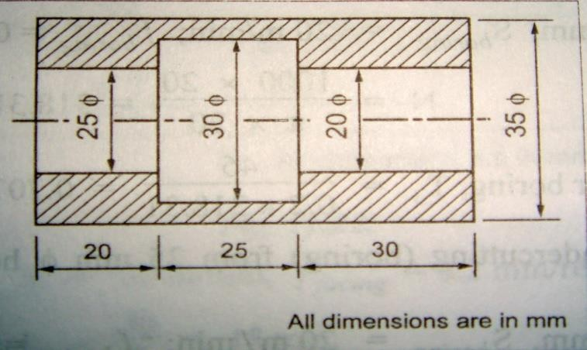**is 0.2 mm/rev .Feed for 20 mm drill = 0.23 mm/rev .Depth of cut not to exceed 3 mm in any operation**

# Find the time required for doing rough grinding of a 15cm long steel shaft to reduce its dia from 4 to 3.8 cm with the grinding wheel of 2cm face width .Assume cutting speed as 15 m/min and the depth of cut as 0.25 min.

1. **Calculate the machining time required to produce one piece of the component shown in fig. Starting from f 25mm bar. The following data is available.**

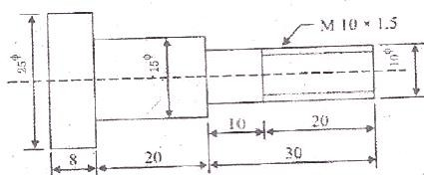

# For turning: Cutting Speed = 40 m/ min Feed = 0.4 mm/rev Depth of cut = 2.5 mm/per pass For thread cutting: Cutting speed = 8 m/ min. (Nov/Dec 2014)

1. **A T-Slot is to be cut in a C.I slab in fig. given below. Estimate the machining time. Take cutting speed 25 m/min, feed is 0.25 mm/rev. Dia of cutter for channel milling is 80 mm. (Nov/Dec 2014,2017,2018)**

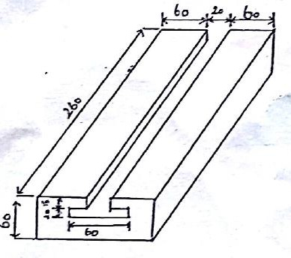

# (i)A 25 cm x 10 cm C.I surface to be faced on a milling machine with a cutter of diameter of 15 cm and 16 teeth. If the cutting speed and feed are 55 m/min and 6 cm/min respectively, determine the rpm of the cutter, feed/tooth and the milling time. (Nov/Dec 2019)

**(ii) find the time required for finish grinding a 20 cm long steel shaft to reduce its diameter from 4.5 cm to 4.3 cm with a grinding wheel of 2.5 cm face width. Cutting speed is 16 m/min and depth of cut is 0.2 mm. (iii)Calculate the cutting speed on a job of 50mm diameter rotating at 200 rpm.(Nov/Dec 2015)**

# i)In a manual operation, observed time for a cycle of operation is 0.5 minute and the rating factor as observed by the time study engineer is 125%. All allowances put together is 15% of normal time. Estimate the standard time.

**ii). In a manufacturing process the observed time for one cycle of operation is 0.75 minute. The rating factor is 110%. The following are the various allowances as the percentage of normal time. Personal allowance = 3% , Relaxation allowance= 10%, Delay allowance= 2%, Estimate the standard time.**

# A 60 mm rod of Al to be machined on a lathe, the finished size is shown in fig. The length of rod is 175 mm. Determine the total machining time and material cost, if purchased at the rate of the rate of 12 per Kg. Assuming cutting speed of 30 m/min

**and feed 0.2 mm/rev. Take density of Al as 2.7 gm/cc. Depth of cut not to exceed 2.5 mm.(April/May 2015)**

# A mild steel bar 120mm long and 40 mm dia is turned first to 38 mm and then to 35 mm over 50 mm as in fig. the bar is chamfered at both ends after facing to give a chamfer of 45 deg X 4 mm . Calculate the machining time. Assume cutting speed of 50 m/min and 0.3 mm/rev. The depth of cut is not to exceed 3 mm in any operation.(Nov/Dec 2016)(Apil/May 2019)

1. **Estimate the machining time to drill four 8 mm diameter holes and one 40 mm diameter central hole in the flange shown in fig. First diameter of 20 mm is drilled and then enlarged to diameter of 40 mm hole. Take cutting speed 10m/min, feed for 8mm drill 0.1mm/rev, for 20mm drill feed is 0.2 mm/rev , for 40 mm diameter drill feed is 0.4 mm/rev.(Nov/Dec 2018)**

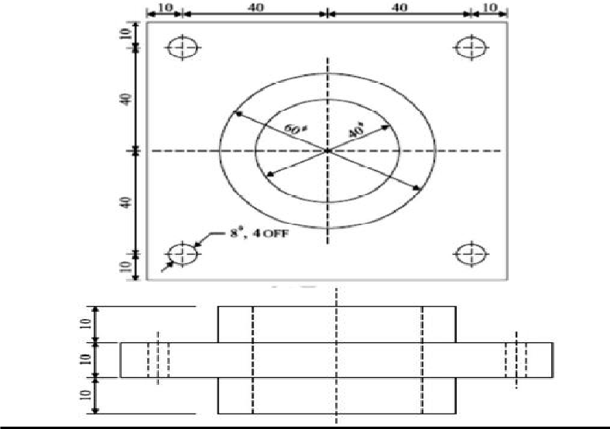

**PART-C**

**1.i) Find the time required to drill 4 holes in a CI flange each of 2 cm depth, if the hole dia is 2 cm. Assume cutting speed as 21.9 m/min and feed as 0.02 cm/rev.**

# A keyway has to be cut in a spindle whose dimensions are 46 cm length, 5 cm dia , 1 cm width. The cutter dia is 13.25 cm .If the cutter revolves at 120 rpm , what is the time required to cut a 1 cm deep keyway at a feed of 0.05 cm/rev of cutter? (Nov/Dec 2016).

1. **Consider the component in fig . It is made from MS with carbide tooling at contact speed of 100 m/min on lathe with maximum spindle speed of 1500 rev/min . The machining allowance is 2 mm. Determine I) if the lathe is capable of turning the component the required surface speed, ii) the total machining time for the component if the lathe is capable.(Nov/Dec 2017)**

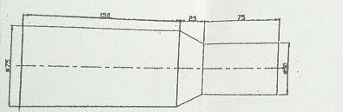

# Describe the procedure of estimating the machining time required during the shaping operation on a shaper.(April/May 2015)

1. **Elucidate the time elements considered to arrive at total time required to perform a machining operation.(April/May 2019)**